EXERP

Exerp Training Manual v20

Contents

Exerp App Summary 9

Front Desk App 9

Membership Sale App 9

Person App 9

Cash Register App 9

CRM App 9

Calendar App 9

Reports App 10

Planning App 10

Finance App 10

Front Desk App 11

Signing in a member 11

Booking a member into a class from sign in 12

Processing a POS product 12

Giving the correct change to a member 14

Pushing an item to their next direct debit 15

Other Payment Method 16

Splitting an item over an instalment plan 17

Applying a discount to a POS Product 19

Giftcards 19

Park a sale in POS 20

Unpark a sale in POS 22

Sales menu tab 23

Sales list 23

Cancelling a transaction 25

Membership Sale App 28

How to create a lead 28

Processing a Membership Sale 33

Splitting an Activation Kit or Start-Up Fees over Direct Debit 38

Signature Pad Process 39

Viewing a signed membership agreement 40

Unsigned paperwork report 41

View a completed membership 41

Processing a Referral as part of the Membership Sale 42

Campaign Codes 43

To waive the joining fee on a sale 44

How to change the staff member who sold the membership 44

Complimentary membership 45

Recurring Clip Cards 45

How to process a reccurring clip subscription. 46

Putting your Recurring Clip Card on freeze 49

Processing a downgrade 49

Processing a membership cancellation 49

Stop Subscription 49

Cancel Stop Membership 51

Splitting the cancellation fee over an instalment plan 51

Missing payment agreement – alerts 53

Regret Subscription 53

Cancel in the cooling off period 53

Person App 54

Member IDs 54

Person Types 55

Person profile 55

Summary Tab 55

Printing off a POS receipt 59

Details Tab 60

Member card 64

*Block/Blacklist/Suspend a Member* 64

Duplicate Checks 65

Transfer Membership – Club-to-Club 65

Transfer – Member-to-Member 65

Membership Tab 69

Subscription tab 69

To make a price adjustment/banking variation to a member’s account 70

To make changes to a subscription 72

Upgrade 73

Downgrade 73

Freeze tab 83

Free Periods 87

Reciprocal Rights 98

Journal tab 99

*Viewing old contact history from FCM* 100

Messages 102

Pausing Messages in Exerp 103

Questionnaires 106

Assigning a Health & Wellness Check-In Questionnaire 106

106

107

*Log tab* 107

*Status history* 108

*Change history* 108

***Account Tab*** 110

Instalment Plan Account 111

*Payment agreement tab* 117

*Updating a members direct debit details* 118

*Cancelling a payment agreement* 119

Staff Profile 123

Add a new Staff Member 123

Exerp staff log-in 123

Add staff roles 126

Add a staff group 128

Staff Mapping from Exerp to Pro.Mywellness 130

How to change a staff members’ password 131

Staff uniform details 133

Staff discounts 133

Cash Register App 133

Open Cash Register - Start of Day Process 133

Close Cash register - End of day process 136

Count Cash Register 139

141

Planning App 143

Opening a shift time 143

Calendar App 145

Complimentary sessions 145

Adding a Complimentary Session to a members’ profile 145

Book a complimentary session 147

Booking a Member into a class via Exerp 148

Making a reoccurring PT Booking 149

Booking a Fernwood Trainer Appointment 152

Cancelling a member from a booking in Exerp 154

Cancellation Windows for Bookable Services 156

Cancelling a member inside 12 hours and not wanting to charge the member. 156

Classes App 157

View class info and bookings 157

Classes Colour Codes 158

Adjusting head count to classes 158

Waitlist Function 159

Finance App 159

Direct Debits (Billing in Exerp) 159

Payment Cycles 159

Direct Debit Process 162

Billing Process in Exerp 162

Rejected Payments 163

Viewing Direct Debit Information 164

Outstanding Debt Report and Managing Outstanding Debt 167

Instalment Plans 169

Cancelling a payment agreement 171

Editing a payment agreement (switching billing cycles) 172

Changing a payment agreement 175

Refunds 176

Price Increase Requests 176

Member Administration Services – Debt Collection 176

Member Administration Services – Full-Service 176

Payment Requests 176

Profit & Loss Reports 176

CRM App 178

Glossary of terms 178

CRM Workflow Summary 178

Lead - Contact Workflow Summary 178

Add a new lead 179

How to manually add the title (lead generation source) to a lead: 184

Add a new task 185

Calling a lead and setting a follow up interval 187

Follow-up Intervals 191

Edit a Follow-Up Interval 191

Sell a membership 193

7-day Post Sale Call 194

Process a Trial 195

End a Trial 196

Post-Trial Call 197

No Sale 198

Adding your Sales Availability 199

Book a Sales Appointment (Tour) 204

Showing up a customer for a sales appointment 210

Reschedule an appointment 213

Cancel an appointment and schedule a follow up call 215

Post Tour Call 216

Alternative CRM Bookings 218

My call list for today 218

How to view all closed leads 219

How to view my leads VS all leads 219

Where are my overdue calls? 220

Where are my closed lead and how do I reopen them? 221

How to resend the Welcome Email 223

Reports App 225

Report Definitions from commonly used reports available in the Reports App 226

Direct Debit Reports 227

Rejection Reports 228

Future Direct Debit - Estimate 228

Payment Cycle Report 230

Royalty Invoicing Reports 231

Periodical DAB Report – Detailed Billing 231

Periodical DAB Report – Detailed POS 231

Payroll Reports 232

Payroll – PT Report 232

Group Fitness Report 232

Revenue Breakdown 233

Build your own reports – Easy Extracts 234

Active Members Report 236

Cancelled Members during a particular period Report 240

Active Student Members 240

18-Day Non-Attendance Report 242

Active Members – Last Visit Date Report 243

Addon Extract Report 245

Clip Cards Report 245

QLIK Reports 246

Logging into QLIK 246

Sales Performance Reports 247

Sales KPI Details 247

Sales KPI dashboard 248

Sales KPI staff 248

Marketing Performance will allow you to check 3 reports 248

Profit and Loss Reports 248

Pro.Mywellness 248

Staff Profiles 248

Edit your staff profile 248

View your schedule 249

Managing Calendars – Personal Training & Fitness Coach 250

Open up a working time 250

Edit/Remove a shift 251

Booking in a member 251

Edit/reschedule a session 254

Cancel a session 255

How to assign a break in your calendar 256

Tasks 256

Assign a Member to a Staff Member 256

Staff App – Mywellness for Professionals 257

View any outstanding tasks 257

View & Manage the Calendar 257

See who is in the club 258

Fernwood App 2.0 258

Notifications to members for classes and appointments 258

Waitlist function 258

Book a Personal Training session via the App 258

Purchasing PT via the App 259

Managing Penalties for Classes 259

Scheduling Classses in pro.mywellness 259

Exerp Hardware Installation Instructions 259

Step Over Signature Pad 259

Requirements 259

Installation 259

Webcam Installation 261

Requirements 261

Installation 261

Posiflex MSR Driver Installation 263

Requirements 263

Installation 263

RFID HID Omnikey reader 266

Requirements 266

Set up Exerp 266

Exerp Hardware Requirements 268

Computers – minimum requirements (recommended) 268

Software 268

Printers 268

Cameras 268

Signature Pads 268

Tablets 269

# Exerp App Summary

What’s processed where?

## Front Desk App



This is where you process POS purchases, sign in members and view the sales menu.

## Membership Sale App



This where all memberships, trials, subscription sales and recurring clip cards are processed and changes are made.

## Person App

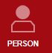

This is where you can view and edit a person’s profile and view all details about their membership.

## Cash Register App

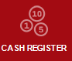

This is where the start of day (open cash register) and end of day (close cash register) is done. You can also view transaction history.

## CRM App

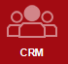

This is your lead management system. Schedules calls, sales appointments, manage and view incoming leads.

## Calendar App



Manage and create bookings for all the club’s services.

## Reports App



View and pull easy extract reports.

## Planning App

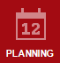

This is where you can manage the calendars. Open up shifts, change working times etc.

Finance App  
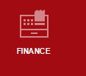 This is where franchisees can view their direct debit information each fortnight.

# Front Desk App

## Signing in a member

**Automatically –** swipe the member card against the reader to automatically sign the member into the club. If they are booked into any classes or appointments within a 2 hour window of checking in to the club it will automatically attend them to the booking.

PLEASE NOTE: the Front Desk App doesn’t have to be open for members sign themselves in via the card scanner. You can be processing a membership or booking into the calendar and it will log in member visits, whichever window you have open.

EXISTING FERNWOOD MEMBERS: You can still *Quick Search* a member by using their FCM Member ID on their card, by typing it into the Quick Search using the magnifying glass.

**Manually –** if a member doesn’t have their card, you can manually sign them into the club but following the steps below.

*Front Desk App > Search member > Select member > Activities > Attend*

1. Click on the Front Desk app
2. 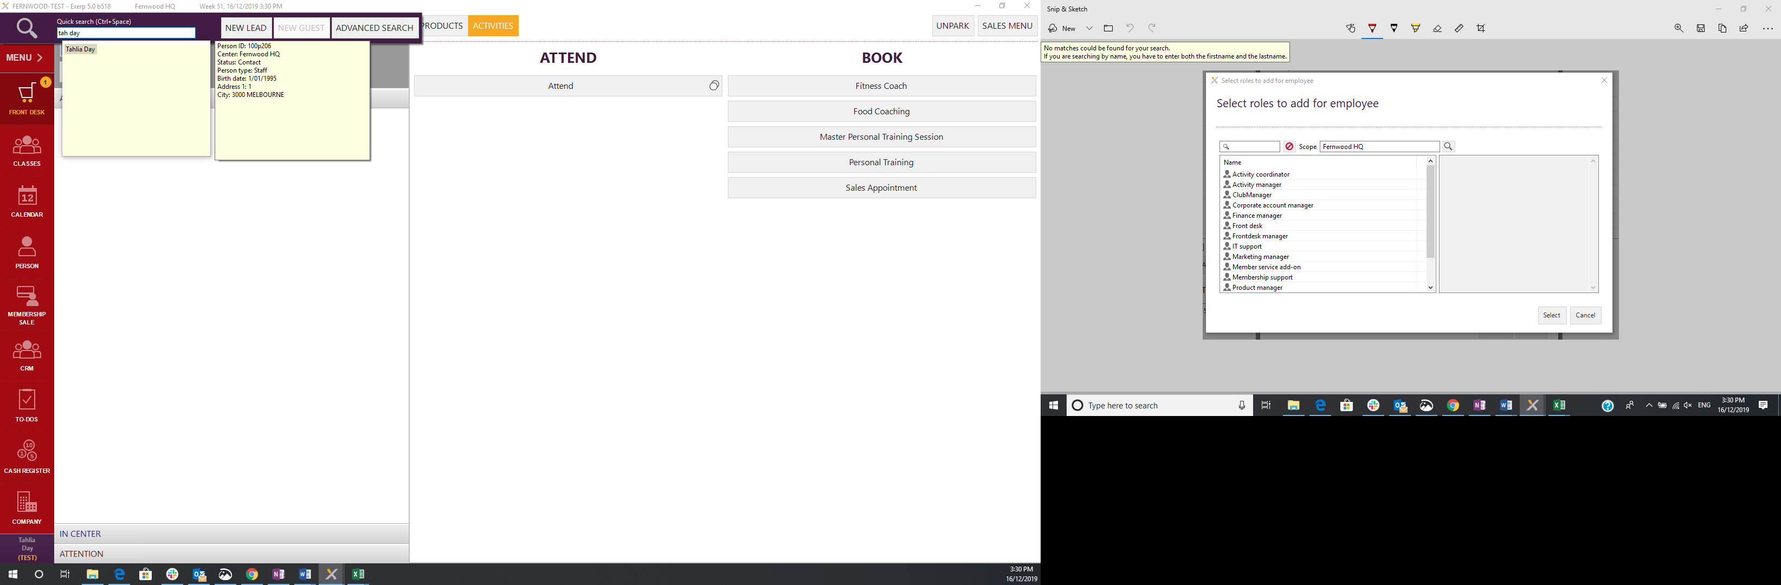Click on the magnifying glass and search the member (first 3 letters of the first name and first 3 letters of the last name)
3. Double click on the members name
4. In the activities tab – click the attend button

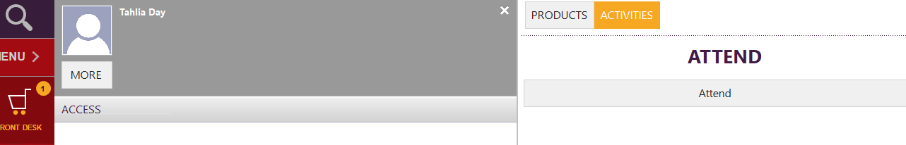

## Booking a member into a class from sign in

You can also book a member straight into a class or appointment from the front desk app.

1. Once you have selected the member, you can sign them into the club by selecting the activity or class they are attending.

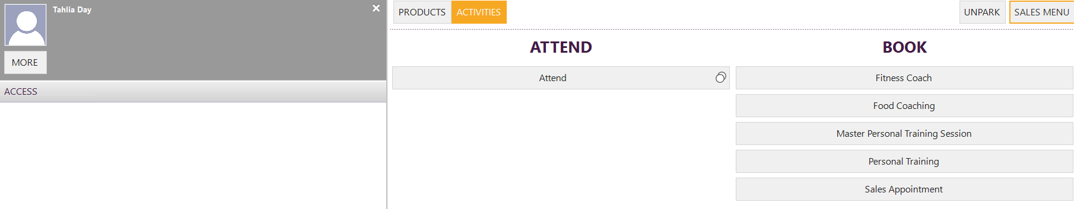

## Processing a POS product

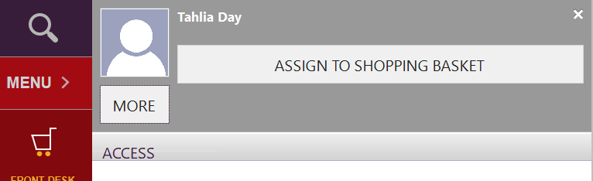IMPORTANT NOTE: If a POS product requires a member to be linked to it (e.g. Personal Training 5 pack) it will be greyed out until you assign the sale to a member. To assign a sale to a member search for them in the magnifying glass in the top left corner of the screen. For items such as Merchandise they will not have to be assigned to a member.

To process a product under a staff or member’s name:

*Front desk > Search member > Select product > Cash register will open > Select payment method*

1. Open the Front Desk app
2. Search the member’s name (using first 3 letters of first and last name) using the magnifying search glass in the top left hand side of the menu bar
3. Click on ‘Products’ tab to search the product or service the person would like to purchase. Select the product to purchase.

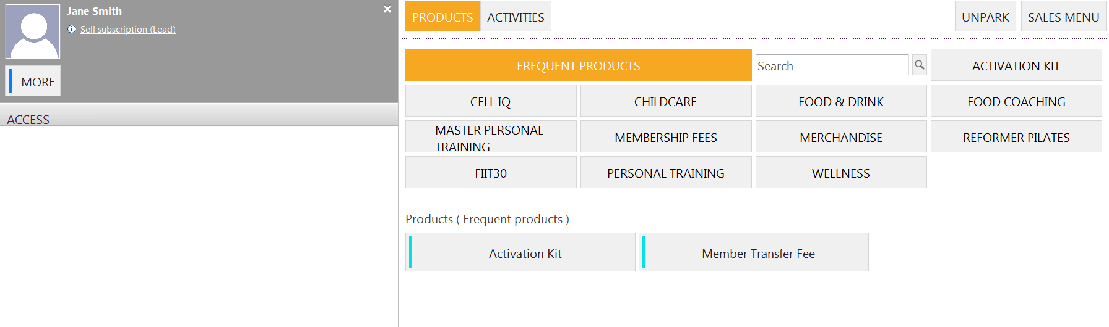

1. The cash register will drop down.

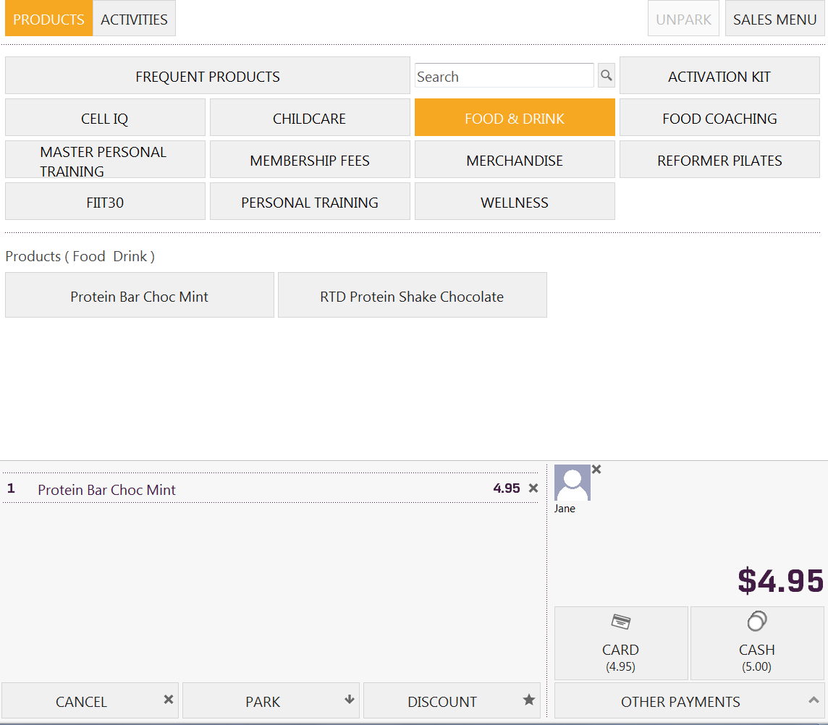

1. Select payment type and finish the transaction.
   1. If the member purchases something by card, ensure this is processed on the card terminal as well



### Giving the correct change to a member

*Process the POS product > Other Payments > Enter cash given > Click CASH > Transaction will save and give you the amount of change to hand to the member.*

1. If a member pays for an item with cash, to ensure you are giving the member the right amount back. Simply click on OTHER PAYMENTS and enter the amount of cash the member is handing over. For example, $10 cash handed over for the protein bar.

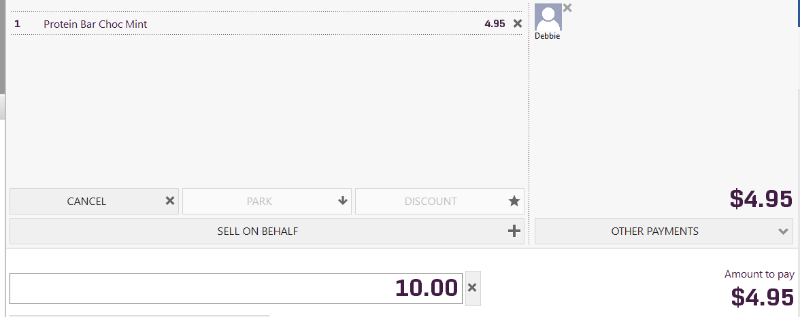

1. Click on CASH and the system will tell you how much change to give to the member.

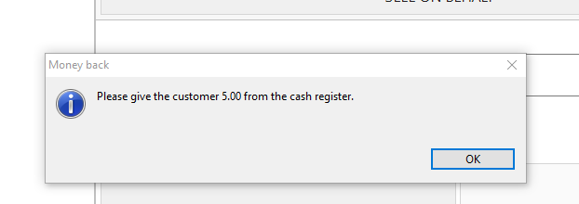

### Pushing an item to their next direct debit

*Front desk > Select Item > Other Payments > Payment Account*

Payment account can be used so that any item in POS can be pushed directly onto the member’s next direct debit. The member won’t have to pay anything up front for the item and the full amount will be processed on their next membership debit.

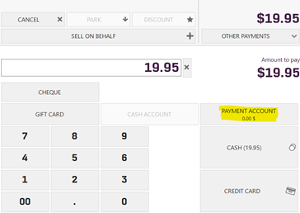

### Other Payment Method

*Front Desk > Find member > Select product > Select ‘Other Payments’ > Select ‘Paid into Account’*

**‘Paid into Account’** is a payment method for those other payment methods that are not cash or card.

1. Bring up item in front desk
2. Select ‘Other Payment’
3. 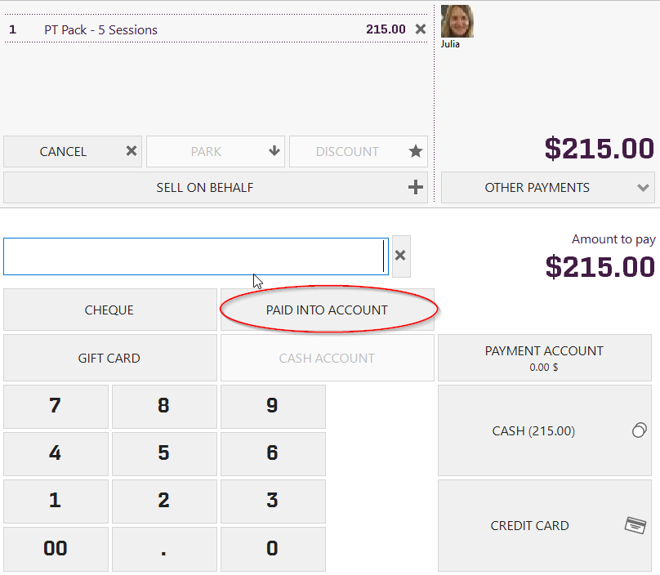Select ‘Paid into Account’

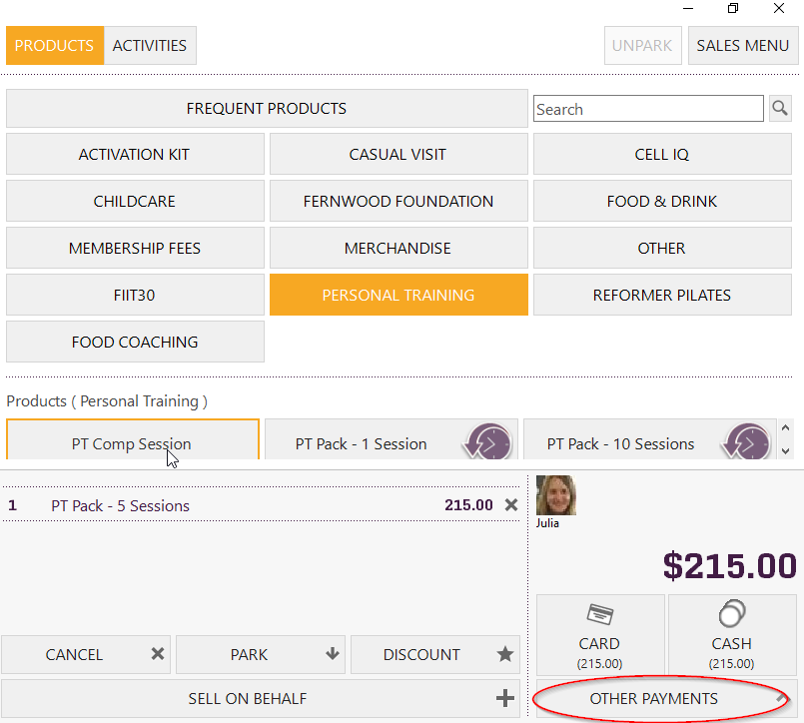

### Splitting an item over an instalment plan

On some items in the Front Desk members can pay for an item by splitting it over an instalment plan of 2 or more direct debits, they will have the option to do so.

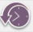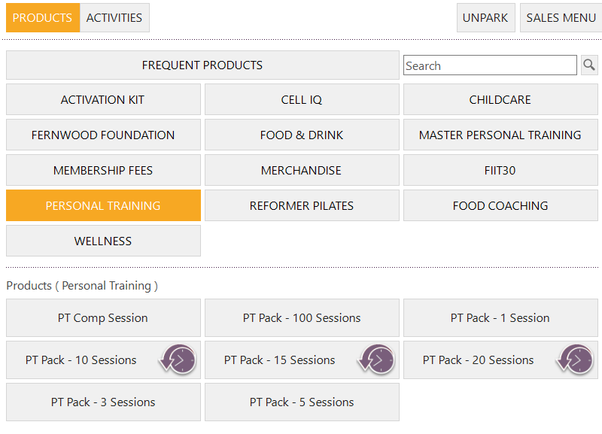*Search member > Front Desk > Select Item with icon*

1. Open the Front Desk App > Find your member > Select the product they wish to purchase.
2. Select the number of instalments the member wishes to pay over

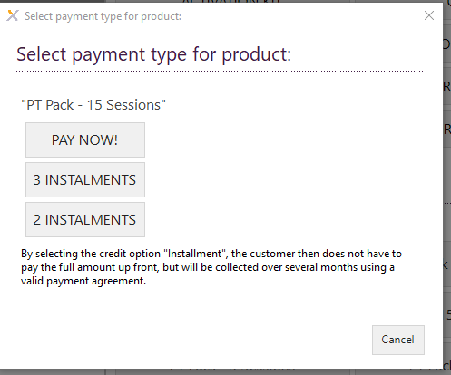

1. This will automatically use the details that are stored on their profile already.
2. The receipt for the purchase will pop up for you to either print or save and email to the member.

### Applying a discount to a POS Product

*Front Desk App > Select your POS product > Cash Register will appear > Select Discount > Enter campaign code*

Once you select ‘Ok’ to the campaign code, the relevant discount will be applied and then you can proceed with the purchase by selecting the payment type to finalise transaction.

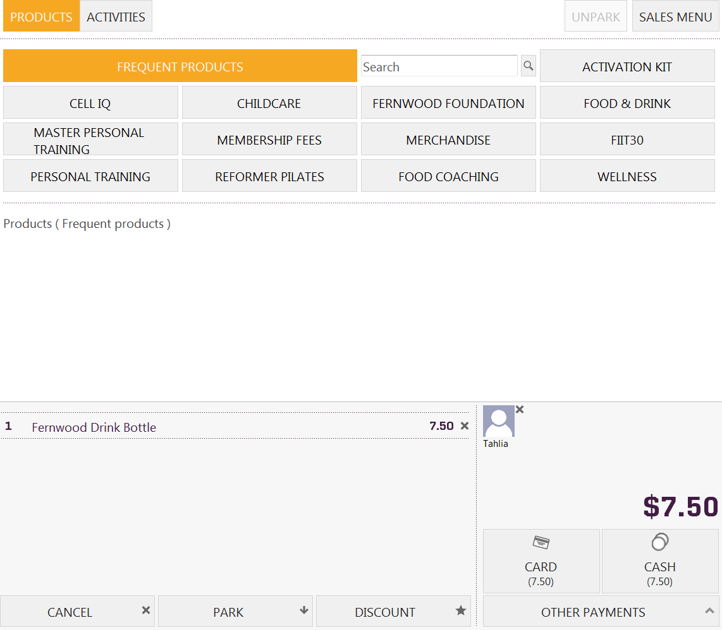

### Giftcards

We have set up the following campaign codes for gift cards that are redeemed in club. These would be applied on a POS product in the Front Desk App.

**Use the code GC$25 -** $25 GIFTCARD

**Use the code GC$100 -** $100 GIFTCARD

For a full list of campaign codes please refer to the list on the Fernwood Intranet under the Operations page > Exerp Training Manual.

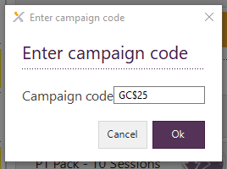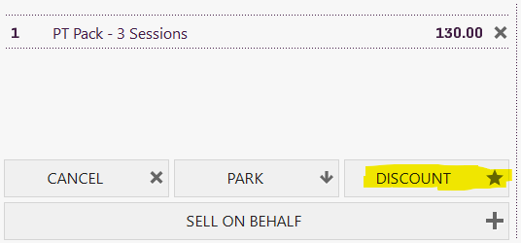

## Park a sale in POS

When processing a product or service through POS, Exerp has the ability to park a sale half way through the transaction and then move to another computer to finish off the sale or return to the transaction later in the day.

This function can be used if another staff member needs to use the computer you are on or if the member needs to get to a session and will return to pay later in the day.

If you ware wanting to park a sale, a product must be allocated to a person first. When you have added the products to the cash register, select the ‘Park’ tab down the bottom of the cash register to park the sale.

## Unpark a sale in POS

To ‘Unpark’ the sale to complete the transaction, all you need to do click on ‘UNPARK’ in the top right hand side of the screen of the cash register

An ‘Unpark basket session’ page will pop up and you will be able to select which product you would like to ‘unpark’ to complete the transaction for the particular person. Be sure to select the correct person to finish off transaction. The cash register will now and you will be able to select the payment method the person will be paying with. Transaction is now complete.

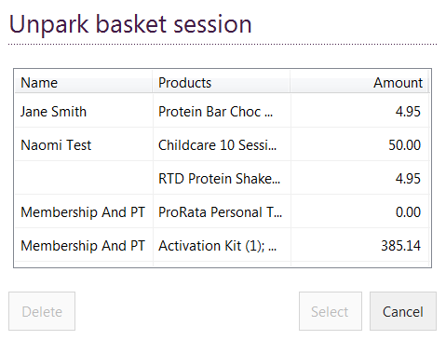



## Sales menu tab



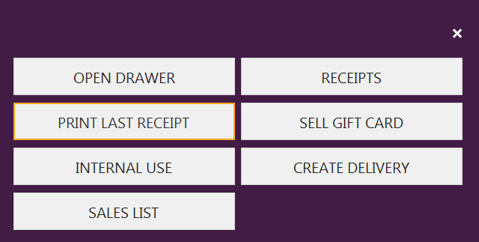

### Sales list

View the transaction list of everything that is sold on a particular day, date range period or under a customer/member. This is where you can also cancel a sale – Club Manager Access Only

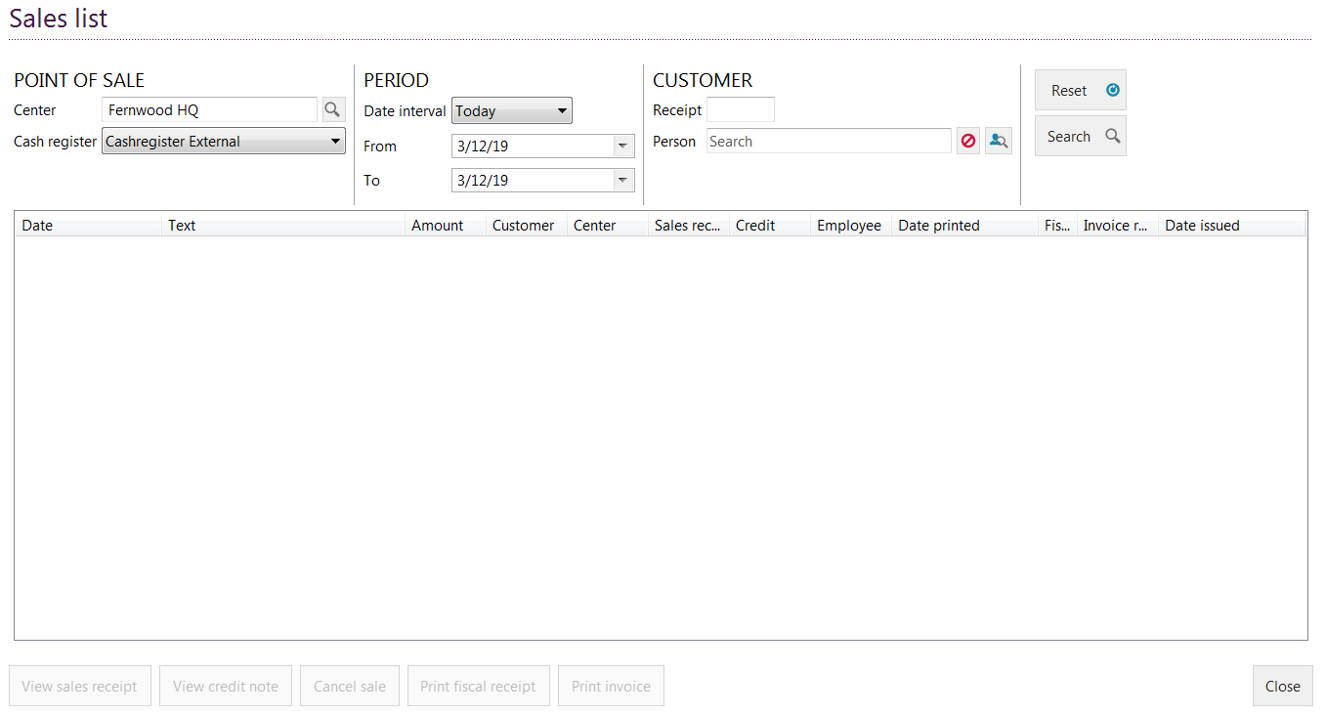

### Cancelling a transaction

*Front desk app > Sales Menu tab > Sales List > Select transaction > Cancel Sale > Select Credit Sales Line*

To cancel a transaction that has been put through the cash register:

1. 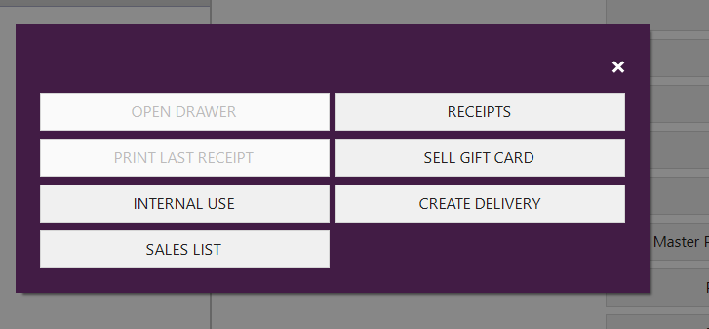Open the front desk app > select the Sales Menu tab in the top right corner of the screen > select Sales List.
2. 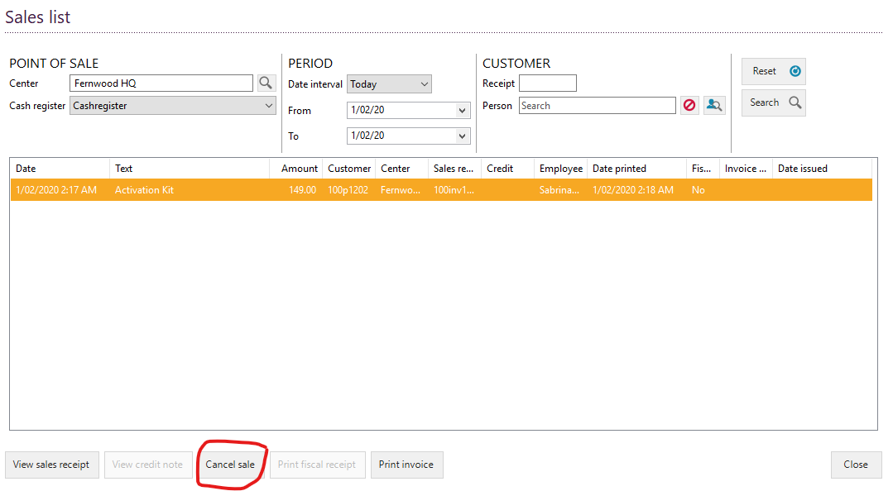Select your chosen transaction and click the ‘Cancel Sale’ button
3. 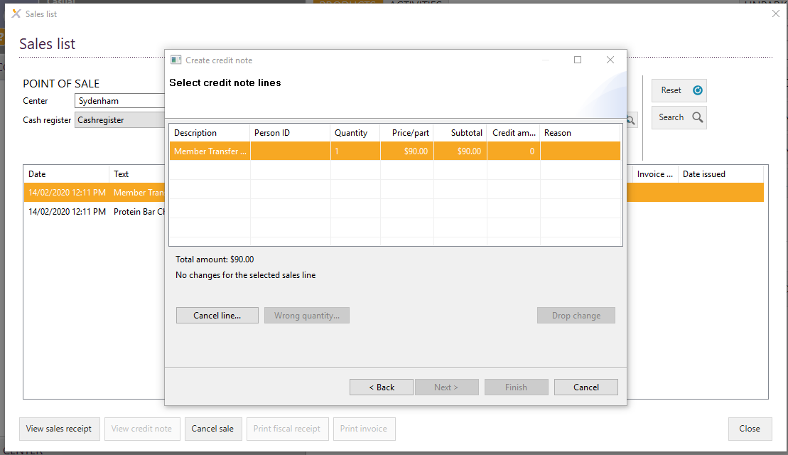Select credit sales line
4. Select the item of the sales transaction you wish to cancel > Cancel Line
5. 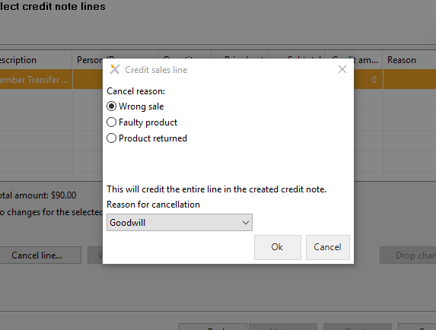Select reason for the transaction being cancelled > Click OK
6. Enter the reason for cancelling the sale.

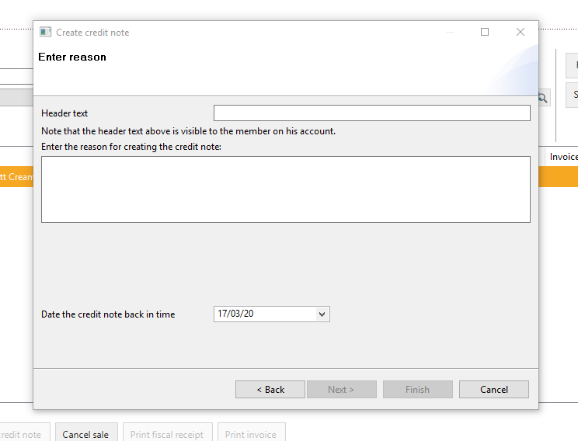

1. Select the refund to either cash register (cash sale) or to the members card (EFTPOS payments). This won’t refund anything to the member as the EFTPOS terminal is not linked to EXERP. Once you have finished this process, refund the amount to the members cards on the EFTPOS TERMINAL.

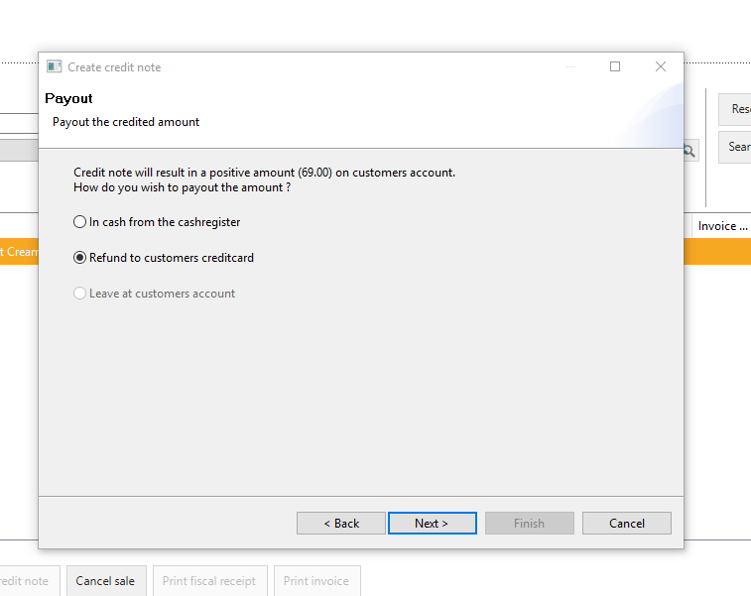

1. Select FINISH – and the sale will now be successful cancelled.

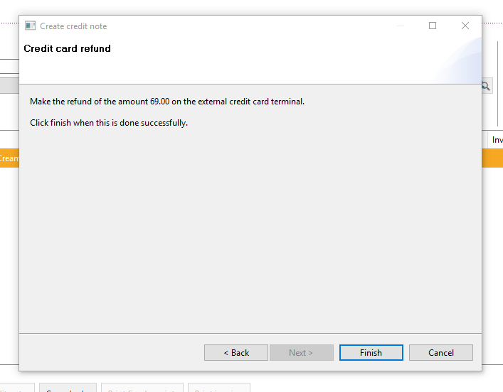

# Membership Sale App

## How to create a lead

1. 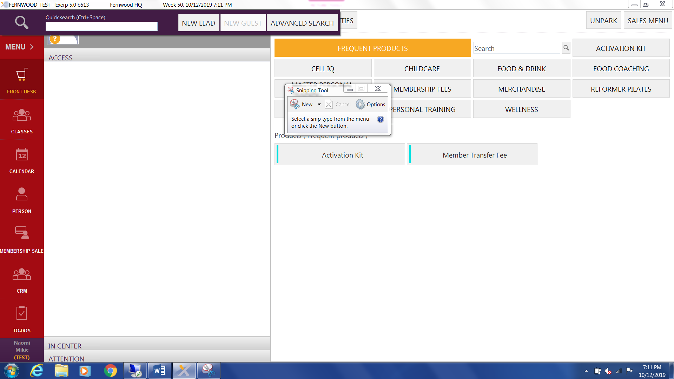Click on the magnifying search glass in the top left hand side of the menu bar and select ‘New lead’
2. 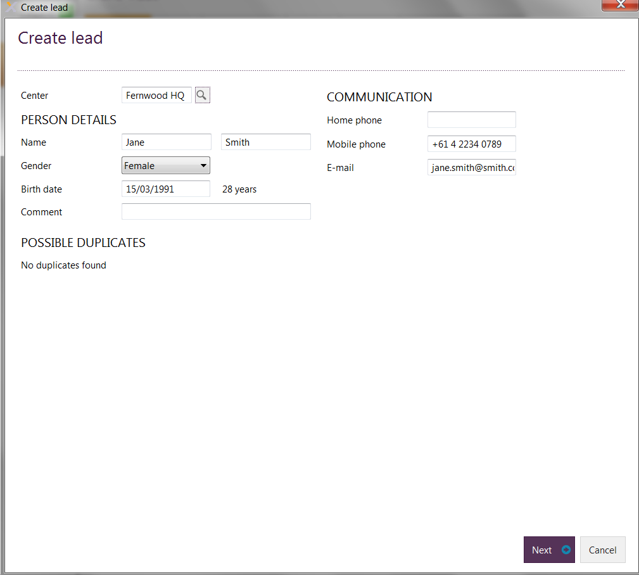Enter in member’s details. The centre name should appear for your club. Click next
3. Leave all communication channels ticked or change if need be. Select next

The communication channels that are selected here refer to **Service Messaging**. This is all emails and SMS related to appointments, deferrals, membership administration tasks etc. that are sent through Exerp. If they opt out of these, they won’t receive any of these type of communications so we

definitely recommend to gather the correct information here. This does not refer to marketing and 3rd party communications.

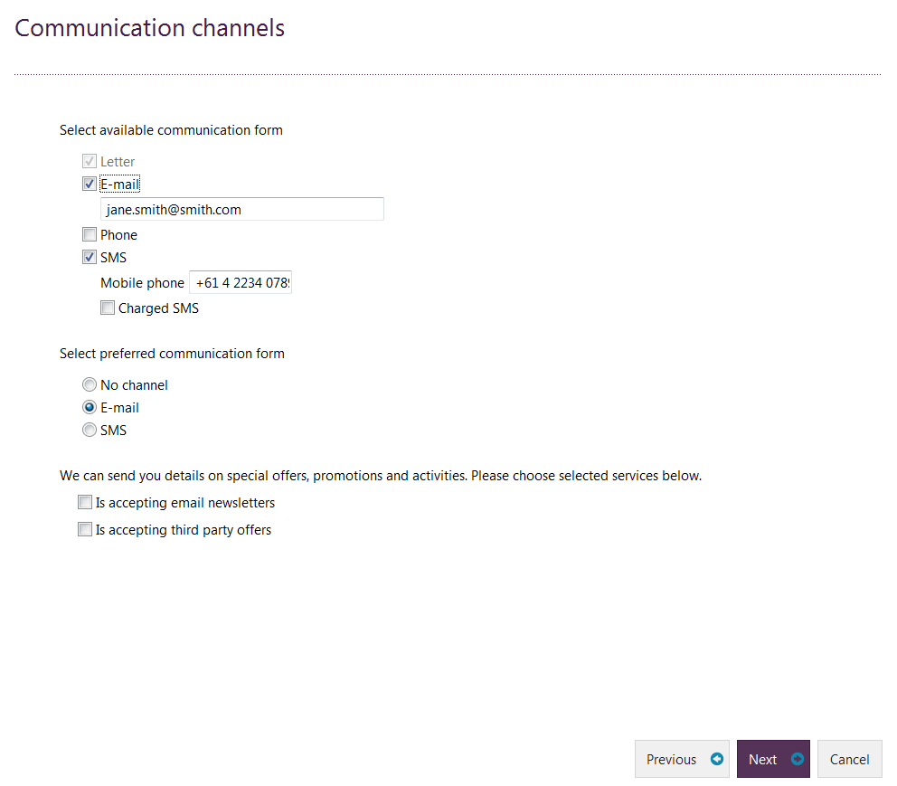

1. Enter in postal information. Select next

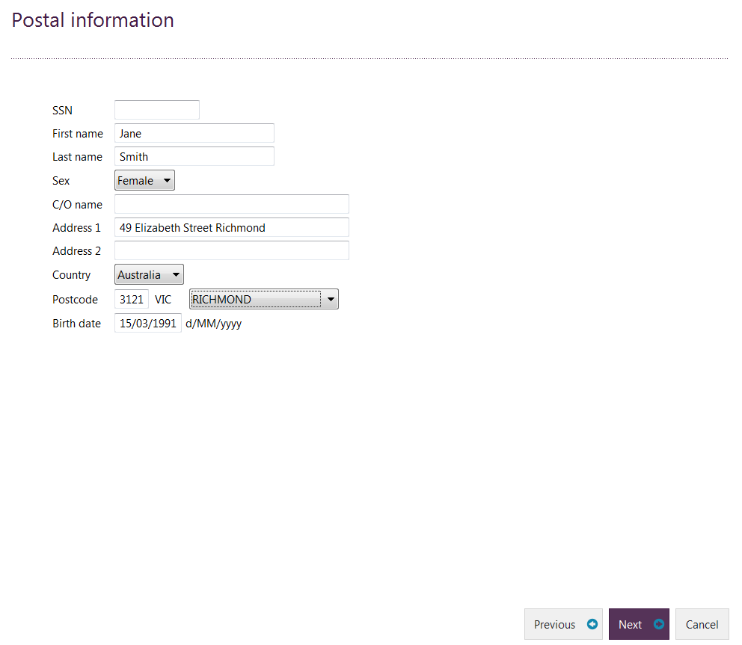

1. Complete the GTKYF

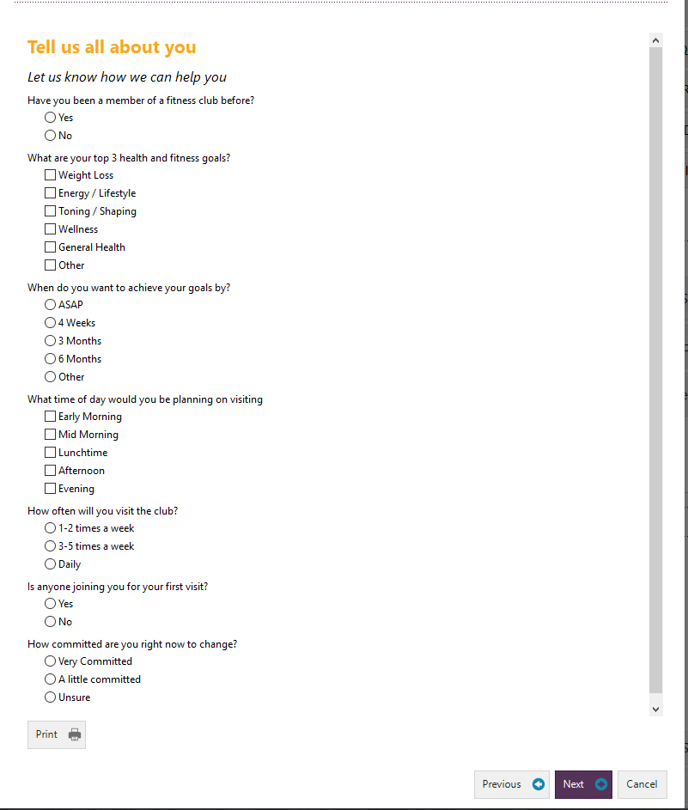

1. Select the person type. Click on finish.

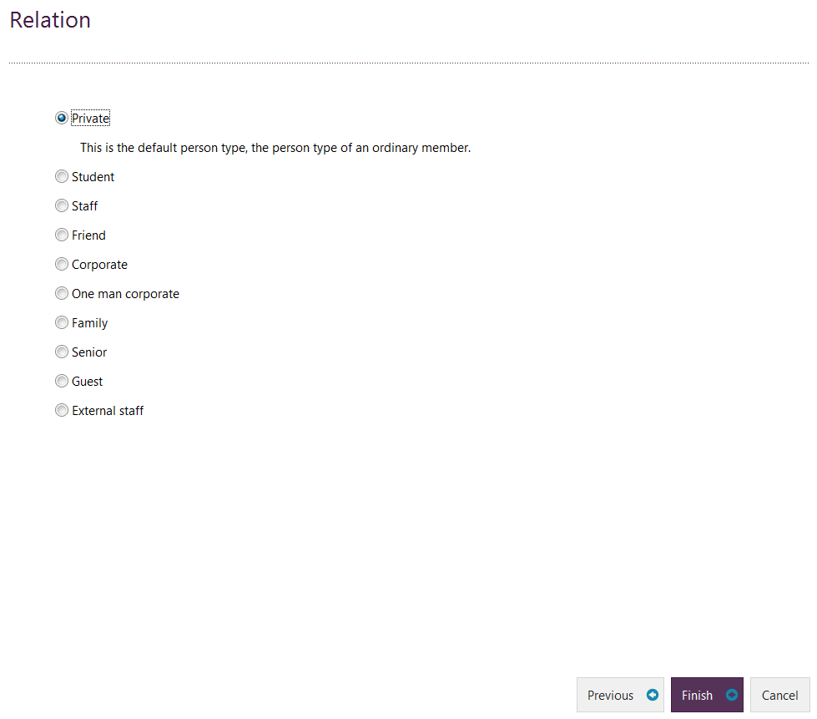

## Processing a Membership Sale

*Membership Sale App > Search for person using the magnifying glass > Select your membership type, NEXT > Select any membership add-ons (i.e. FIIT30 Flexi) > Personal Details > Set up Payment Agreement, NEXT >*  Membership Summary Screen > Member Card, Member Photo & Signature Pad > Front Desk Payment/Instalment plan > SAVE.

1. Click on the ‘Membership sale’ app in the menu bar on the left hand side of the screen

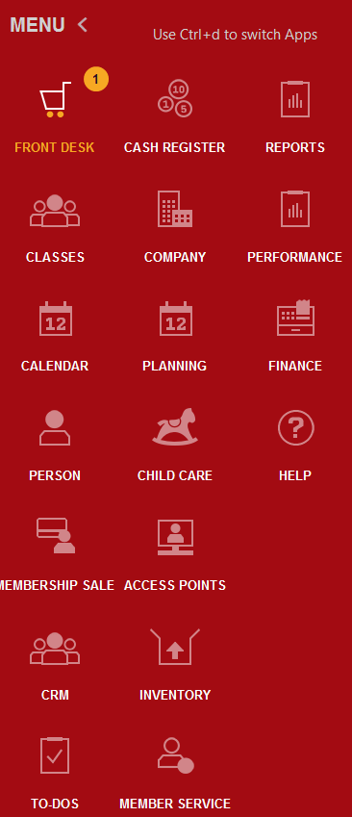

1. Search the member’s name by clicking on the magnifying search glass on the top left hand side of the menu bar. Either quick search the member (first 3 letters first name & first 3 letters last name) OR click on advanced search.
2. Enter in the person’s name, select find and then open profile.

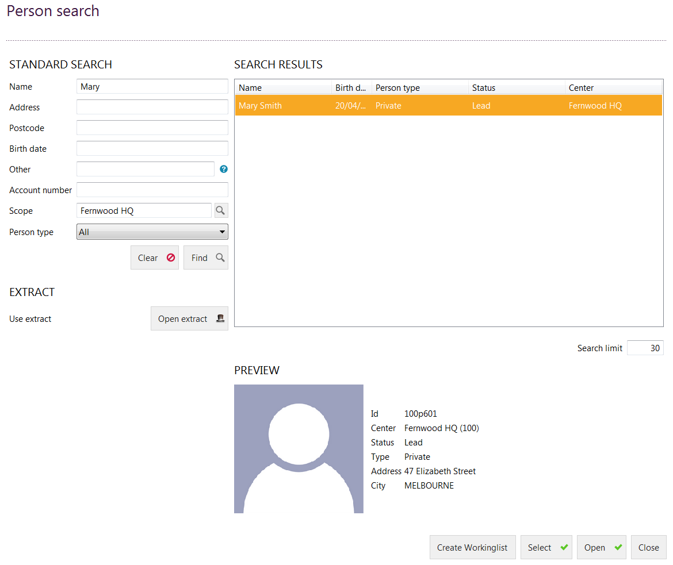

1. You will now see the member’s name up the top in a new tab. Select the type of membership the member would like to purchase. Click on ‘Next’ to continue.

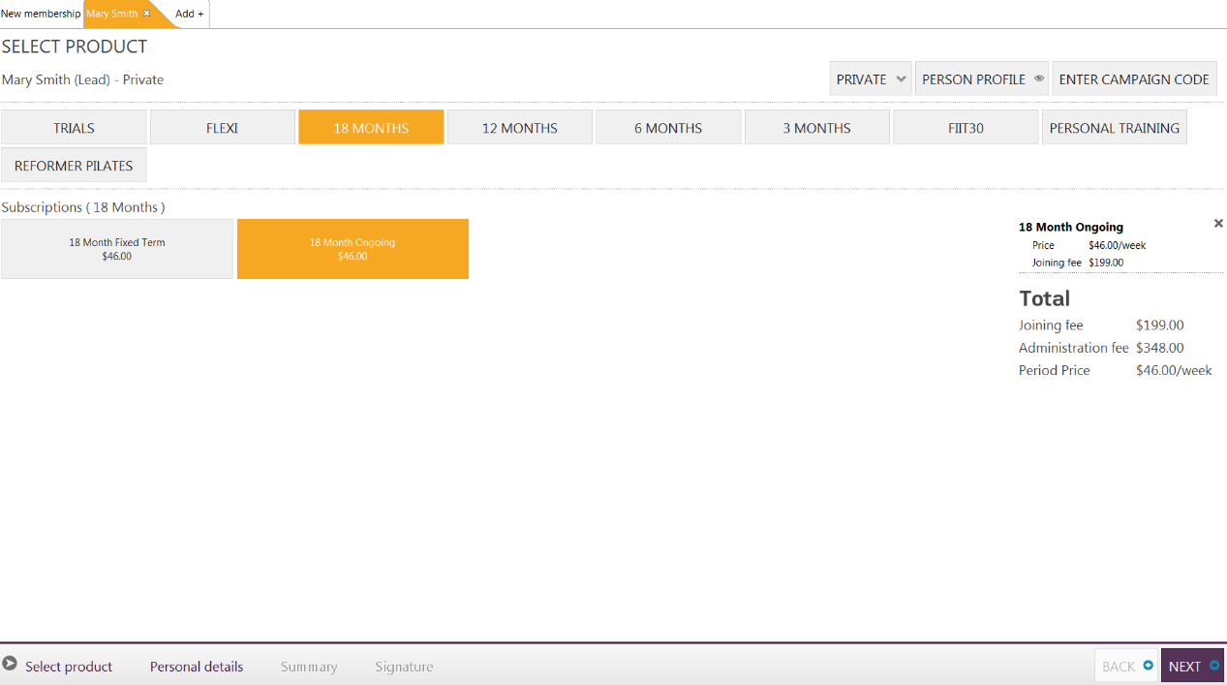

1. Select any Add-Ons the member wishes to add onto their gym membership i.e. FIIT30 Flexi

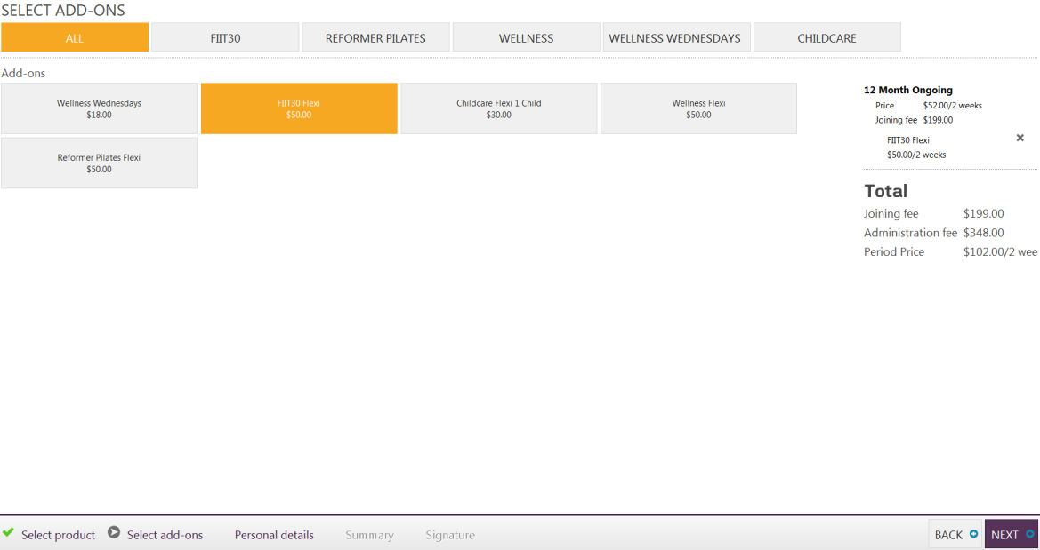

1. Check personal details or edit/update as required. Set up payment agreement information.

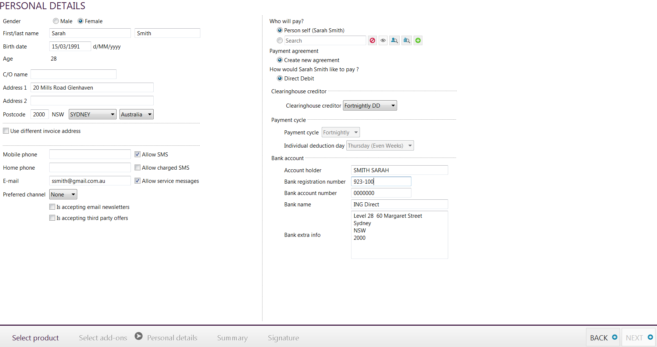

**Direct Debit:** Member paying for their membership via bank account – enter details on this page

**Credit Card:** Member paying for their membership via credit card – redirect to “open completion web page”. This will redirect you to a webpage to securely enter the members credit card details.

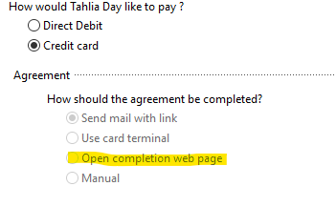

1. Membership Summary page – check all details of the membership are correct. You can adjust the start date of the membership. Click NEXT.

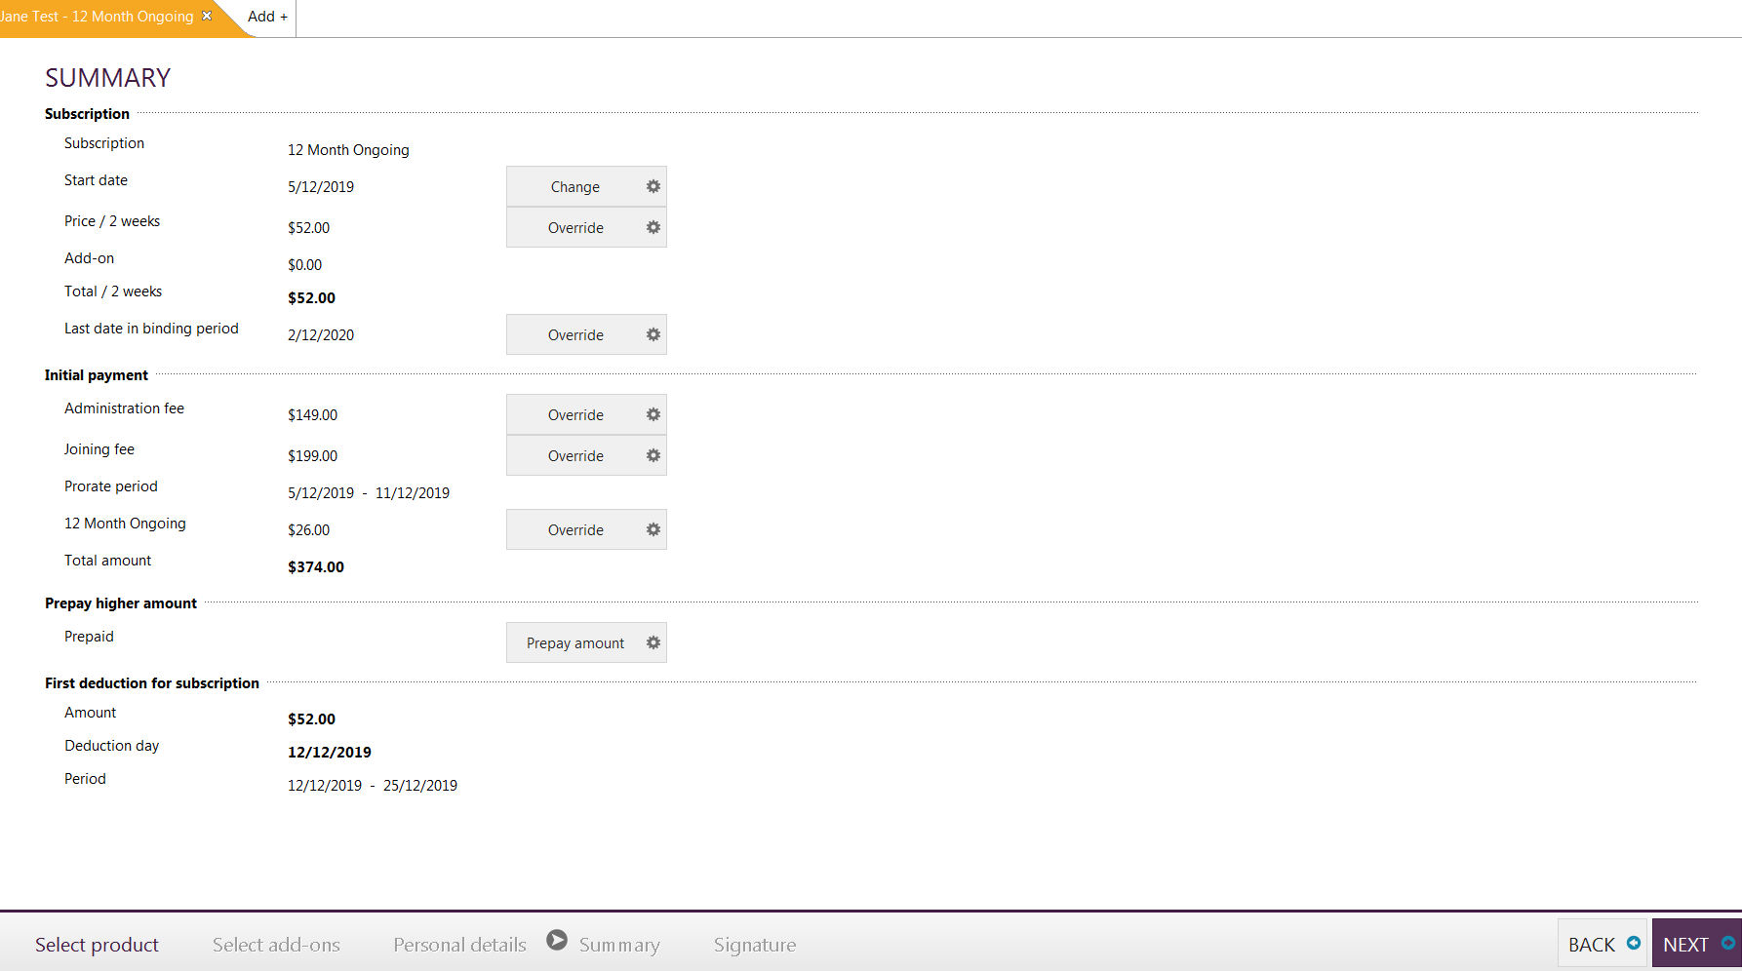*Club Managers will have the access to override prices on this page if required. To override a price click on the ‘Override’ tab next to the type of product you want to change the price for and enter in the new price in the pop up screen. Click on ‘Next’ to continue.*

1. Take the member photo > Assign a member card/24 Hour FOB if applicable and go through membership paperwork and digital signature process with the member.   
     
   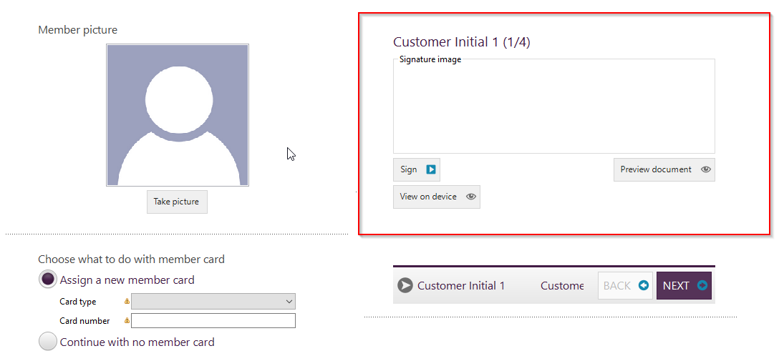

1. Complete the sale and process any up front payments of the membership or split any outstanding payments over an instalment plan.

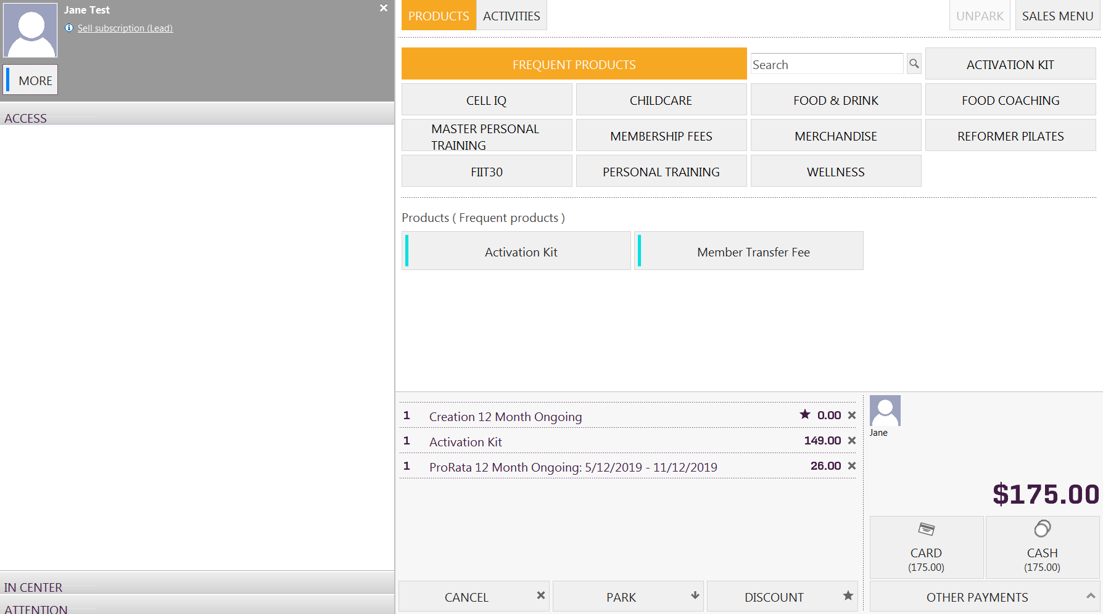

## Splitting an Activation Kit or Start-Up Fees over Direct Debit

If the member wants to split their Activation Kit or start-up fees (joining fee, pro-rata) over their first few direct debits, when you complete the membership sale process it will bring an instalment screen before your complete the sale. You have the option to split their start-up payments over 1,2,3,4,5,10 or 26 debits.

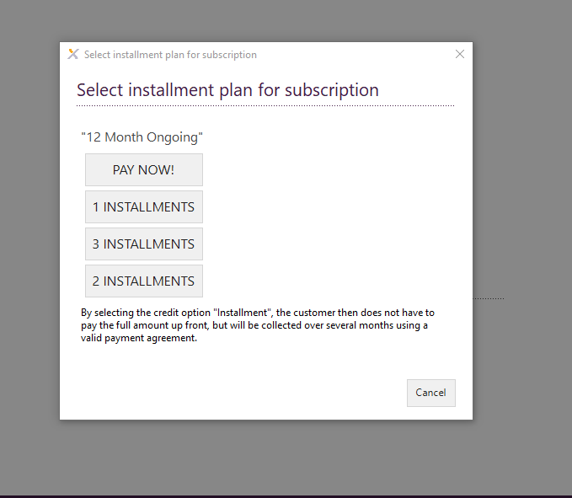

# Signature Pad Process

1. Ensure your signature pad has been successfully set up using the signature pad installation document available to you on the Intranet (Operations page > Exerp Training Manual)
2. When you get to the signature section of the sign-up process you can select **View on Device** which will bring up the membership agreement on the signature pad for members to review prior to signing.
3. Once the member is ready to sign > select the **Sign** button. It will load on the signature pad, the member signs or initials and it will load back onto the Exerp screen. It is critical you wait for their signature to populate in the signature image box before selecting Next. This can take a few seconds depending on your internet.



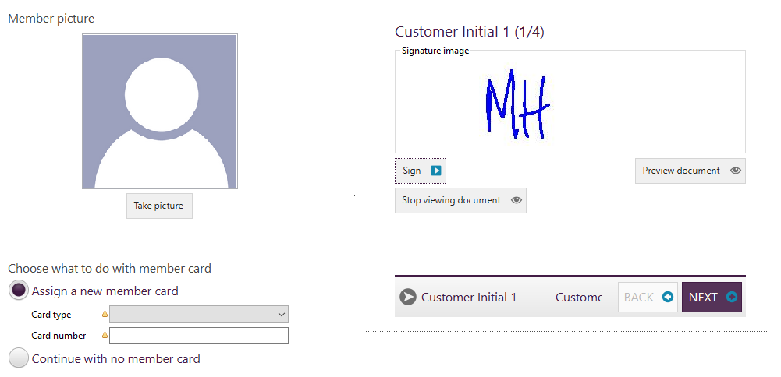

1. Once the signature has loaded as per the image above, you can then select next to move through each signature step.
2. There are 4 signatures required in total for the membership sign up.   
     
     
     
     
   1. Initials from the member agreeing to the 24/7 policy, privacy policy and membership terms & conditions
   2. A customer signature agreeing to the membership agreement
   3. A staff signature of the staff member who is processing the sale
   4. A customer signature for the direct debit request

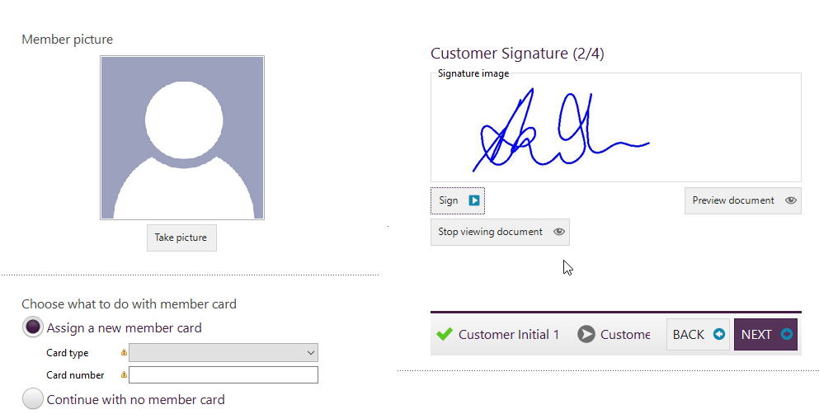

## Viewing a signed membership agreement

When a member has successfully signed up through Exerp, they will receive their welcome email with their membership agreement attached. This copy will be an unsigned version.

1. To review their membership agreement go into their person profile > Journal > Documents. You will notice a little padlock next to the PDF document indicating it has been signed.

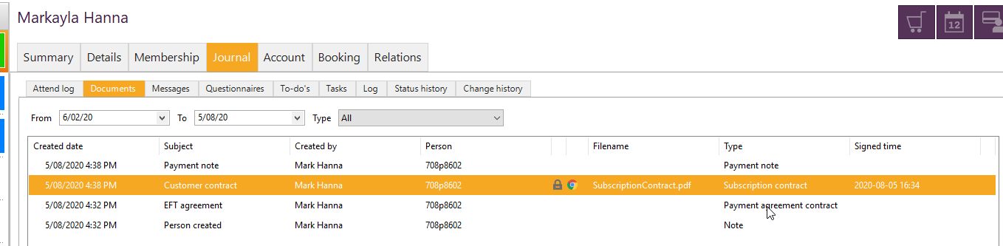

1. A new window will pop up with two sections – the top section is the unsigned PDF version of the contract, however the section below where the signatures are located will produce the signed copy of the contract.

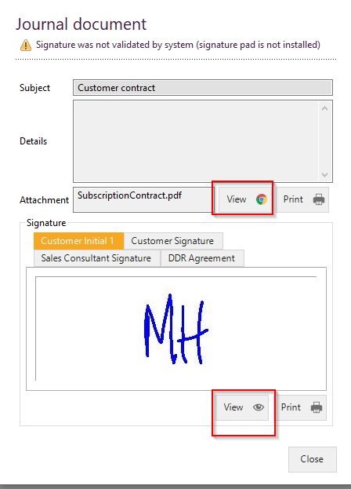

**IN-CLUB RECOMMENDATIONS FOR THE SIGNATURE PAD**

* Print off a template version of the membership agreement that you can have laminated at reception. This way for any members that are having difficulties reading the smaller text on the signature pad they can read through a paper copy.
* If you have any members that have signed up through Exerp and you have completed a paper sign-up, you will notice they have an alert on their profile ***“Missing document to be signed”*.** 
  + To remove this alert you can simply click on the text and it will bring up the document that needs to be signed. Provided that the member has signed a copy of their agreement, you can get a staff member to go through the signature pad process and where it prompts a signature just write Paper Copy so you have reference.
* For those clubs on Gantner this is very important as if there is a missing document to be signed, it will block their entry to the club.

## Unsigned paperwork report

We have put together a report for clubs to pull to see which members have unsigned paperwork so it is easy to track on your end in club.

*Reports App > Extract Wizard > Franchisee > Unsigned Member Contracts*

## Under 18 members – THINGS TO KNOW

When an underage member joins in club we have added some extra fields as part of their personal details in Exerp that should be completed for any member under the age of 18.

You will now see in the member’s profile at the time of sign-up the fields below:

* Guardian Name (Member under 18)
* Guardian Contact Number (Members under 18)
* Guardian Relation (Members under 18)
* Guardian Email (Members under 18)
* Guardian Address (Members Under 18)

It is crucial we collect this information for our members under the age of 18, if in the event we need to contact their parent/guardian e.g. debt collection.

### Parent/Guardian Signature on the Membership Agreement

At the time of signing an under age member up via the signature pad – the parent or guardian will be prompted to sign for the new member on their membership agreement.

### How to view/edit this information on a member’s profile

If you need to edit or view this information for member at a later time, you can access this information on the member’s profile in *Exerp > Details > View extended attributes*.

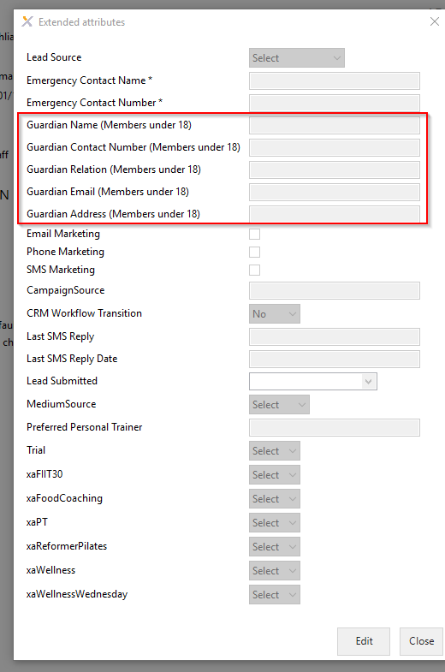

## View a completed membership

*Person profile > Membership Tab > Subscriptions*

Membership subscription is now complete and will appear under the ‘Membership’ tab, under ‘Subscriptions.

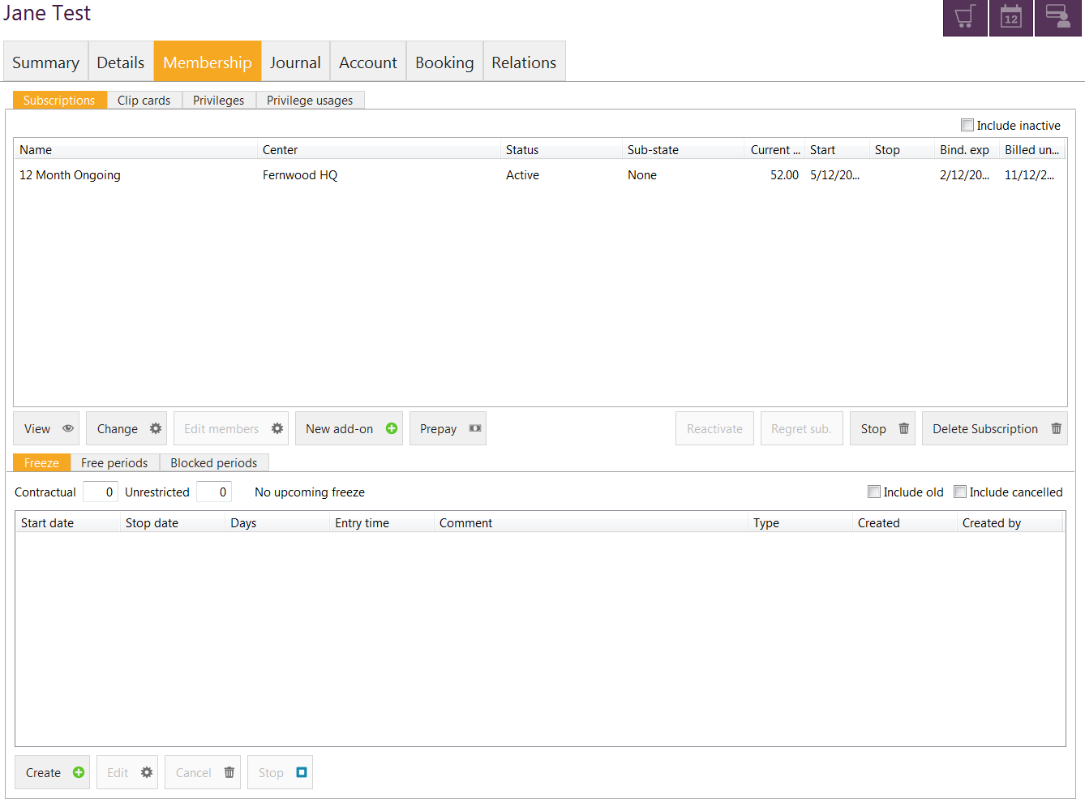

## Processing a Referral as part of the Membership Sale

When processing a membership you can also link them to an existing member to action them as a referred member. This is a really useful tool when processing girlfriend memberships or doing a referral campaigns in club.

In the membership sale app, on the first screen when you select the membership type the member is joining on, you can select the box **IS REFERRED.**

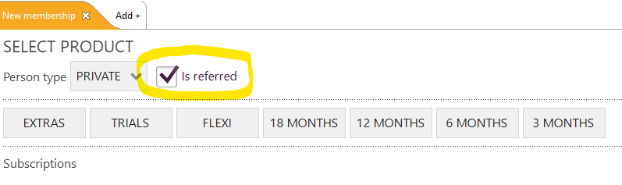

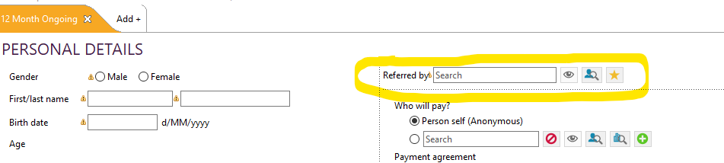When this box is checked, on the personal details screen of the membership, you will then be prompted to link the referring member to the referred member.

Simply search for the member by typing their first 3 letters of their first and last name into the field and double click to select them.

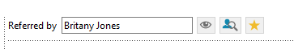

This will link them once the membership sales has been completed and you can track any referrals campaigns that you run in the club.

## Campaign Codes

Campaign codes will be used to apply any membership promotions that clubs are running at any given time, as well as apply a direct discount on the subscription e.g. waive a joining fee.

Campaign codes can be applied in the membership sale to apply a discount on a membership, as well as in the Front Desk when purchasing a POS product.

PLEASE NOTE: When entering a campaign code during the membership sale process ensure you enter the code before you select the membership type to ensure it applies correctly. Once you have applied the code you will notice a star next to the memberships which implies the discount as been applied.

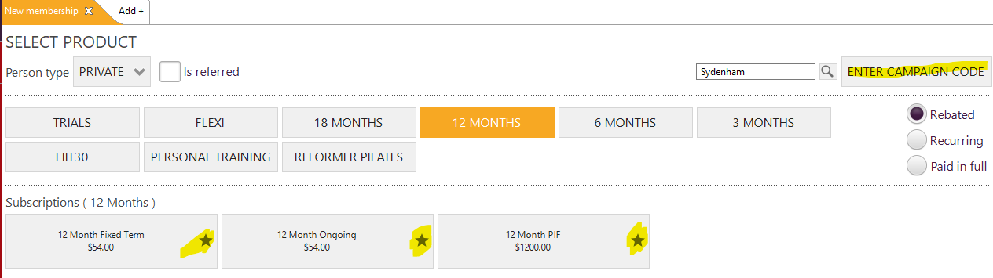

### To waive the joining fee on a sale

During the subscription sale process you will need to enter the campaign code **ZJF** to waive the joining fee.

**ZJF10 –** 10% discount off membership + zero joining fee

**ZJF15** – 15% discount off membership + zero joining fee

For a full list of campaign codes refer to the Intranet on the Operations page > Exerp Training Manual

## How to change the staff member who sold the membership

If you need to update who sold the membership after the sale has gone through – follow the below steps to update.

1. Go into the member’s profile in Exerp > Summary tab > Sales List.

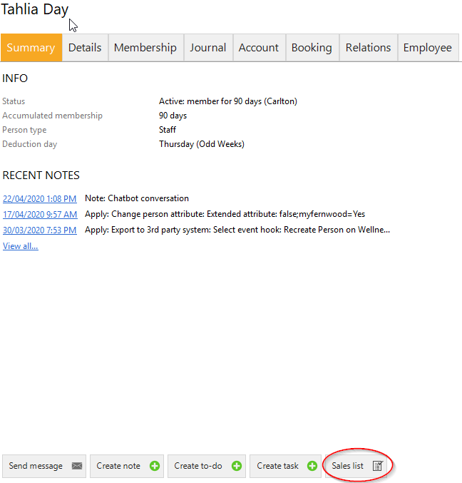

1. Find the Sales Line of **Creation 12 Month Ongoing** (or whatever the name of their membership type is) and open this sales line.
2. From here a new window should pop up > go to the Seller tab > Select Change sold on behalf of employee
3. Enter the name of the staff member and click Save.

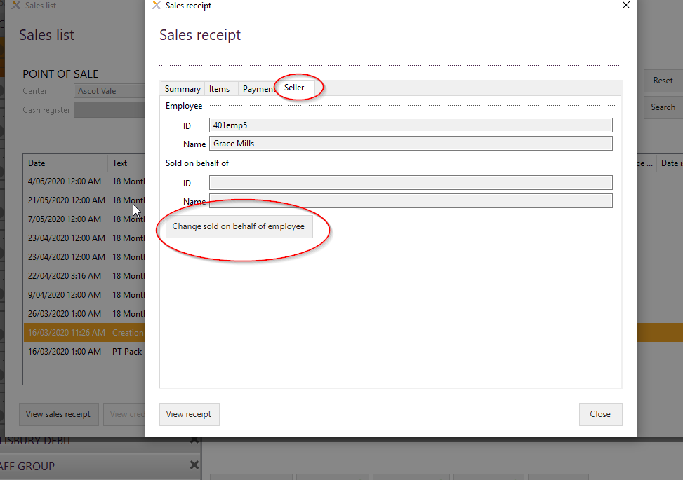

## Complimentary membership

Please note the default access to process a complimentary membership is club manager

*Membership Sale App > Select Subscription length > Tick Paid in full > Select Complimentary subscription*

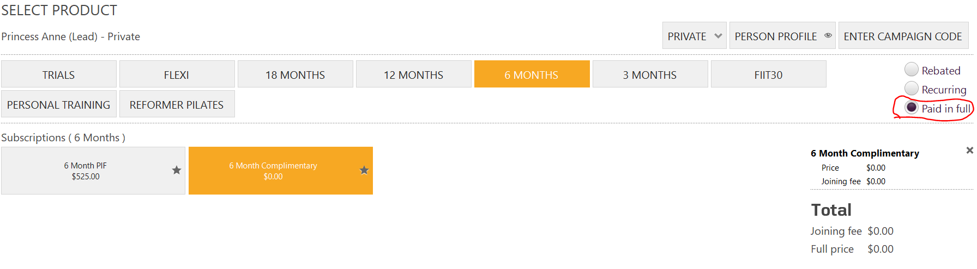

## Recurring Clip Cards

Adding on any session based services such as personal training, food coaching or FIIT30 to a member’s direct debit. This will charge the member for the sessions with their membership payment and drop the sessions into their account each fortnight.

A reccurring clip card subscription has to be processed after a member has a subscription.

### How to process a reccurring clip subscription.

*Membership Sale App > Search for member > Select Recurring Clip Card > Select Service > Add the amount of sessions the member will do each fortnight*

1. Click on the ‘Membership sale’ app in the menu bar
2. Search for the member by using the magnifying search glass in the top left hand side of the screen.



1. You will now see the member’s name up the top in a new tab. Select the type of ‘Clipcard’ subscription the member would like to purchase (FIIT30, Personal Training or Reformer Pilates). Now click on the appropriate clip card below.

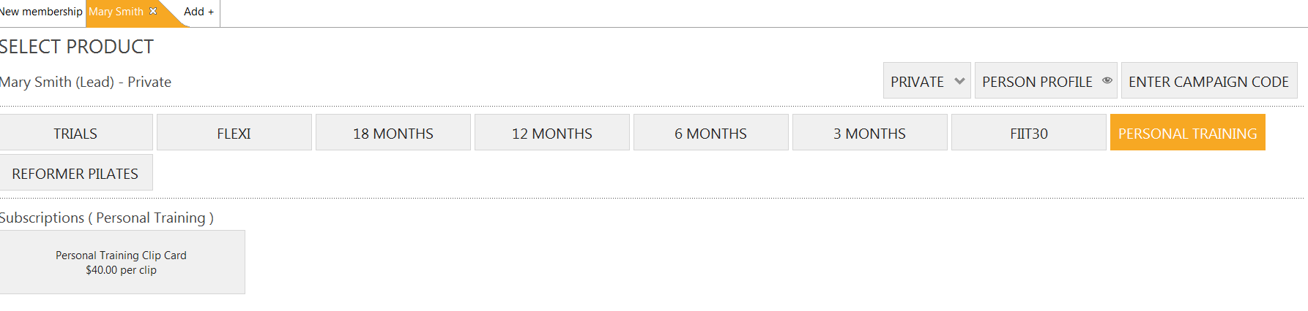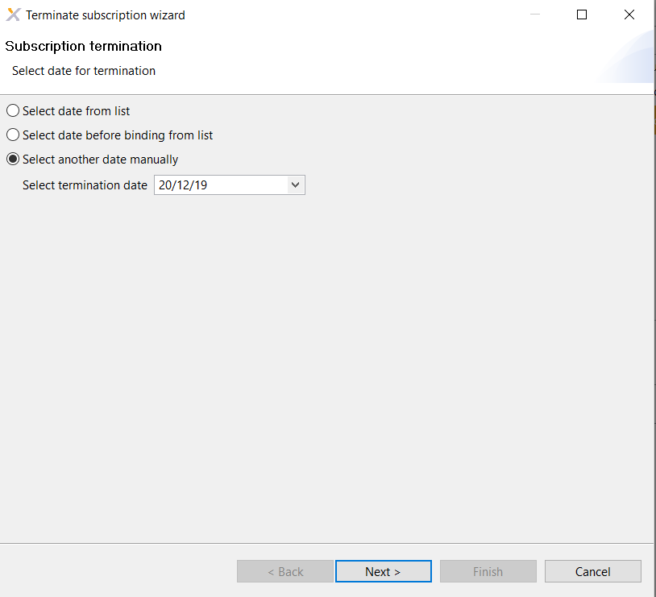

1. You will now see a pop up screen to ask you how many clip cards you would like to add onto the members account on a fortnightly basis (1 personal training session per week is 2 clip cards a fortnight). Enter in amount of clip cards to add on and then select Ok.

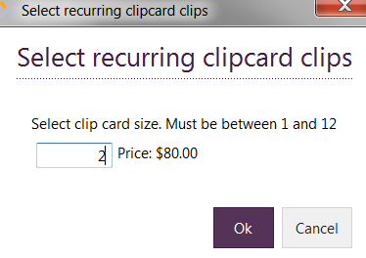

1. You will now see on the right hand side of the screen the amount that will be added onto the direct debit. Once you are happy with the amount, click on ‘Next’ to continue in the bottom right hand side of the screen.

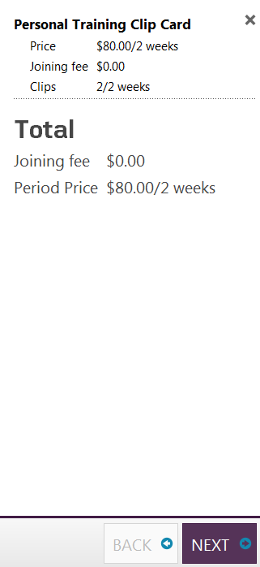

1. 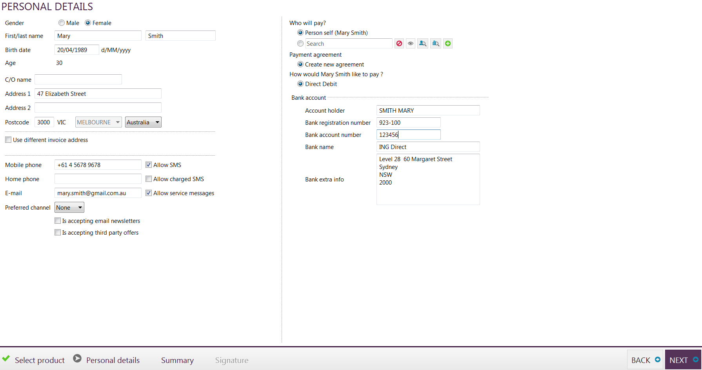 The next screen will show all personal details. Here you will enter in payment details if they haven’t already been added in. Click on ‘Next’ to continue.
2. PLEASE NOTE: if the recurring clip card is processed in between a debit and the member wishes to book straight in for Personal Training that week the system will prompt you for an upfront payment for a session straight away.
3. A summary screen will now pop up. Please ensure that all amounts are correct before proceeding. Click on Next to continue.

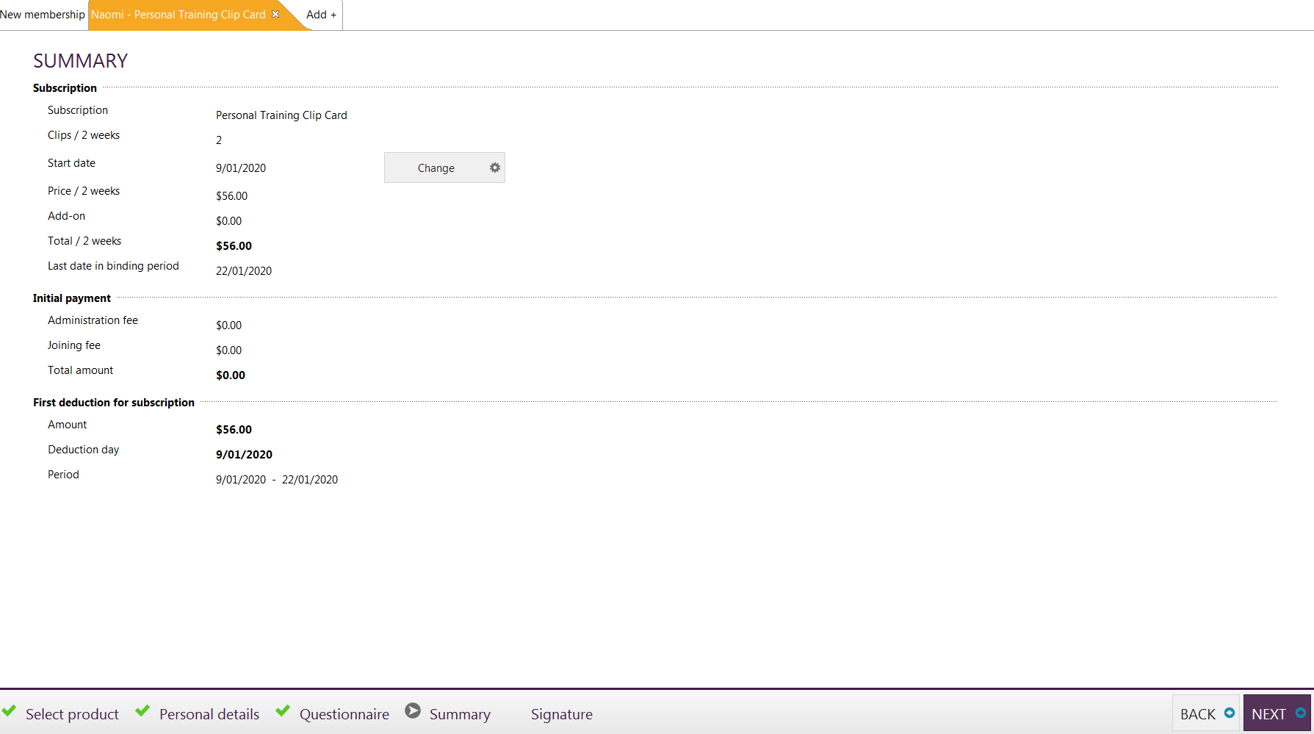

## Putting your Recurring Clip Card on freeze

When processing a freeze on a member’s recurring clip card, you must process this any time before midnight the Tuesday before your debit run, otherwise the member will still be charged for this component and receive the clips from that week’s debit.

## Processing a downgrade

To remove a recurring clip card from a member’s account, you will follow the same process as a cancellation of membership.

1. Go into the member’s profile in Exerp > Membership tab
2. Select the Recurring Clip Card line time (will be highlighted in orange) > Select Stop.
3. Complete the details for their cancellation, keeping in mind the 14 days’ notice period, members need to provide in downgrade
4. Select SAVE

This will trigger an automated email to the member advising them of their membership downgrade.

## Processing a membership cancellation

## Stop Subscription

**Club Manager Access & Club Member Admin access only**

This will only ever be used when a member wishes to cancel their subscription outside their cooling off period.

1. Go into the member’s profile
2. Membership tab > Subscriptions
3. Select their current subscription
4. Click the  button
5. Select the appropriate termination date by choosing a date from list or select another date manually (last day of access to the club)



1. You will see a summary of the members cancellation including last deduction date (direct debit date). Select finish to complete task.



## Cancel Stop Membership

PLEASE NOTE: If the member changes their mind (which we hope they do!) and you need to cancel the cancellation, you will see in the same tab a  button.

## Splitting the cancellation fee over an instalment plan

**Club Manager Access & Club Member Admin access only**

If a member cancels their membership within their binding period and needs to split their cancellation fee (buyout fee) over several direct debits, follow the steps below to process.

1. Process the membership cancellation as per the steps above under ‘Processing a membership cancellation’
2. Change the buy out fee in the cancellation window to $0.00

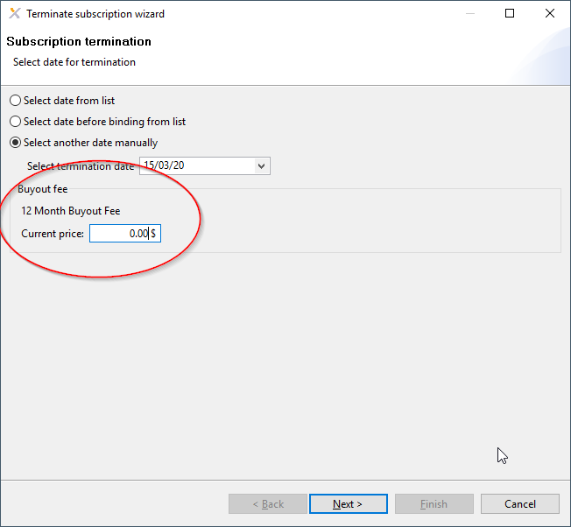

1. Complete the cancellation through the Terminate Subscription Wizard.
2. Open the Front Desk for that member
3. Select item “Cancellation Fee” under Membership Fees product group – override cancellation fee to the price the applies to that member i.e. change to $200 if they are cancelling a 12 month membership, $100 for a 6 month etc.

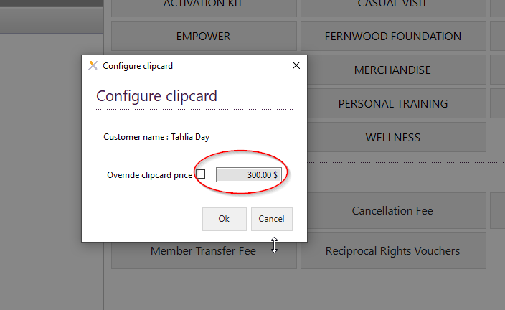

1. Select the instalment plan that applies to that member.

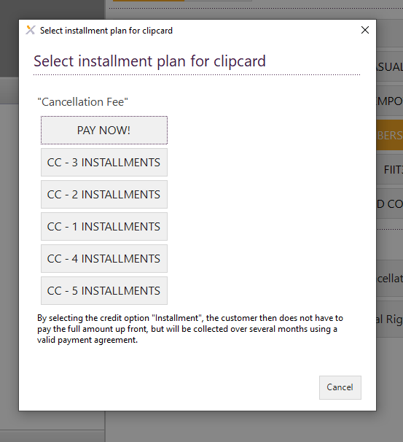

## Missing payment agreement – alerts

Missing payment agreement is just a subscription that either has no banking details or credit card information linked to their account or they have incorrect banking details. If you have a member that signs into the club with this a missing payment agreement, it will prompt you on them signing in, you can click on the link “Missing Payment Agreement” and it will take you to their account screen where you can update this information.

## Regret Subscription

## Cancel in the cooling off period

**Club Manager Access & Club Member Admin access only**

This will only ever be used when a member wishes to cancel their subscription in their cooling off period of 48 hours.

1. Go into the member’s profile
2. Membership tab > Subscriptions
3. Select their current subscription
4. Click the regret subscription button

PLEASE NOTE: after the 48 hours cooling off period has passed this button will automatically be disabled.

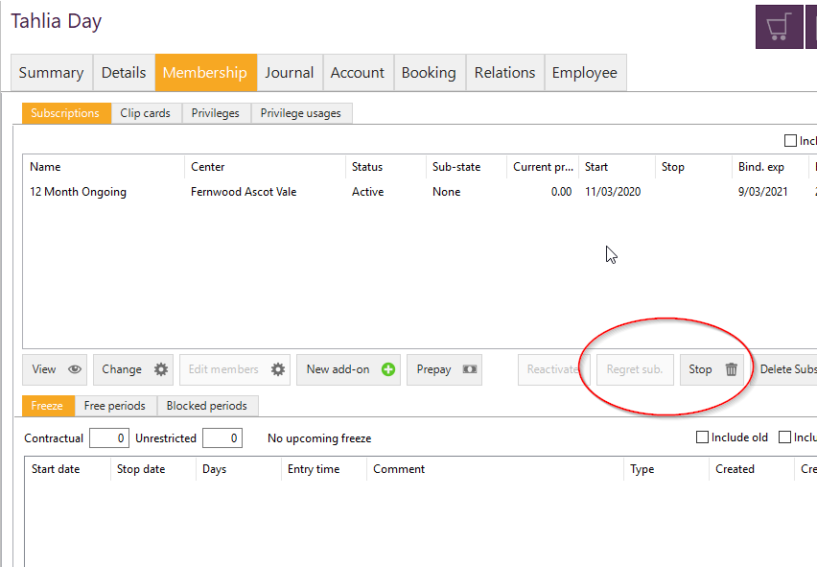

Before binding (contract is up) – cancellation fees will be applied

Select another date manually – this will bring up a calendar for you to manually select a date to end the membership.

# Person App

## Member IDs

In the member profile you will see in the right hand corner their Member IDs.

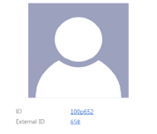

**ID:** 100p652 – this is their unique member ID in Exerp that is linked to their club.

100 p 652

Club ID Person type Unique member ID

**External ID:**  Another unique ID that will never change against a person, even if they transfer to another club.

**Old System Person ID:** Members that have been migrated over from our legacy system (FCM) will show their old membership ID.

## Person Types

**Private:** Selected for majority of new members and leads – no discount associated with this person type

**Student:** Student memberships have a pre-defined 10% discount on their membership fees and will be prompted to present their student card on joining. This can then also be scanned and stored under their profile for reference.

**Senior:** Student memberships have a pre-defined 10% discount on their membership fees and will be prompted to present their student card on joining. This can then also be scanned and stored under their profile for reference.

**Corporate:** If you have lots of local corporate deals in your club please log a helpdesk ticket ([helpdesk@fernwoodfitness.com.au](mailto:helpdesk@fernwoodfitness.com.au)) and we can look into setting these up for the club with the pre-defined discount.

**Staff:** This is chosen for all employees within the club and when you are setting up a new staff member. Please refer to the Staff Member section of the Person App chapter for more information on setting up staff.   
Staff will automatically receive a 30% discount on products and services in the club.

## Person profile

### Summary Tab

*Provides a snap shot of the person’s membership.*

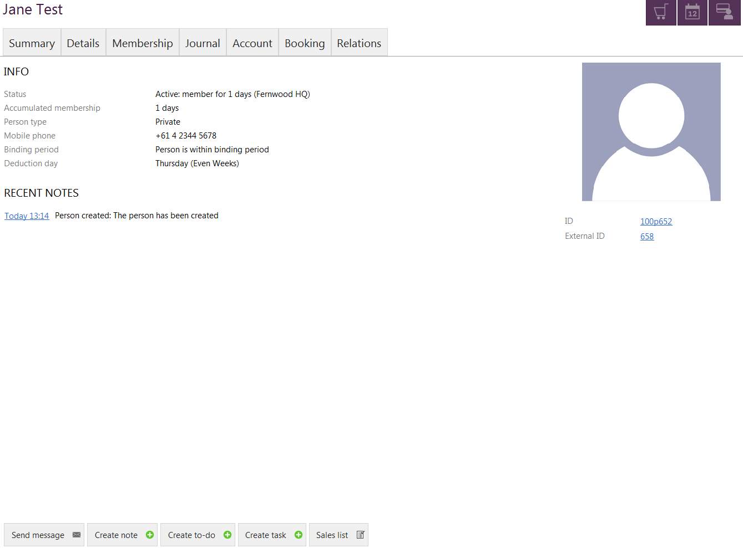

**Status of the member** – active or inactive and how long the person has been a member for  
Active: A current paying member (includes members on deferral)

Inactive: A cancelled member

**Accumulated membership** – number of days they have been a member for

**Person type** – Whether the person is a private, senior, staff or student member

**Mobile number** – contact details

**Binding period** – snapshot of whether the member is inside or outside their binding period

**Deduction day –** their subscription payment cycle

##### Create Journal Note

*Person Profile > Summary tab > Create note*

1. Click on ‘create note’ to open journal document



1. Click on the dropdown menu to select the subject of journal document

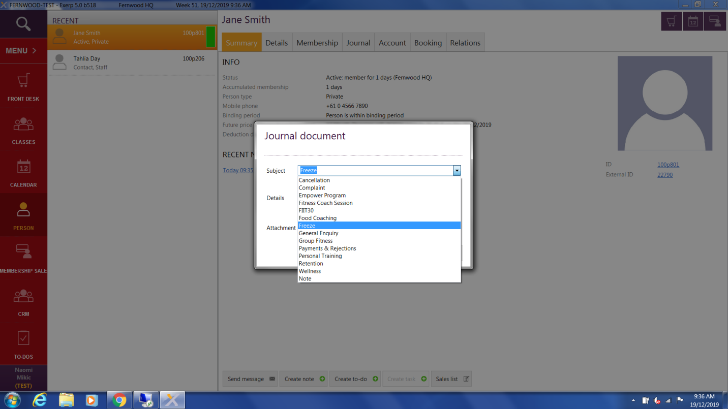

1. Type the contact note in the details section.
2. Upload any assisting documentation with the journal note i.e. a medical certificate, health screen questionnaire etc.

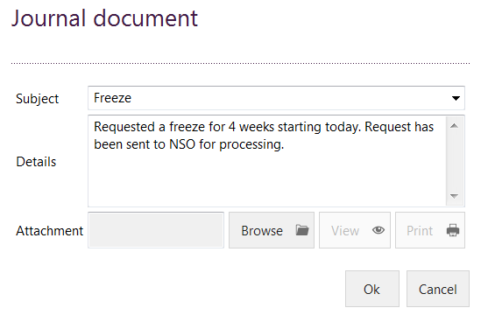

Once you select OK the most recent contact note will appear under the summary tab of a members’ profile

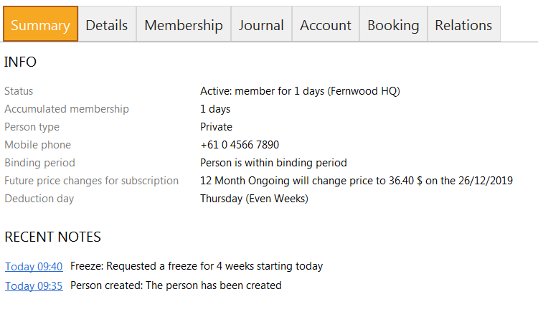

##### View Previous Transactions for a Member

*Person Profile > Summary > Sales List*

This screen will show the sales transactions that the member has made. Click on this to see a list of all transactions made under a subscription, to view the sales receipt, to cancel a sale (only club managers will have this access) or to re-print an invoice.



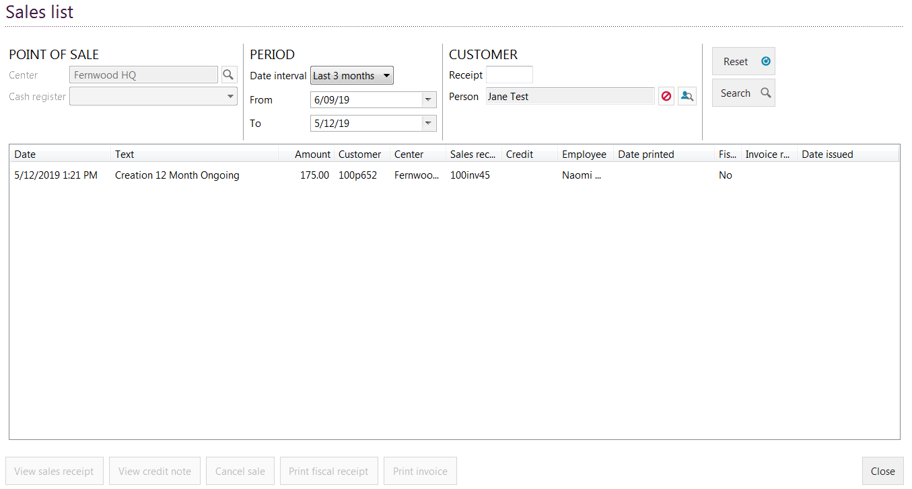

### Printing off a POS receipt

To print off a PDF POS receipt for the members from any purchase they have made in club, this can be done from their profile under their Sales List.

*Person profile > Summary tab > Sales List > Select transaction > View Sales receipt > View receipt > Print PDF.*

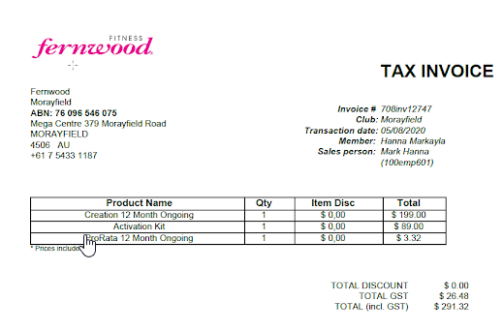

### Details Tab

*Person Profile > Details tab*

View a members’ personal details and communication preferences.

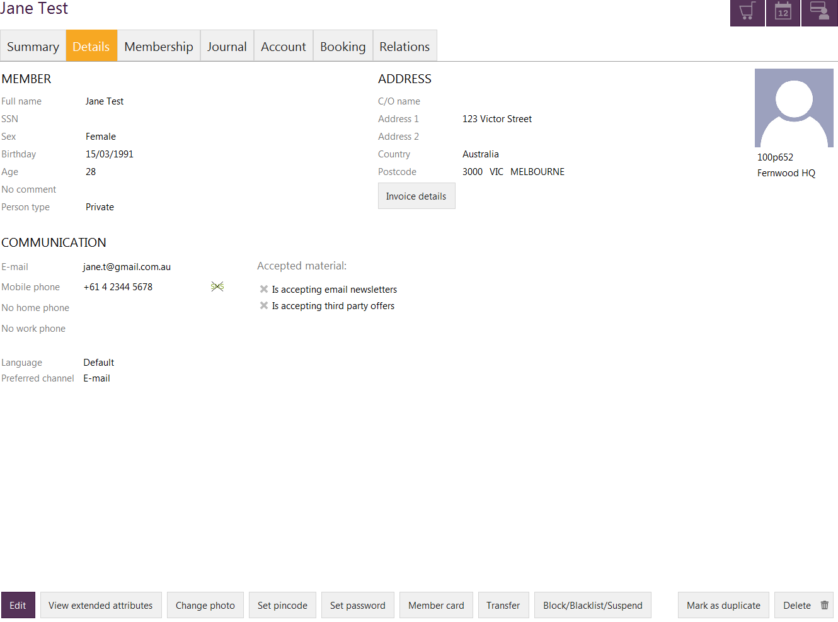

#### Edit Member Details

1. *Personal Profile > Details tab > Edit*
2. Make any necessary changes to personal details and click SAVE

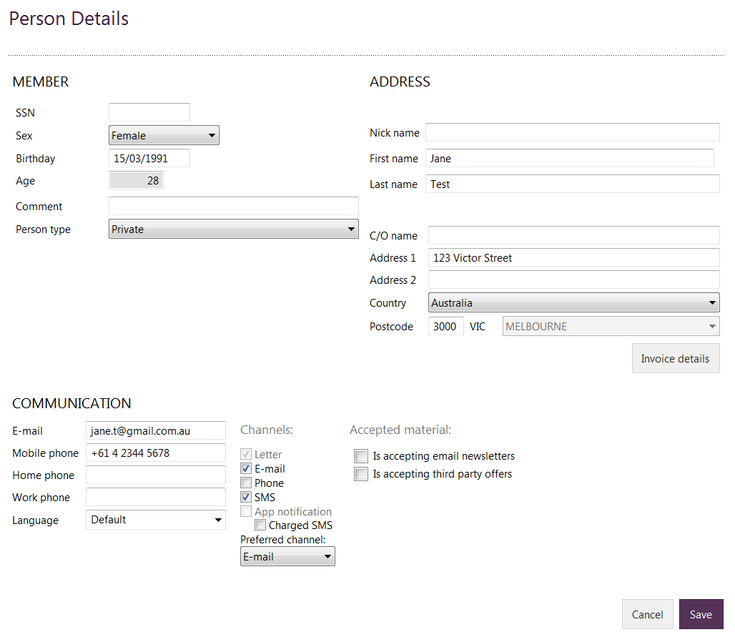

#### **Edit a person type from Private to Staff/Student**

To update a member’s person type from Private to a staff member or senior person type, simply go into their Person profile > Details and Edit.

In the person type drop down > select the person type you are needing to update their profile to and Click Save.

If you create a person type: Staff, this will update their profile in Exerp to include the Employee Tab.

PLEASE NOTE: If you change a person type to student or senior, it will adjust their membership rate to include the 10% standard discount that is applied to those members.

The system will also ask you to confirm that you have seen appropriate documentation for the student members – until this box is checked it will not apply the discount.

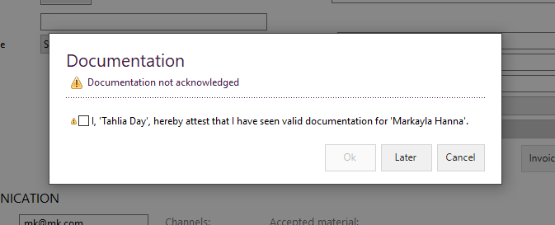

#### Extended Attributes

*Person profile > Details > ‘View extended attributes’*

This section of the member profile is where you will need to add any additional information about the member.

* Lead Source (e.g. Walk-In, Social, Referral, Outreach)
* Emergency Contact Name
* Emergency Contact Number
* Preferred Personal Trainer
* Is 24/7?
* Whether or not the member is accepting email newsletters or if they are accepting third party offers

Edit Extended Attributes

1. Person Profile > Details > ‘View extended attributes’
2. Click on edit, make appropriate changes and then click on ‘Save’.

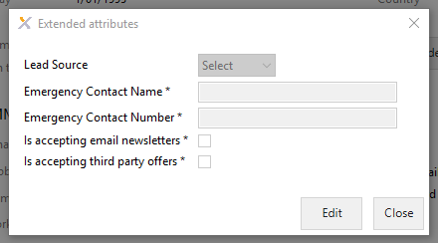

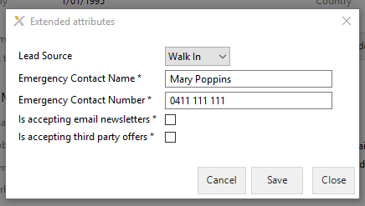

#### Upload a Member Photo

**Change photo tab** allows you to upload a new picture of the member. Make sure the camera is linked correctly to Exerp before selecting this option.

1. Click on ‘Change photo’



1. Select ‘Take picture’ to take a new photo or select ‘Upload picture’. Select OK to save photo

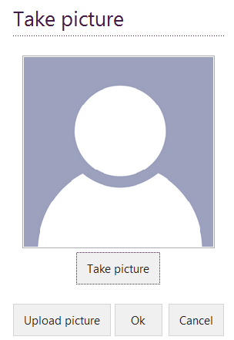

#### Set Password

The set password feature on the member’s profile is linked through to their Fernwood account which gives them access to their Fernwood App and MyFernwood portal.

If you need to reset a member’s password at any time to assist with their access, this can be done via their profile in Exerp.

*Person profile > Details > Set password > change password & confirm new password > OK.*

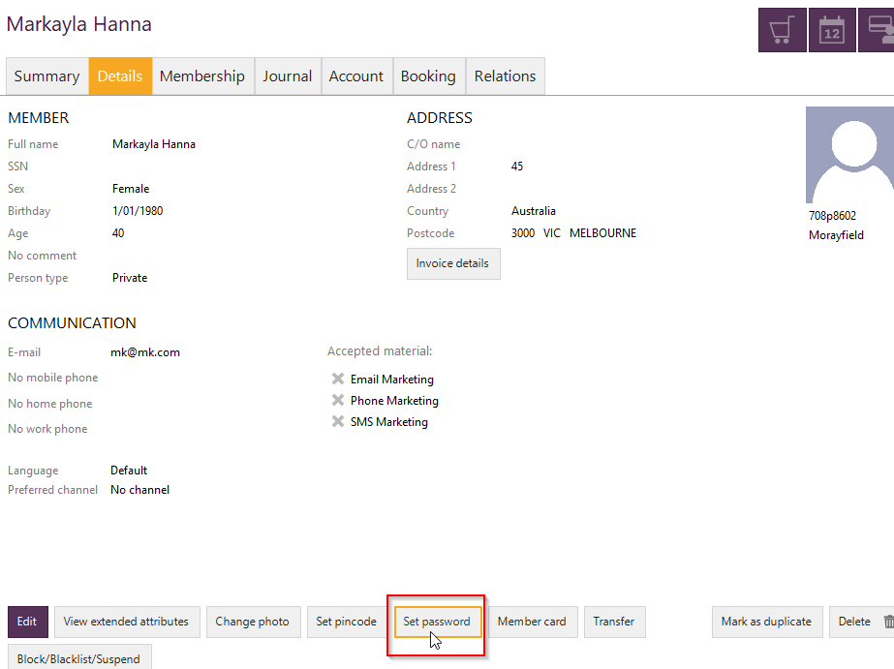

#### Member card

If you wish to assign a new member card to a member follow the steps below.

1. Click on ‘Member card’
2. Enter in relevant information in the ‘member card administration’ pop up page and program a new swipe card for the member

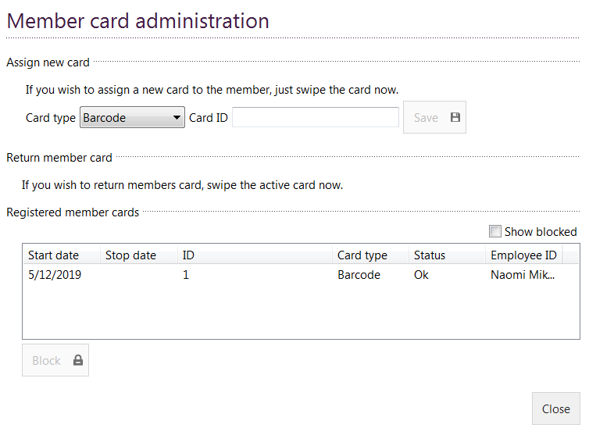

#### Block/Blacklist/Suspend a Member

**NSO Member Admin access only**.   
**Block:** Blocks a members access to the gym due to debt or other specified reason by a club manager or senior management.

If the member’s payment keep rejecting, club managers will be able to click on this button, so that an alert will pop up on the member profile when they scan in at reception for a visit explaining that they have been blocked from using the facilities until payment is made.

### Duplicate Checks

**Mark as duplicate tab** – **Club Manager access only.**Exerp has the ability to pick up on duplicates when a lead is created. A duplicate will either be a soft or a hard duplicate check in Exerp.

Soft duplicate check: can be overridden - for example if a mum and daughter join and decide to use the same email address, the duplicate warning will pop up when entering the email address in for the second time. You will be able to override this to state that there is two different members using the same email address and the daughter is a minor.

Hard duplicate check: The hard duplicate check will not allow you to override the details. For example if all details (first name, last name, DOB & mobile) match a person that is already in Exerp you will not be able to override this and will have to use the same member profile. This will only be the case if you are entering in the same person twice.

Only use this ‘mark as duplicate’ button if there are accidentally two records for the same person in Exerp that the duplicate check didn’t pick up when entering the person in the first time.

### Transfer Membership – Club-to-Club

* Nothing is required to be done by the original club (if a member comes to you to transfer out of your club, please direct her to go to the new club to look around and initiate the process from that club)
* All transfers must be initiated by the member at her new home club
* The new home club must discuss all fees with member and have her complete the following paperwork:
  + Manual Membership Agreement
  + Direct Debit Request
* Send all paperwork to your club administrator at NSO (if your administration is not processed by NSO please send this to [membershipadmin@fernwoodfitness.com.au](mailto:membershipadmin@fernwoodfitness.com.au))
* NSO will then perform the transfer between clubs within Exerp on your behalf
  + You will be notified of any Clip Cards that the member may have which will be transferred to your club (for your purposes of invoicing the original home club for these sessions)
  + The original home club will also be notified of the transfer

### Transfer – Member-to-Member

*Create a new lead in Exerp for the incoming member > Set them up with a payment agreement > Search for the current member > Person Profile > Membership Tab > Select membership > View > Assign to new member.*

PLEASE NOTE: When you are processing a member to member transfer, you must enter the new incoming member into the system as a lead with a payment agreement (valid payment details) before you can action the transfer.

1. Person App > Search for existing member who wishes to transfer the membership
2. Go to their membership tab > Subscriptions and select the membership they are wanting to transfer > Click View
3. 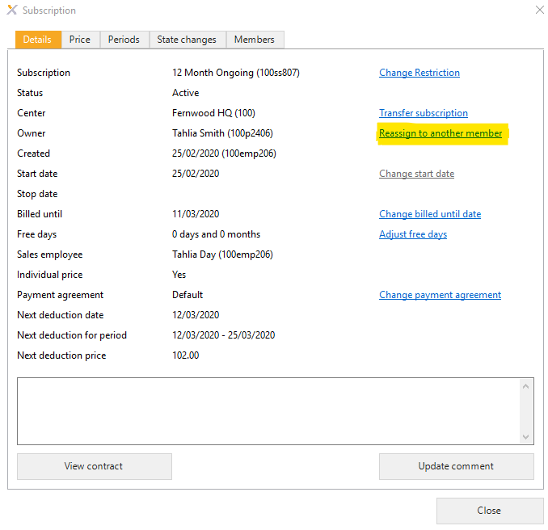The below window will pop up > Select the *Reassign to another member* button
4. Search for the member you are wanting to transfer the membership to

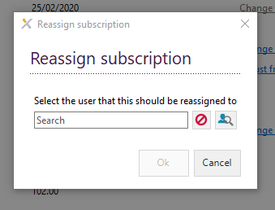

1. The membership transfer has been completed.

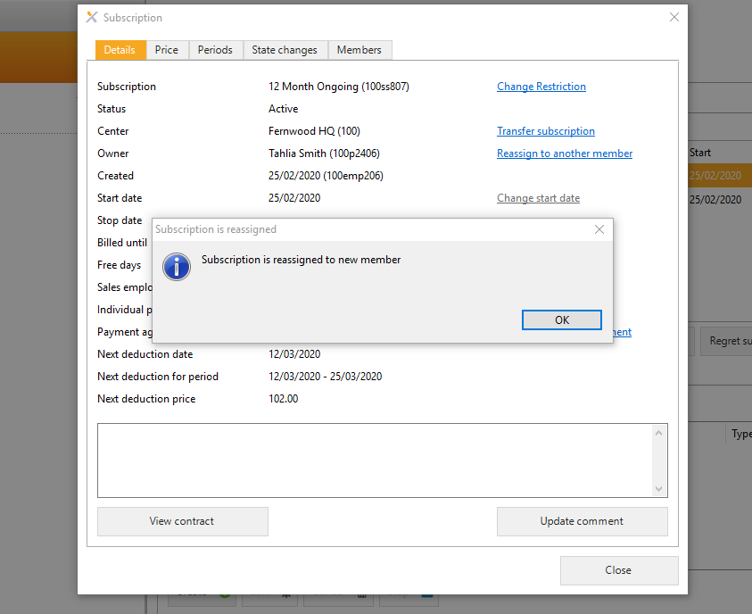  
  
  
  
  
  
  
  
  
  
  
  
  
  
  
  
  
  
  
  
  
  
  
  
  
  
  
  
  
  
  
Create a payment agreement for a lead

*Create lead > Personal profile > Account tab > Payment Agreement > New*

1. Ensure the lead is entered in Exerp
2. Person tab > Search for the lead and pull up their person profile.
3. Go to the Account tab > Payment Agreement > Add

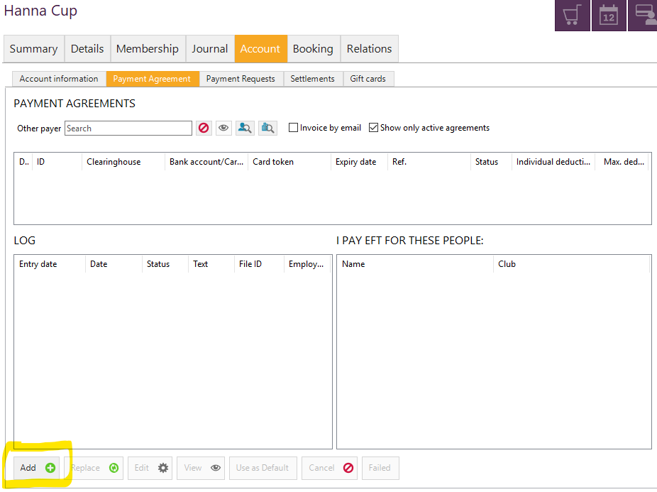

1. Follow the steps to enter their banking details by selecting either EFT (Bank account) or Credit Card

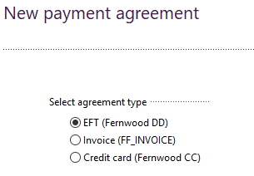

### Membership Tab

*Person Profile > Membership*

The ‘membership tab’ will show the following details:

#### Subscription tab

Summary of the members past, current and future subscriptions.

* Name – type of subscription the member has
* Centre – member’s home club
* Status - status of their subscription i.e. frozen, active etc.
* Sub-state – provides further details on the member’s status i.e. blocked or frozen (none = active)
* Current Price – current fortnightly membership amount
* Start – start date of that subscription
* Stop – will have their cancellation date if applicable
* Bind. Exp – binding period
* Billed until – the date their current direct debit is paid until

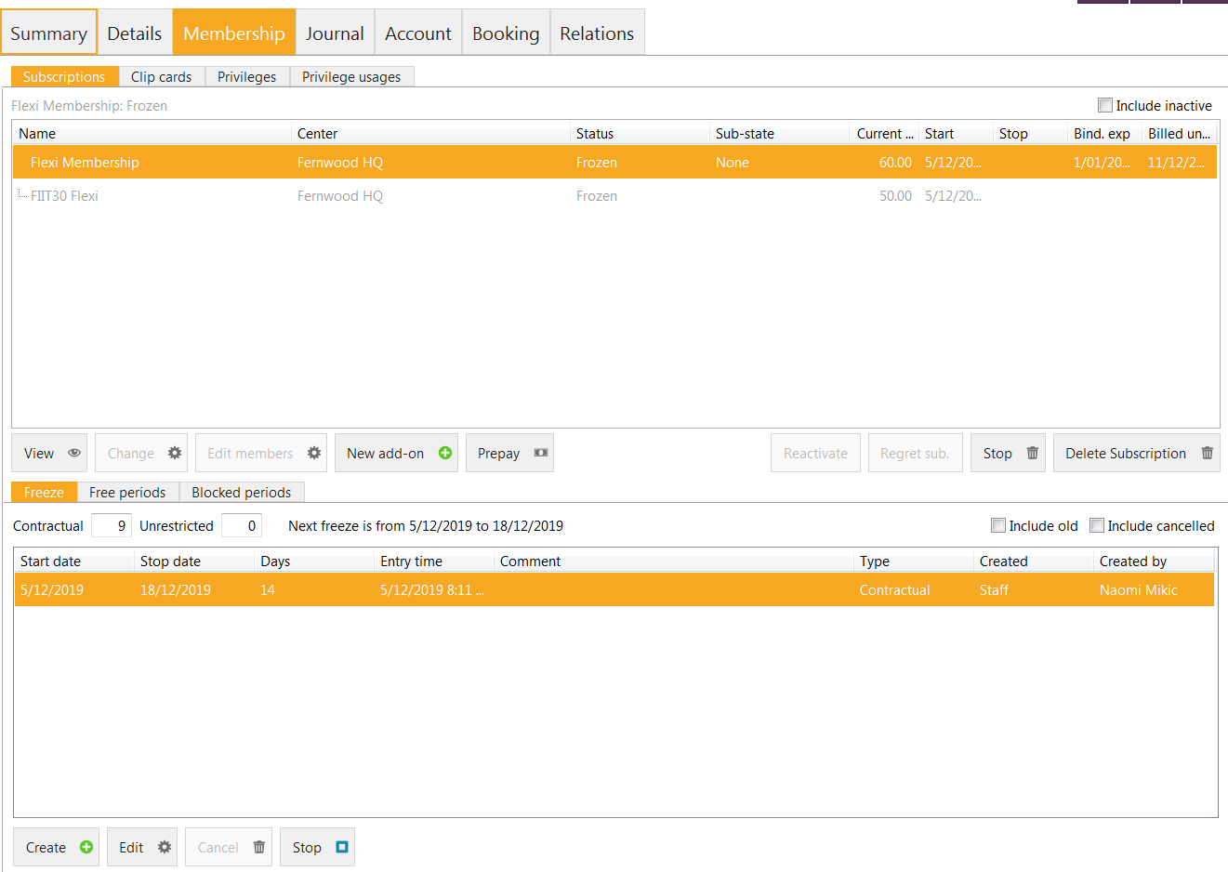

*To view more detail on a specific subscription:*

1. Click on ‘View’ tab

##### To make a price adjustment/banking variation to a member’s account

If you need to make an ongoing pricing adjustment to a member’s account or a banking variation, this can be done through the member’s profile – following the steps below.

*Person Profile > Membership tab > Select the membership you wish to update so it is highlighted in orange > View > Price tab > Add > Change the price > check the date this is going to be effective from and adjust if required > Add a comment/reason for the change > OK > View the new price change > Close.*

1. Go to the member’s profile in Exerp > membership tab and select the membership you are wanting to update so that it is highlighted in orange.
2. Click on View

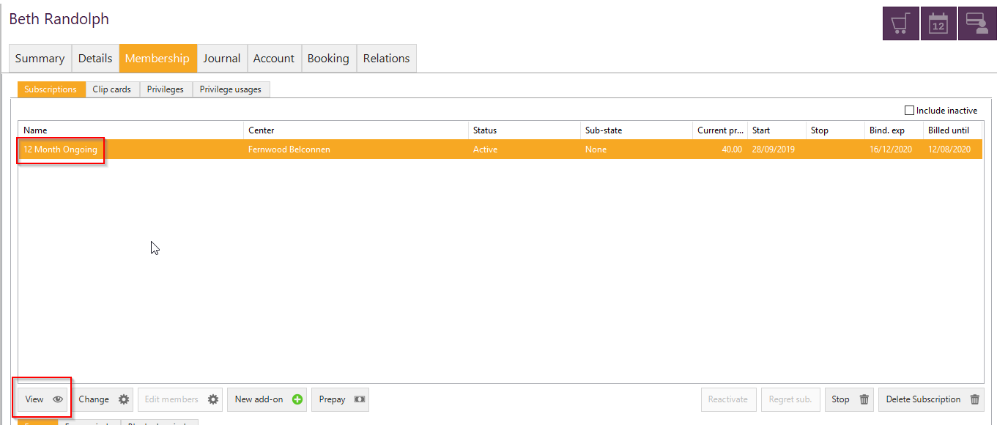

1. A new window will pop up > select the Price tab along the top. Click on Add down the bottom of the window to add a new price to the membership.

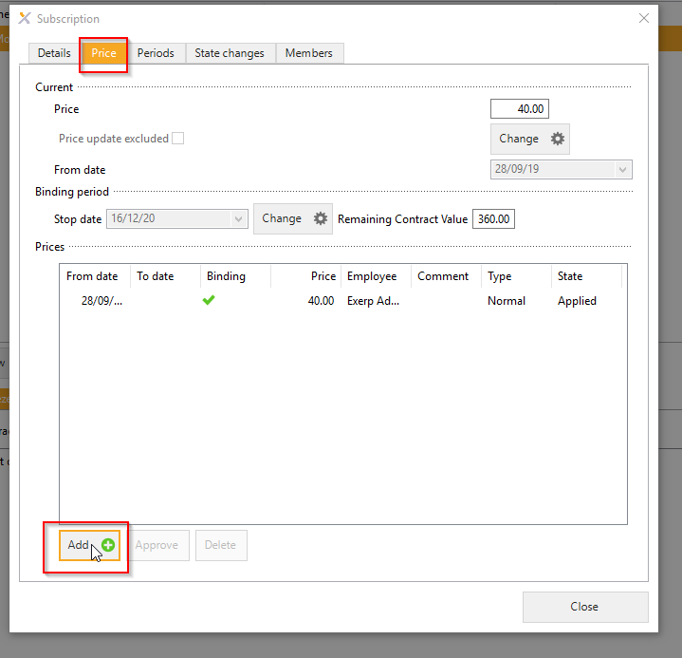

1. This will bring up a new window where you can adjust the price of the membership and update the date it will take effect from. This will default to the next scheduled direct debit. Enter in a reason for the update for record and click OK.

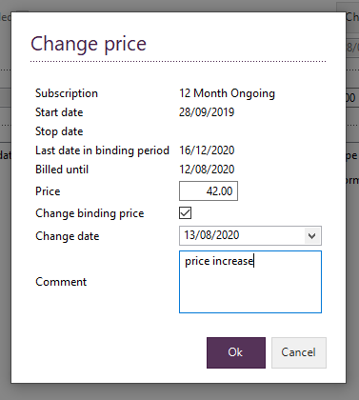

PLEASE NOTE: If you are making an adjustment for a set period of time i.e. 5 direct debits you MUST add in a second price change to bring the rate back down to the membership fee. This feature is designed for ongoing membership price changes not instalments.

##### To make changes to a subscription

**Club Manager Access Only**

*Person Profile > Membership > Subscriptions > Select Subscription > View*

Once you open the view details tab, you will notice the underlined blue tabs on the right hand side of the pop up screen. These blue tabs allow you to make changes to the type of subscription i.e. change billed until date, adjust free days (if a member receive two weeks free for joining) or change payment agreement – to update payment details.

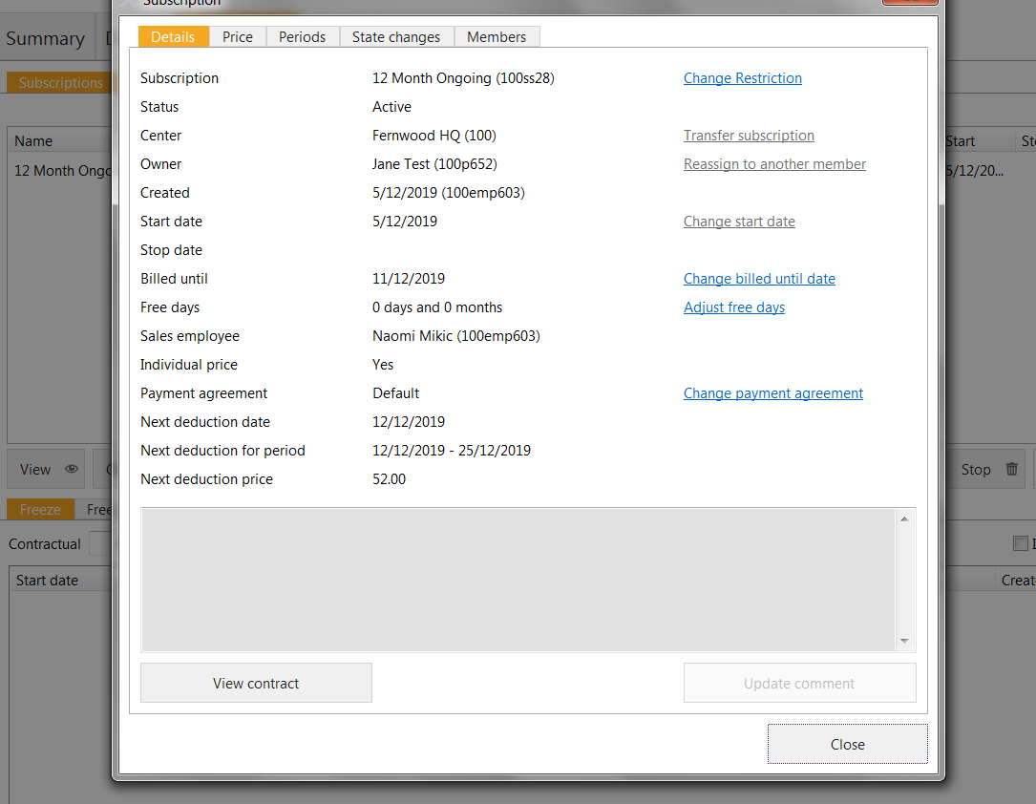

##### Change tab

The change tab gives you access to upgrade or downgrade the person’s subscription.

The change tab gives you access to change the type of subscription the member is on. For example if a member was on a 3 month membership but wanted to upgrade to the 12 month membership to reduce their membership rate this is where we can process this request.

###### Upgrade

Refers to increasing their membership term i.e. jumping from a 3 month membership to a 12 month membership.

###### Downgrade

Refers to decreasing their membership term i.e. jumping from a 12 month membership to a 3 month membership. This will only be able to be processed by Club Managers and if a member is in their minimum term they will also face the usual membership cancellation fees.

To upgrade or downgrade a subscription follow these steps:

1. 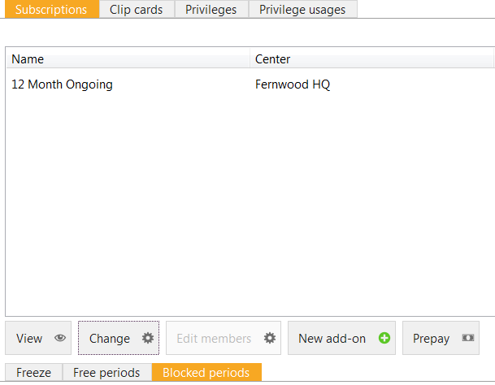Click on ‘Change’ tab
2. Click on upgrade or downgrade depending on what you are wanting to process

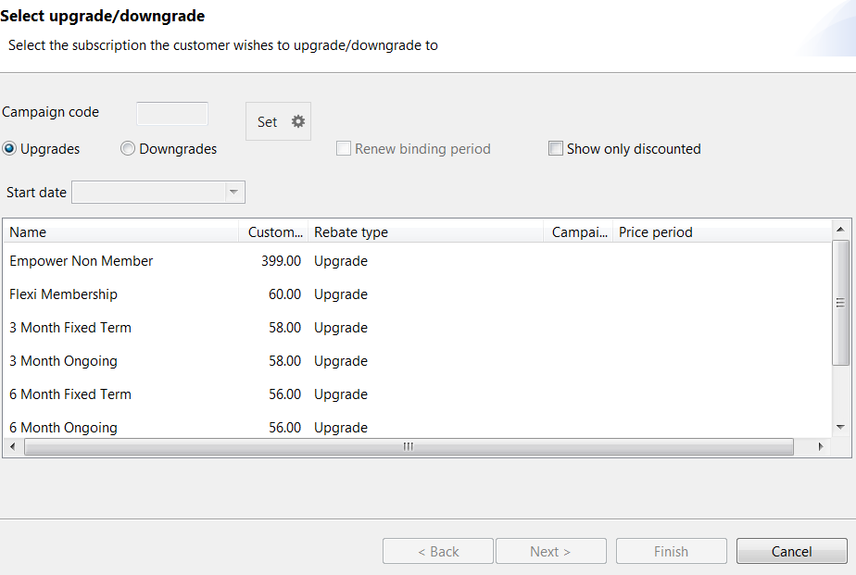

1. Select the name of upgrade or downgrade you would like to process. Click on ‘Next’

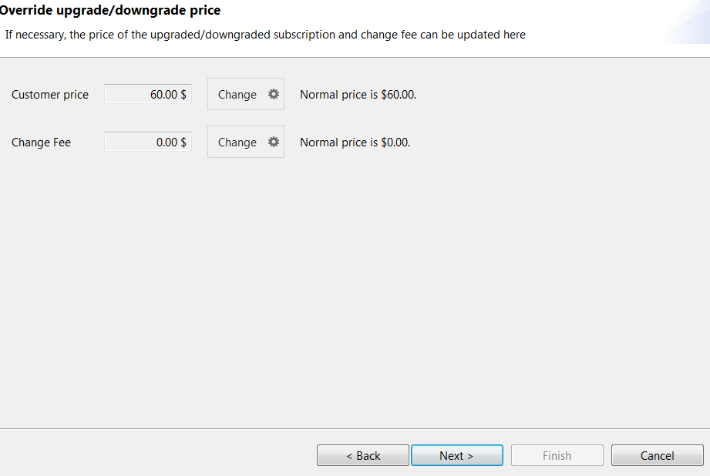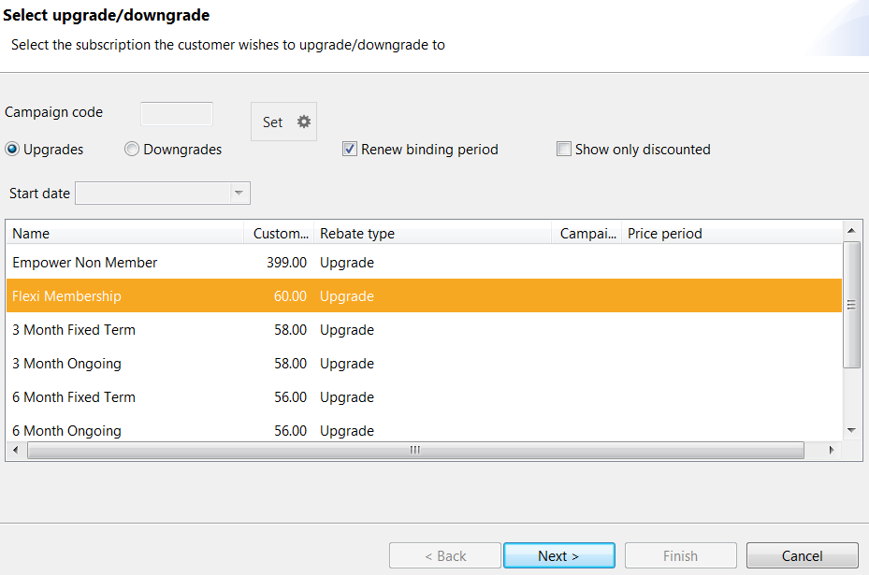

1. Now select the add-ons that you would like to include in the upgrade. (add-ons are unlimited flexi components). Click ‘Next’ to continue.

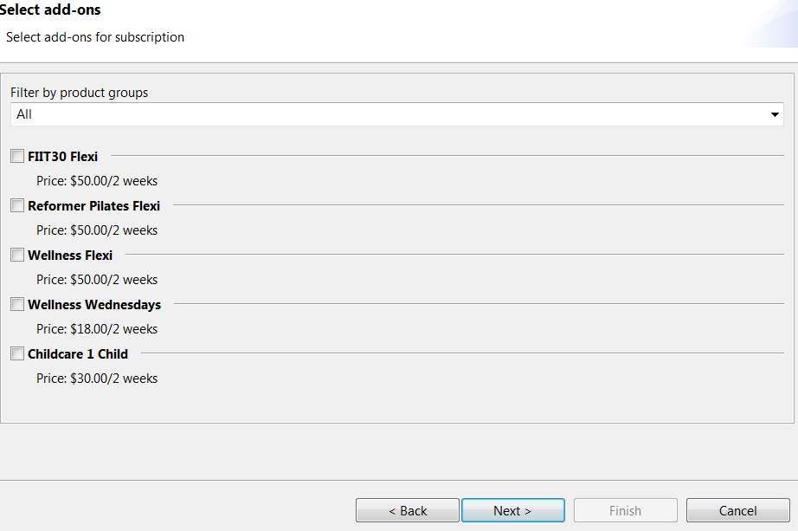

1. The next page will show you what the member needs to pay to finish the upgrade/downgrade process and it will also give you a summary about the upgrade/downgrade.

PLEASE NOTE: Exerp calculates everything by a day by day pro-rata. For example if the member changes their membership from a 12 month to a flexi membership, as the rate is higher the system will calculate a pro-rata that would allow them to start accessing the club as a flexi member from the day of processing.

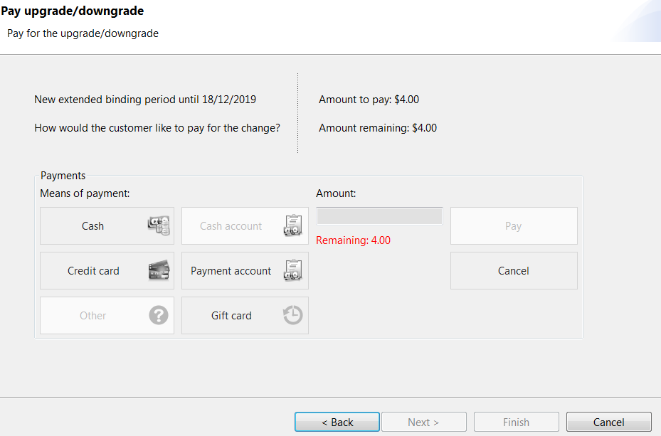

1. 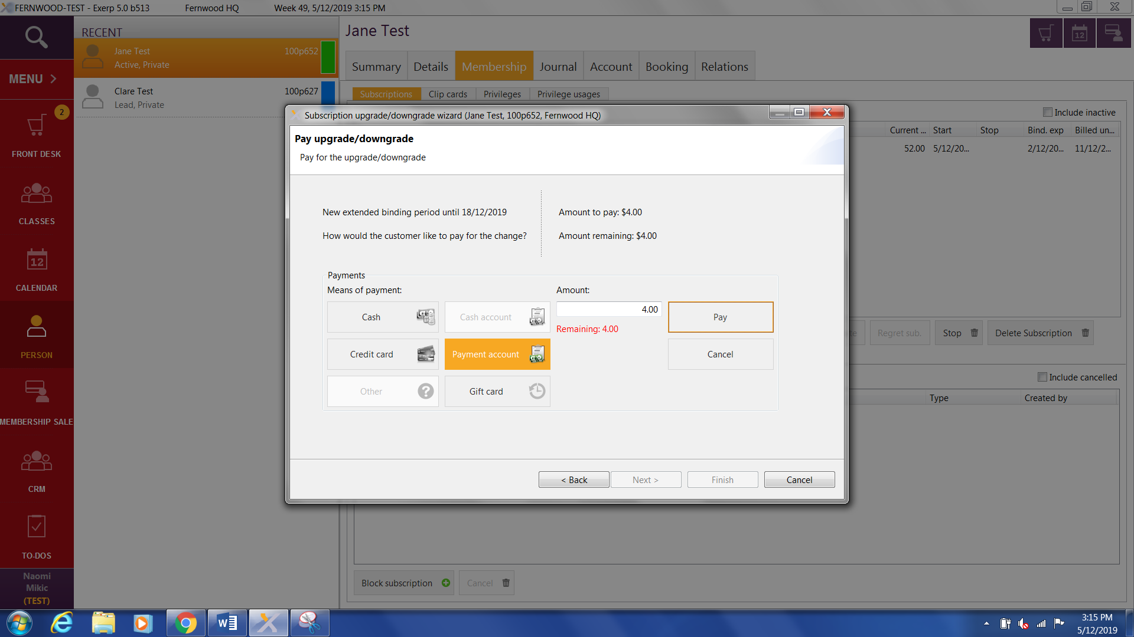Now select ‘Pay’ and then ‘Finish’.

##### New Add On

An Add-on is a service that is added to the member’s payment agreement on a fortnightly ongoing basis (unlimited flexi component) as a separate subscription.

To process an add-on new subscription under a **member’s profile**, follows these steps.

1. Click on ‘New Add-on’ tab

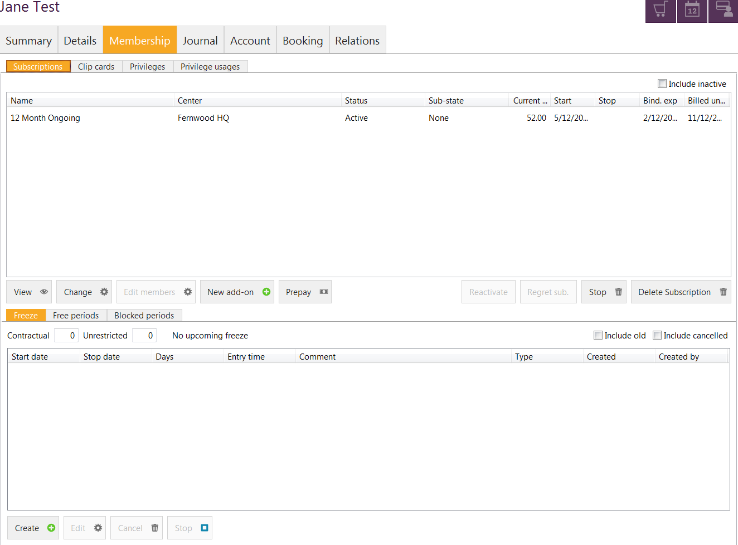

1. Select the start date of the add-on followed by what type of service you would like to add-on i.e. FIIT30, Reformer Pilates
2. Click ‘OK’ to continue.

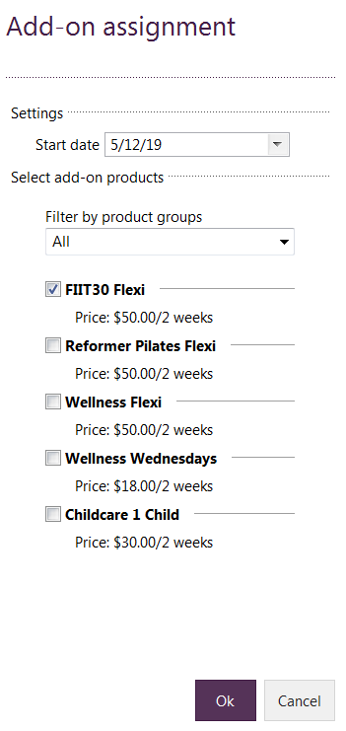

1. The cash register will pop up and you will be able to select how the member will be paying for it.   
   If the upgrade start date occurs in between debits, the system will calculate the pro-rata and prompt the member to pay for this, it is assuming that as they start today, they wish to start using the service today i.e. FIIT30 which means they should also be paying for it from that date.

The amount the pops up can be pushed straight through to their next DD by selecting the Payment Account option in Front Desk.

*PLEASE NOTE: If the member wishes to push the payment to their next direct debit just click on ‘Other payments’ to add it to the members’ payment account (direct debit).*

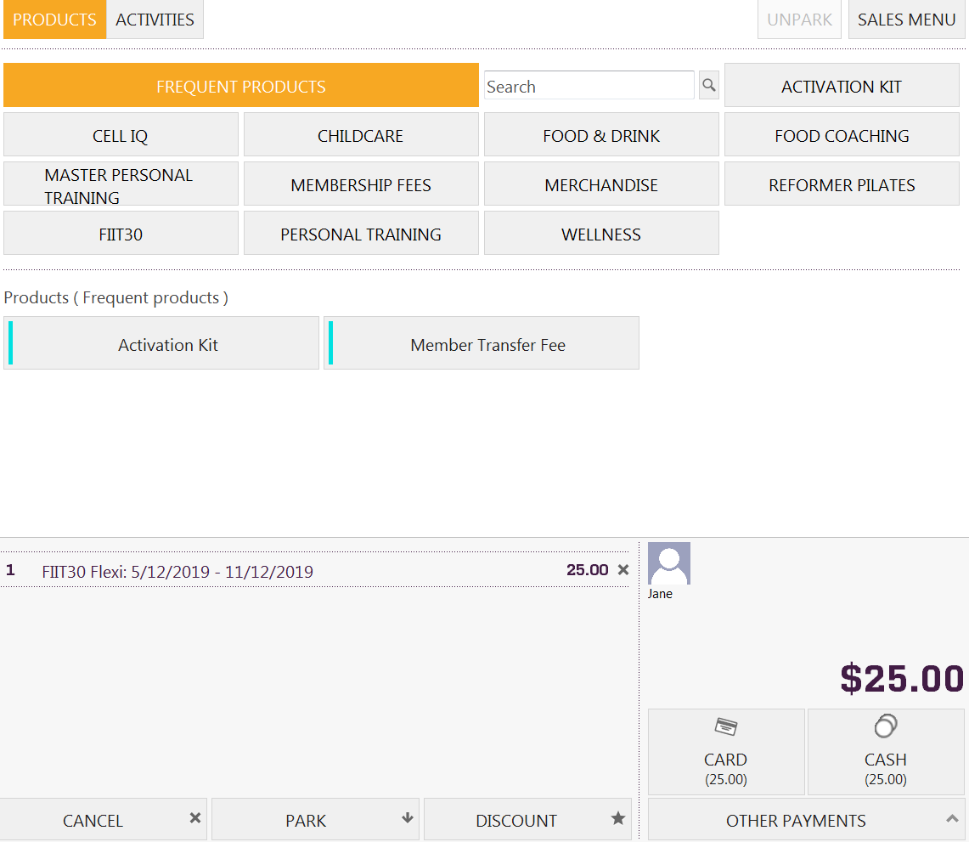

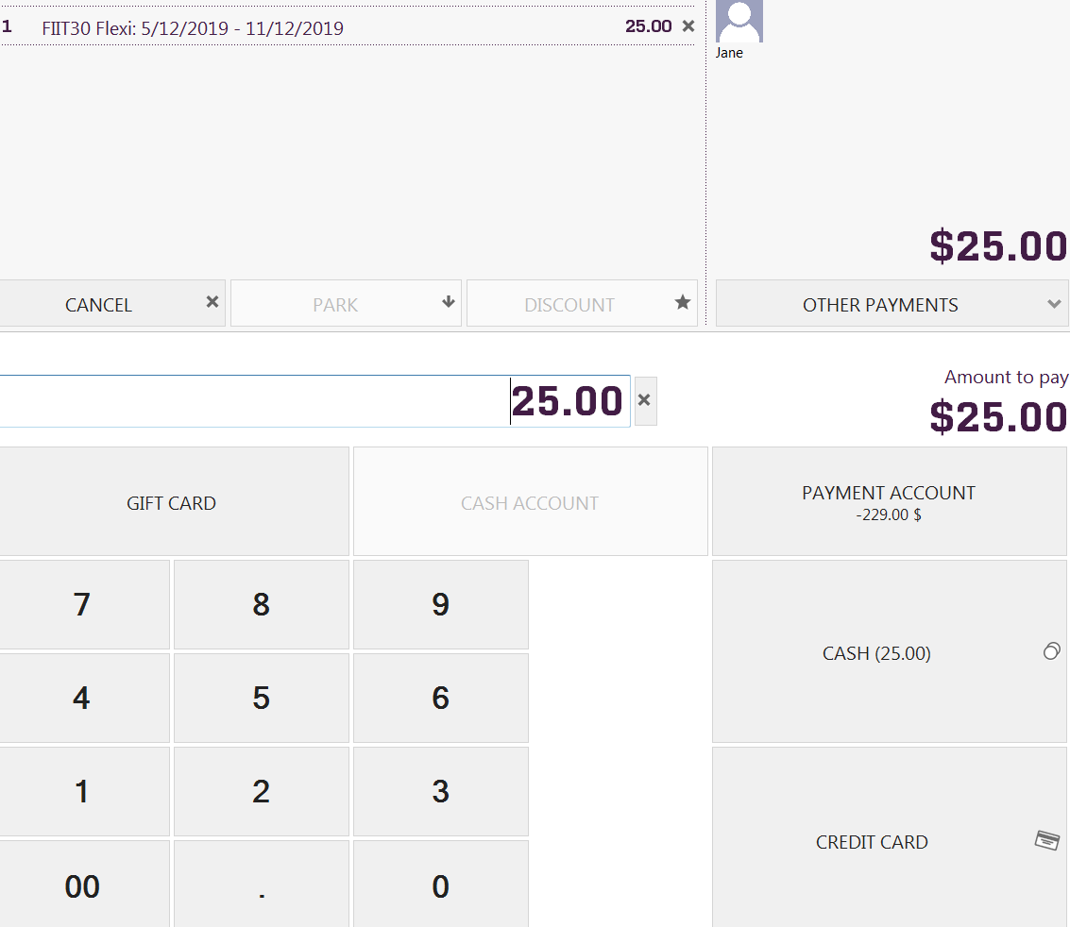

Once the add-on is complete, you will now see two subscriptions under the membership tab, under subscriptions.

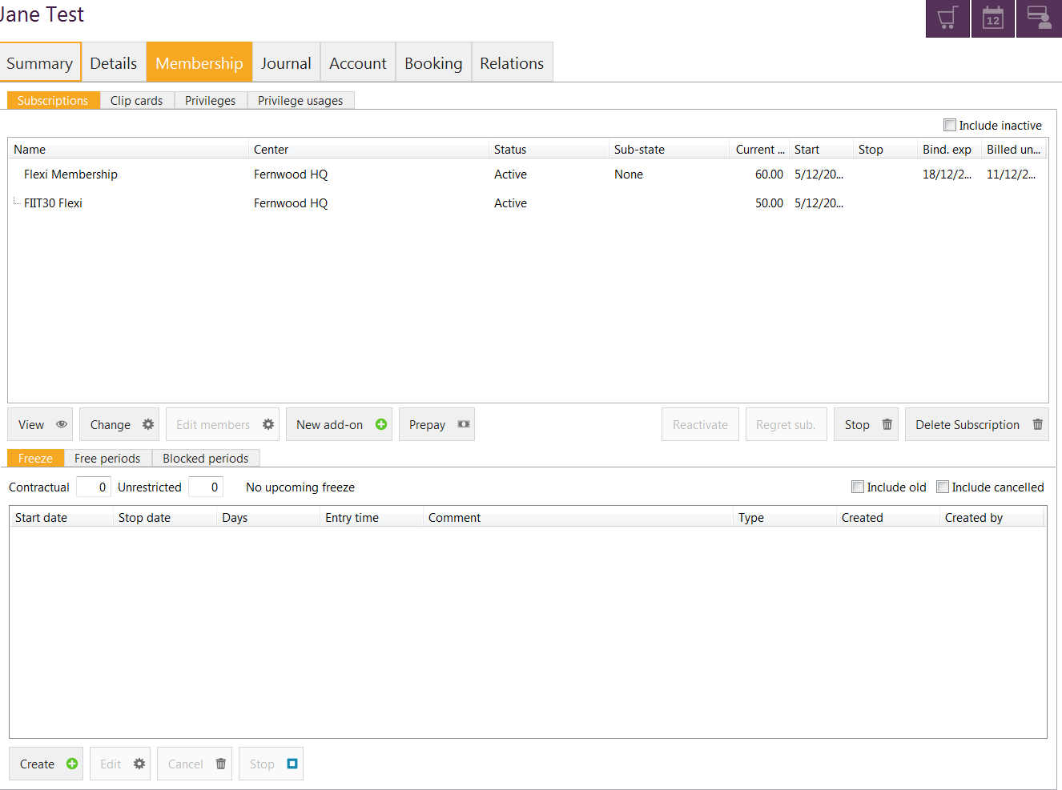

##### Remove Add On – Downgrade a membership

*Membership > Subscription > Select your Add On > STOP > Select Stop date> Finish*

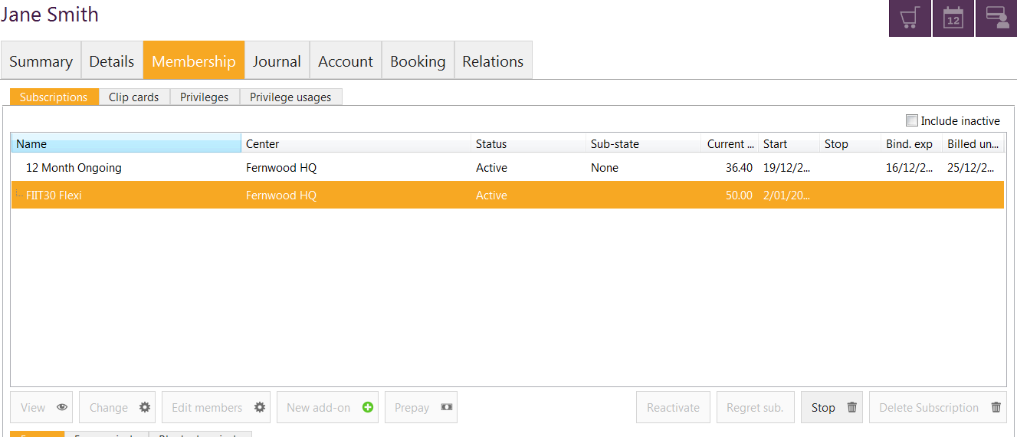

1. The ‘Addon termination’ screen will pop up. Select the date from the list or select the date manually of when you would like to stop the add on from. Now select ‘Finish’.

##### Freeze tab

Previously known as a deferral, member have the ability to ‘freeze’ their subscriptions for $8.00 per fortnight.

Unrestricted freeze: this type of freeze can only be processed by staff with **Club Manager** access or above and is only used for medical reasons or approved freezes.

Contractual freeze: this is the freeze that is pre-defined in all the subscriptions and be processed for a minimum of 2 weeks and maximum of 8 weeks, as per the terms and conditions of the membership agreement and will incur an $8.00 a fortnight freeze fee.

###### Processing a Freeze

*Membership > Freeze > Create >Select freeze type> Select dates > OK*

1. Click on ‘freeze’
2. Click on ‘Create’



1. 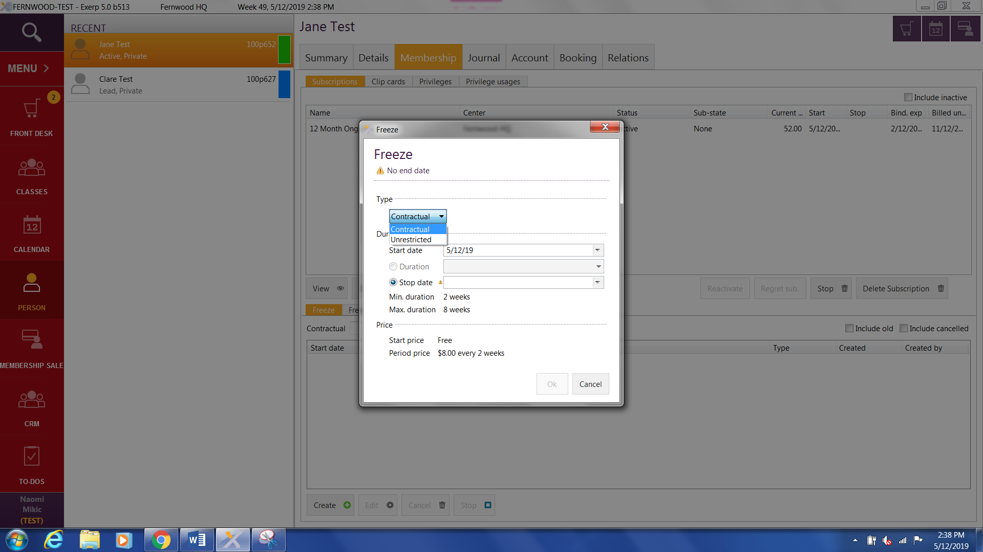Select the type of freeze the person requires.  
   *PLEASE NOTE: this will only display both options if your access level allows*
2. Enter in the start date of the freeze followed by the stop date. All of the details of the freeze will be shown down the bottom. Now select ‘OK’ to proceed.

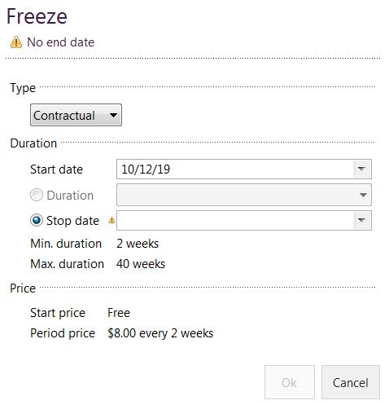

1. Once you select OK the ‘freeze’ will save.
2. The freeze will now be displayed under the membership tab of the members’ profile and under the freeze section.

PLEASE NOTE: Members will receive an auto email, confirming that the freeze has been processed for them including their dates of their freeze.

UPDATE TO FERNWOOD FREEZE: You may notice when you have processed a freeze for members that it will process the deferral fee based off a pro-rata amount

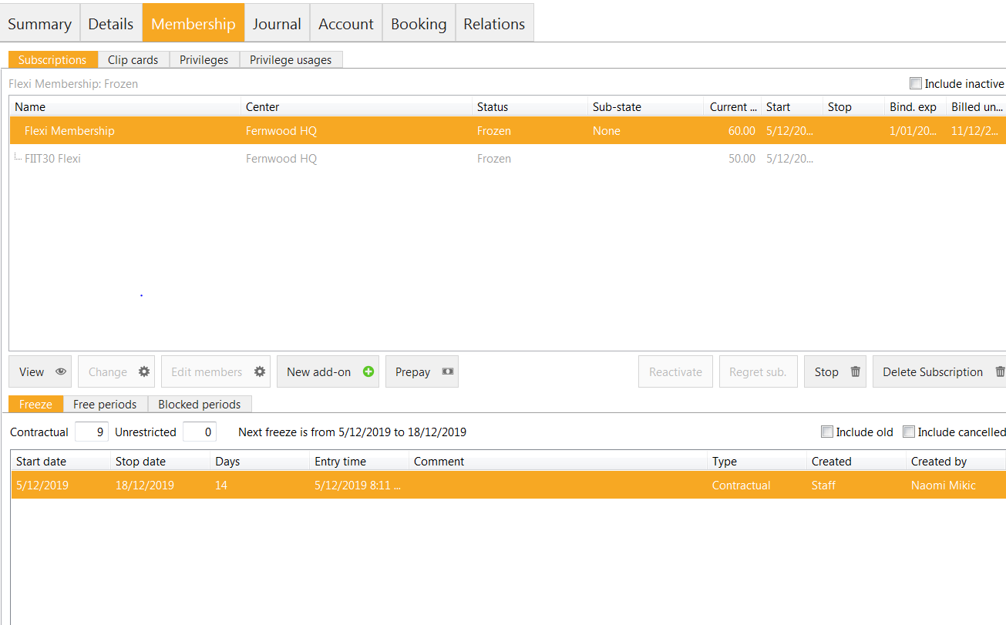

###### To make changes to the freeze:

*Membership > Freeze > Select freeze > Edit*

1. Click on the ‘Edit’ tab down the bottom of the screen

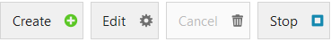

1. Re-enter the correct dates in the ‘Freeze’ pop up screen and then select ‘Ok’ to save freeze.

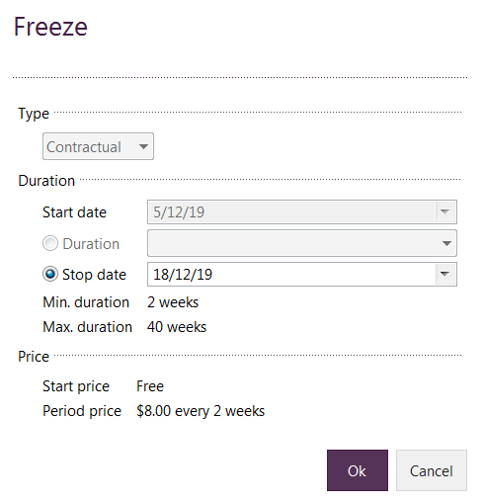

Updated freeze details will now be displayed under the ‘Freeze’ tab in in the membership details page.

###### Returning early from a freeze

If a member would like to return early from their freeze:   
*Membership > Freeze > Select freeze > Stop*

1. Click on the ‘Stop’ button down the bottom of the screen under the ‘Freeze’ tab.



The freeze will automatically be stopped.

If a member decides to return to the club early before their freeze has finished and you ‘stop’ their freeze, their debit amount will have a pro-rata amount added to it. For example if a member freezes their membership for 4 weeks and returns after 3 weeks, Exerp will automatically calculate the pro-rata for the remaining week and add the extra payment amount to their next direct debit to cover the cost of returning early to the club.

##### Free Periods

**Club Manager access only**

A free period is given for referring a friend, signing up on a subscription with a promotion deal (2 weeks free) or winning a competition that has been run in club – 30 days free.

*Membership > Free Periods > Assign free period > Enter details > OK*

1. Click on ‘Free periods’

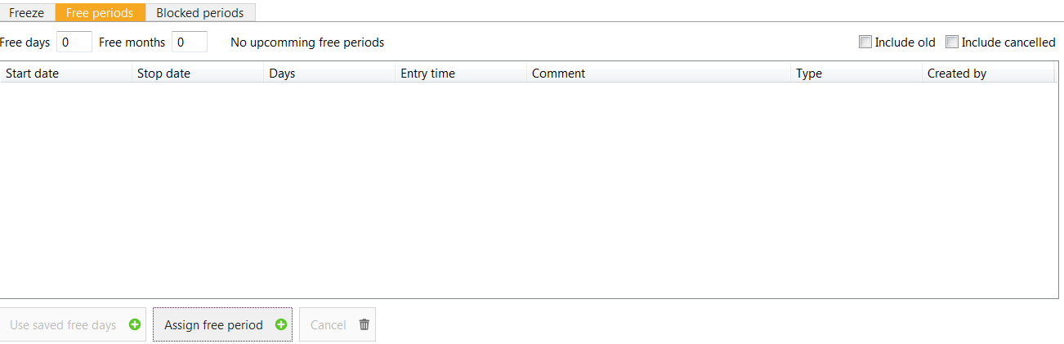

1. Click on ‘Assign free period’.



1. Enter in the start date and stop date of the free period in the ‘Assign free period’ pop up screen. Click on OK after you have entered in the details.

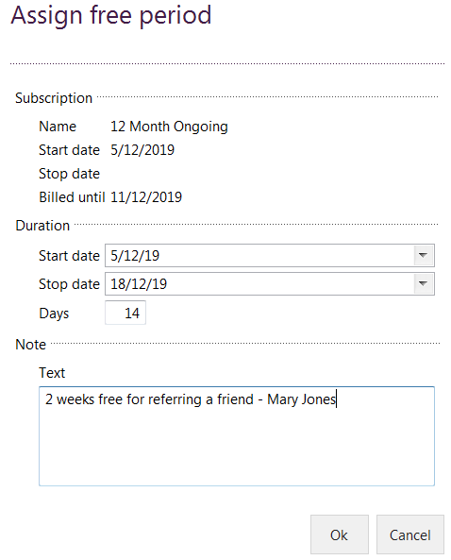

1. The details of the ‘Free period’ will appear under the ‘Free periods’ tab in the member profile.

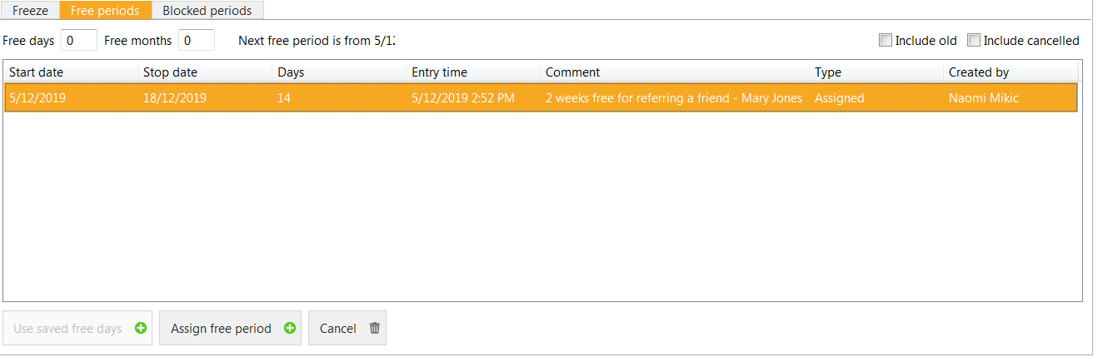

**Cancel a free period**

Click on the ‘Free periods’ tab, ensure the correct free period is highlighted and click on the ‘Cancel’ button down the bottom of the screen.



##### Blocked periods

**– Club Manager access only**

If you need to block someone out of the club, due to having an outstanding debt that needs to be cleared before using the gym, club managers will be able to block their subscription so that they are unable to use the facilities.

To block a member from using their subscription:

1. Click on the ‘Blocked periods’ tab

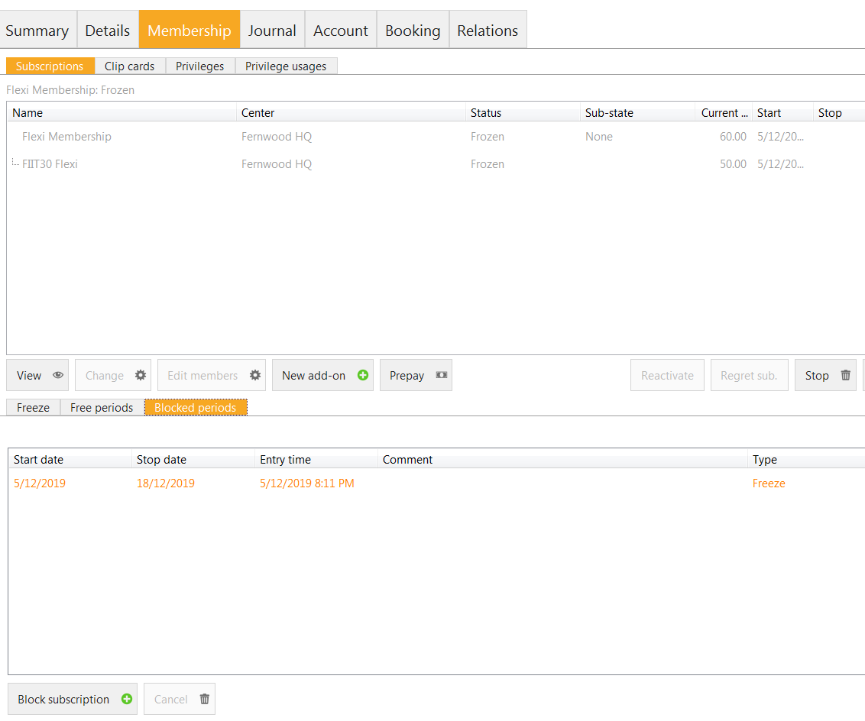

1. Click on ‘Block subscriptions’ tab in the bottom left hand side of the screen



1. Enter in the blocked period dates and click OK.

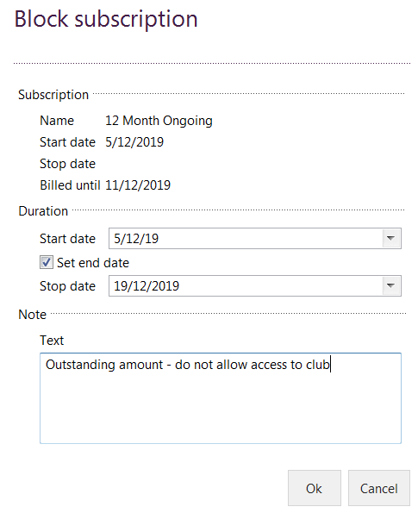

The blocked period will now show up under the ‘Blocked period’ tab.

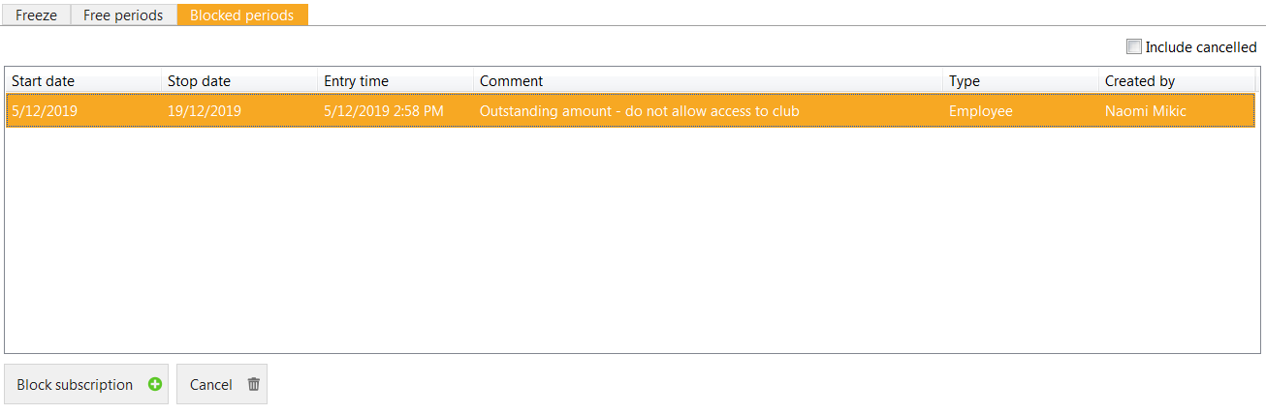

To cancel the blocked period, click on the blocked period and select ‘Cancel’ down the bottom.



##### Clip cards tab

This section is where you can view all the session balances and purchase history of Personal Training, FIIT30, Food Coaching, Reformer Pilates, Wellness Wednesdays, Wellness, Sauna and Childcare that have been added as a recurring clip card on direct debit or via a POS clip card pack.

###### Processing a Clip Card

*Membership > Clip Cards > New > Select Product > Process through cash register*

1. 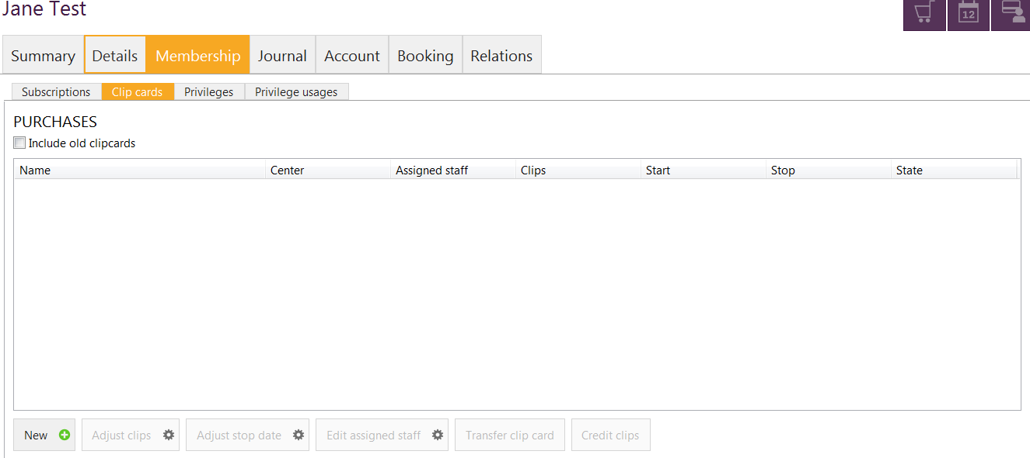To add a clip card click on the ‘Clip cards’ tab followed by the ‘New’ tab
2. Select the ‘Product group’ drop down menu to select the service or product the person would like to purchase

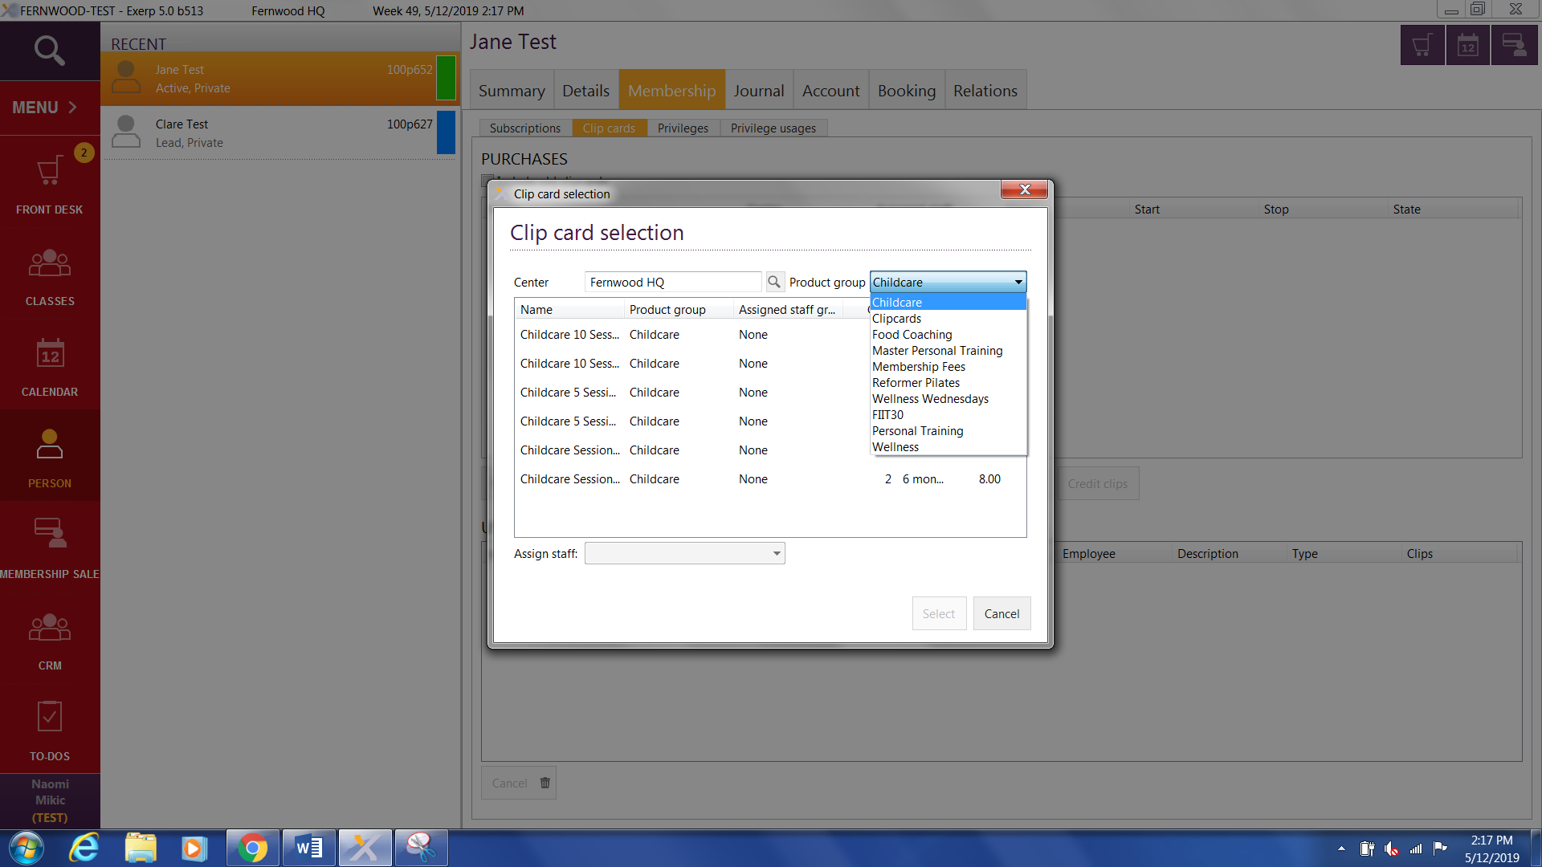

1. Select the name of the product they would like to purchase, then click select.

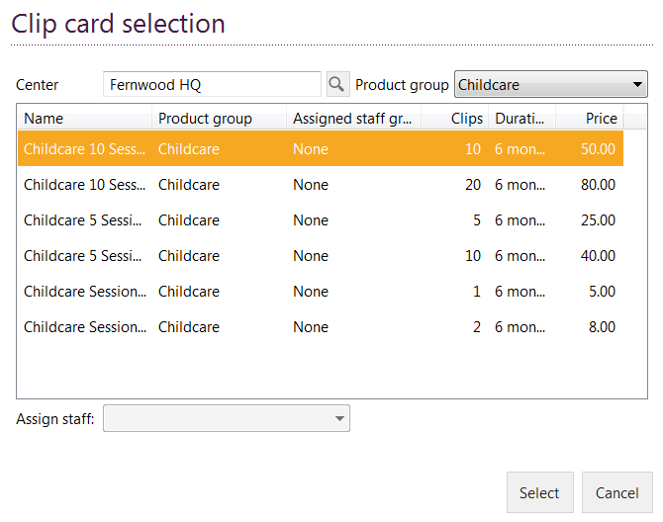

1. The cash register will now open and select the payment type the member will be purchasing the service/product with (CASH OR CARD) or select other payment to select ‘Payment account’ (debit account that we have on file for the member for their fortnightly direct debits)

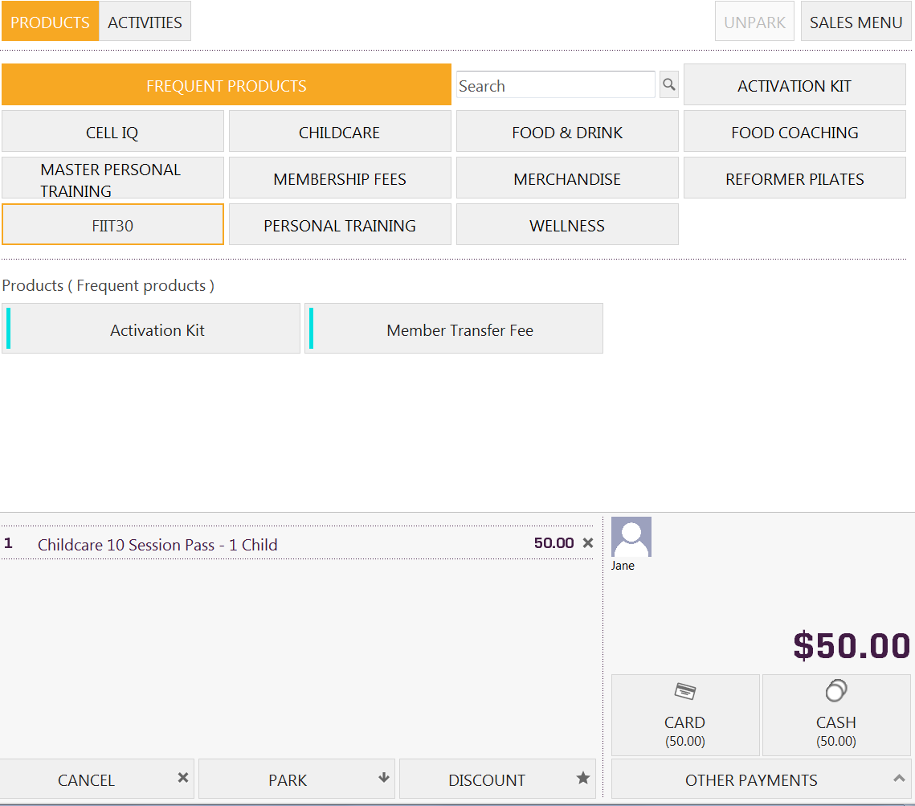

Other payments will add payment amount onto the direct debit

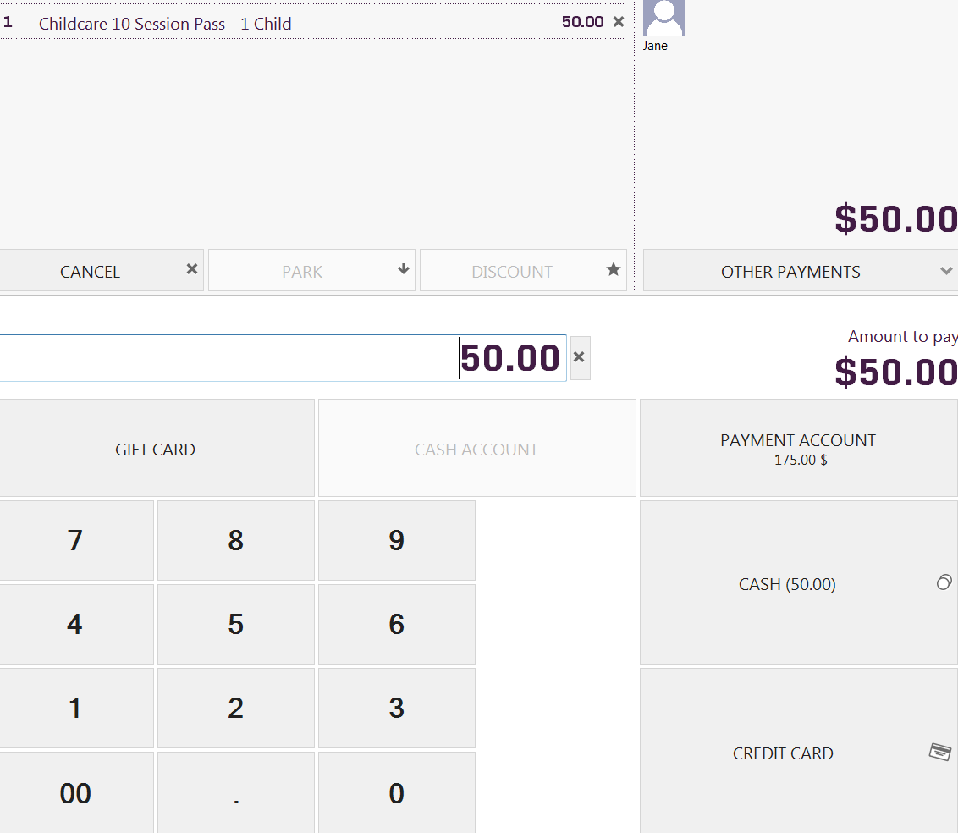

Click on ‘Payment account’ to add to the members’ fortnightly debit

###### View Clip Card Balances

*Membership > Clip Card > View summary of all clip cards assigned to a member*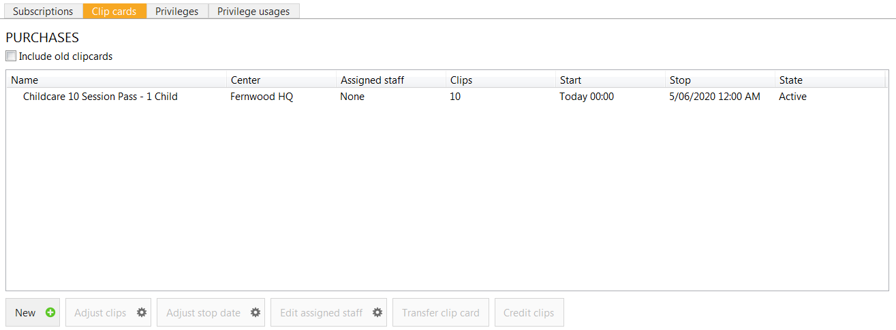

#### View Clip Card Usage

To view when a member has used a session in Exerp or to audit their clips being deducted and when follow the steps below:

1. Go to the person’s profile in Exerp > Membership tab > Clip cards
2. Check the box “View Old Clip cards”. This will ensure any packs that been used will be loaded her as well.

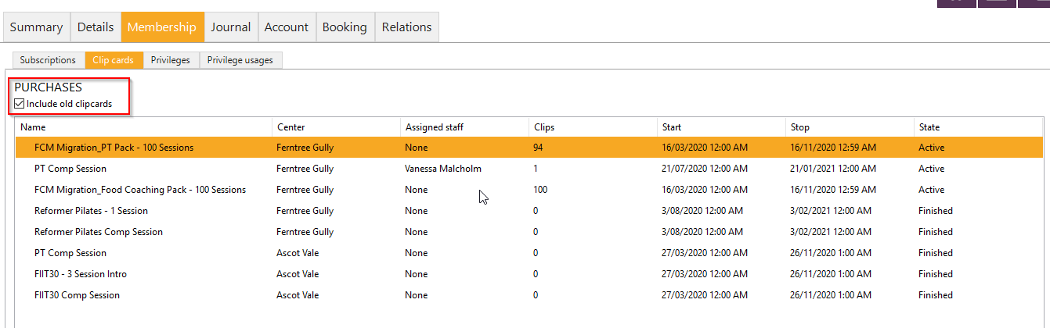

1. Select the clip card you are wanting to view the usage for so that it is highlighted in orange. You will then notice in the bottom half of the screen the Usage table will load the information on the sessions each clip was used for.

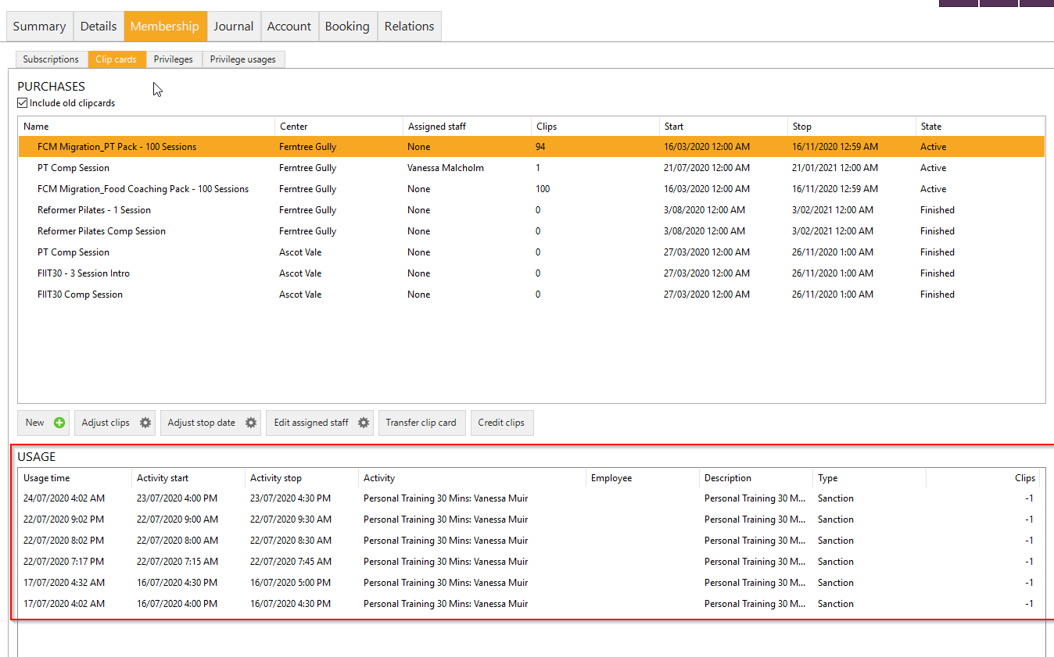

1. Each line will give you the below information:   
   **Usage time:** This is the time of when the member has used the clip (the time of booking)   
   **Activity start:** The start time of their appointment

**Activity stop:** The end time of their appointment **Activity:** The activity they are doing i.e. Personal Training **Employee:** The staff member it is with **Description:** Description of activity  **Type:** This will be 1 of 3 options.   
Sanction: a no show or late cancellation and they have been charged for their appointment  
Privilege: they have attended the session

Adjustment: there has been a manual adjustment of their session balance

**Clips:** -1 a clip has been deducted or 1 a session has been added onto their account

###### Adjusting Clip Card Balance for a Member

*Membership > Clip Cards > Select clip card > Adjust Clips*

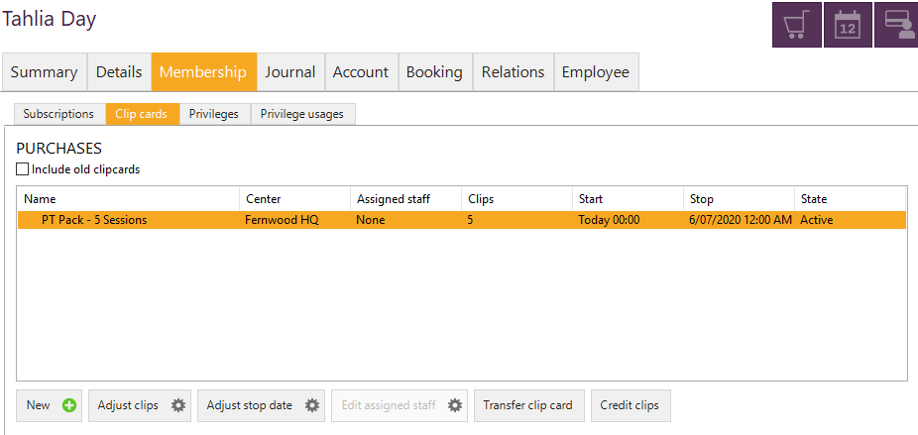

1. Click the ‘Adjust clips’ button.
2. Click either ‘Add’ or ‘Remove’ and adjust the clip card balance as required.
3. Ensure you type in the reason for adjusting the clip card balance, then click OK

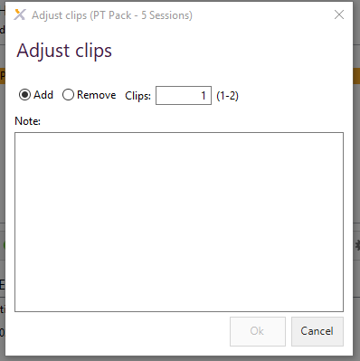

PLEASE NOTE: any manual adjustments of clips cards, the system will apply an automatic reconciliation to the associated pack. For example, if a member has purchased a 5 pack of PT you will only be able to adjust their clip balance to a maximum of 5 clips.

If you require to add additional clips over this balance, we recommend processing a new PT Pack through Front Desk and apply a 100% discount to the product.

###### Privileges

Privileges define what a member has access to in the club.

**Privileges that are included in every subscription**

* Gym access
* Reciprocal rights
* Fitness Coach

###### Reciprocal Rights

Each member has the privilege to visit any other Fernwood club 24 times in a 12-month period. Members simply take their membership card to the Fernwood club they wish to visit and swipe their card as per normal. The system will automatically deduct the visits each time a member swipes into a sister club. Their visits will reset on January 1st each year.

If a member reaches their limit of 24 visits they will then be prompted to purchase additional visits at their visiting Fernwood club.

**Fitness Coaching:** Each member has the privilege to book into Fitness Coach appointments as it’s included in their subscription.

As you can see below, Jane Test has access to the gym, reciprocal rights (visits to any Fernwood in Australia), fitness coach appointments and childcare (seeing Jane purchased a clip card through POS).

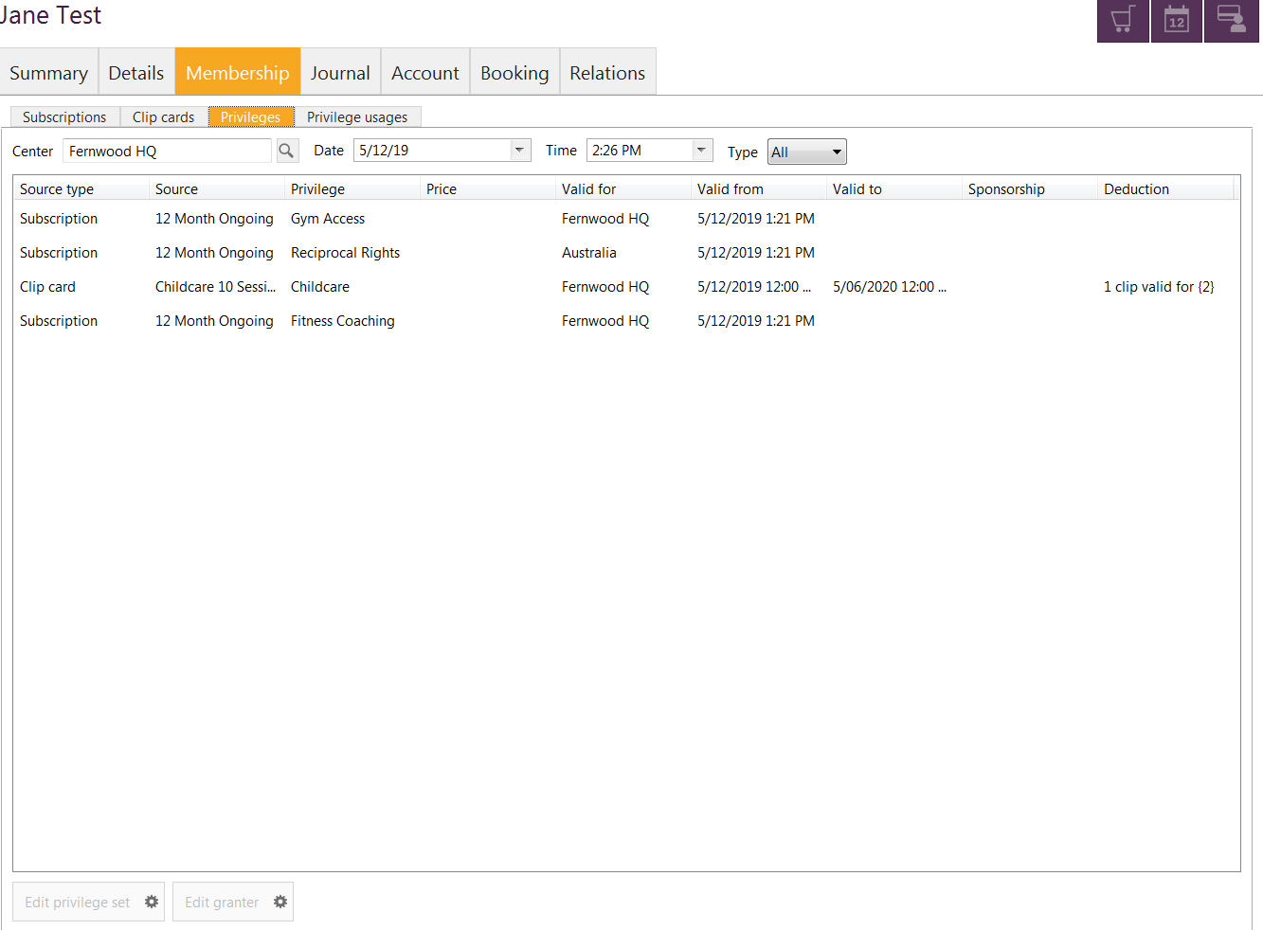

### Journal tab

#### Attend log

This is where all member visits and check ins are recorded.

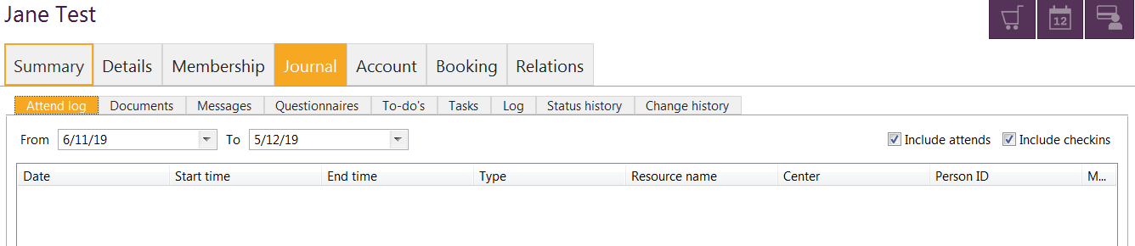

#### Documents

This is where all journal notes and old contact history is stored. You will also find any documentation that has been produced for that member under here in a PDF.

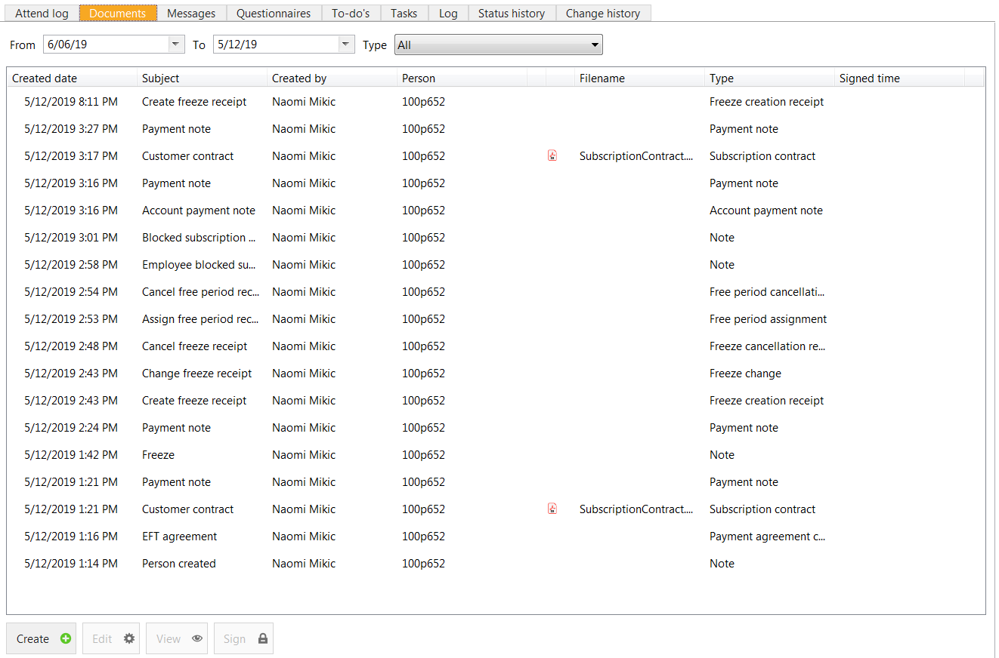

#### Viewing old contact history from FCM

To find any old contact notes that were migrated across from FCM – these can be found under the member’s profile > Journal > Documents.

From this screen you need to manually adjust the date range selected to include any of these migrated contact notes. The subject of the contact notes will be listed as **“Personal Training – Internal Contact” or “Cancellation – Internal Contact” etc.**

To view the details of the contact > select the journal document > click on View.

This will bring up a new window to read the journal note and you can then drag the edge of the note to make it a bit more user friendly to read.

#### 

#### Viewing payment history for members from FCM – Creating a Health Fund Receipt

To review a member’s previous payments and debit history from FCM – this can be found under their profile in Exerp > Journal > Documents > Subject: Member [FCM MEMBER ID] Previous Payments.

1. In the member’s profile > Journal > Documents.
2. Find the subject line Member [FCM MEMBER ID] Previous Payments and select the line and click View.

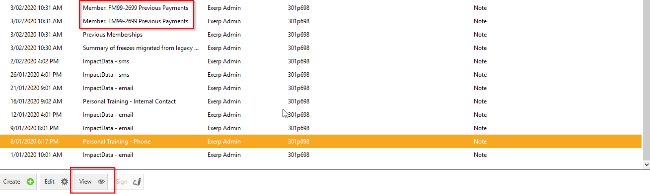

1. This will bring it up in a new window for you, however I would recommend using the arrows to drag the window across for a more user friendly view. This window will give a line item for each debit, whether or not it was successful and the amount that was debited.   
     
   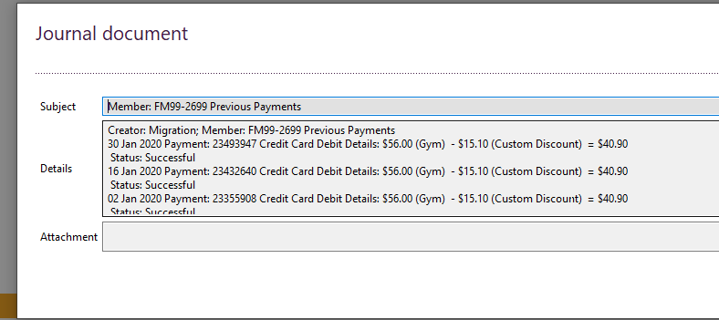
2. From here – if you need to put together a template for a health fund receipt or tax invoice for the member, you can pull the debit information from the journal documents and input the information using the Health Fund Receipt template we have uploaded onto the intranet under the Operations page > Exerp Training Manual.

Messages

This tab will show all messages sent to the member via text or email through Exerp.

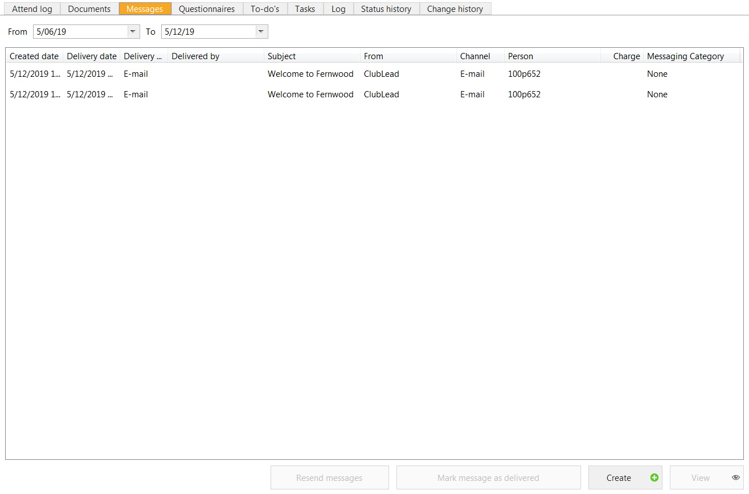

### Pausing Messages in Exerp

If you want to stop the automated communications going out in Exerp when processing a cancellation, freeze, downgrade etc. you can do so by applying Pause Messages.

1. Click on your name in the bottom left corner of Exerp
2. Select Pause Messages
3. Process what you need in Exerp
4. Remember to un-pause the messages afterwards so they start up again for Welcome Emails etc.

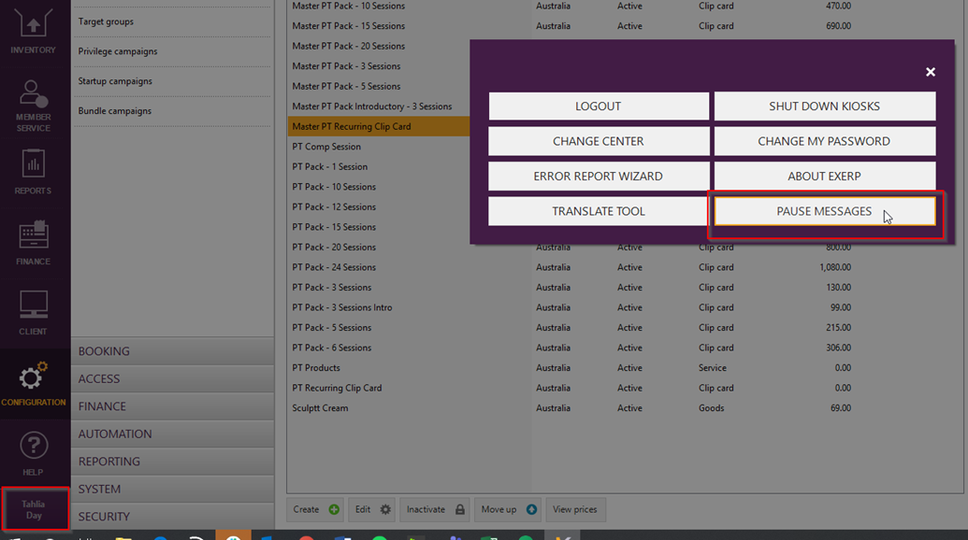

#### Sending a direct email or SMS to a member or lead via Exerp

If you would like to send a customised email to a member via Exerp, you can do this from their Journal > Messages tab.

All emails that get sent from here are in a Fernwood branded email template that will display your club’s details in the signature of the email.

1. Go to the member’s profile in Exerp > Journal tab > Messages
2. Click on Create in the bottom right corner

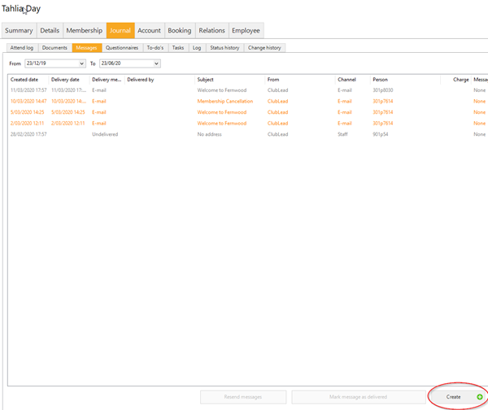

1. Update the channel to Email or SMS
2. Type in your subject line and copy of the email in the Details text box
3. You can click on Preview so you can see exactly what is being sent to the member and how it will be displayed.
4. Once happy click Send.

PLEASE NOTE: The SMS is a charge to the club of $0.07 cents per SMS.

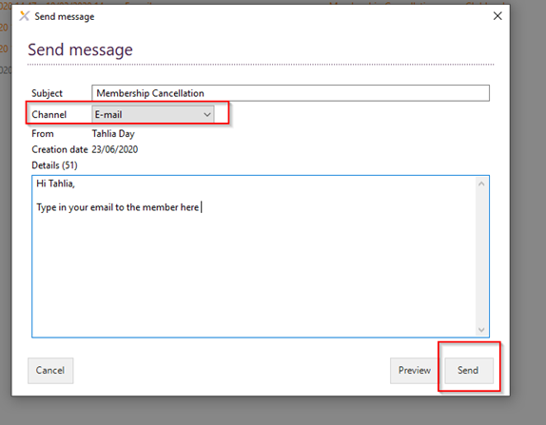

Email format to the member below:

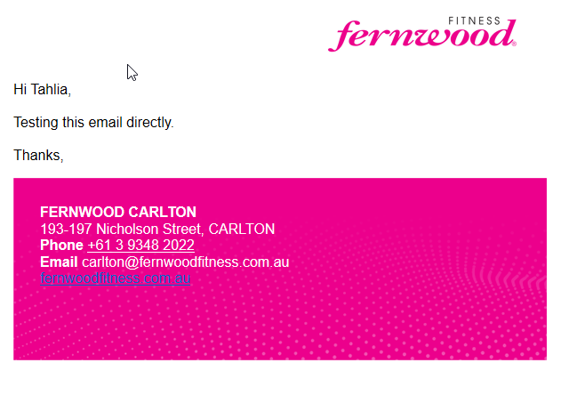

Questionnaires

Exerp has the ability to store questionnaires that could be used for CRM, membership sale or exit interviews when a member cancels their membership.

This is where you can review the answers members have given on their Getting to Know You questionnaires, completed their MyPassport tasks and the Health and Wellness Check-In questions.

Assigning a Health & Wellness Check-In Questionnaire

As part of the new member journey, we have set up a questionnaire in Exerp that you can assign to a member at any time throughout the lifetime of their membership.

1. Go to the member’s profile in Exerp > Journal tab > Questionnaire
2. Click on Create

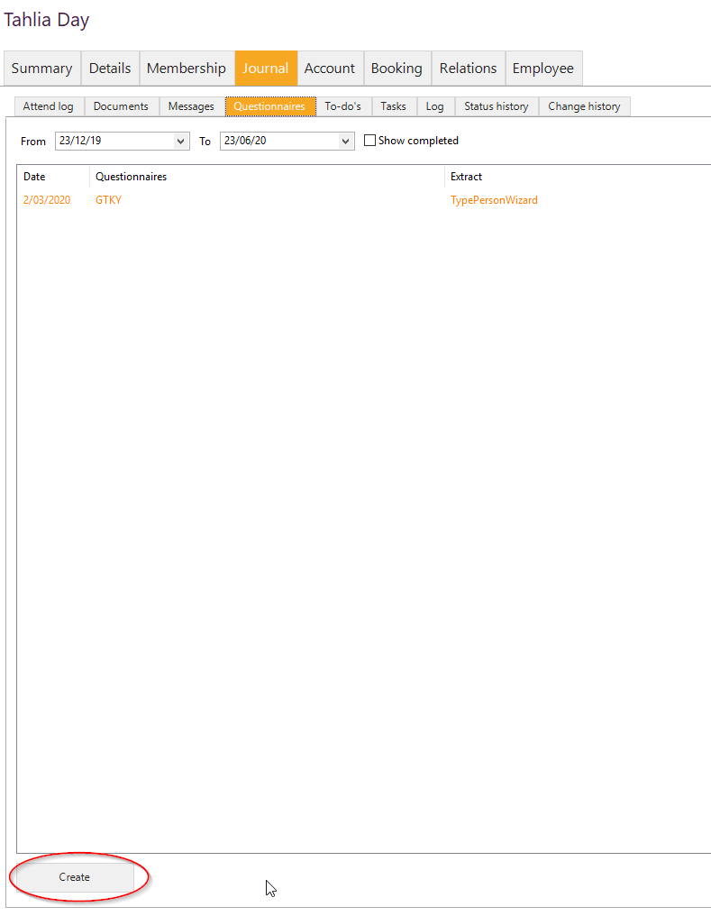

1. Select the Health & Wellness questionnaire that is available > Select OK

#### 

1. This will bring up the Health & Wellness questionnaire that you can use as guidance when talking to the member, but also to complete their answers so it is stored in their profile. You can also use the answers here to report on at a later date.

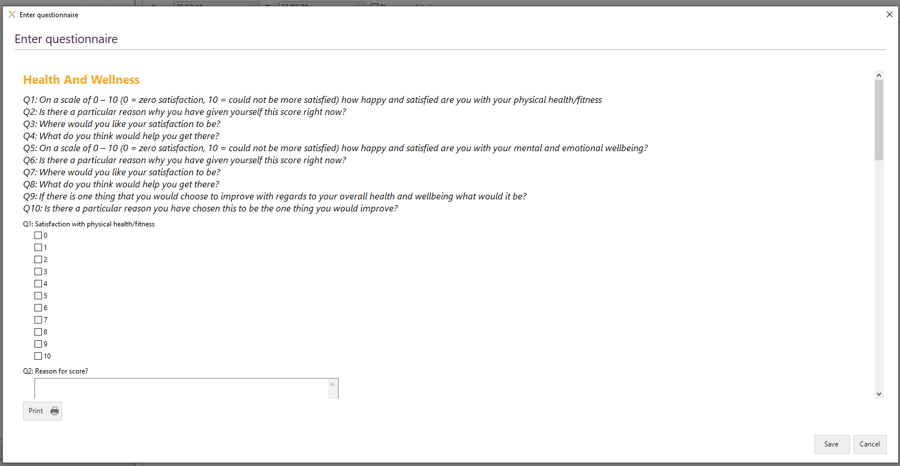

#### Log tab

The log tab shows any changes or updates to a members’ subscription

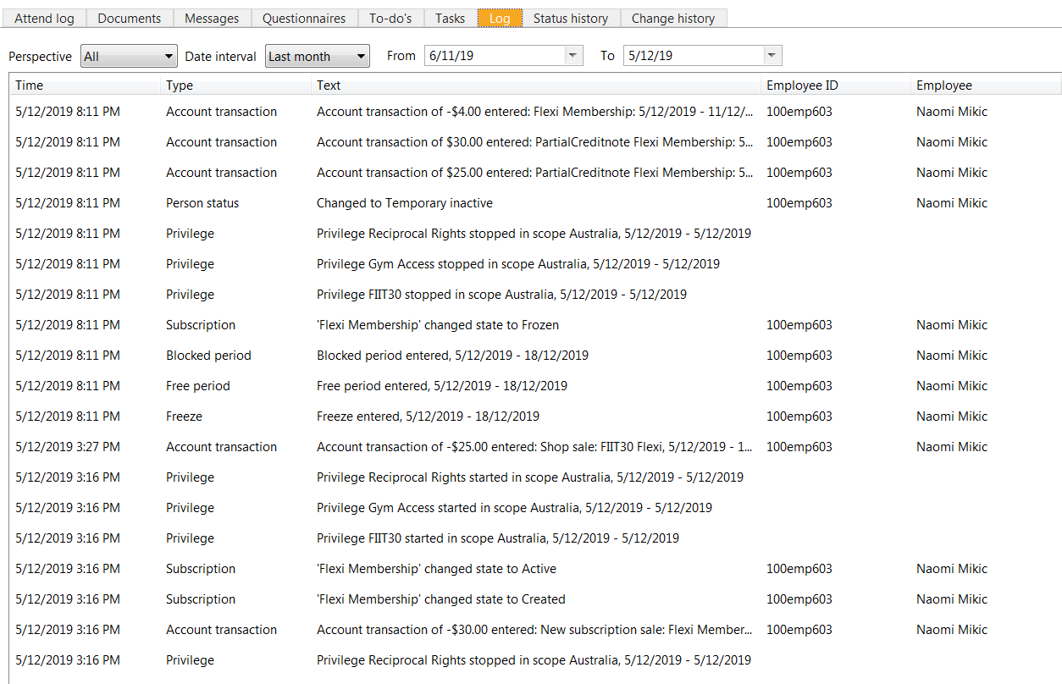

#### Status history

View the status journey of a member. View details on when they moved from a lead to a member and inactive to active.

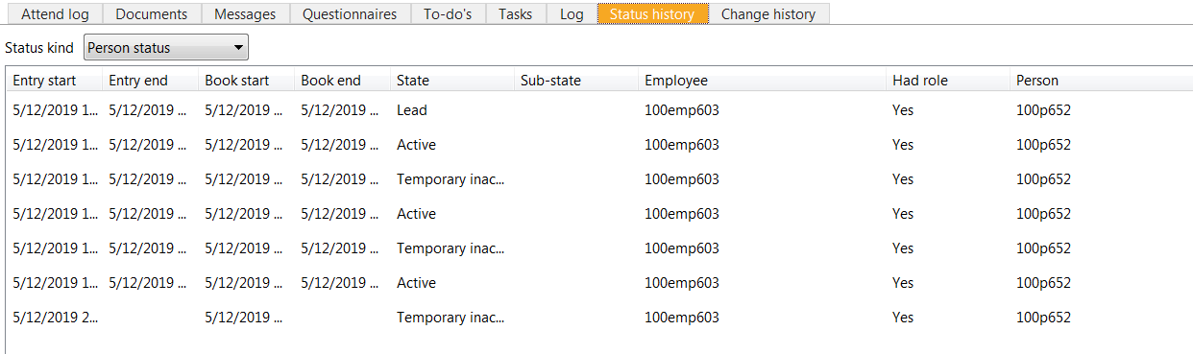

#### Change history

This tab provides a log of all changes to made against a person’s profile, including a dates and full audit history.

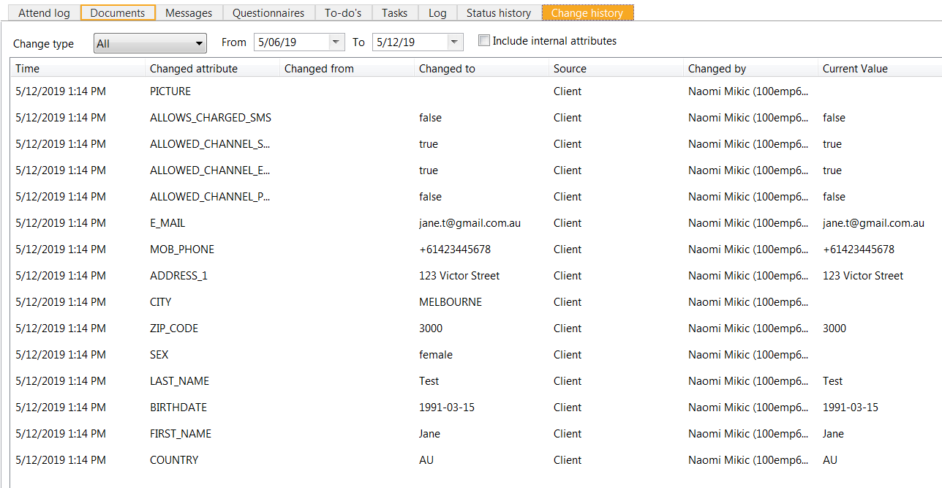

### ***Account Tab***

The account tab shows debit history, date of the next deduction and where you can raise an invoice and/or credit a member’s account.

IMPORTANT REMINDER: When looking at a member’s account you should always select the **View details** box so you can see a full summary of the member’s account balance.

#### View a Member’s Next Direct Debit

Under the account tab of the person’s profile, the Next deduction line will the give the next schedule debit date with the amount.

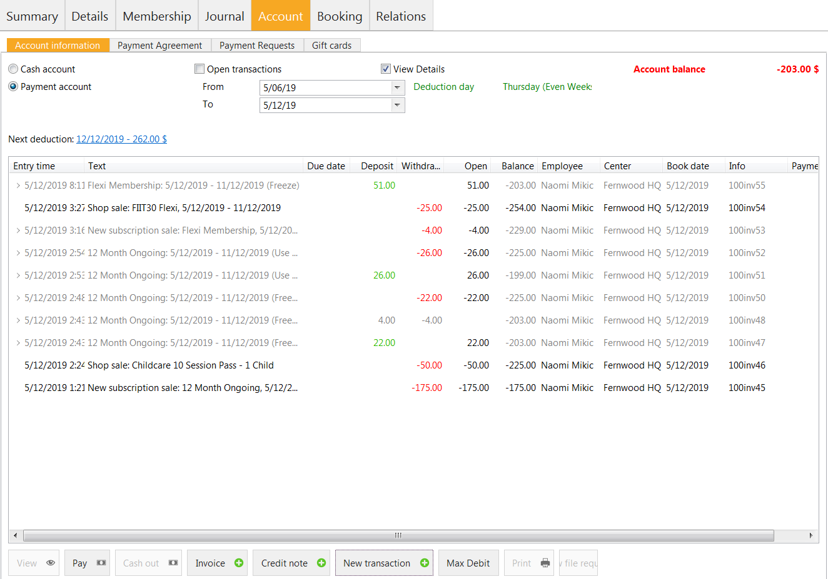

The deduction details screen will pop up to see what the member will be debited for their future payments. If there are no changes to the member’s price, you will just see the one amount and the system will debit that amount each fortnight.

If there is a scheduled price update or credit/invoice applied onto the account it will display here with the date. The image below references this.

The member has a debit for $262.00 on the 12/12/2019 and then the debit after that on the 26/12/19 will be at $110.00 ongoing.

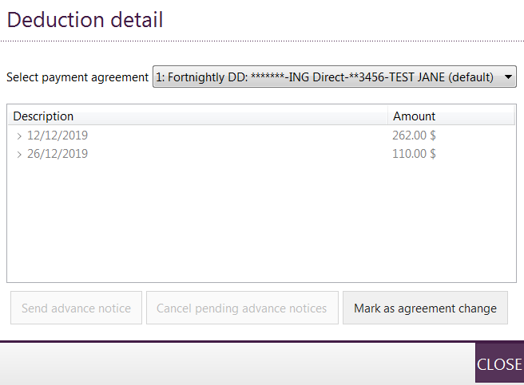

PLEASE NOTE: If there are no changes to a member’s direct debit and there are no upcoming payments that are different to their usual membership amount, it will just display their next payment date with their membership amount. Rather than showing 20 entries of the same amount, it will just show 12 Month Ongoing $48.00.

### Instalment Plan Account

If a member has any items they are paying over an instalment plan i.e. Activation Kit, 5 pack of PT etc. the instalment plan information will display under the **Instalment Plan** account section, not the Payment Account section.

It is important to note here, that any instalment plan amount will not show under **Next Scheduled debit** as this is only looking at their payment account.

The scheduled instalment plan will have all details in the **Instalment plan account** section.

From the screenshot below, you can see that this instalment plan of $130.00 is to split over their next 3 debits as per below.

* 20/08/20 @ $43.33
* 03/09/20 @ $43.33
* 17/09/20 @ $43.34

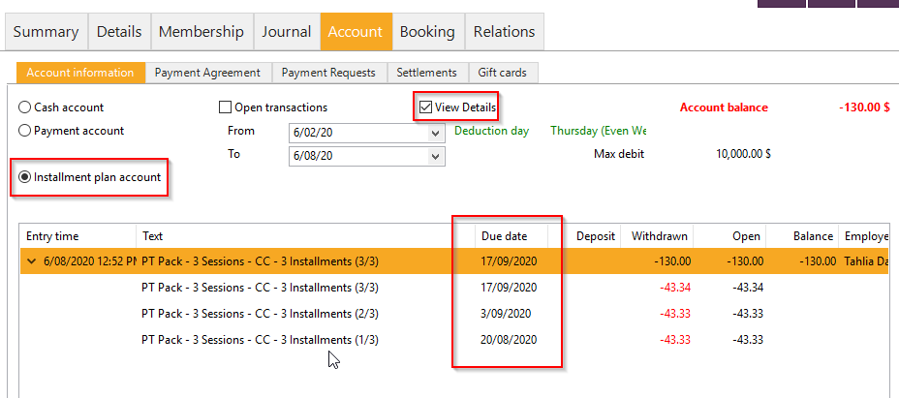

#### How to Raise an Invoice

*Member profile > Account tab > Invoice > Enter Details > Click Add > Search for product and update unit price to the amount you want to charge to a member, Select OK > Choose print options > Next & FINISH.*

1. Open the member’s profile in Exerp, select the Account tab
2. 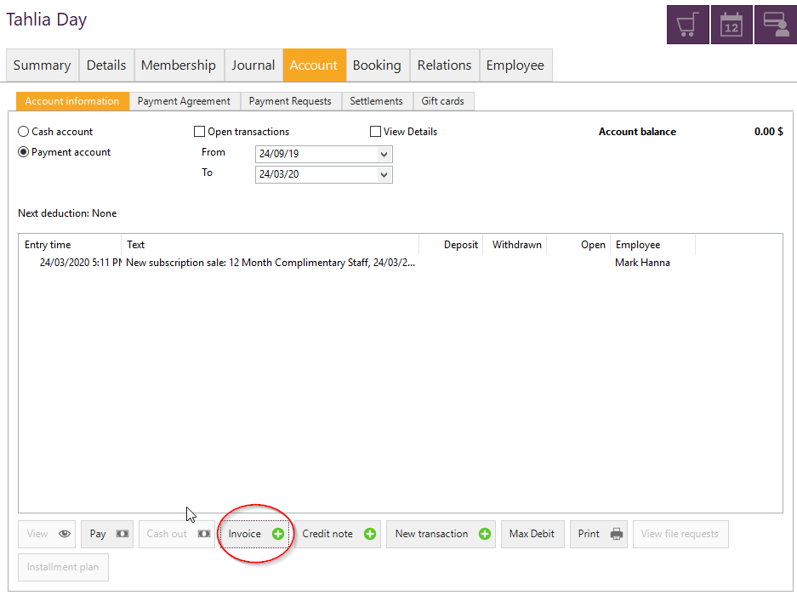Select Invoice

1. In the Text field enter – enter the reference for the invoice being raised >Select the book date (this can just be today’s date) > Check your Centre is correct
2. 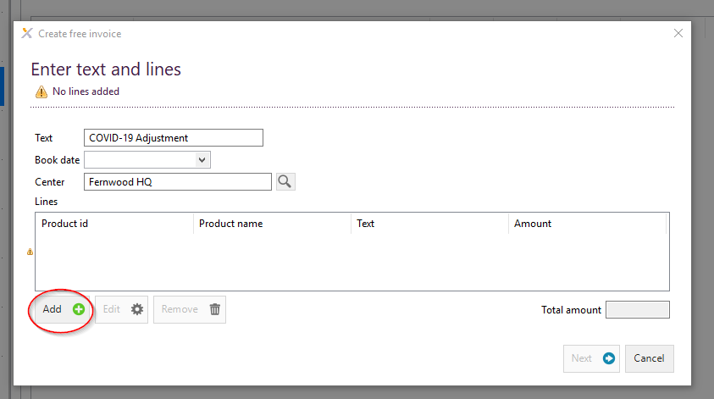Under Lines section > Click Add
3. In the Product field – select Membership Fee
4. 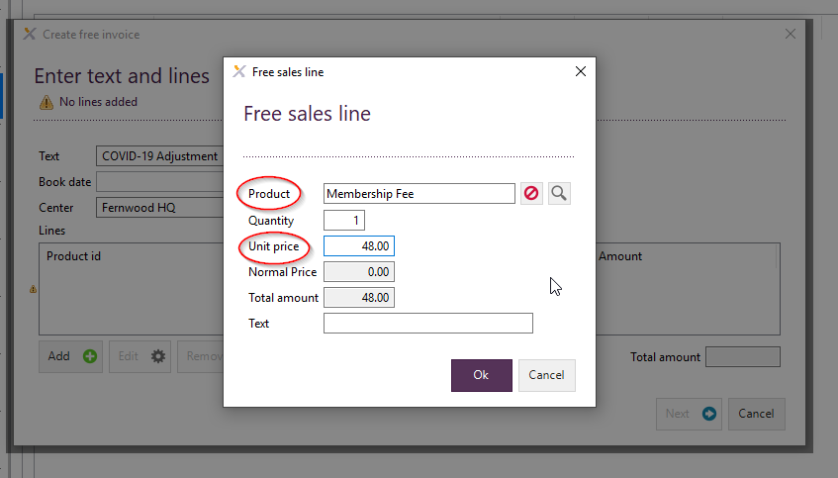Adjust the Unit Price to the applicable amount for that member > Select OK
5. Select Next > Choose Print Option
6. Review and Select Next to complete the invoice.

#### How to Issue a Credit Note

*Member profile > Account tab > Credit Note > Add new credit line > Complete all the necessary details > Select Next > Review Summary > Select Payout option > FINISH.*

1. Open up the member’s profile in Exerp > Select the Account tab
2. Select Credit Note

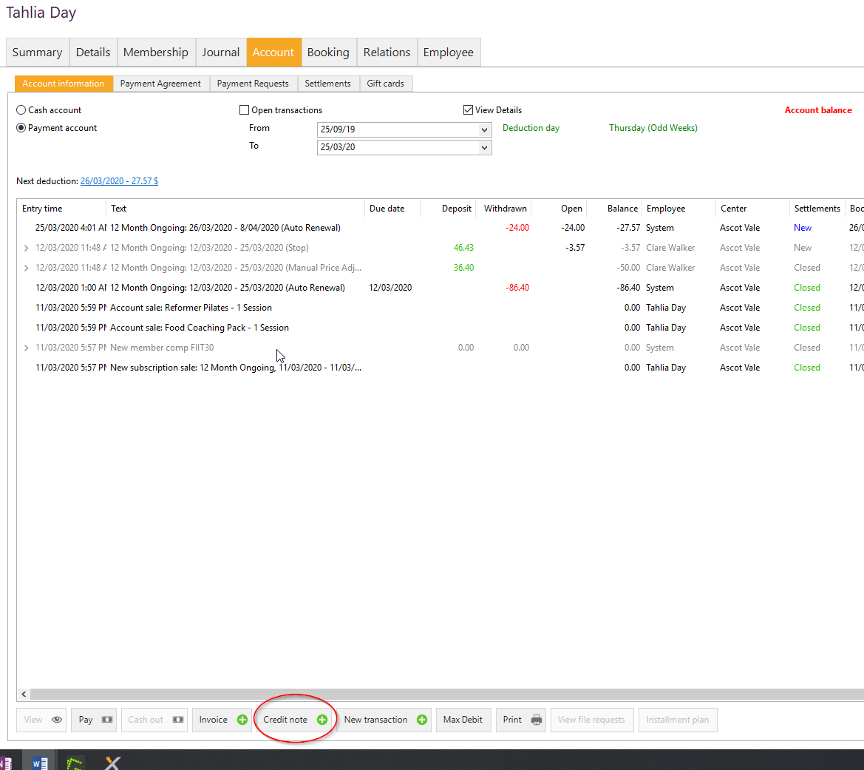

1. It auto-selects ‘Free Credit note’ > Select Next
2. Select New Credit Line
   1. In the Credit Product field type in ‘Membership Fee’ and select
   2. In the Cancel Type field – select ‘Wrong Sale’
   3. Enter the credit amount
   4. In the Credit Line field enter reference i.e. Wrong Sale – refund required
   5. In the Reason field – select the applicable reason
   6. Select OK

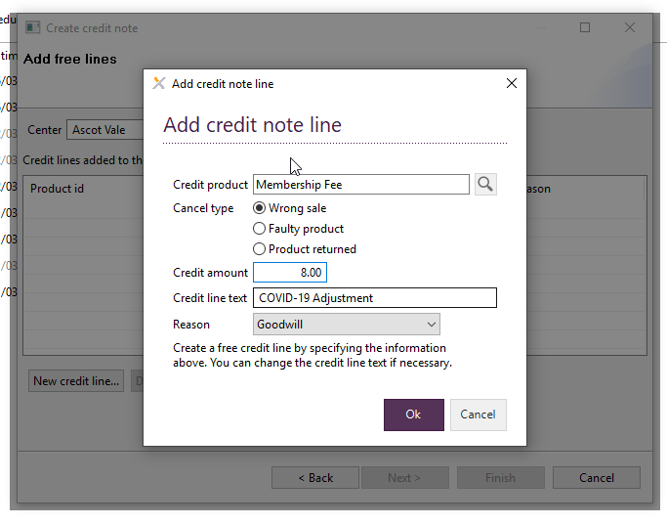

1. Select Next > Update the Header text for reference > Enter the reason for the credit note e.g. Goodwill > Select Next

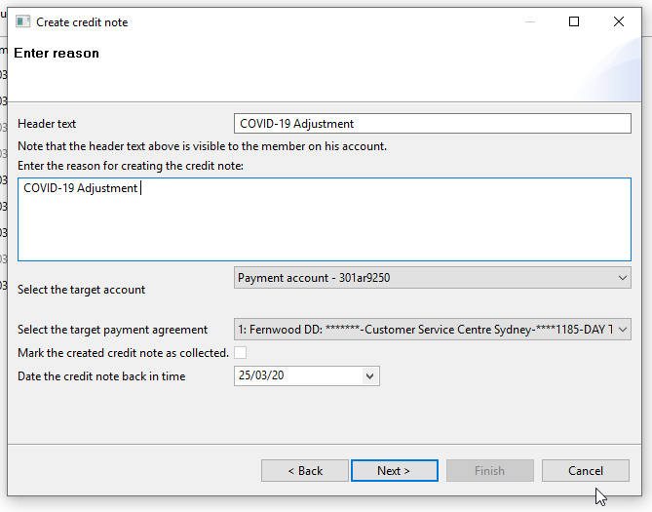

1. Review summary and select Next
2. In the Payout window > Select ‘Leave at customers account’ > Select Finish

#### Payment agreement tab

Gives a summary of how many payment agreements a member has. For example - if a member has two subscriptions set up, one for their membership and one for their personal training sessions they will have two payment agreements displaying in this tab.

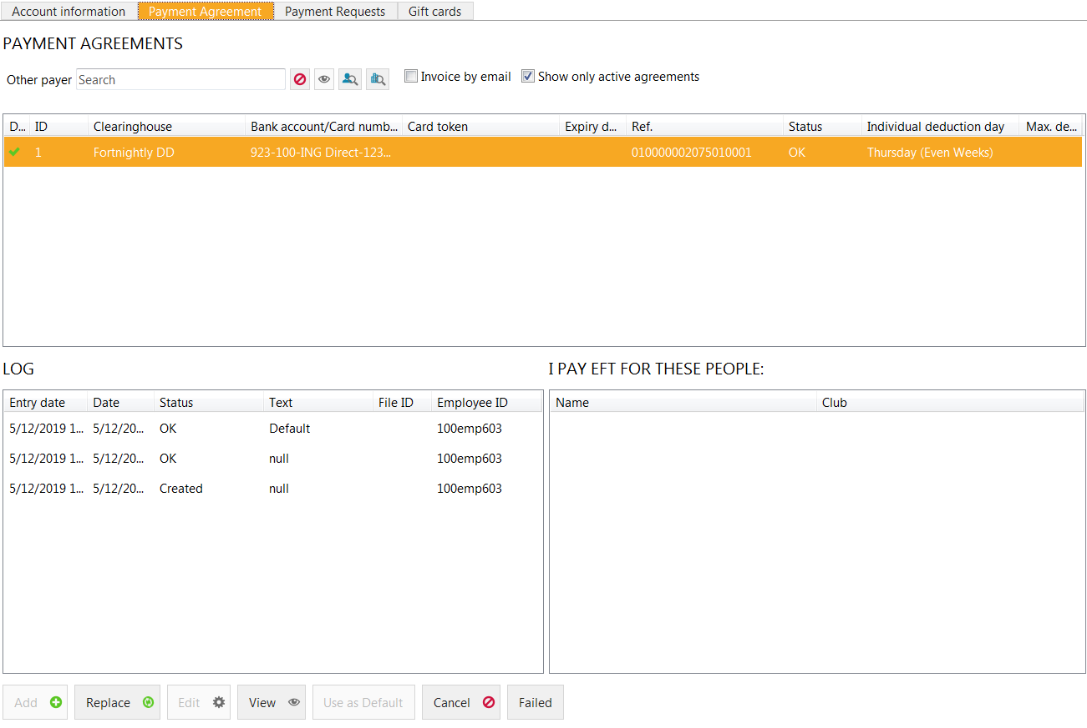

#### Updating a members direct debit details

*Person profile > Account tab > Payment agreement > Replace > Select Bank account or CC details > Complete the details of the new banking details*

1. Search for the member > go to their person profile
2. Click on the Account tab > then click on the Payment Agreement tab > Click on Replace

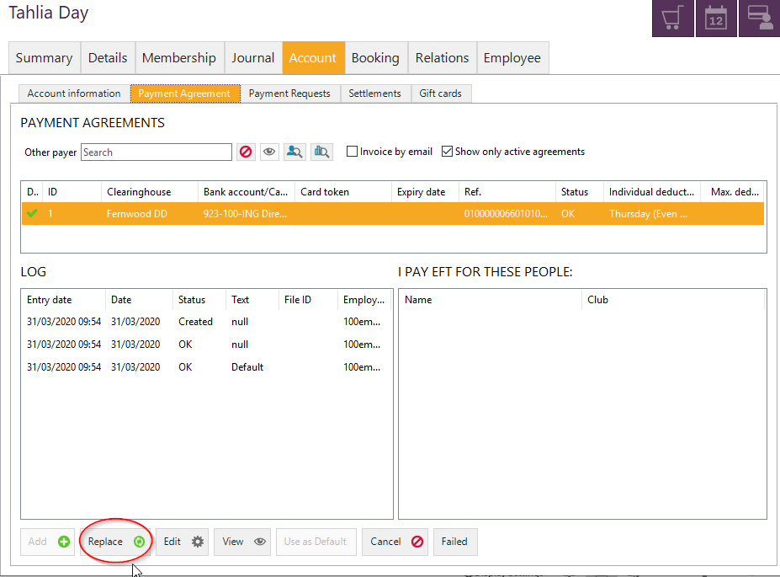

1. The new payment agreement screen will pop up > select either EFT (bank account) or Credit Card depending on which account the member chooses to use and complete the details as required > Select FINISH.

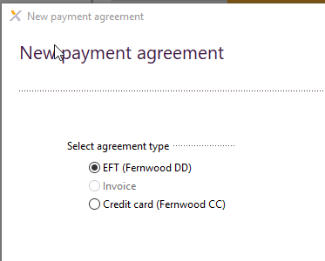

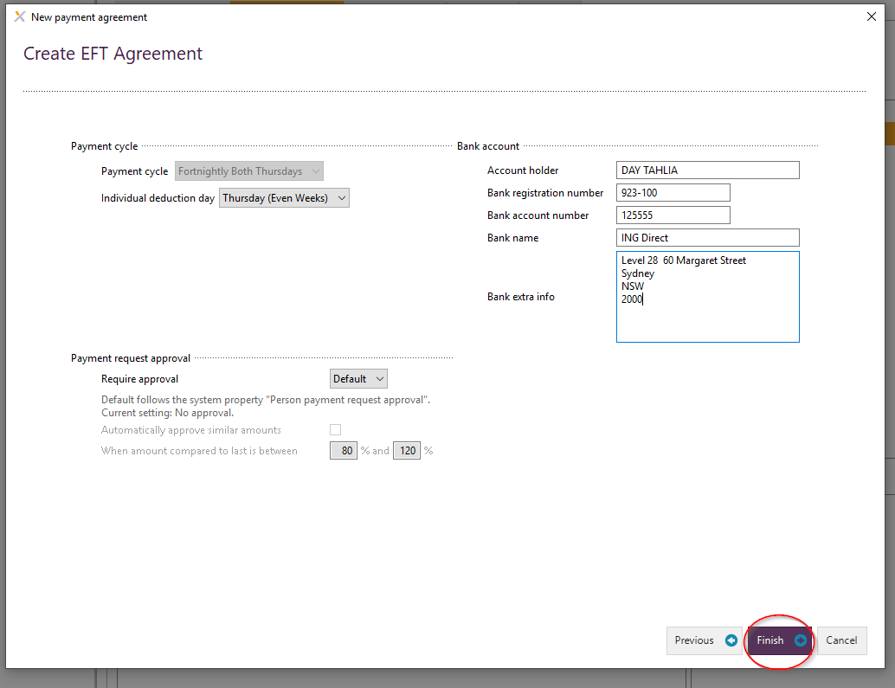

#### Cancelling a payment agreement

**Club Manager Access only**

Simply select the payment agreement you wish to cancel and hit the ‘cancel’ button.

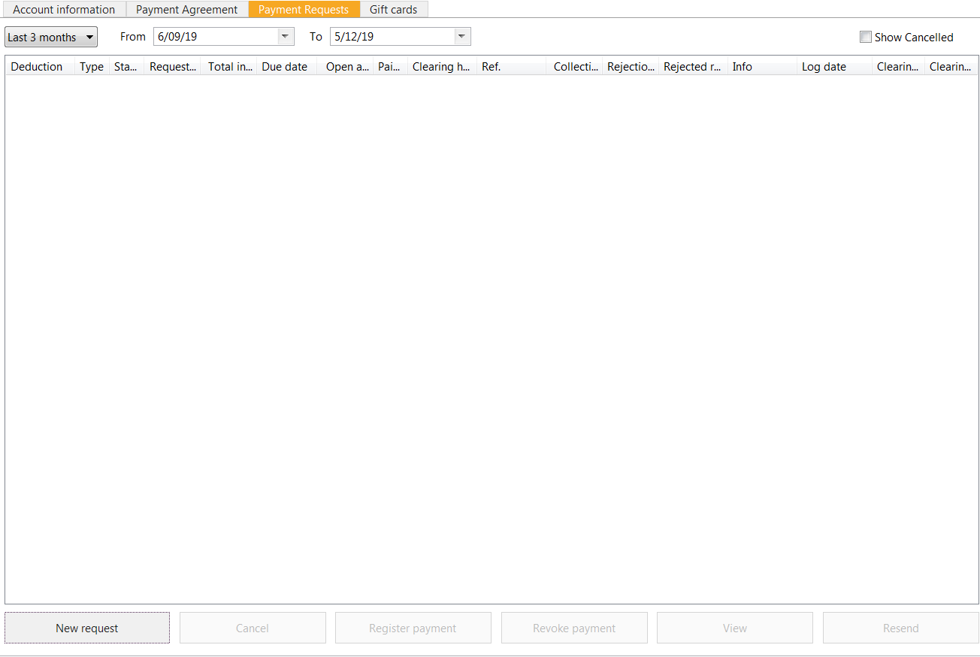

#### Booking tab

##### View Booking History

The booking tab will show a complete booking history of all bookings that have been made under a members’ profile. You can filter by the options below:

* Future bookings
* Old bookings
* Non-showups
* Showups
* Historic bookings
* Review

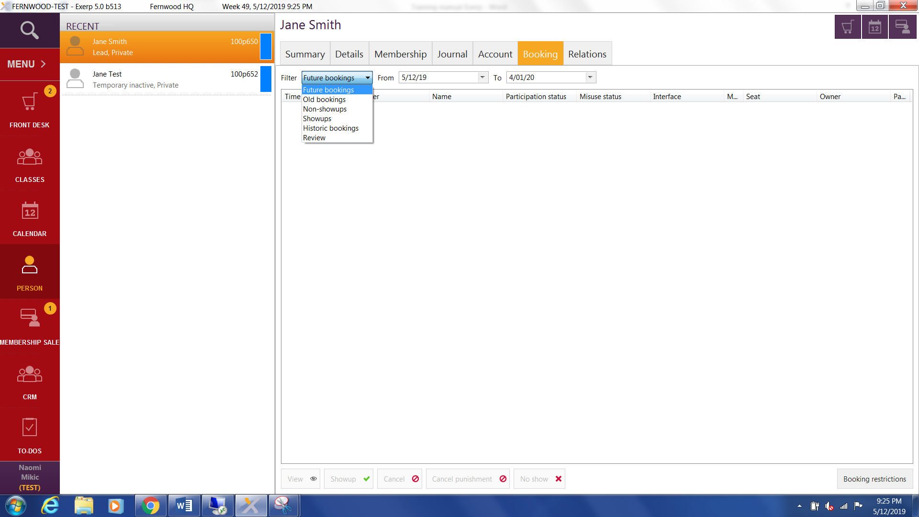

##### Relations tab

This tab will display any history and relations that a member has with another member. Whether they be mother and daughter that joined on a girlfriend membership or if they referred by another member.

Company relations = this will display any corporate relationships (if they are a staff member at one of Fernwood’s corporate partners)

Transferred and duplicate = This will display any relevant information if there was a member to member transfer.

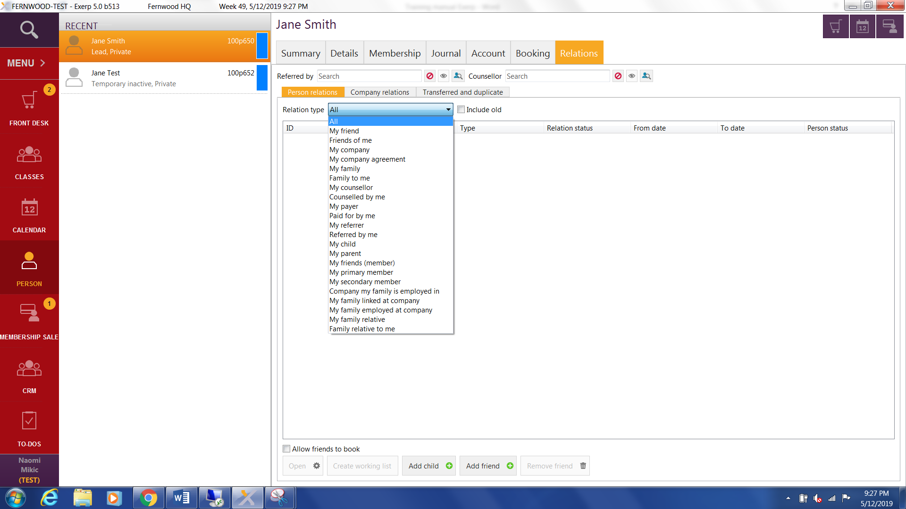

If there is a Fernwood member classified as a minor (under the age of 18) you can also link them to their parent or guardian if they are paying for their subscription. This will also ensure that debt communication for the minor will go directly to their parent/guardian rather than the underage member.

## Staff Profile

### Add a new Staff Member

**Club Manager access only**

*Select Magnifying glass in the top left hand corner of the screen > Add new lead > Enter their personal details > Select person type STAFF > Assign appropriate staff roles and staff groups.*

1. Select the magnifying glass in the top left hand corner of the screen > Select Create lead (refer to page 20 for the full lead process)
2. Enter in the personal details of the staff member
3. On the Relation Window > Select the person type as STAFF. This will give them their employee tab in the person profile.
4. Select finish
5. Once the staff profile is set up, ensure your assign the following:
   1. Staff Login
   2. Staff Roles – this will define their access level in Exerp
   3. Staff Groups – this will ensure they are in pro.mywellness and available for any calendars required.

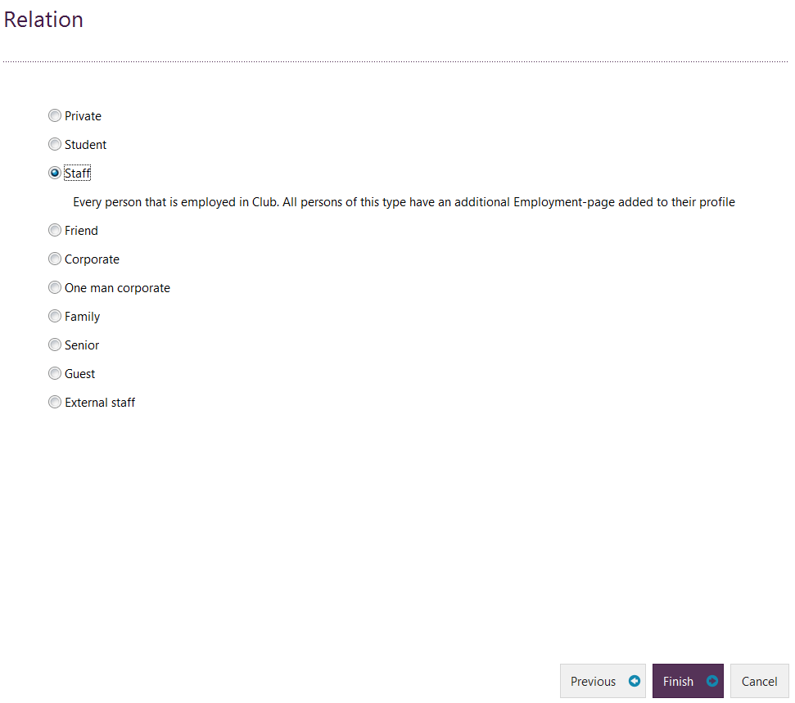

#### Exerp staff log-in

*Person profile > Employee tab > Under the Logins section, select ADD > Select Club (will default to your home club) > Select OK.*

A unique code is then generated for each staff member which is linked to sales transactions, subscriptions, bookings, reporting etc.

1. 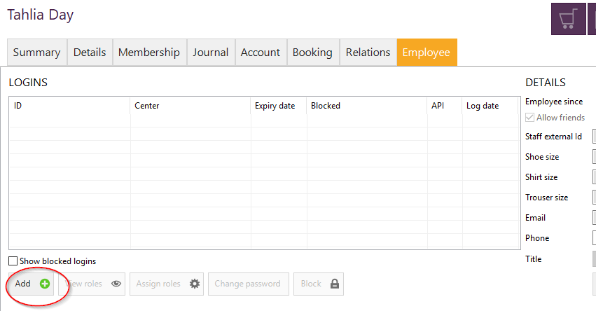In the staff members profile, go to the Employee tab > Under the LOGINS section > Click ADD.
2. 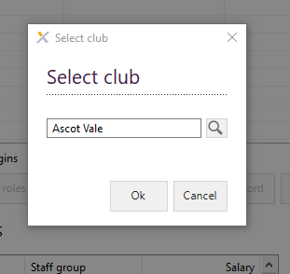Choose the club (this will default to your own club). Select OK.

1. Once you have created the login – ensure you reset the password so they can log in easily for the first time. We recommend updating this Fernwood1.   
   The first time the staff member logs into Exerp they will be prompted to reset their password and create their own.

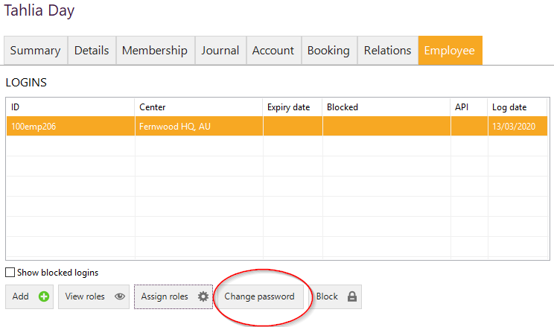

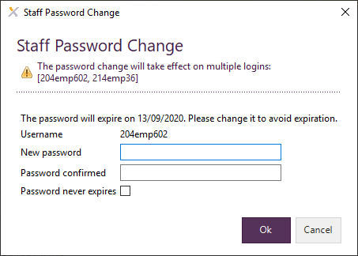

This will generate their staff login credentials for Exerp. A staff member can use the below 3 options when logging in to Exerp.

1. Email
2. Full Exerp ID e.g. 100emp206
3. Last 3 digits of their Exerp ID e.g. 206

#### Add staff roles

*Search for staff member in the system > Open up their person profile > Employee Tab > Assign Roles*

1. Search staff member by clicking on the magnifying search glass in the top left hand corner of the menu bar.



1. Type in member name or last 3 digits of their ID number to find staff member.
2. Click on the employee tab in staff members’ profile

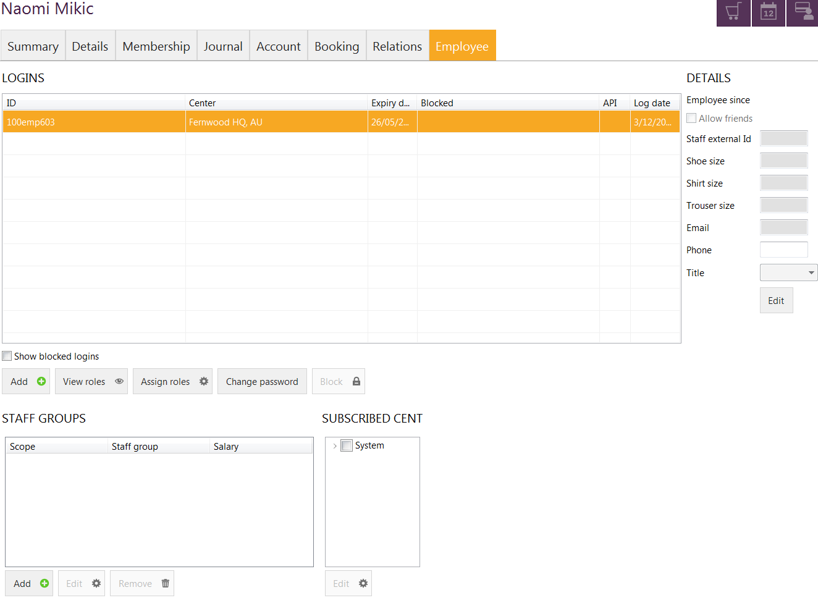

1. Click on the assign roles button
2. Select the appropriate role for the staff member to add it to their profile.

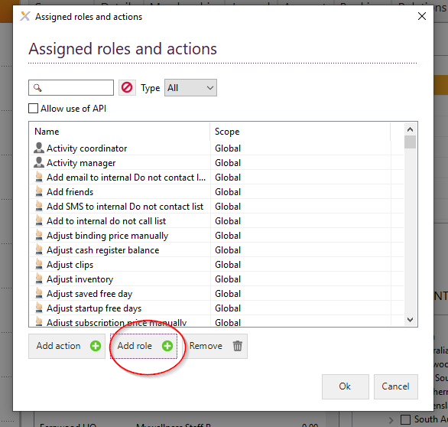

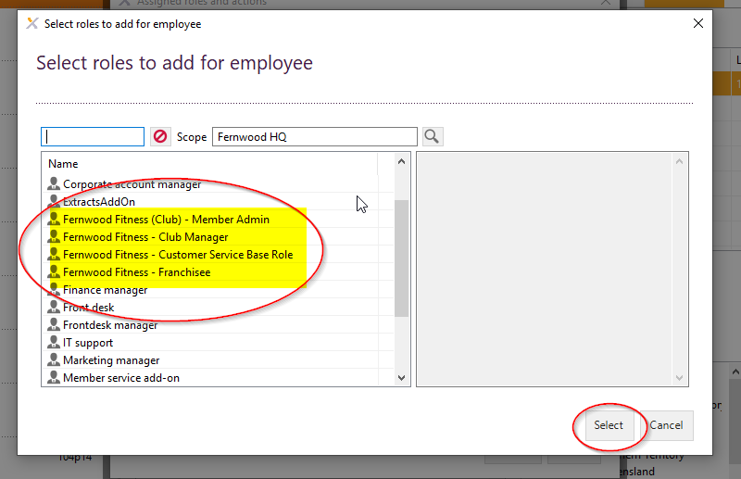

Each role in Exerp will have a different level of permission and certain actions they will be able to perform in Exerp. For example override access for certain processes will only be available for the Club Manager role.

The four roles we have set up in Exerp equate to the following:

**Fernwood Fitness Customer Service Restricted Role:**

* Restricted access in the system
* Can process basic tasks in Exerp such as process items through the front desk, updated personal details and process bookings

**Fernwood Fitness Customer Service Role:**

* Access to do all basic processing in club through the front desk, process membership sales, manage bookings in the calendars.
* Process basic admin tasks such as freezes & cancellations

**Fernwood Fitness (club) Member Admin Role:**

* Access to do all basic processing in club through the front desk, process membership sales, manage bookings in the calendars.
* This role includes pricing override access to things like membership pricing, joining fee, freeze and cancellation fees etc.

**Fernwood Fitness Club Manager:**

* Access to do all processing in club through the front desk, process membership sales, manage bookings in the calendars.
* This role includes pricing override access to things like membership pricing, joining fee, freeze and cancellation fees etc.
* This role includes access to all required reports for Club Manager role

**Fernwood Fitness Franchisee:**

* Access to do all processing in club through the front desk, process membership sales, manage bookings in the calendars.
* This role includes pricing override access to things like membership pricing, joining fee, freeze and cancellation fees etc.
* This role includes access to all required reports for the Franchisee role

#### Add a staff group

*Search for staff member in the system OR create a new staff (lead) > Employee Tab > Staff Groups > Add > Select the staff group(s) relevant to that staff member.*

IMPORTANT: You will need to set this up for every staff member in Exerp so that they can be linked to any bookings and calendars in Exerp and pro.mywellness. i.e. Fitness Coach Staff Group needs to be assigned to all Fitness Coaches and Membership Consultant staff group be assigned to all Membership Consultants so they can assigned Sales shifts and availability.

1. Find the staff member’s profile in Exerp > go to their Employee tab > Click Add underneath the Staff Group heading

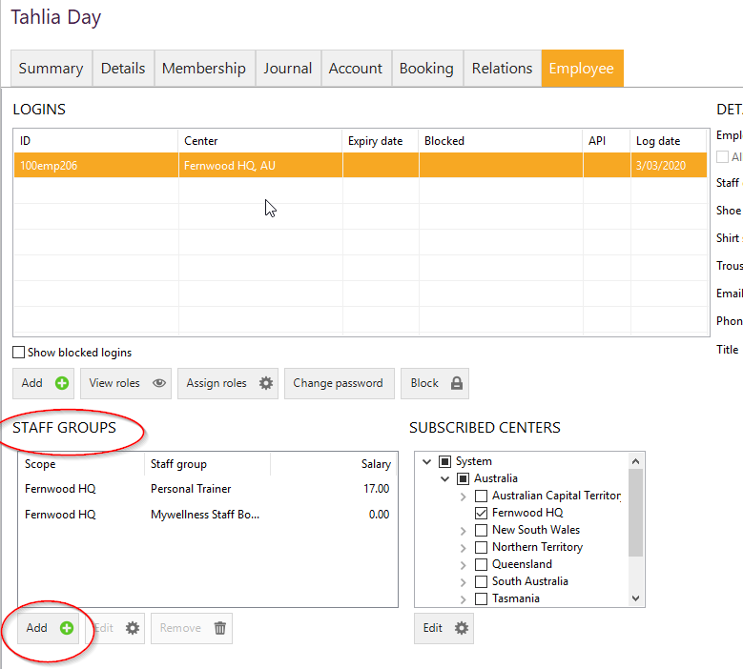

1. 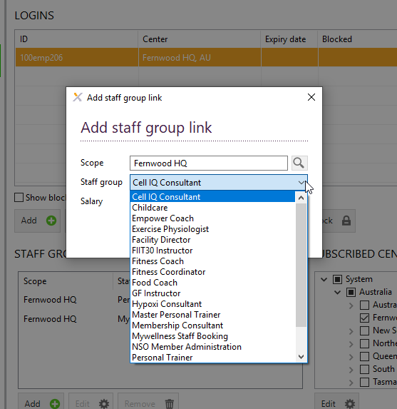Choose the relevant staff role (group) for that staff member from the drop down displayed > click SAVE

### Staff Mapping from Exerp to Pro.Mywellness

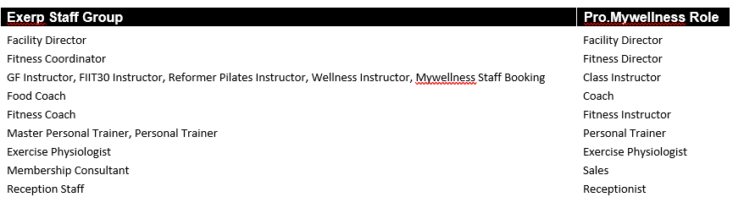

**Setting up Staff in Pro.mywellness**

To set a staff member up in pro.mywellness, they will need to be set up as a staff member in Exerp first. Once they are set up in Exerp, it is **crucial** that you assign all staff members the **Mywellness Booking** Staff Group in Exerp so that they are pushed through to pro.mywellness as well.

By assigning this staff group it sets them up in pro.mywellness with a matching profile.

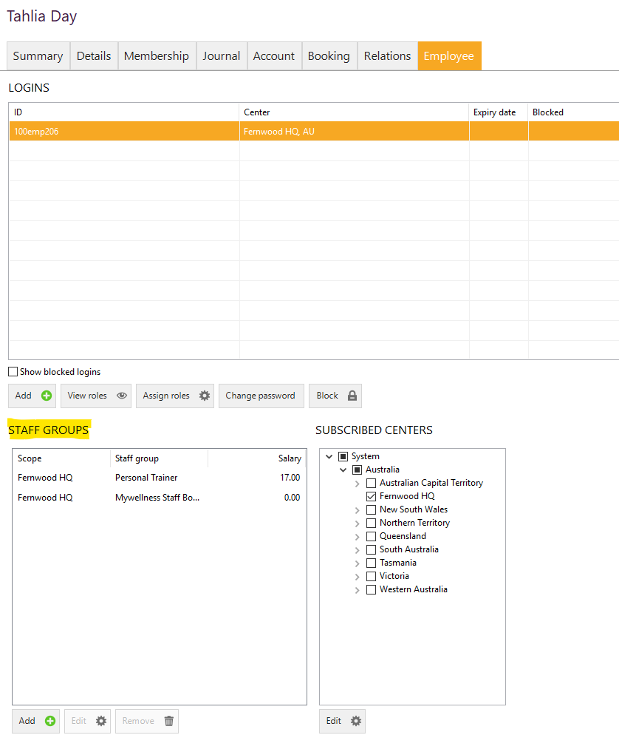

### How to change a staff members’ password

**Club Manager access only**

1. Click on employee tab under the staff profile



1. Click on change password tab to update password
2. Enter in new password details and click on OK to finish



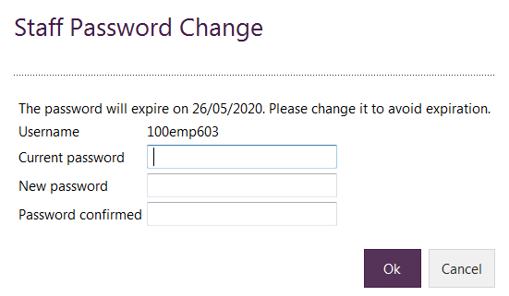

### Staff uniform details

You can keep a record of staff uniform sizes under the employee tab of each individual staff member. Search the staff member, click on the employee tab under their name and enter in uniform details on the right had side of the screen

### Staff discounts

Fernwood National Support Office has set up the standard 30% discount code for all staff members in every club. Every purchase that gets processed through the Front Desk (includes all services) will automatically apply the 30% staff discount to the sale.

## Removing Staff Members from Pro.Mywellness and Exerp

When we have a staff member leave the club, as best practice we want to remove all of their calendars/availabilities and access to both pro.mywellness and Exerp. To remove a staff member follow the steps below:

1. If they are a Personal Trainer or Fitness Coach, ensure you remove all future bookings and availability from pro.mywellness.
2. Once availability has been removed, go into their Exerp profile and remove the following:
   1. Block their Exerp login
   2. Remove all of their staff groups so they do not display on the calendars (see image below for reference)
3. Delete their staff profile in Pro.mywellness > Contacts > Staff

Once you have complete the above, the staff member will no longer have login access to either pro.mywellness or Exerp and they will no longer display in any of the calendars.

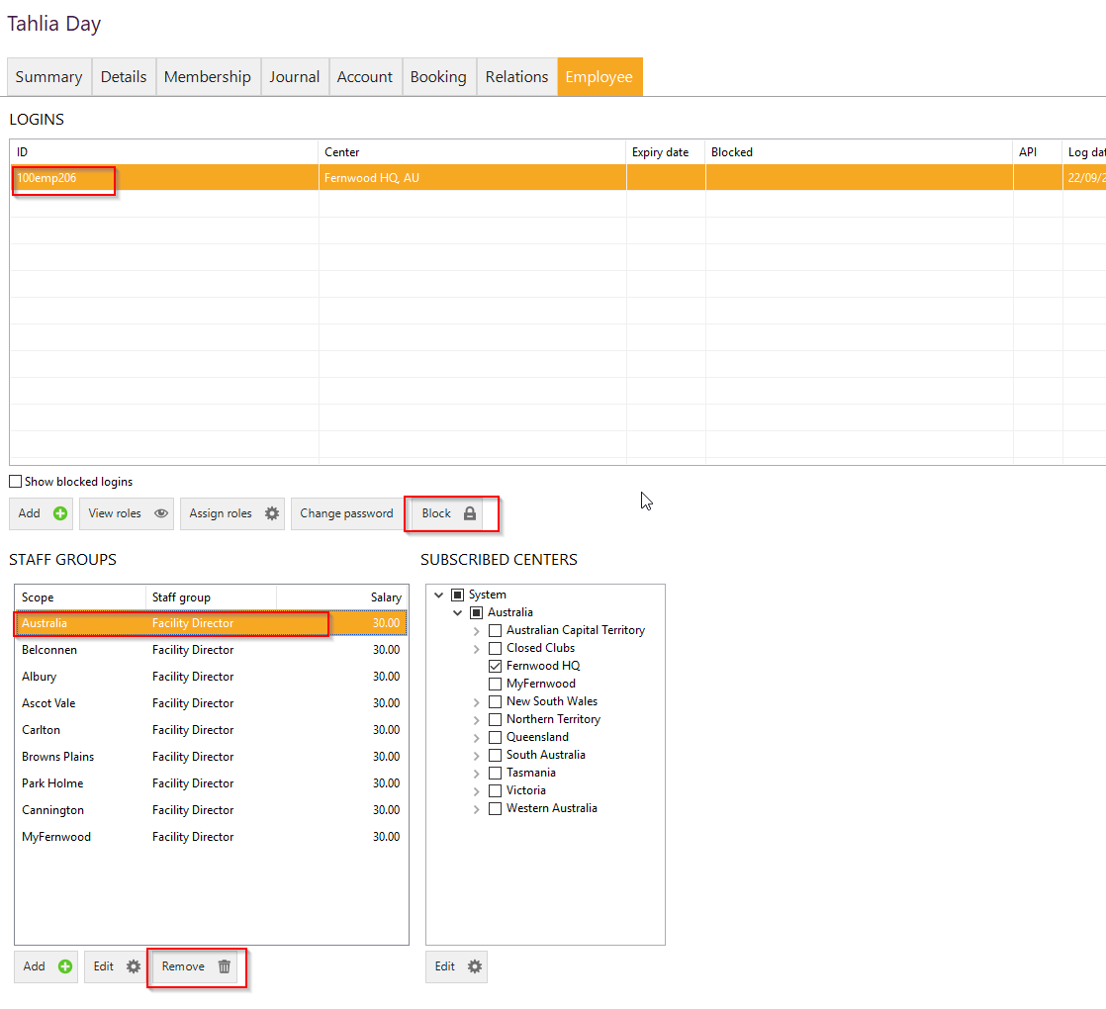

# Cash Register App

## Open Cash Register - Start of Day Process

*Cash Register App > Open Cash Register > Enter the float amount > Check for any differences > FINISH*

1. Click on menu tab in the top left hand side of the screen and click on ‘Cash register’ app
2. Click on ‘Open cash register’ button in the bottom left hand side of the cash register screen



1. Enter in all notes and coins for the float amount (2 x $10 notes – put the number 2 under $10 note etc). Select ‘Next’ to continue.

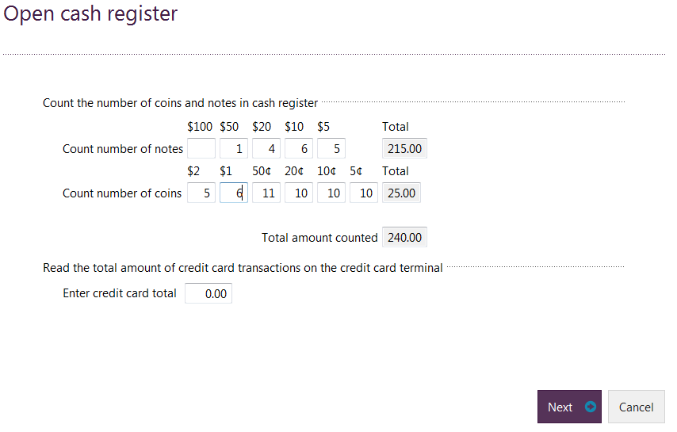

1. Confirm the next screen by clicking on ‘Finish’. Please note that if the float amount entered is different from set float amount in system, you will need to type in a reason or return to the previous screen to re-enter correct data.

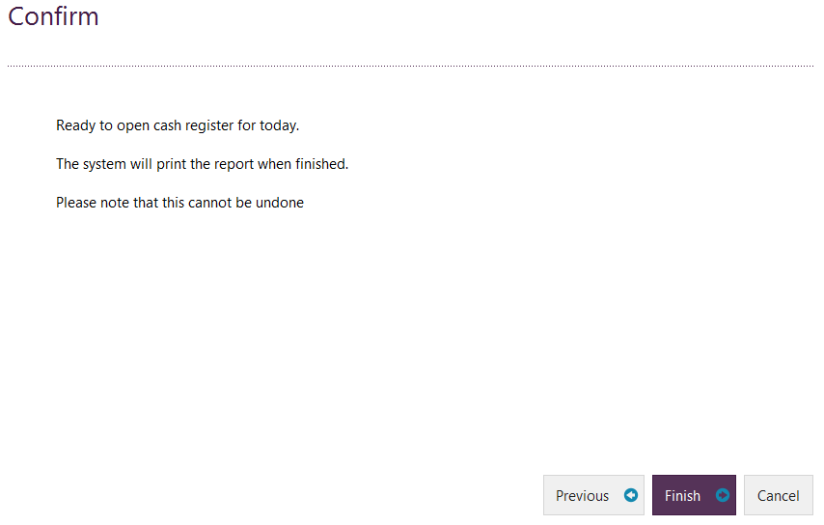

## Close Cash register - End of day process

*Cash Register App > Close Cash Register > Enter the cash amount found in the register > Reconcile EFTPOS > Check for any differences > Confirm Bank Transfer amount > FINISH*

1. Click on menu tab in the top left hand side of the screen and click on ‘Cash register’ app



1. 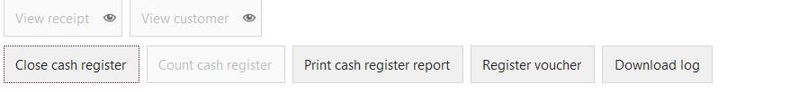Select close cash register in the bottom left hand side of the screen
2. Enter in all cash amounts that you have on hand as well as EFT total transaction amount (taken from your EFT machine totals). Click on ‘Next’ to continue.

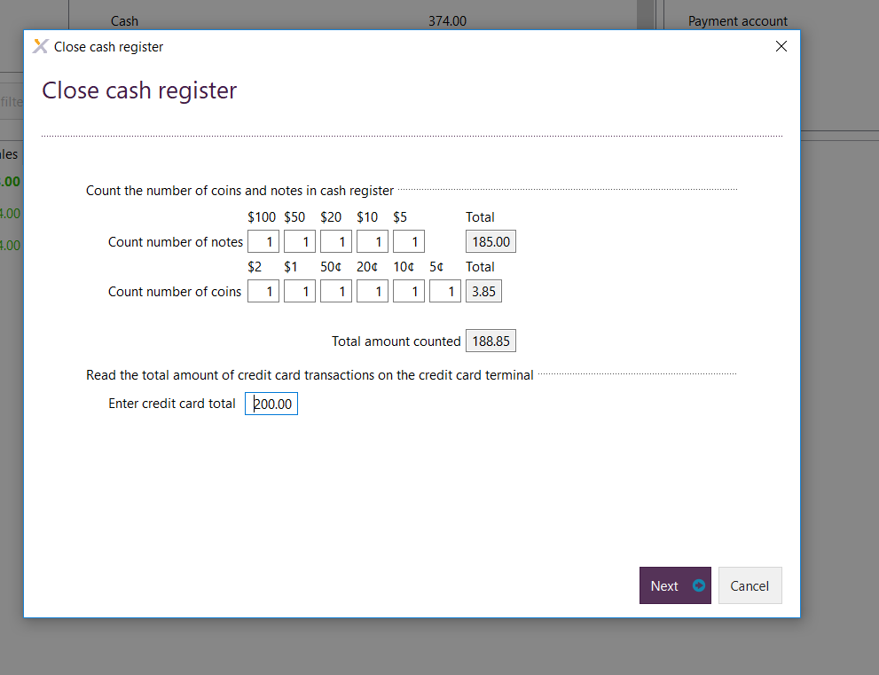

1. ***Cash difference screen*** will then appear which will explain any differences in the cash register (if any) and ask for a reason. Click on next.



1. **Cash Transfer** screen will appear. Fill in the fields of what is physically being banked for day. This will give you a balance of what is left in the register which should be your float for the next day. Click next & Confirm.
2. 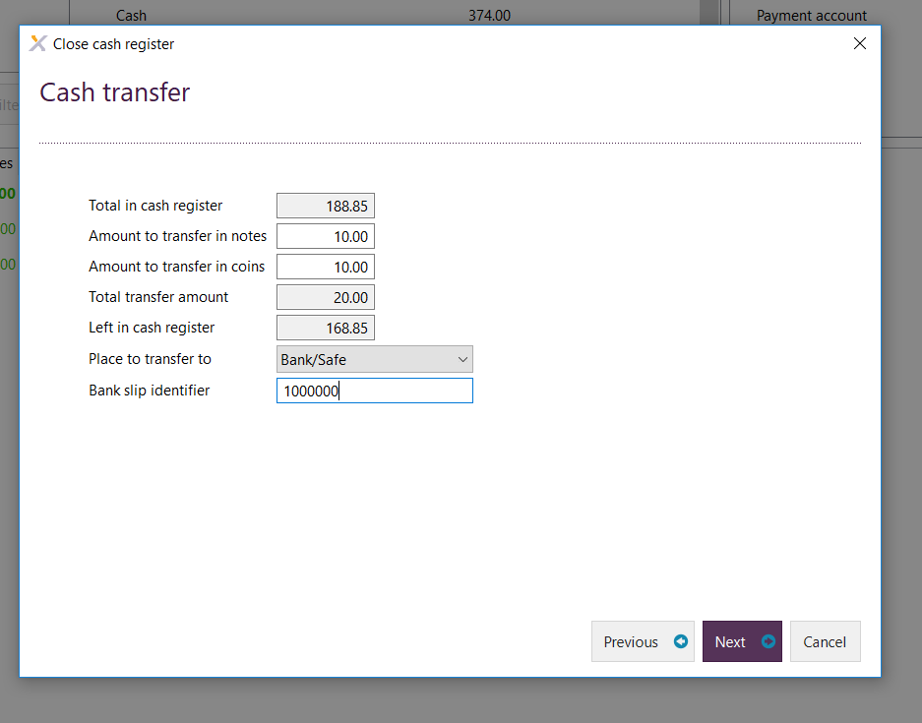**Bank slip identifier:** Enter your bank slip reference number from your bank deposit book (if applicable) in this field. This will allow you to search and see who processed this end of day and if there are any discrepancies.

## Count Cash Register

*Cash Register App > Count Cash Register > Enter the float amount > Check for any differences > FINISH*

Count Cash Register should be used when balancing cash register between shifts and before closing the cash register at the end of the day.

1. Click on the ‘Menu’ button on the top left hand side of the screen and select ‘Cash register app’



1. Now click on ‘Count cash register’ button in the bottom left hand side of the screen



1. Enter in all notes, coins and EFT totals. Select ‘Next’ to continue if all totals balance

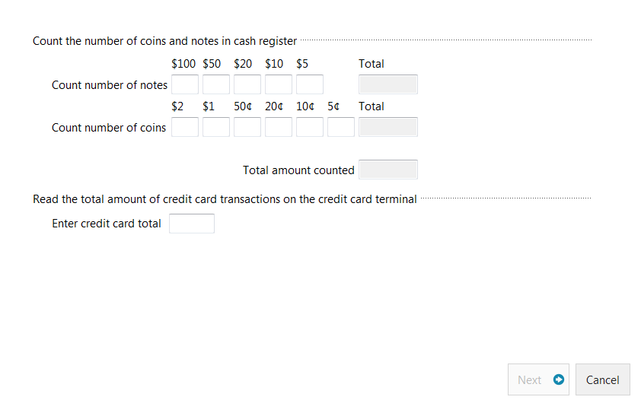

1. On the next screen you will be asked to enter a reason in if there is a difference with what was registered and what was counted. Enter in reason and click on ‘Next’ to proceed.

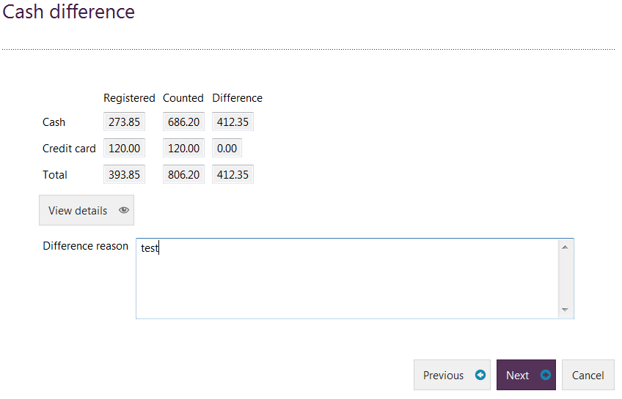

1. The next screen will you ask you to confirm the figures. Click on ‘Finish’ if you are happy with what you have entered.

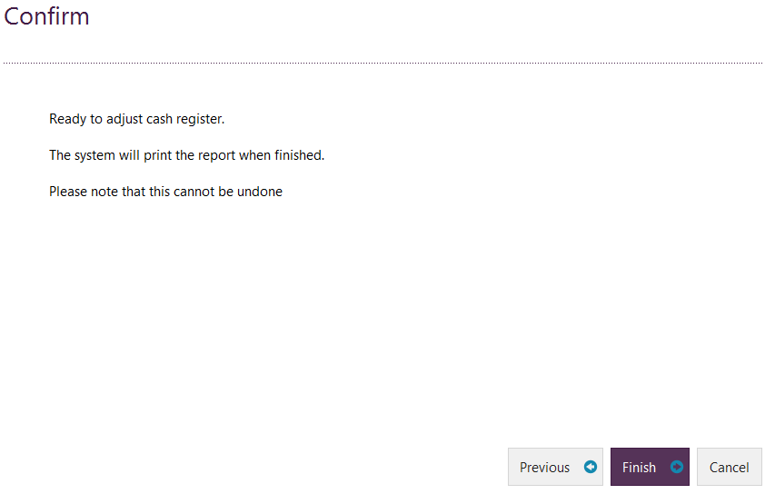

## *How to export all sales for the day (including break-down of transactions) into an Excel spreadsheet*

You can pull a report straight into Excel for all of your transactions made in a day or cash register session.

1. Go into the Cash Register App in Exerp
2. Check the dates of you cash register session to make sure it is accurate for what you are looking for
3. Right click on the data and choose Save to Excel

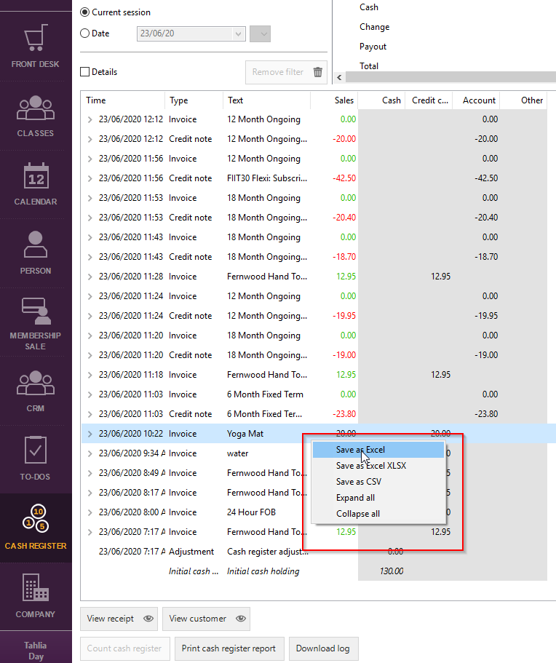

1. Once you have pulled it into Excel, you notice 2 tabs along the bottom of the spreadsheet
   1. **Transactions:** Will give you summary of the transaction that was made against the member (usually their first line item), how much the total sale was and whether their paid by cash, credit card (EFTPOS), payment account (adjustment made to their account such as a freeze) or if it’s been added to their instalment plan account.
   2. **Transaction lines:** This break down each item that was put through on the transaction and how much it cost e.g. 1 x Yoga Mat, 1 x 12 Month Membership Ongoing. It will also include the staff member and member.   
      PLEASE NOTE: VAT refers to GST. I would recommend hiding these columns.

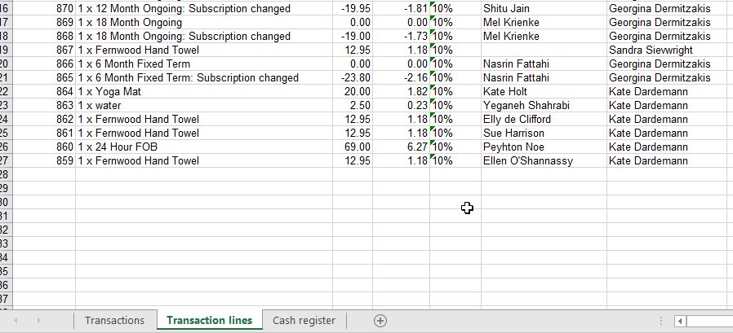

# Planning App

## Opening a shift time

*Planning App > Create Booking > Select Activity > Choose the working date and time > Select staff member > Define the recurrence > Review booking summary > FINISH*

1. 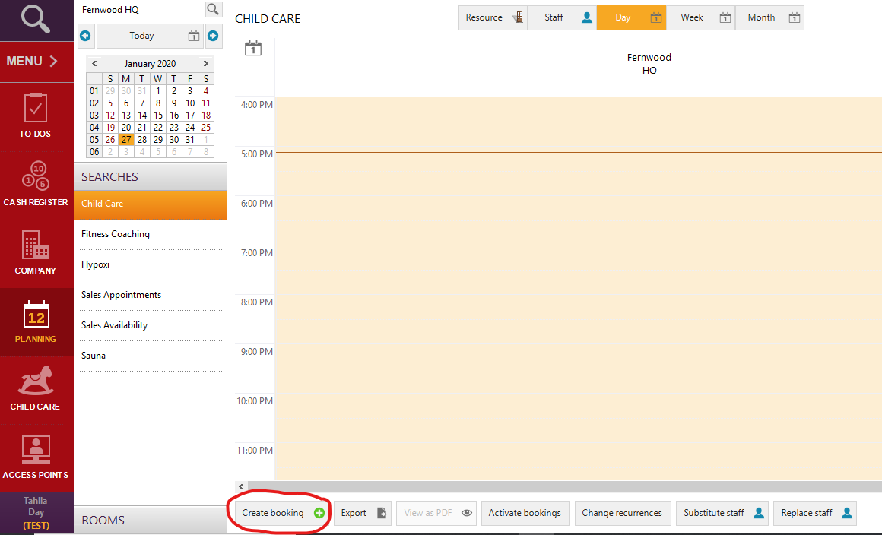Open the Planning App and click ‘Create Booking’
2. Select the activity you are wanting to open a working time for

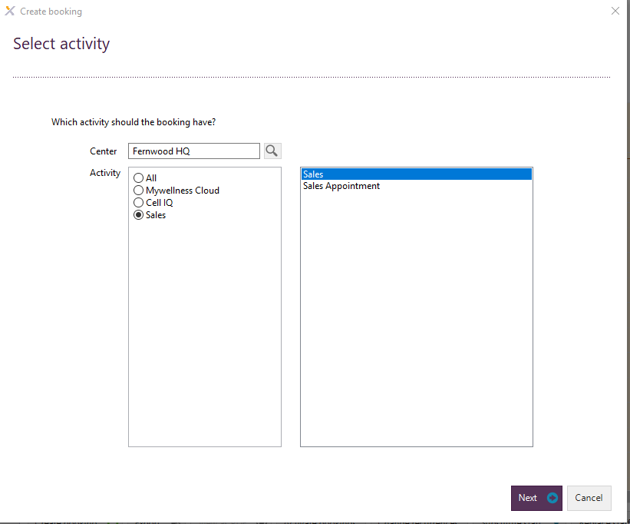

1. Choose date and time of shift
2. 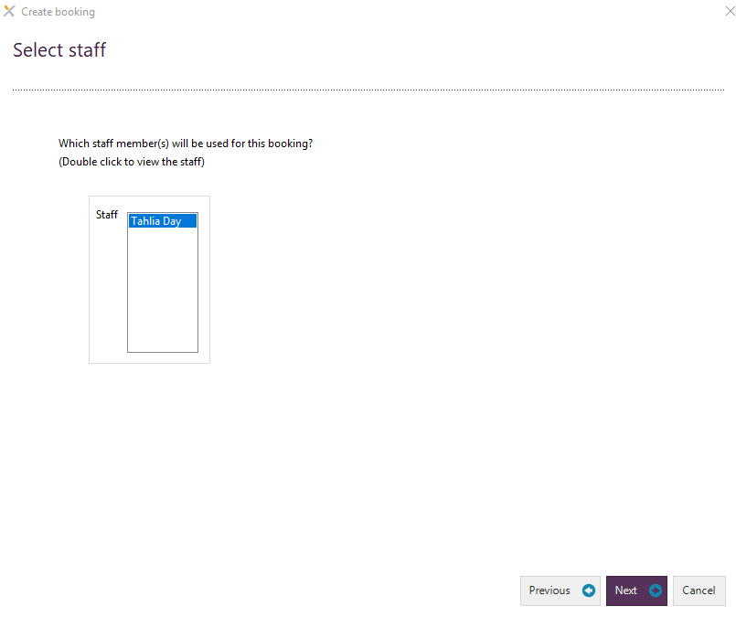Select the staff member working this shift
3. Define the recurrence of the shift i.e. once off or every Monday and Thursday for 3 months

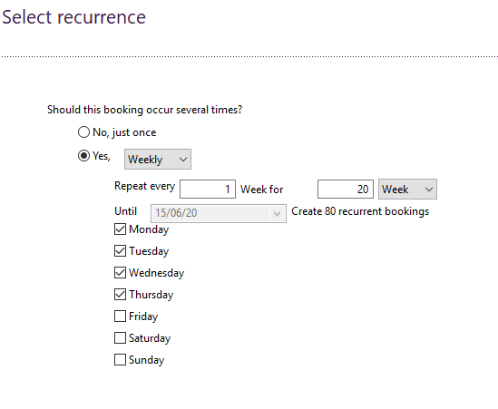

1. 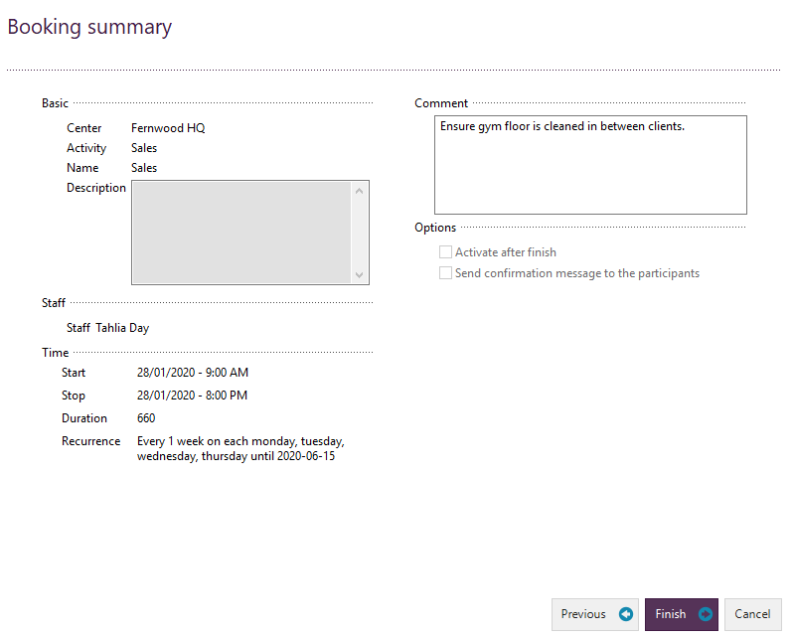Review booking summary and add in any comments for the staff if required i.e. Target of 3 gym floor referrals, Select FINISH.

# Calendar App

## Complimentary sessions

Complimentary sessions will be allocated to new members post-joining. Once they have been allocated to a member’s account they will have an expiry of 30 days. Please see below the possible complimentary sessions a member can receive, depending on your club’s offerings.

* Personal Training
* FIIT30
* Reformer Pilates
* Food Coaching
* Wellness Wednesdays
* Wellness

### Adding a Complimentary Session to a members’ profile

*Person App > Search member > Membership Tab > Clip Cards > New > Select Product Group i.e. Personal Training > Select Comp Session > Process through the cash register.*

To add a complimentary clip card to a members’ profile, follow these steps below:

1. Search the members’ name by clicking on the magnifying search glass in the top left hand side of the screen and then click on advanced search. Type in at least the first 3 letters of the first and last name to search the member. Now click on find. Select the member you want to book a session for and click “open’



1. Click on the ‘Membership’ tab, followed by ‘Clipcards’ tab and then select ‘New’

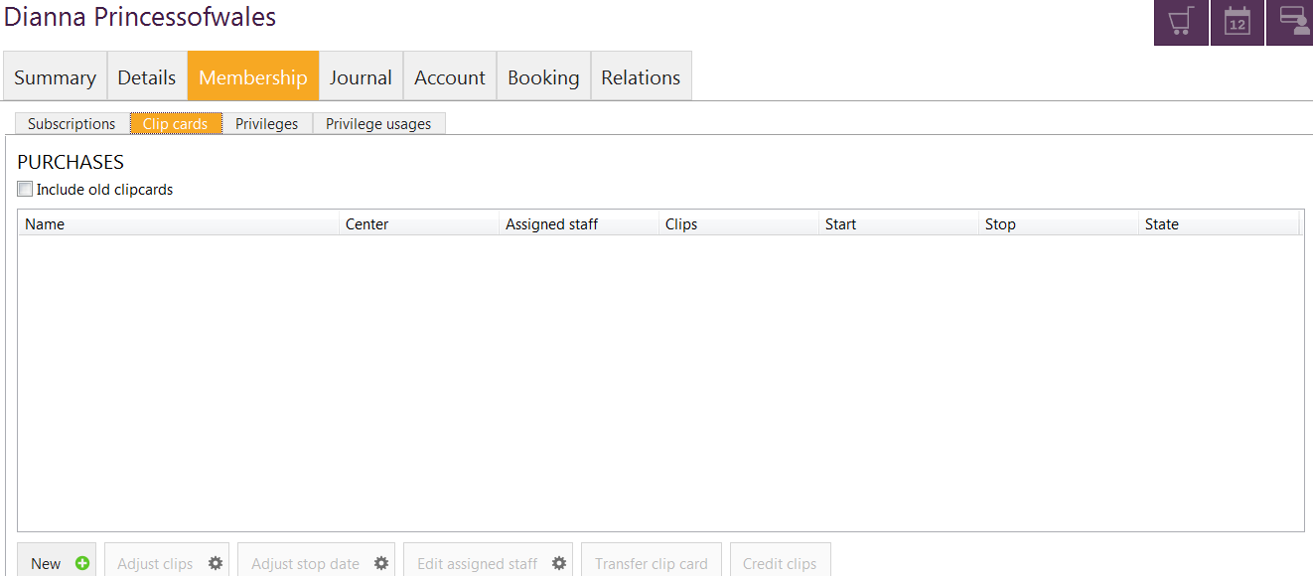

1. Select ‘Personal Training’ for the product group and then select PT comp session below. Click on ‘Select’

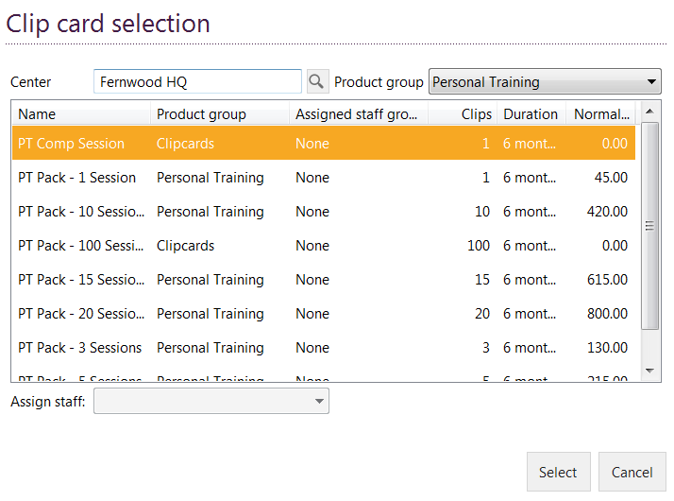

1. The cash register will automatically pop up with 1 Comp PT sessions at $0.00 and will save this session under the ‘Clipcards’ tab under the members’ profile. You will now see 1 Comp PT session on the members’ account, which will be valid for 6 months.

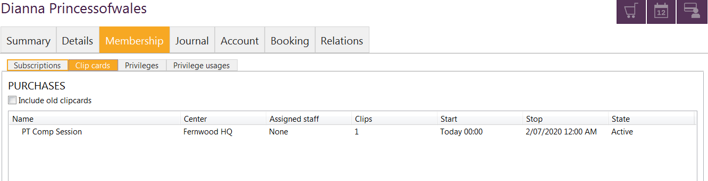

### Book a complimentary session

To book in a complimentary PT session follow these steps below:

1. Search the members’ name and open profile
2. 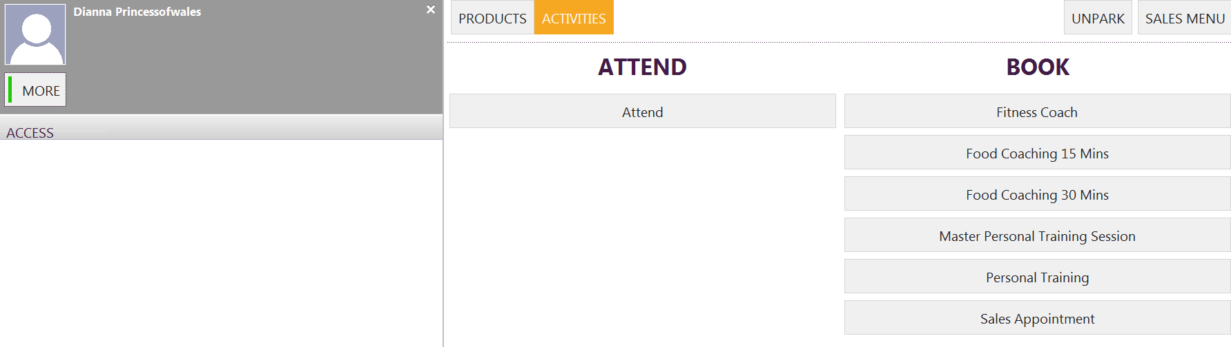Select ‘Activities’, followed by the ‘Personal Training’ tab under ‘Book’
3. Enter in instructor’s name (personal trainer), duration, start time of session and then type in any comments relating to the session. Select ‘Book’ to schedule in PT session.

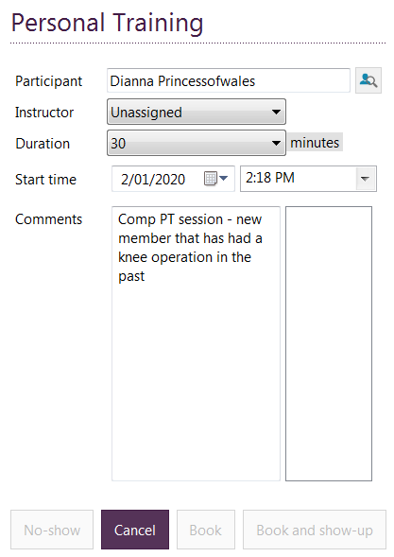

1. Booked PT session will show up under the ‘Booking’ tab in the members’ profile.

## Booking a Member into a class via Exerp

*Calendar App > Classes > Group Fitness > Double click on the class > Book Participant > Search for the member > Select BOOK.*

1. Go to the Calendar App in Exerp > Under the searches, make sure you have selected the correct service i.e. Group Fitness, Sales, Personal Training, Fernwood Trainer etc.
2. Find your class you want to book the member in for and double click on the class.
3. 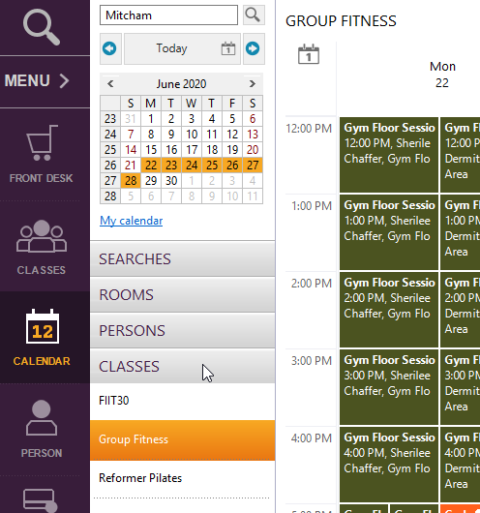Select **Book Participant** > Search for the member > Choose Book and the member will be successfully booked into that class.

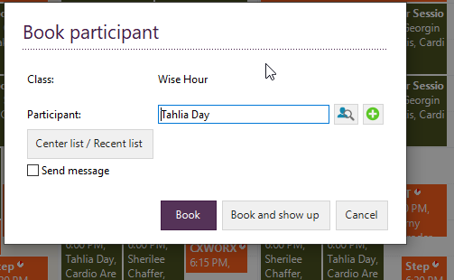

## Making a reoccurring PT Booking

1. Set up your staff availability in Pro.MyWellness
2. Go to **Exerp** > Calendar App
3. Make sure you select the Personal Training calendar in the App

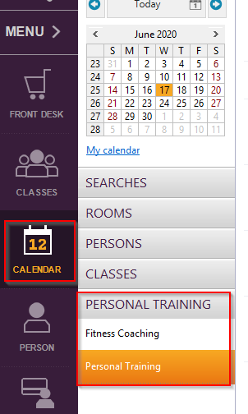

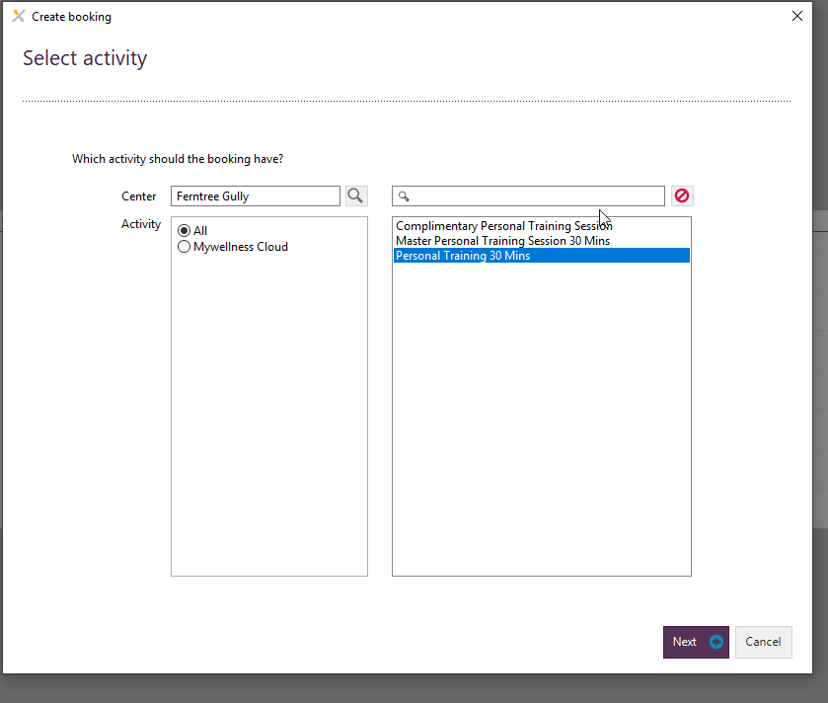

1. Click Create Booking or double click on the available time in the calendar
2. Select Personal Training 30 Mins as your activity > Next
3. Choose the time of the booking > Select Next

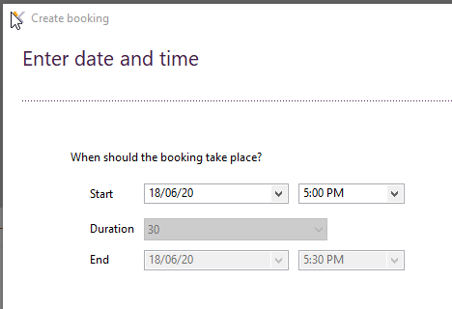

1. 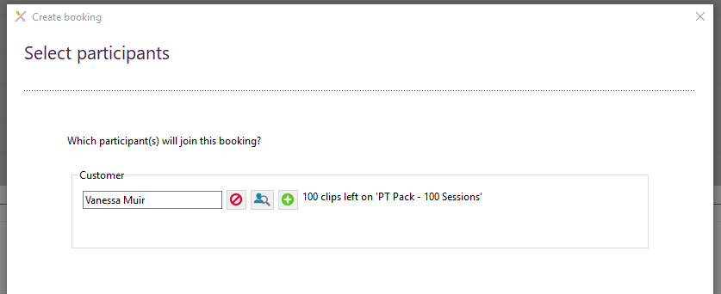Select your member > this will display how the member is paying for their session. If they need to purchase anything or be assigned a complimentary PT session you can from this screen > Select Next
2. Select your **recurrence** of how many weeks you wish to book this spot for.

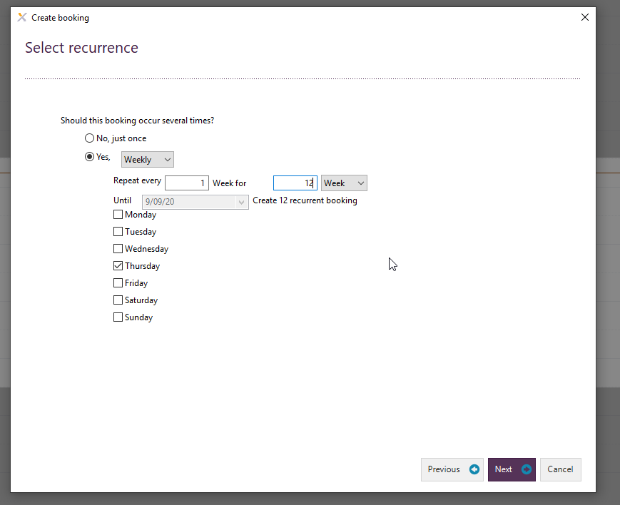

1. Review your summary of the booking, add any additional comments and click Finish.
2. Your booking will be displayed in Pink in the calendar. This will also sync through Pro.mywellness.

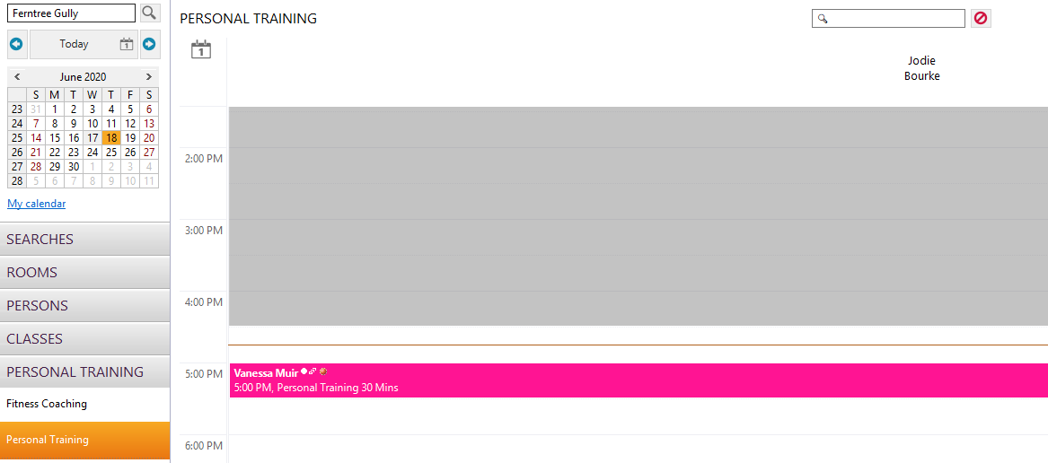

## Booking a Fernwood Trainer Appointment

Before we can take any bookings in the Fernwood Trainer calendar we need to make sure we have set up the below:

* All staff members that are in the role Fernwood Trainer / Member Motivator role MUST be allocated the staff group **Fernwood Trainer** in their Exerp staff profile
* The shift times must be opened up in the Planning App in Exerp (refer to Planning App chapter > Opening a shift time)

1. Go to the Calendar App in Exerp > Under Searches, select Fernwood Trainer

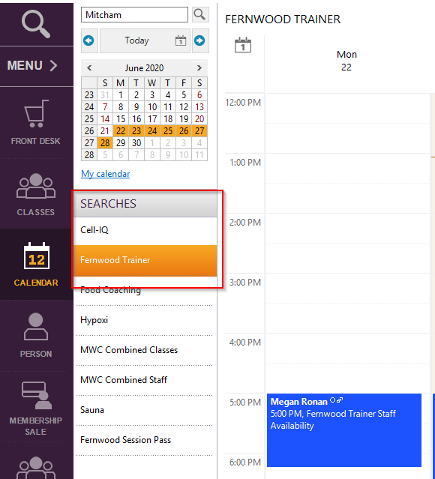

1. Click on Create Booking on the bottom left corner of the calendar
2. A new booking window will come up > Select Next on the first screen
   1. This displays blank as there is one type of appointment you can book in for with the Fernwood Trainer so it defaults to this appointment type

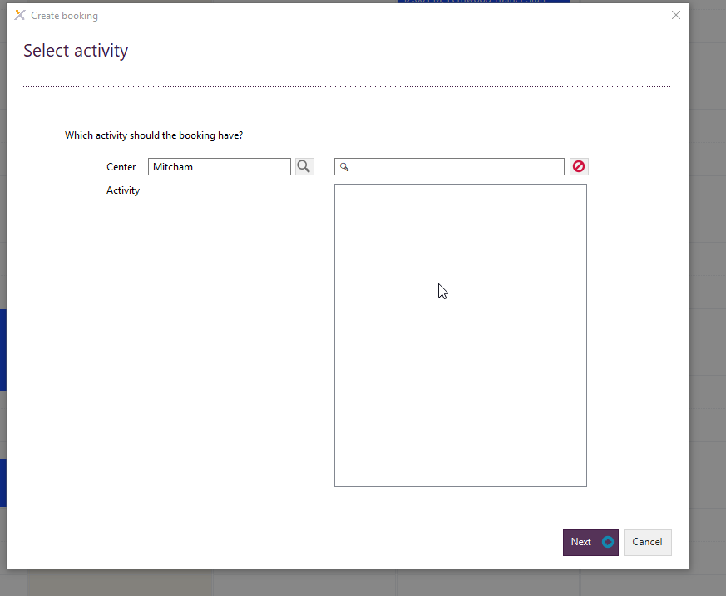

1. Enter the date/time and duration of the booking > Select Next
2. Search and select the member that you are booking in > Select Next

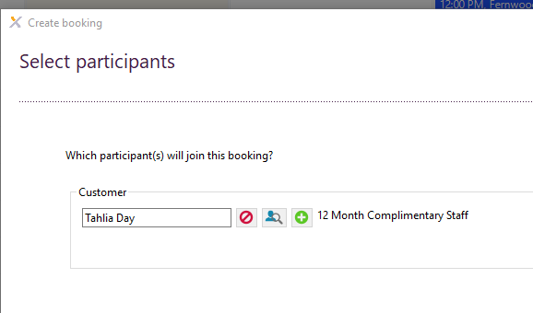

1. Choose the staff who is taking the shift > Select Next
2. 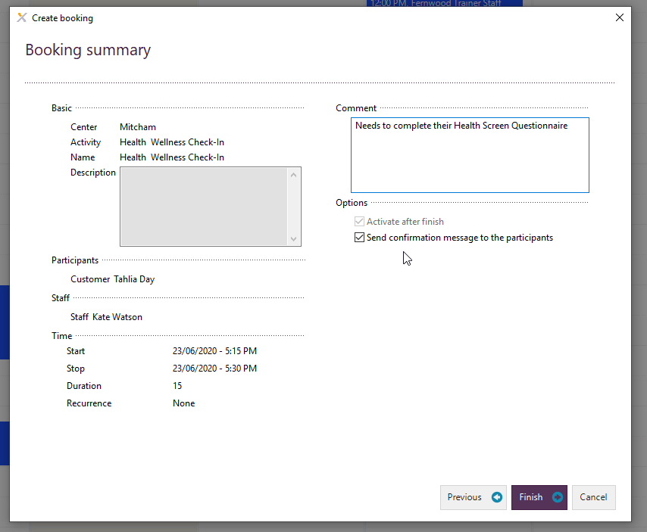The Booking Summary will come up where you can add some notes about the member for the staff member’s reference
3. The appointment will save and you will be able to view their appointments in the Calendar App.

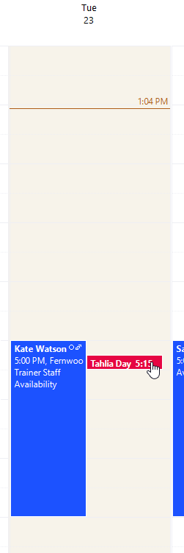

## Cancelling a member from a booking in Exerp

To cancel a member from a class or appointment in Exerp, the same steps as per below apply.

1. Go to the Calendar App and find the members appointment or class
2. Double click on the appointment
3. A new little window will come up > Select Cancel ‘[member’s name]

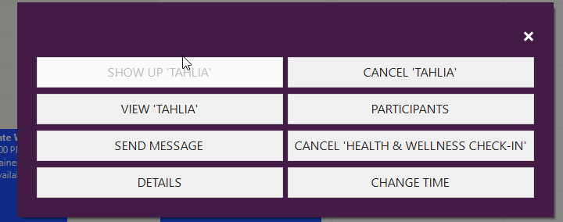

1. A cancel window will come up with a summary of the cancellation. Here you can either select **member cancelled or centre cancelled** depending on the reason and also add in any notes regarding the cancellation.

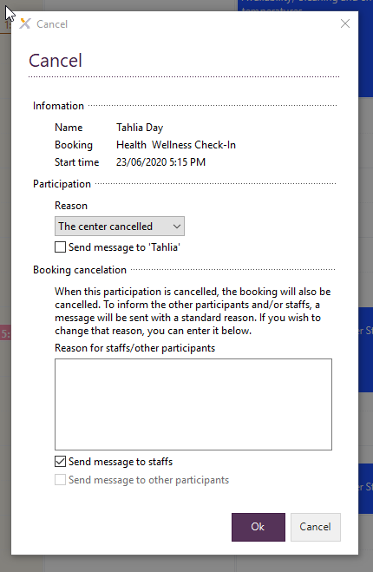

## Cancellation Windows for Bookable Services

**Group Fitness & Bootcamp:** cancellations will close via the app **2 hours** prior to the class

**FIIT30 & Wellness classes:** cancellations will close via the app **4 hours** prior to the class

**PT, Reformer & Food Coaching:** cancellations will close via the app 1**2 hours** prior to their session

If you have a member that calls the club and needs to cancel within this cancellation window, you can update this in the Exerp calendar. Simply follow the steps above for **Cancelling a member from an appointment or class.**

## Cancelling a member inside 12 hours and not wanting to charge the member.

If you have a member that you don’t want to charge for their late cancellation, make sure on the final Cancel window, select **Centre Cancelled.** This will cancel the session from the calendar and reimburse the member for their session so they don’t lose a clip.

## Setting up Group Food Coaching as a bookable service

Group Food Coaching is now available for clubs to set up for purchase in club and bookings via the Fernwood App.

**Scheduling a Group Food Coaching session**

*Pro.mywellness > Planner > Class Scheduling > New > Class name: Group Food Coaching Session > Select room, date, time, instructor and schedule > Set booking to max participants.*

1. In pro.mywellness > Planner > Class Scheduling > New
2. Select the class Group Food Coaching
3. Select the room – either group fitness studio or request a new room via [helpdesk@fernwoodfitness.com.au](mailto:helpdesk@fernwoodfitness.com.au)
4. Enter in date, time, instructor and recurrence (do not schedule it longer than 6 months) – adjust the booking tab for max participants.
5. SAVE

Once you have the session scheduled in pro.mywellness, you also be able to view this in the FOOD COACHING calendar in Exerp for clubs to make bookings on their end.

A few things to remember:

* Member’s need to purchase a clip card pack via the Front Desk to have the privilege to then book themselves in via the app or in club.
* There is a complimentary session set up
* Member’s will receive a push notification reminder from the Fernwood App
* Bookings can be managed through pro.mywellness or Exerp Food Coaching Calendar.

Any requests for products/pricing adjustments please notify [helpdesk@fernwoodfitness.com.au](mailto:helpdesk@fernwoodfitness.com.au)

## Setting up Buddy PT as a bookable service

For those clubs that are wanting to offer 2:1 Buddy PT, this is now set up in Exerp and pro.mywellness so that it is bookable via the Fernwood App for your members. At this stage, we can only have 1 member of the Buddy PT group book into the PT session, which will reserve the spot for both members.

We have set up separate Buddy PT products (as listed below) which you will need to sell to one member of the Buddy PT. This will cover the cost of both members for their Buddy PT sessions so it will be up to the members to work out how they split the cost between them. The member that purchases the pack of Buddy PT will have to also be the member that the booking is made for.  I would also recommend adding a journal note on both member’s profiles so it is easy to track who they are training with.

Members can purchase their sessions either through Exerp or they can purchase via the App which will push the purchase to their next scheduled debit.

**PLEASE NOTE:** Members must have these Buddy PT clips purchased to book themselves into a Buddy PT spot, their existing standard PT clip cards will not work.

**Buddy PT Products**

* Buddy PT Pack – 1 Session $60.00
* Buddy PT Pack – 3 Sessions $170.00
* Buddy PT Pack – 5 Sessions $300.00

*If you want to update your price from the above, please email* [*tahlia.day@fernwoodfitness.com.au*](mailto:tahlia.day@fernwoodfitness.com.au)

Each time a member purchases their pack of Buddy PT, they will also receive the email below which outlines their T&Cs, booking policy and how to manage their bookings.

**How to set up Buddy PT**

* Personal Trainers should open up their availability like they normally would for standard PT in pro.mywellness
* When booking Buddy PT session in Exerp/PMW, select the activity Buddy PT 30 Mins
* Search for the member that has purchased the sessions to reserve the spot for the member.

**Members Booking via the Fernwood App**

When a member goes to book their spot for their Buddy PT in the Fernwood App, the process is the exact same for when they are booking standard PT, except they will select the Buddy Personal Training 30 mins tile as per the image below.



**Buddy PT Confirmation Email**

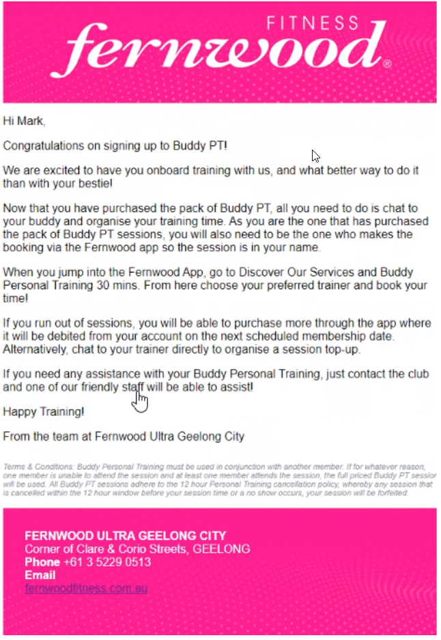

# Classes App

## View class info and bookings

*Exerp > Classes App > Select date/day of the week > View of all classes running that day > Select your class*

From this screen you can view;

* Members that have booked into the class so far and how they booked into the class
  + Mobile API – booked via the Fernwood App
  + Staff – booked via in-club staff
* Status of their booking – Booked, No Show etc.
* Remaining spots available in the class
* Waiting list participants as well as re-run the waiting list

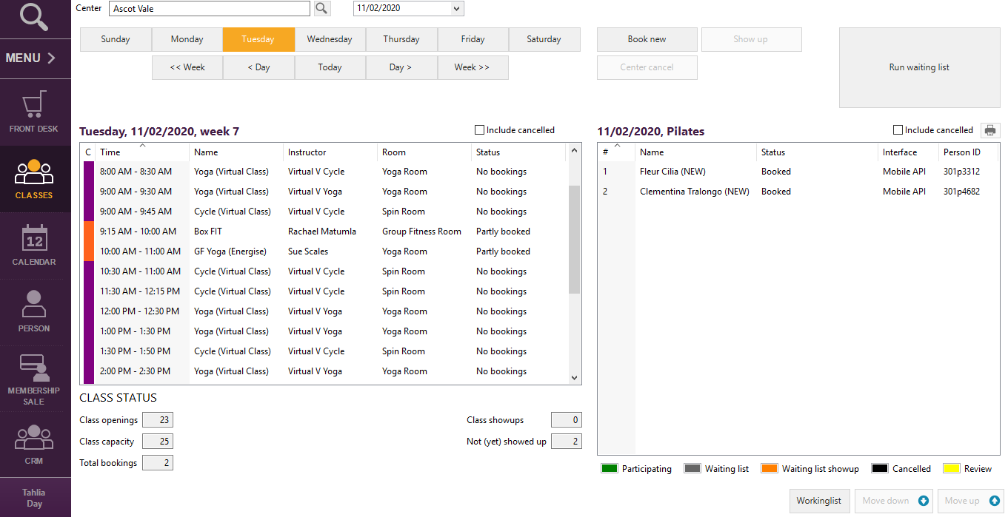

## Classes Colour Codes

Purple = Virtual Group Fitness

Orange = Group Fitness Classes

Blue = FIIT30

Purple = Reformer Pilates

## Adjusting head count to classes

After a class has been completed you can go back into the class via the Classes App and adjust the headcount of the class. This way your group fitness numbers can be accurate and in the system to report on.

*Classes App > Find & Select your class > Select Adjust Head Count > Enter in the head count of the class.*

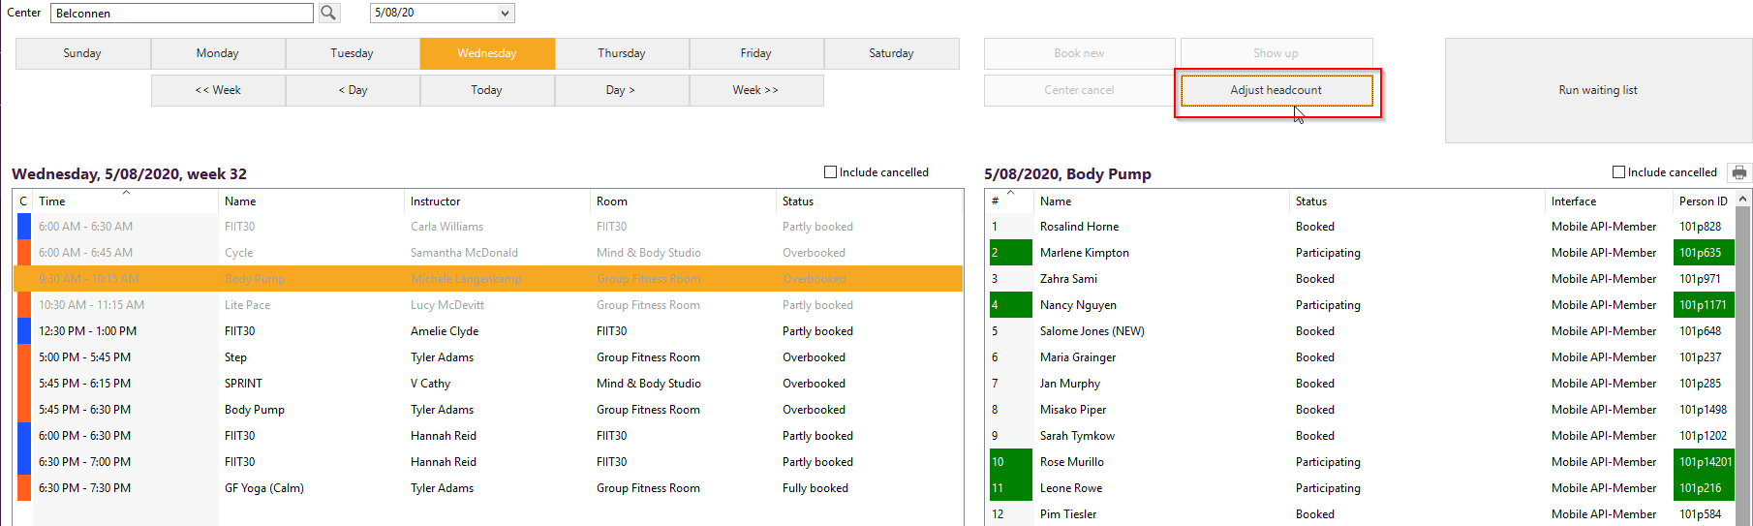

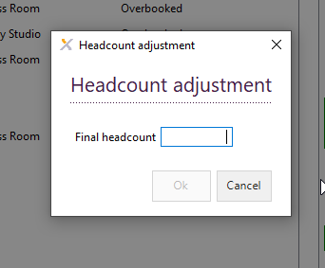

## Waitlist Function

When a class is full and the member cannot book a spot, it will allow them to join the waitlist for that class. We have set the waitlist capacity to 10 members.

The waitlist works like a que, when a spot in the class becomes available the next member in the que will be sent a push notification in the Fernwood App and pushed into the class. The push notification is as per below.

*“Great news! You are now booked into Body Attack at 5:00pm on 20/07/20”*

# Finance App

## Direct Debits (Billing in Exerp)

## Payment Cycles

Fernwood have two payment cycles, both payment cycles are on Thursdays and debited fortnightly.

When a member sign’s up there is the option to choose a deduction day, this can either be the Thursday (Even Week) or Thursday (Odd Week). Thursday odd week is known as ‘week 1’ for Fernwood, and Thursday even week is known as ‘week 2’ for Fernwood. (please refer to calendars on the next page: odd weeks (pink), even weeks (grey)).

All clubs will have both payment cycles as an option so that their members can choose which payment cycle they would like to be on. If you would like all of your members to be on the same payment cycle and not give the option, then this must be managed in club and all staff trained appropriately.

Please note however that if a member transfers into your club and they are paying on the opposite payment cycle to that of your other members, these members will transfer in on the payment cycle they are currently paying on and they will not be moved to your main payment cycle.

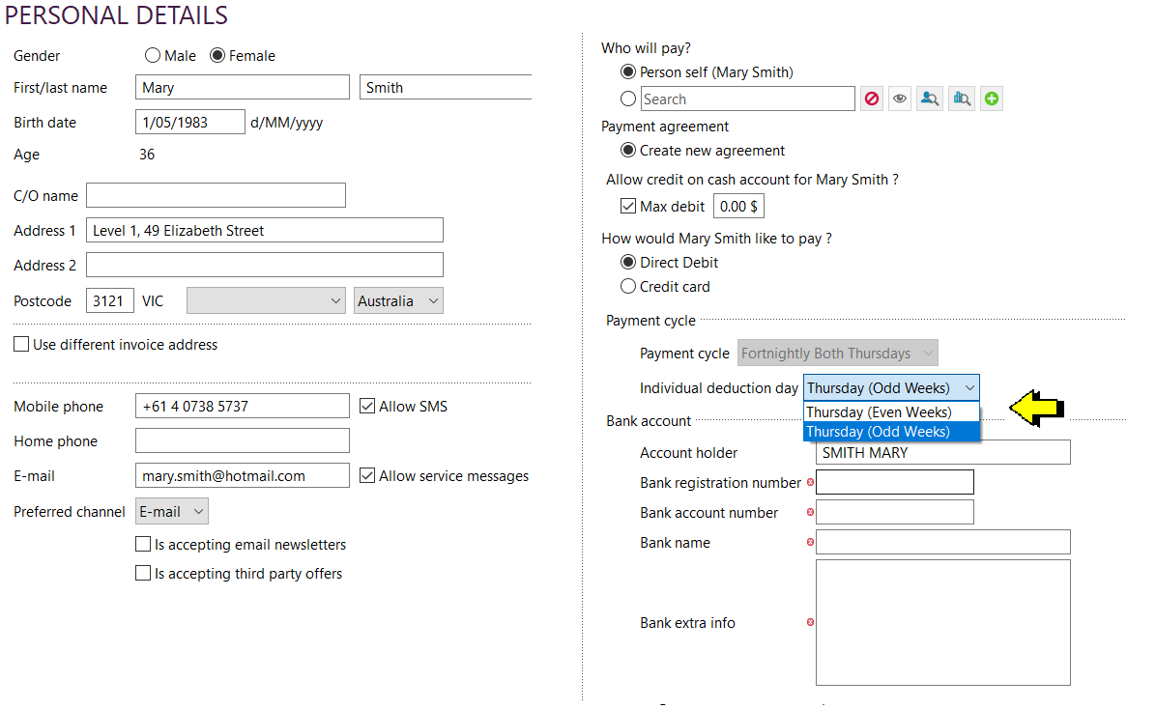



## Direct Debit Process

Please note that all direct debits (Fernwood DD (bank account) and Fernwood CC (Pay Way) will be sent to the bank by NSO each week.

Funds will be transferred to franchisees bank accounts before 10am each Thursday and an email sent confirming the amount transferred.

## Billing Process in Exerp

Exerp generates an amount to be debited to each member’s payment account overnight on Tuesday evening. This amount is the amount that will be directed debited on Thursday. The account balance will reflect an amount owing as seen by the screen shot below of $43.20 (account balance). This amount is not due yet. This is merely the amount that will be direct debited on the scheduled debit day (Thursday).

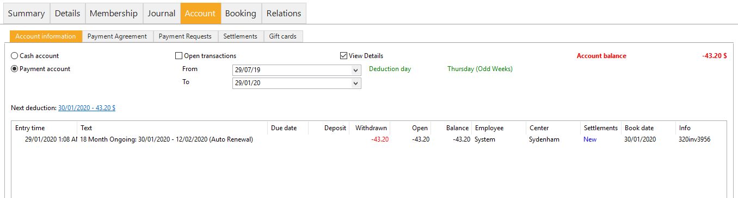

Changes can still be made to members direct debits/account on a Wednesday throughout the day. If a member cancels and you do not want the debit to proceed the next day, stop the membership using todays date (Wednesday the day before the debit) and the debit for tomorrow will not proceed.

Exerp generates direct debit files for all members overnight on a Wednesday evening and prepares the debit files ready to be sent to the bank. PayWay will be sent automatically at 3am and rejections loaded as soon as the results are received by Exerp (anywhere from 3am to 5am). Bank files are sent to Westpac by NSO on Thursday morning around 9am.

Below is an example of an account that is paid by credit card. The second line (amount in red) is the amount that was generated overnight on Tuesday evening in advance of the direct debit being processed.

The first line is the direct debit being received on Thursday and this now shows the account as paid. The account balance is now showing $00.00 in the top right-hand corner of the screen.

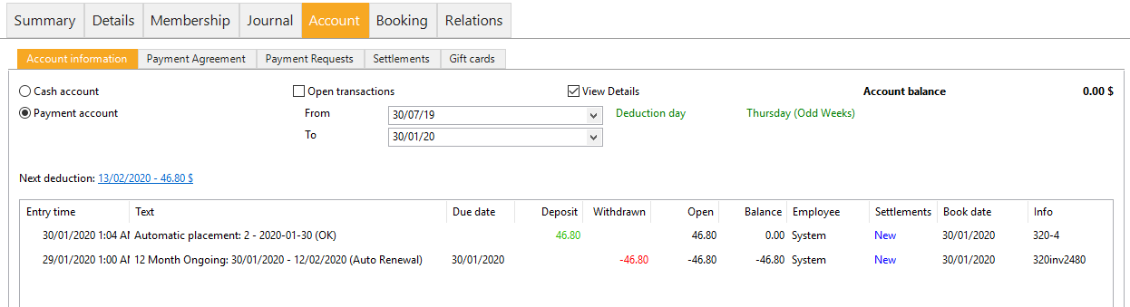

It is important to note that any members who pay by bank account will continue to show an account balance for the day on Thursday and will not show the debit line coming in until Friday morning.

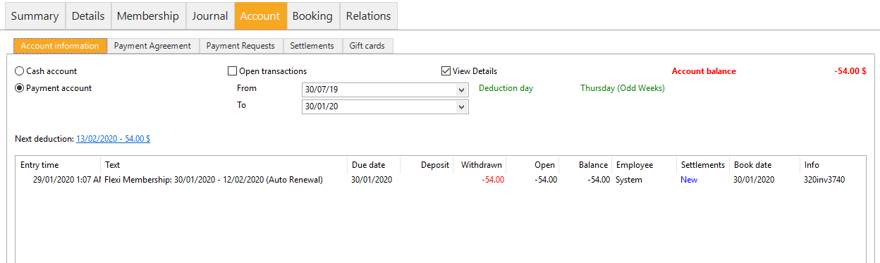

If you would like to confirm that a debit has been generated you can view the payment requests screen.

On Friday morning once the batch jobs have run overnight the account will show an amount paid the same as members who pay by credit card.

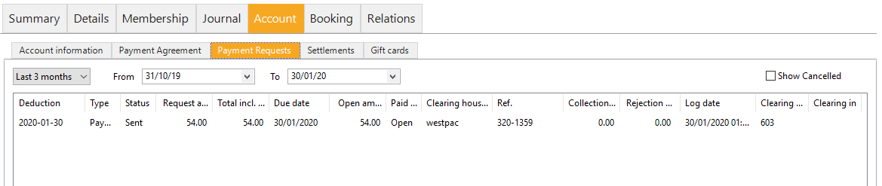

## Rejected Payments

Rejections for members who pay by credit card will be visible on the members account information tab on Thursday morning of debit day.

If a member rejects a new line is created on their account showing a ‘rejection fee’ which is made up of the debit attempted and the rejection fee amount - $46.80 + $9.00 = $55.80 as shown below.

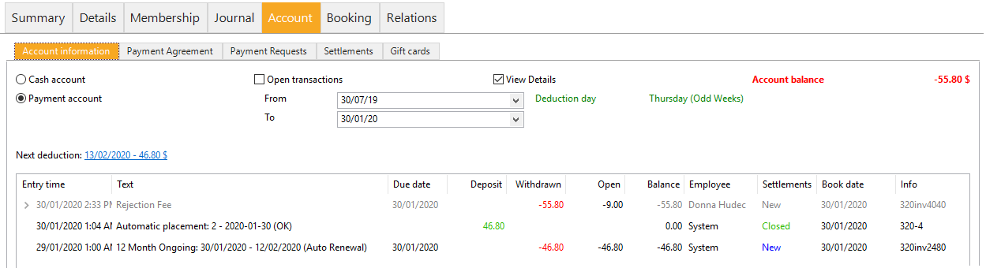

You may have noticed that the rejection fee line is shown in a grey colour, whereas the other two lines are in black. This indicates that by clicking on the arrow next to the rejection fee you can drill down further to see a breakdown of the amount. Below is a screen shot showing the debit amount and the rejection fee amount shown separately.

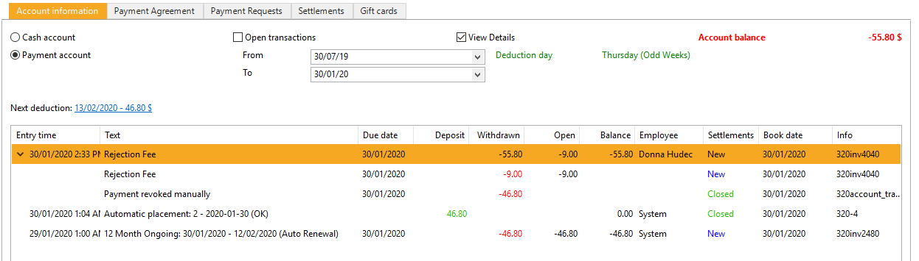

Rejections for members who pay by bank account will be visible in the member’s account information tab on Monday morning following the debit. Until rejections are received the account is assumed as being paid.

## Viewing Direct Debit Information

If you would like to view details about your direct debit and which members have been debited, this is located under Payment Requests of the finance section.

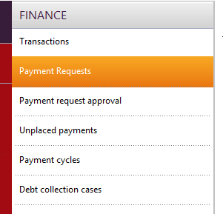

Select criteria to view the information you are looking for:

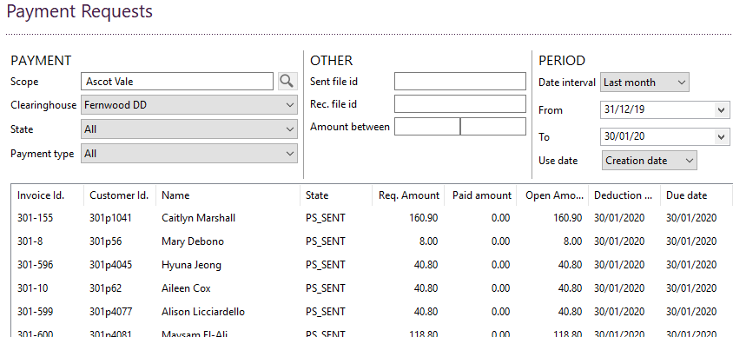

**PAYMENT**

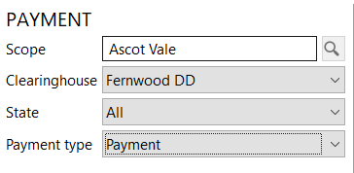

**Scope:** Select the club.

**Clearing House:** Fernwood have two clearing houses - Fernwood DD (members who pay by bank account) and Fernwood CC (members who pay by credit card).

**State:** The options to choose from are: All, requires approval, new, sent, open, closed, cancelled, rejected, failed. Usually you will select all or rejected. All will provide you with a full listing of all members that have been debited. Rejected will provide you with a listing of only the members who were debited and rejected.

**Payment type:** Select ‘payment’ to view which members were part of the direct debit.

**OTHER**

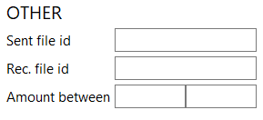

**Sent file id:** If you know the sent file id number you can view all members debited in a particular id.

**Amount between:** If you would like to see which members were debited a specific amount or members between two amounts, enter the lowest figure and the highest figure in this section.

**PERIOD**

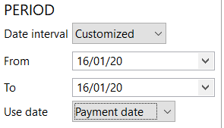

**Date interval:** Select the period of time that you would like to view member debit information. The options are today, last week, last month, last 3 months, last 6 months, the last year or a customised date period.

**Date from and to:** Enter the dates that you would like to view debit information

**Use date:** Creation date - the date that the direct debit was created (this will be the Tuesday of debit week), deduction date – the date that members were debited, payment date – the date members paid, due date – the date that the debit was due to be paid.

**CUSTOMER**

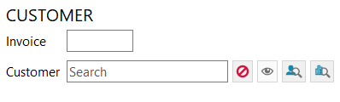

**Invoice:** If there is a particular members invoice that you wish to view enter the invoice number in this box.

**Customer:** If you wish to view a particular members previous direct debits enter the member ID in this box.

Once all criteria has been selected click on search.

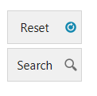

If you wish to reset the data and view new information, then click the reset button and enter the new selection criteria that you would like to view.

The data extracted can be exported to excel by right clicking anywhere on the data.

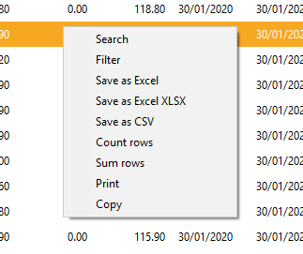

If you would like to view a summary of the members who rejected for the same debit, change the state in the selection criteria to rejected.

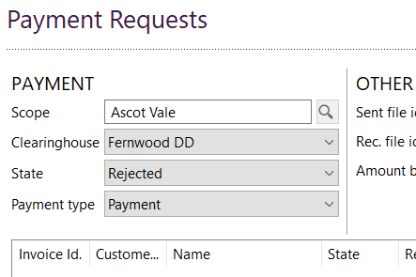

Below is a screen shot showing a member who rejected for the debit of 30/01/2020.

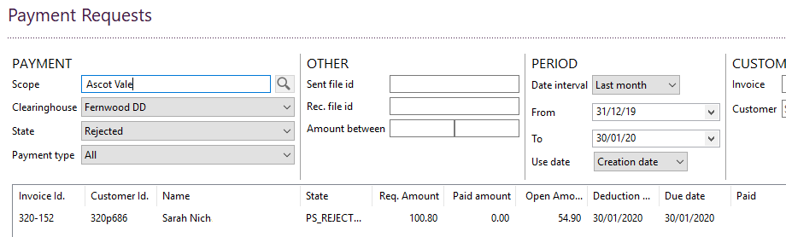

## Outstanding Debt Report and Managing Outstanding Debt

If you would like to see which members still have outstanding debt and what their outstanding balances are, you can use the debt collection cases report under finance.

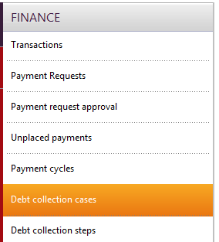

**Debtor type:** The debtor type must be set to person.

**Missing entity:** The missing entity should be set to overdue debt. If you would like to see which members do not have a valid payment agreement, change the missing entity to missing agreement.

**From date:** change the date to the date that you want to see outstanding debt from.

**Scope:** Select a club

**Debt collection service:** To see debt that has not been sent to debt collectors select not sent. To view members who have been sent to Bill Chaser then change this dropdown to Bill Chaser (this is only for clubs who have their debt managed by NSO and are sent to debt collectors by NSO).

**To date:** change the date to the date that you want to see outstanding debt up to.

Click search.

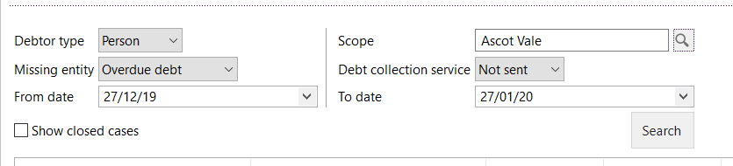

Below is a screen shot showing how this page looks.

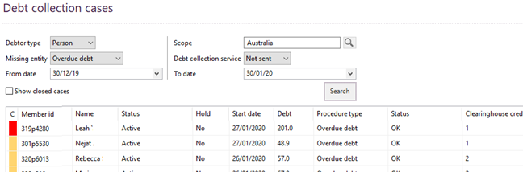

In order to view the person, click on ‘view person’ at the bottom of the screen.

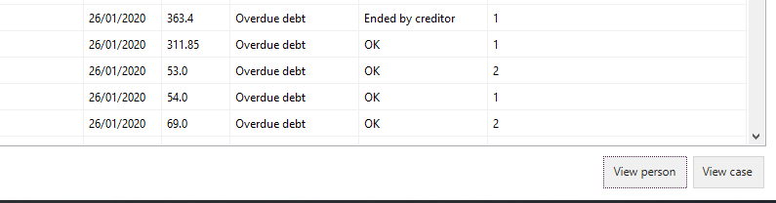

After clicking on the ‘view person’ button you will be able to view the members account information, contact details etc. and add any contact notes if contact is made with the member through debt collection.

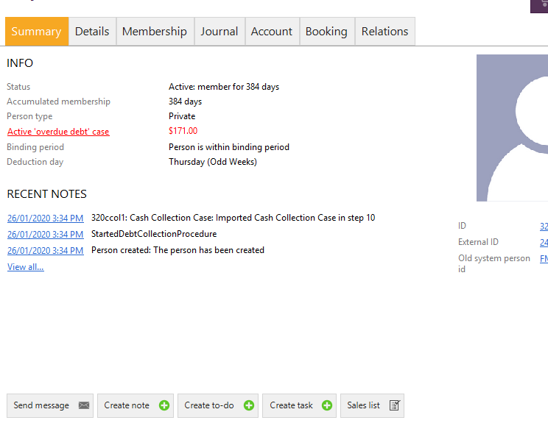

Close the person box by clicking the cross in the top right corner of the person box. If payment is made through collection processes, and the debt is cleared the member will disappear from this listing if you click the ‘search’ button again or view the report again at a later date.

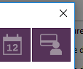

## Instalment Plans

If a member has outstanding debt that she would like to pay off over her future direct debits, the installment plans can be used.

The ‘installment’ plan button can be found at the bottom of the account information tab.

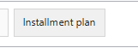

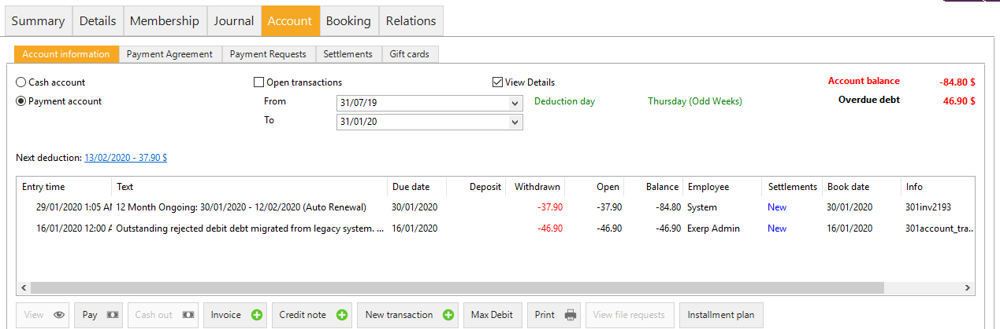

Click on ‘installment plan’ and select the number of payments that the debt will be paid over.

The available options are to pay over:

1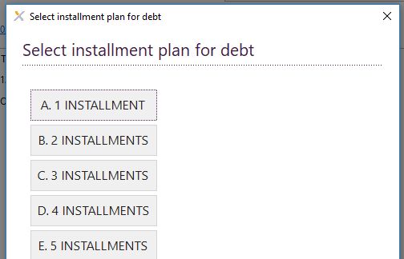 installment

2 installments

3 installments

4 installments

5 installments

6 installments

8 installments

10 installments

15 installments

20 installments

25 installments

30 installments

35 installments

Click on the installment plan that will be used.

In the below example $46.90 was outstanding and $37.90 was not yet due. Therefore, only the outstanding amount of $46.90 has been placed on an installment plan. The account screen has now recorded the outstanding as paid and the installment plan has been placed on the installment plan account.

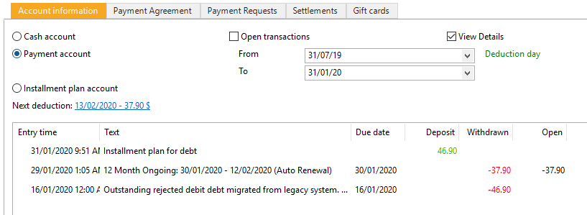

Select the installment plan account in order to view any existing installment plans.

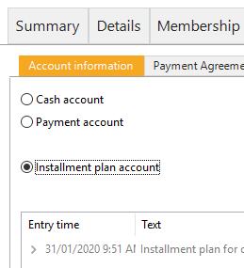

As shown in the below example the debt of $46.90 has been placed on an installment plan over 5 payments, by using the arrow next to the installment plan on the left you can drill down to view the amounts and dates that installments will be direct debited.

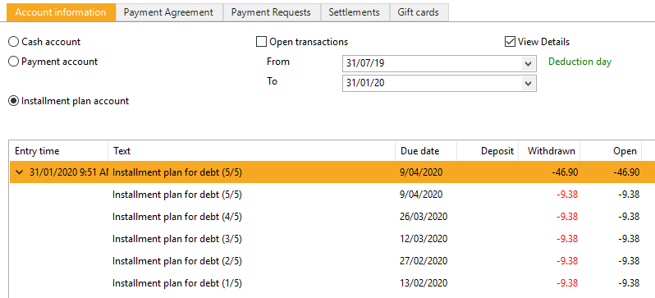

### Cancelling a payment agreement

If a member has requested for her payment agreement to be cancelled, go to the account tab – payment agreement. Click on the payment agreement then click the cancel button at the bottom of the screen.

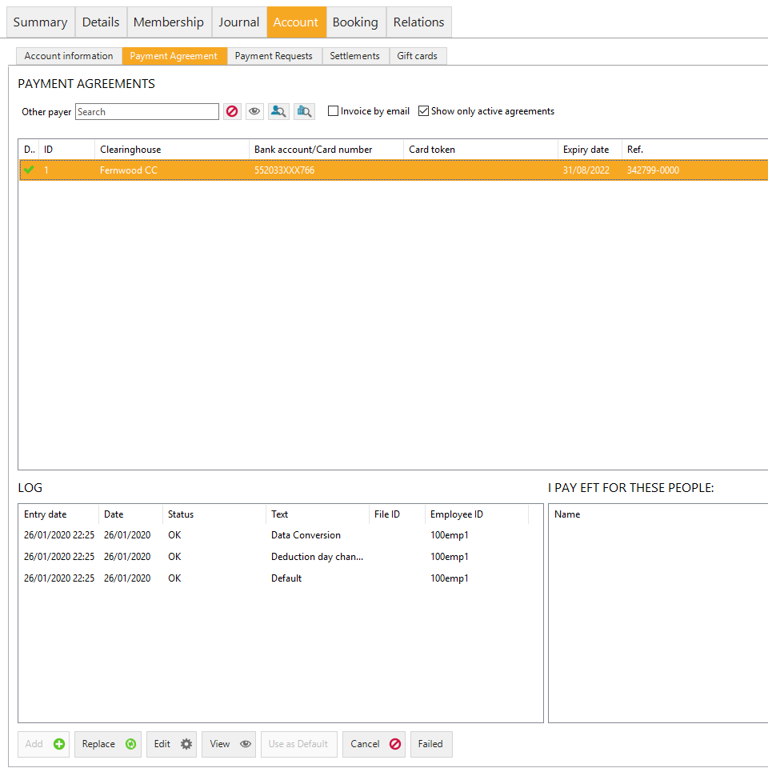

### Editing a payment agreement (switching billing cycles)

If a member would like to change her payment agreement in some way, which could include changing her debit day from the current Thursday she is paying to the opposite Thursday, or changing her details to a new bank account or credit card. This can be done in the payment agreement screen.

If the payment day is being changed then click edit.



Use the dropdown to switch from the even to the odd week and visa versa.

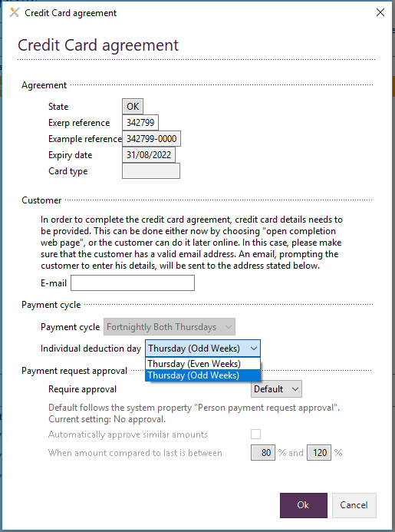

In the case of the below example, the change to the payment request was done on a Wednesday after the next debits payment had already been prepared. Therefore the member will not be debited with her direct debit tomorrow (Thursday), instead the payment will remain on her account and her next payment will be $72.00. This is the $48.00 that was owing which covered the next fortnight + an additional $24.00 for the one week to get to the next direct debit and align her with the new payment cycle.

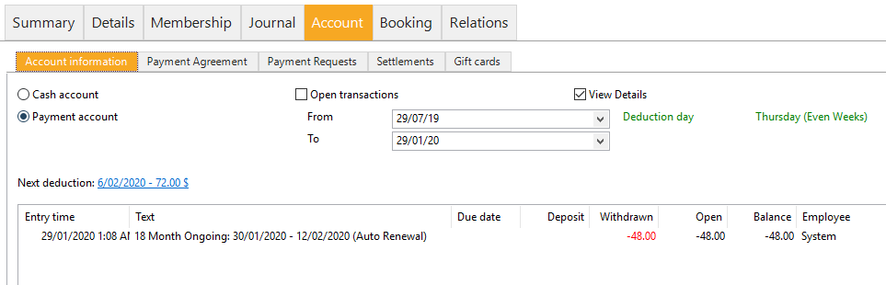

### Changing a payment agreement

In order to update members banking information, click on ‘replace’ in the payment agreement tab at the bottom of the screen.

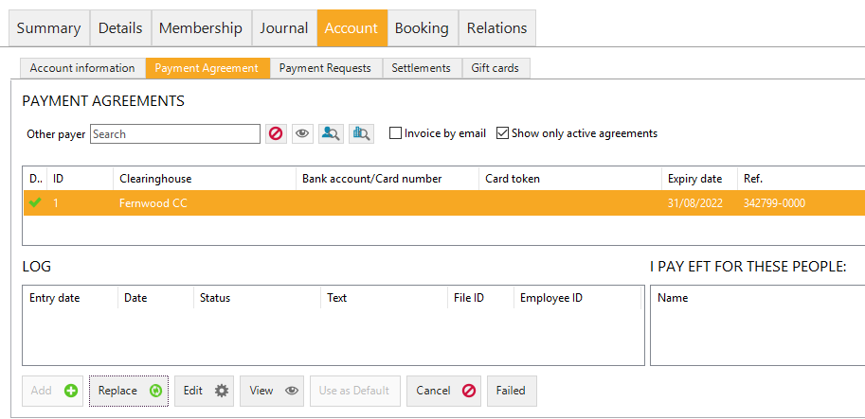

Select either ‘EFT’ or ‘credit card’ and click next.

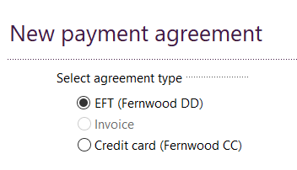

Add in the banking details and click finish.

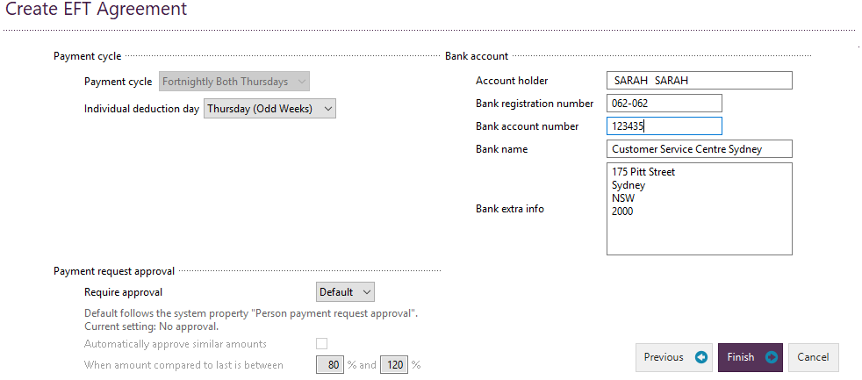

When adding a credit card agreement select ‘credit card (Fernwood CC)’. You will be taken to a screen that pops up for you to complete entering the credit card details. Enter the details and click save, you can now close the screen the popped up and return to Exerp.

## Refunds

At first refund functionality will not be used and usual processes will still be used.

Please email your administrator with the usual information (member ID, name, payment information, amount) if you require a refund to be processed. Any refunds processed will be deducted from recouped funds transferred.

Once we start using refund functionality, we will advise clubs and provide instructions.

## Price Increase Requests

If clubs would like to increase prices for any members please contact Donna Hudec at Fernwood NSO to confirm what information is required for any price increases to be applied. First please ensure that you have given your members notice of an increase by providing a minimum of 60 days’ notice as per the terms and conditions.

## Member Administration Services – Debt Collection

For those clubs using member administration partial service where we are doing your debt collection only, we will continue to do what we usually do and emails will still be sent as usual providing you with the details of funds transferred to your account and details relating to your direct debits. During the pilot period our processes and the way we do things may need to change slightly to work in line with Exerp, however we will do our very best to ensure that any changes are kept to a minimum, and that we are still providing the same service that we always have.

## Member Administration Services – Full-Service

For those clubs using member administration full service where we are processing paperwork on your behalf. Our processes will not change. For any requests that you have please continue to send through paperwork on a daily basis as usual.

## Payment Requests

Payment requests is not currently being used. This is additional functionality that has not been available to Fernwood previously. We will advise in due course when payment requests can be used along with instructions.

## Profit & Loss Reports

Clubs are required to provide NSO with their profit and loss report on a monthly basis. Clubs are given 1 month to complete their P&L in their accounting system and then email it to us on [finance@fernwoodfitness.com.au](mailto:finance@fernwoodfitness.com.au). For example, January P&L must be received by 1st March.

Below is a summary of the information required which will be emailed to you in an excel template.



# CRM App

The CRM app is your lead management system where you will manage all of your leads in the journey up to selling a membership.

The icons down the side represent your current call lists and leads.

## Glossary of terms

* Pending = all current and future tour bookings.
* On hold = your schedule of future calls, when the call gets to it’s scheduled day it will move into the open queue.
* Overdue = Overdue calls we didn’t get to and need to prioritise – club goal is to never have any overdues.
* Unassigned = leads to be actioned and set to call by the club (web leads).
* Open = your call list for today

## CRM Workflow Summary

|  |  |  |  |
| --- | --- | --- | --- |
| **Task** | **Call Attempts** |  |  |
| **Lead** | 12 | |  |
| **Trial** | Mid Trial 1 call at day 3 | Post-trial  8 call attempts |  |
| **Tour Not Joined** | 8 | |  |
| **Reschedule a tour** | 8 | |  |
| **Sale** | **Post sale referral call 1** | |  |
| **Renewal** | **No workflow scheduled, clubs to schedule own call where needed** | |  |
| **Member Save** | **No workflow scheduled, clubs to schedule own call where needed** | |  |
|  |  |  |  |

## Lead - Contact Workflow Summary

|  |  |  |  |
| --- | --- | --- | --- |
| *Leads will follow the below workflow unless they move to another task (Eg - tour, trial etc)* | | | |
| Lead - contact 1 | Day 1 AM |  |  |
| Lead - contact 2 | Day 1 PM |  |  |
| Lead - contact 3 | Day 2 AM |  |  |
| Lead - contact 4 | Day 2 PM |  |  |
| Lead - contact 5 | Day 3 |  |  |
| Lead - contact 7 | Day 6 |  |  |
| Lead - contact 8 | Week 2 |  |  |
| Lead - contact 9 | Week 3 |  |  |
| Lead - contact 10 | Week 4 |  |  |
| Lead - contact 11 | Week 5 |  |  |
| Lead - contact 12 | Week 6 |  |  |
|  |  |  |  |
| * At any stage the club wished to stop the workflow they can action the lead as not interested which will close the leads workflow | | | |
| * Clubs can also choose to edit the standard workflow schedule where needed via the edit button * If the workflow is closed, a new task can simply be created for the closed lead in order to open it up again | | | |

## Add a new lead

Leads coming from the webpage will go straight into unassigned, however when you have a walk in, a referral or outreach lead for example, you will need to enter a new lead.

*CRM App > New Lead > Enter details of your new lead > Enter lead questionnaire information (if applicable) > Select person type > FINISH > Create task > OK.*



1. Go to CRM App under Menu.
2. Click the New Lead button at the bottom of the screen.

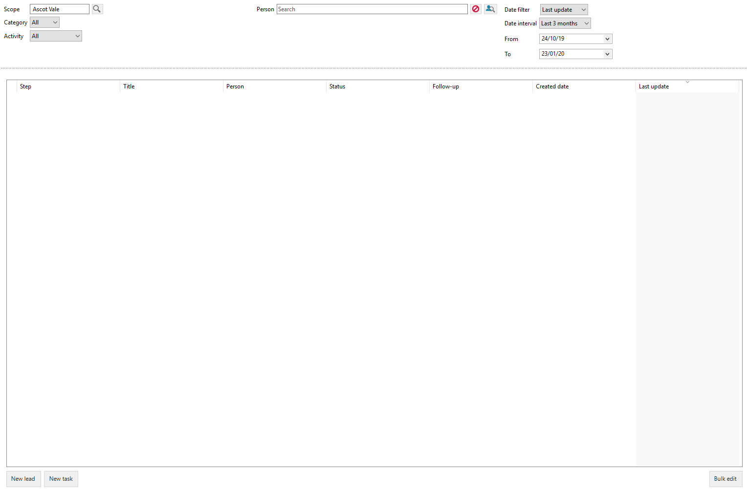

1. The create guest screen will pop up > Enter the lead’s details

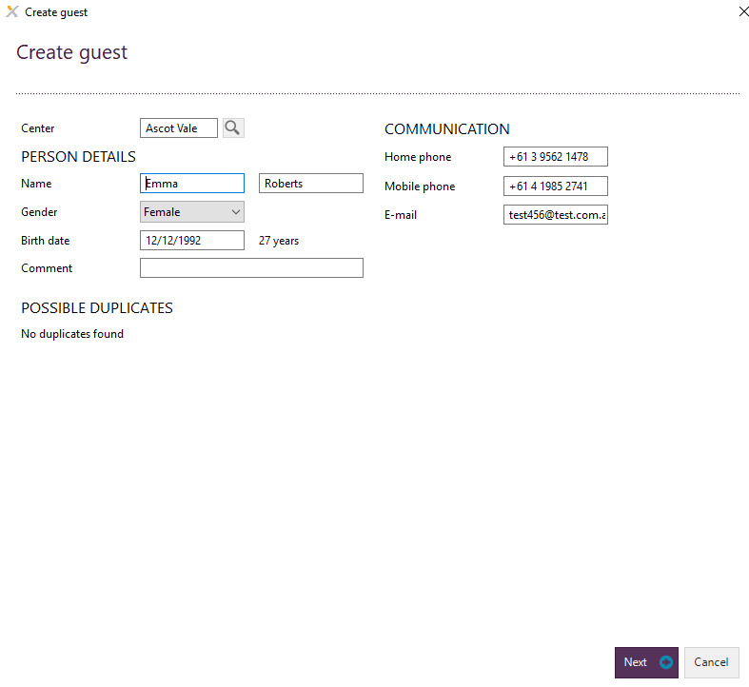

Mandatory fields are:

* Name
* Gender
* Birth date
* Email
* Either Home phone or Mobile phone (it is not mandatory to give both)

1. Enter the leads preferred communication channels

* You are able to tick and untick the customer’s required communication channel(s). The goal would be to have leads opted into all communication channels, unless of course they do not want to be.

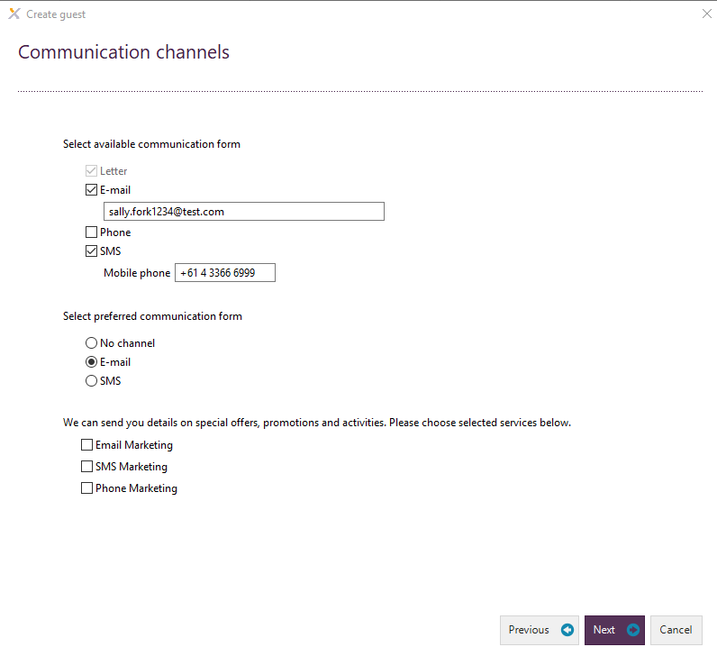

1. Complete the remaining person details of the lead

* 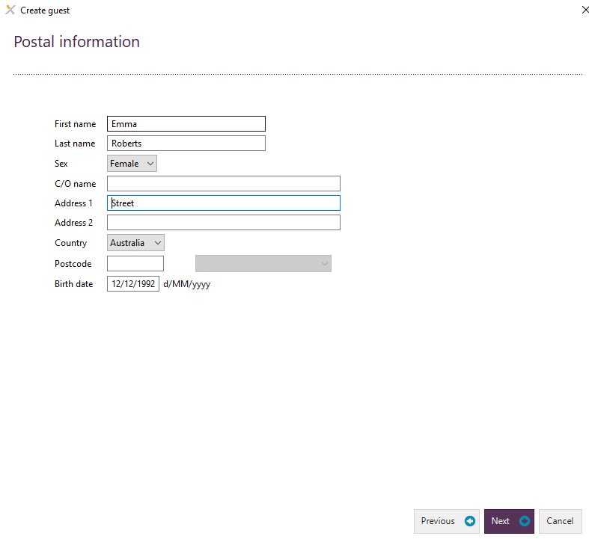It is not mandatory at this point to provide the lead’s address however it is mandatory to have this at the membership sale step.

1. Click next and you will have the option to fill out the Lead Getting To Know You Form > Complete the answers if applicable.

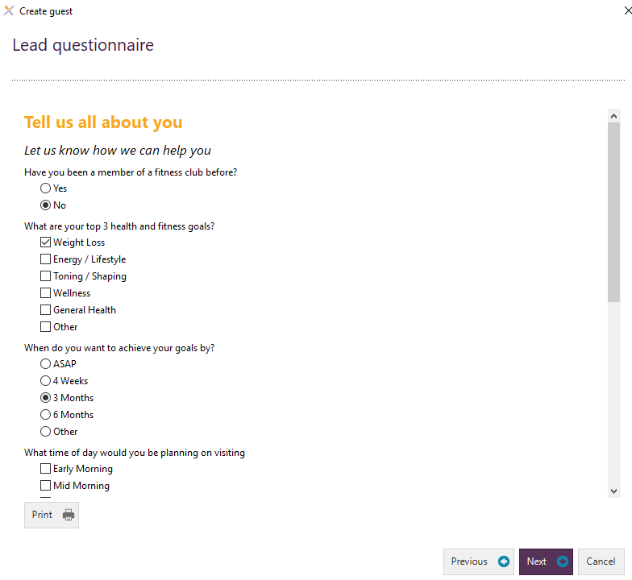

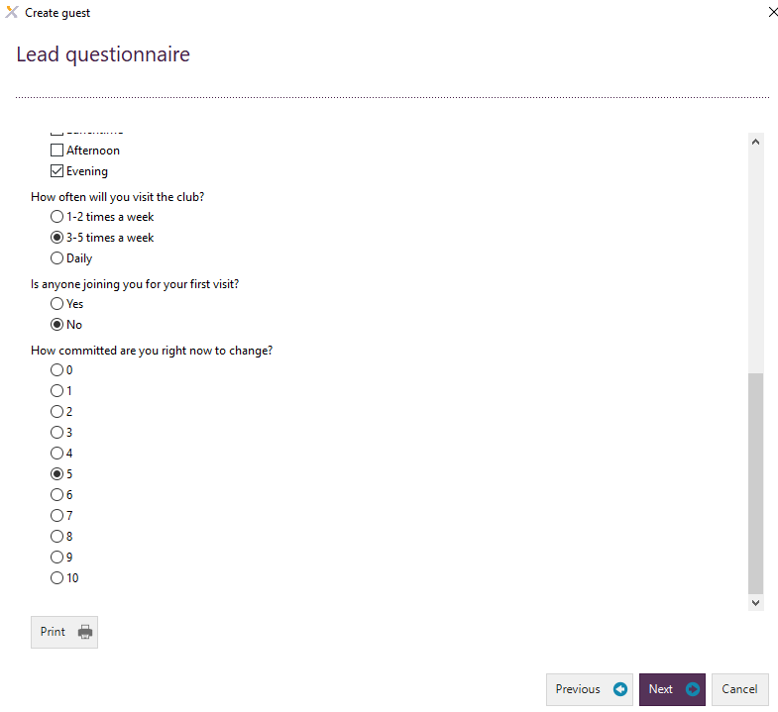

1. Select the person type of the lead. Then click Finish.

Relation refers to the type of membership. Majority will be private, this is your standard membership. However you can use things such as Student, senior etc, in order for the standard discount or promotion for that group to apply.

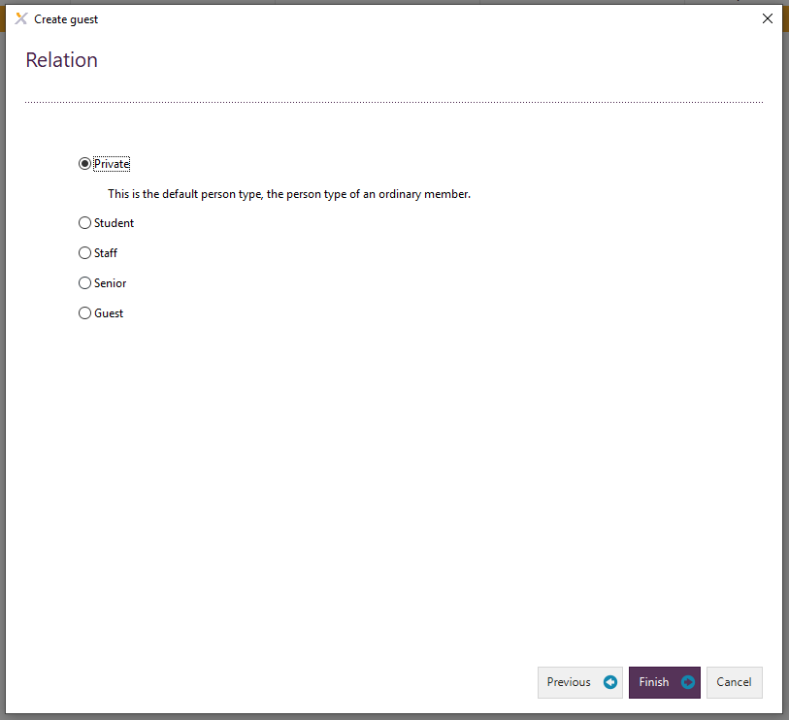

1. The Create task screen will then pop up. You will need to add the Title field by clicking on the drop down next to the Title field. Then click the Ok button. You would only need to add a new task the first time entering a lead.

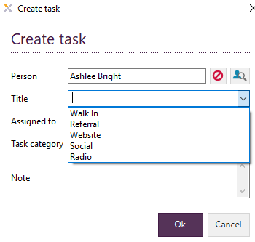

One of the features of Exerp is you do not need to schedule calls once the first call or task has been made or set up. There is a backend workflow designed to make all leads fall into the next step for the club to contact and the correct time. Of course, in the event that automated set up is not what the member needs (Eg – they tell you they are away for 2 weeks) then you can go into the person and edit the call date)

1. The lead is now created in the Lead – 1st Contact step.

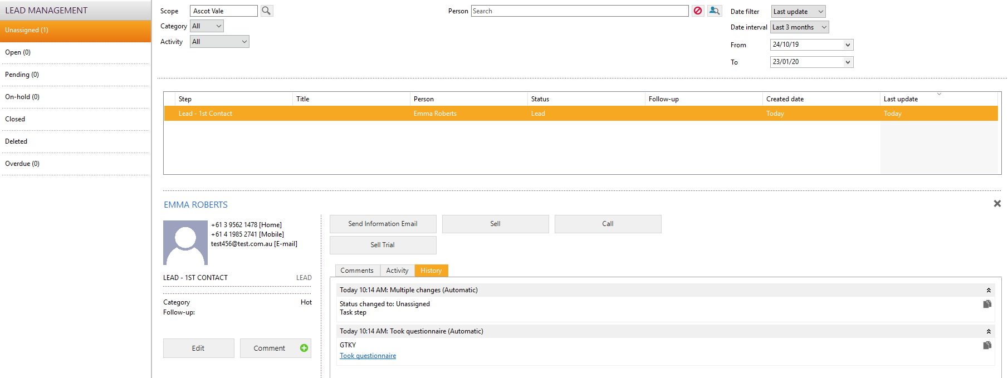

### How to manually add the title (lead generation source) to a lead:

1. Follow the instructions on how to add a lead.
2. Click the Edit button on the Lead – 1ST Contact screen.

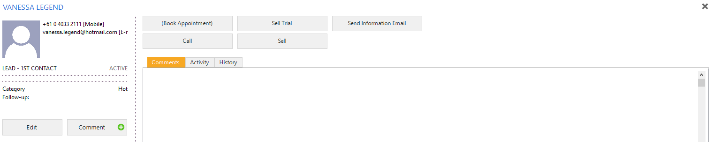

1. Type into the title field one of the following sources: Walk in, Referral, Website, Social, Radio.

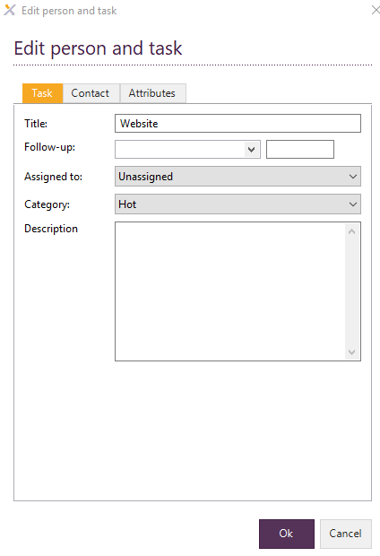

1. The Title will then show under the leads name.

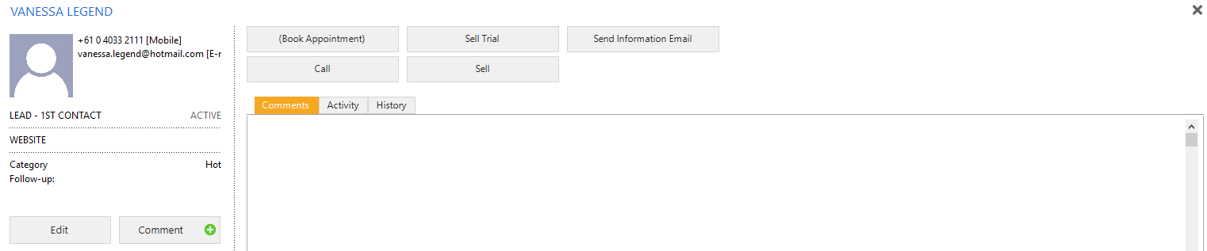

## Add a new task

*CRM App > New Task > Search lead > Select Ok*

1. Go to the CRM section in the Exerp platform.

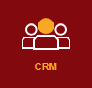

1. Click the New Task button at the bottom of the screen.



1. The Create Task screen will pop up. Type in the name of the person who you would like to create a new task for. Select the person by double clicking on them on the drop down. Select Ok.

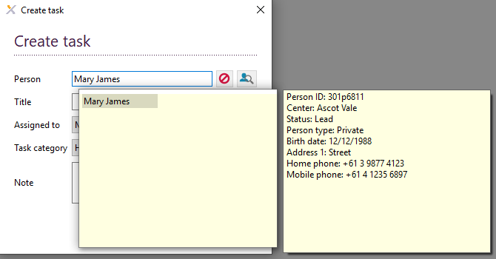

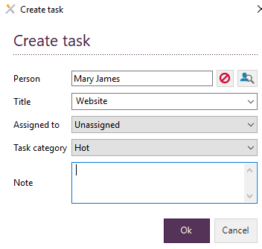

1. The lead will then be re-opened in the Lead – 1st contact step.

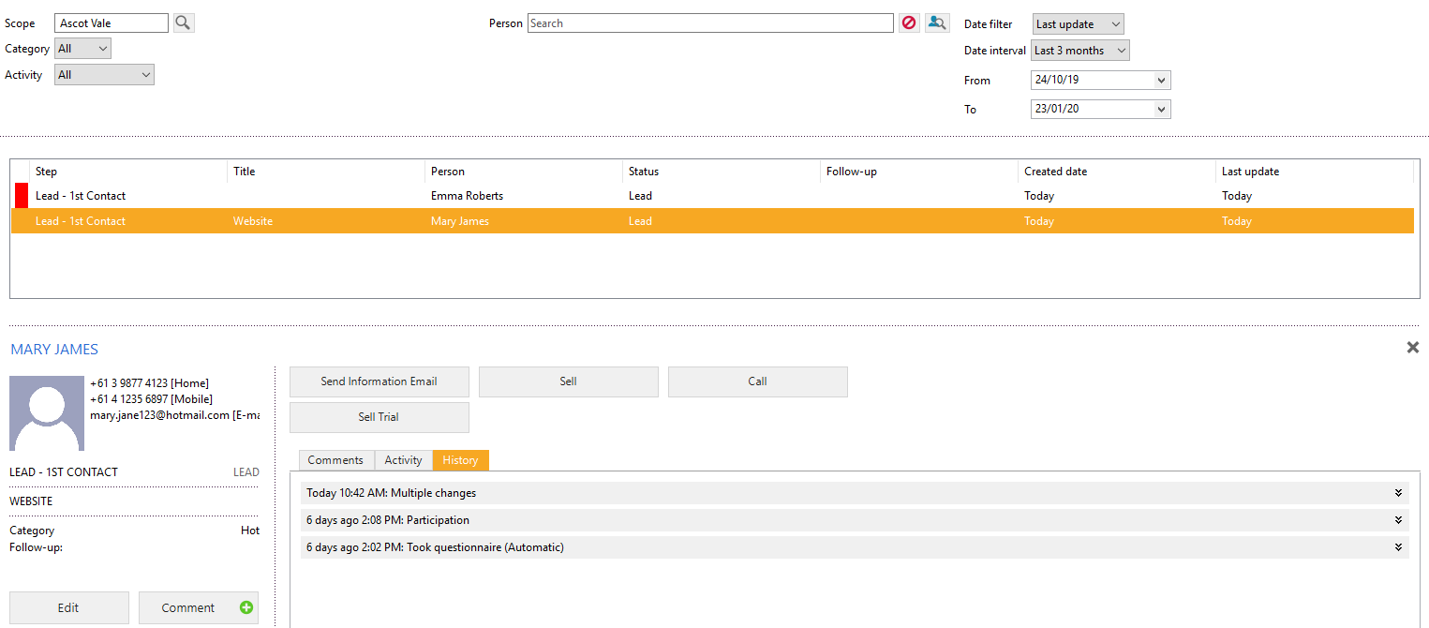

## Calling a lead and setting a follow up interval

*CRM App > Find your lead in the Person field > Select Call > Select Outcome > Finish*

1. Go to the CRM Section of the Exerp platform.



1. Choose the lead that you would like to phone by typing in the name of the lead into the Person field at the top of the page. The person’s name will appear in a pop-up box underneath the Person field. Double click on the Name and the lead’s details will then pop up on your screen.

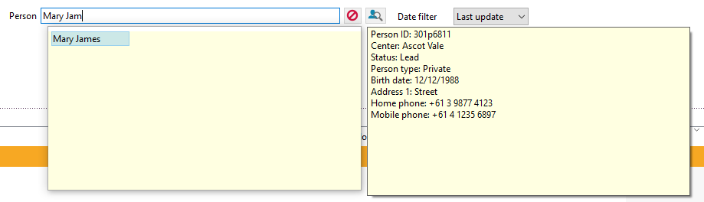

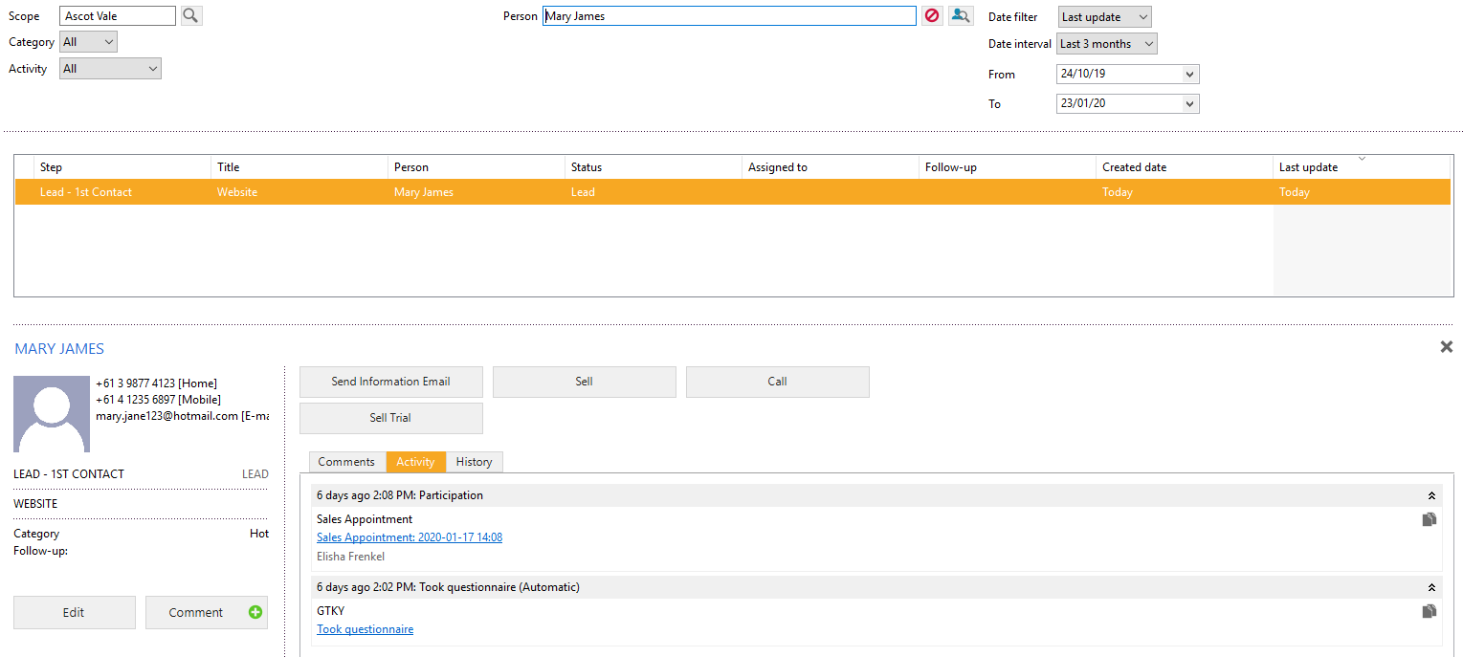

1. Click the call button.



1. The Call screen will then populate with the potential user choices. As pictured below.

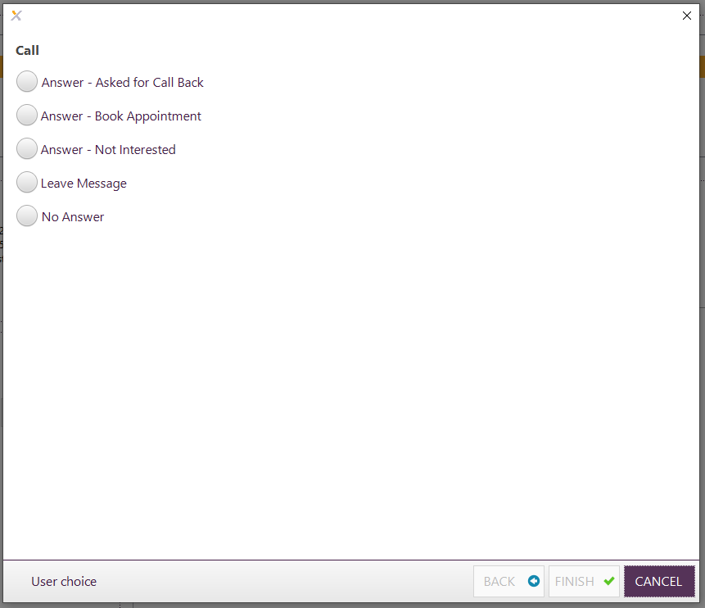

1. Click the tick box next to Answer – Asked for Call Back.

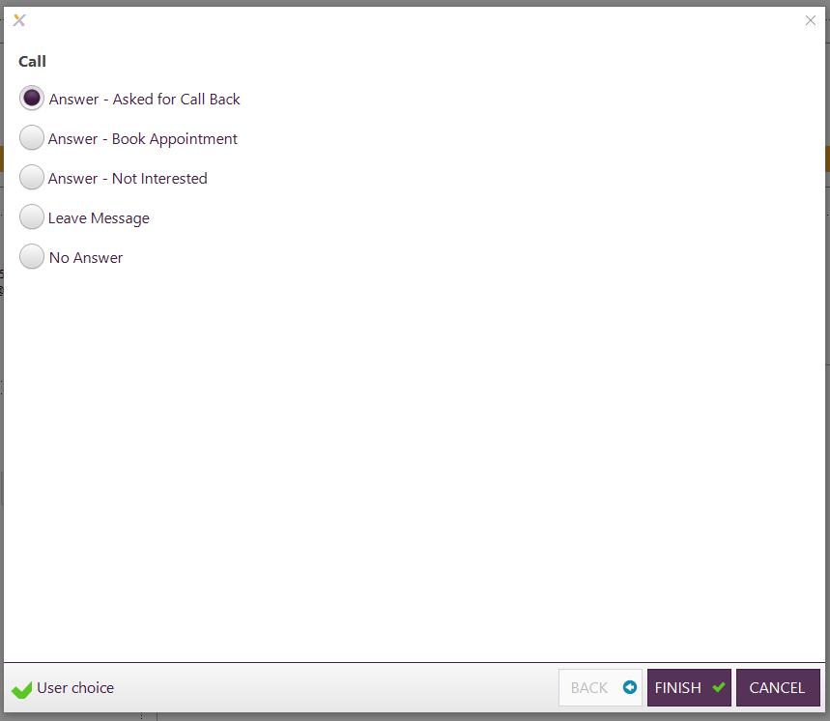

1. Then click Finish.



1. To schedule the call you will then click on the Edit button under the leads stage.

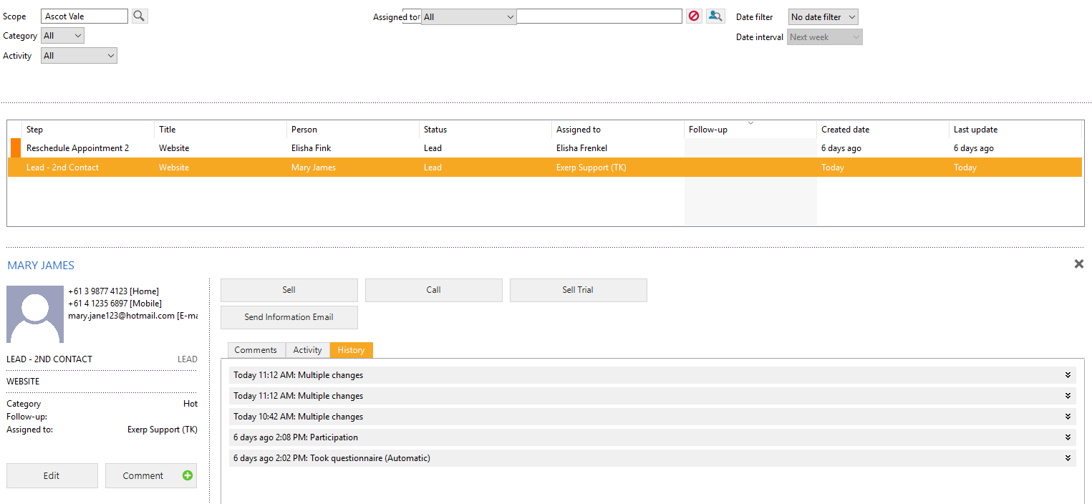

1. The edit person and task screen will then pop up.

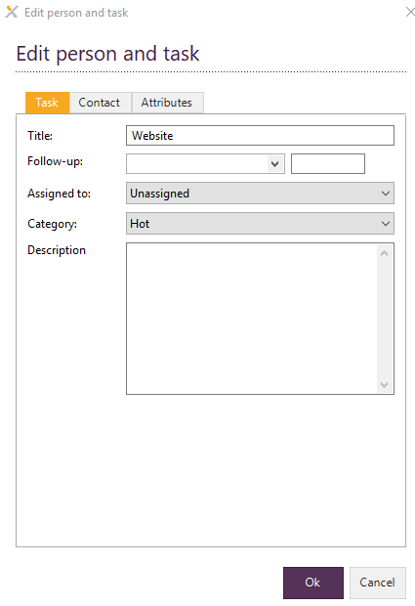

1. Click the drop-down arrow next to follow up and a calendar will appear.

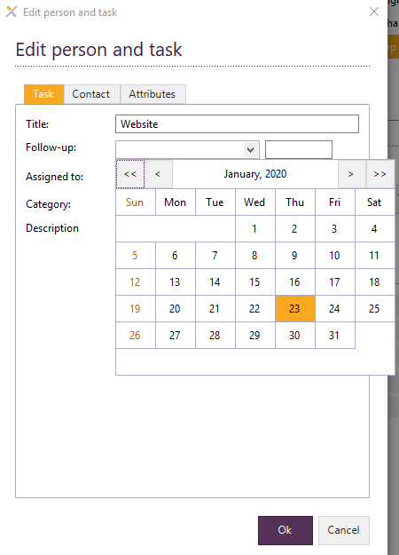

1. Click on the date the you agreed to call back the lead.

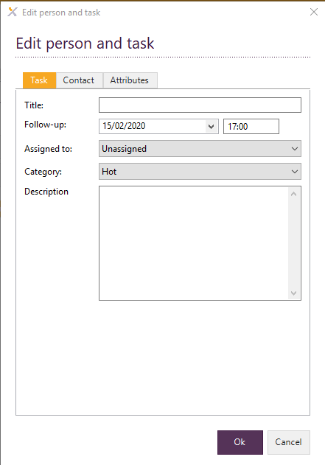

1. Please enter the time that you have agreed to call the lead back in the box next to the date.   
   PLEASE NOTE: This will need to be in 24-hour time format i.e. 5pm would be 17:00. Then click Ok.



1. The follow up section on the lead contact will now have the follow up date as the relevant date.

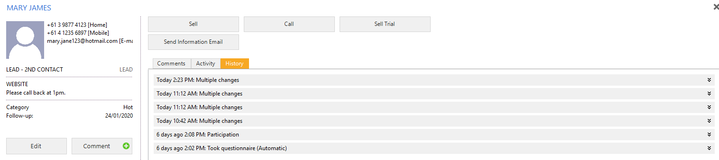

## Follow-up Intervals

Follow up intervals refers to the amount of time you have to follow up a lead before it falls into the overdue status of the lead management flow. As previously mentioned the system automates when to call, you would not need to adjust unless the lead has told you to call them at a specific time that is different from the automation. – Eg – the system schedules tomorrow, however the lead tells you they are away for 2 weeks.

### Edit a Follow-Up Interval

*CRM App > Find your lead > Edit > Task screen will op up > Change date/time in Follow-Up drop down*

1. You are able to adjust the follow up intervals by clicking on the relevant lead and then clicking on the Edit button.

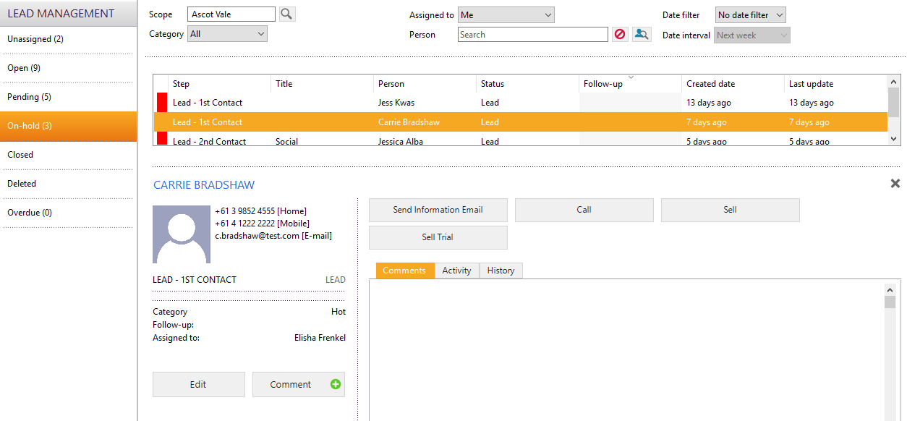

1. The Edit person and task screen will then pop up.

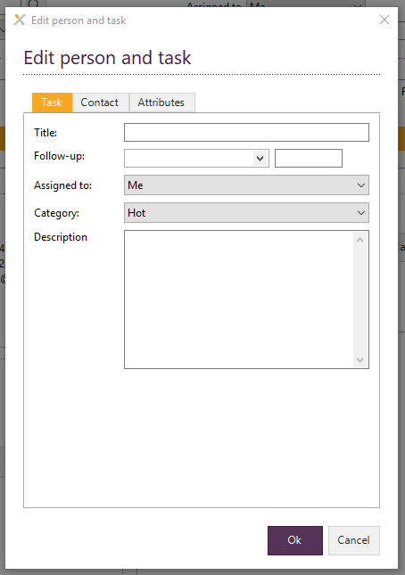

1. Add in the date to the Follow-up drop down. Add the time in 24-hour format to the box next to the date. Then click Ok.

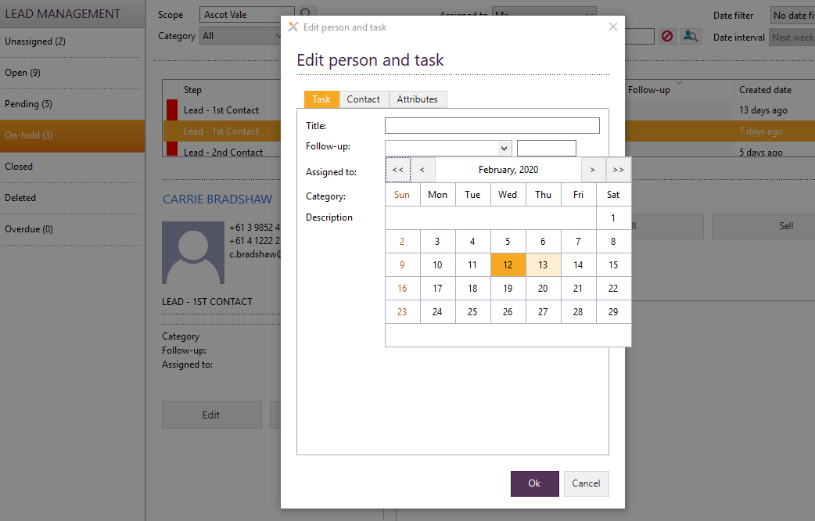

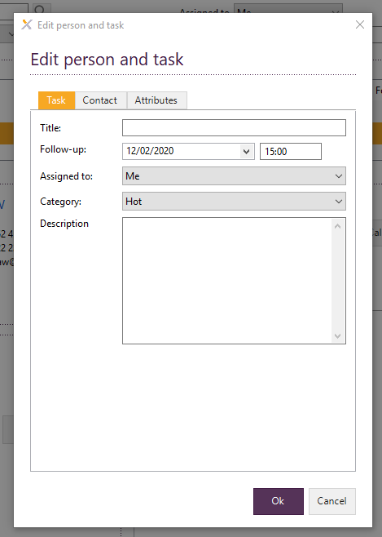

## Sell a membership

*CRM App > Find your lead > Lead will come up > Select Sell > Complete the sale via the Membership Sale App*

1. Bring up the lead that you are going to sell a member subscription to by typing in the name of the lead into the Person field. As you type in the name a pop up with the lead will appear below and you will need to double click on the correct name.

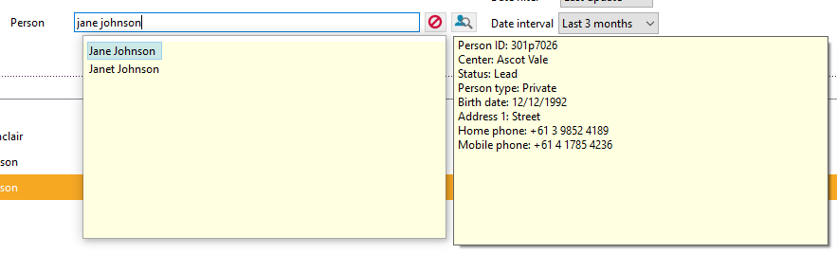

1. This will bring up the details of the lead.

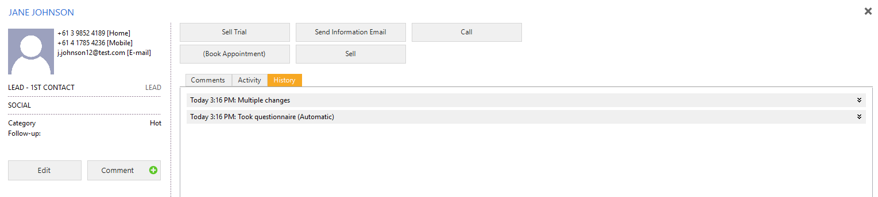

1. To Sell to the lead please click on the Sell button

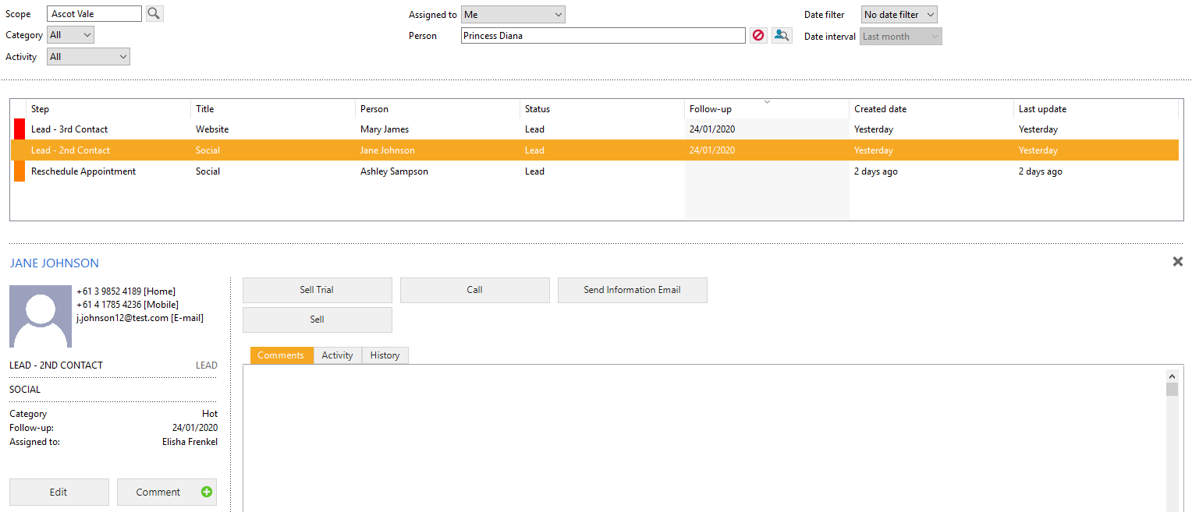

1. This will take you to the Member Sale section of the platform where you can sell a membership subscription. Please refer to instructions for Processing a membership subscription sale.

### 7-day Post Sale Call

Once the membership is sold it will transition to "Post Sign Up Call" with a follow update 7 days in the future, the name of the action (button) is "Post Sale Call. This will sit in the on hold calls for the membership consultant to do at the given time. The idea of this call is to ensure the member has settled in nicely to the club, has began their induction and is a great opportunity to remind about the member privileges referral passes.

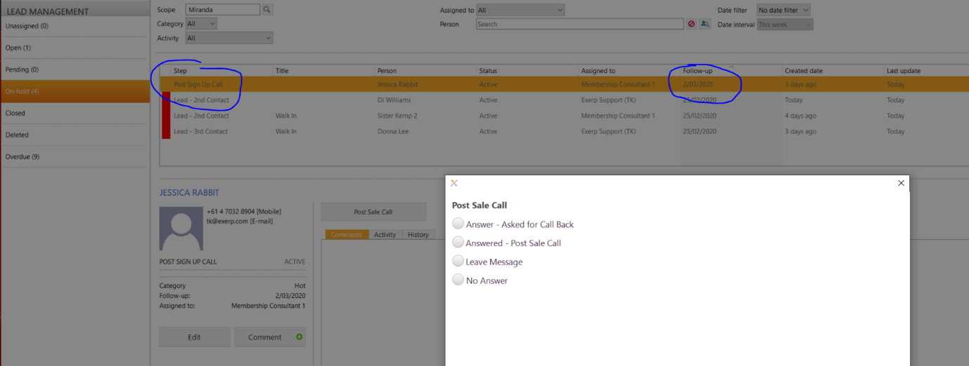

## Process a Trial

*CRM App > Search for your lead in the person field > Select Sell a Trial > Complete the process through the Membership Sale App.*

1. Bring up the lead by typing in the name of the lead into the Person field. As you type in the name a pop up with the lead will appear below and you will need to double click on the correct name.



1. This will bring up the details of the lead.



1. To sell a Trial subscription to the lead please click on the Sell Trial button



1. This will take you to the Member Sale section of the platform where you can sell a Trial subscription. Please refer to instructions for Processing a membership subscription sale however please use the TRIALS product.

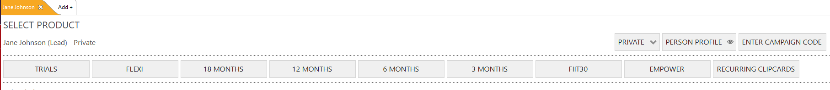

### End a Trial

1. Follow the instructions for Sell Trial subscription.
2. Go to the CRM section of the Exerp platform.
3. Bring up the lead by typing in the name of the lead into the Person field. As you type in the name a pop up with the lead will appear below and you will need to double click on the correct name.

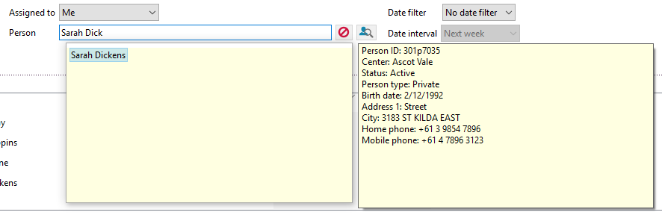

1. This will bring up the details of the lead.

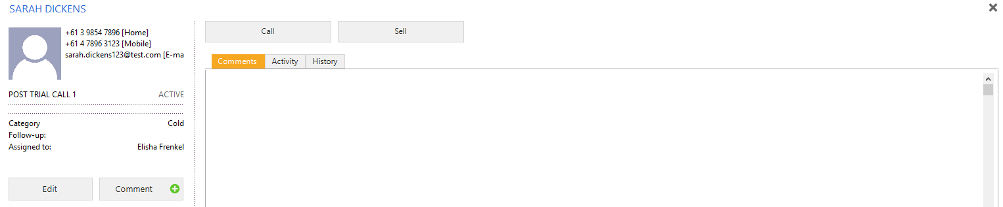

1. As the leads trial has now finished, the system will automatically transition the lead from the Trial step to Post Trial Contact 1.
2. An SMS will be sent one day before the trial ends. The copy is below:

Hi @@owner/firstName@@ - your Fernwood trial ends tomorrow. Keep those feel-good endorphins flowing - become a member today!

### Post-Trial Call

1. Follow the instructions for Sell Trial subscription.
2. Go to the CRM section of the Exerp platform.
3. Bring up the lead by typing in the name of the lead into the Person field. As you type in the name a pop up with the lead will appear below and you will need to double click on the correct name.



1. This will bring up the details of the lead. As the lead’s trial has now finished, the system will automatically transition the lead from Trial to Post Trial Contact 1.



1. Click the Call button.



1. If the lead does not answer then click on the radio button next to No Answer in the Call screen which will pop up. Then click the FINISH button.

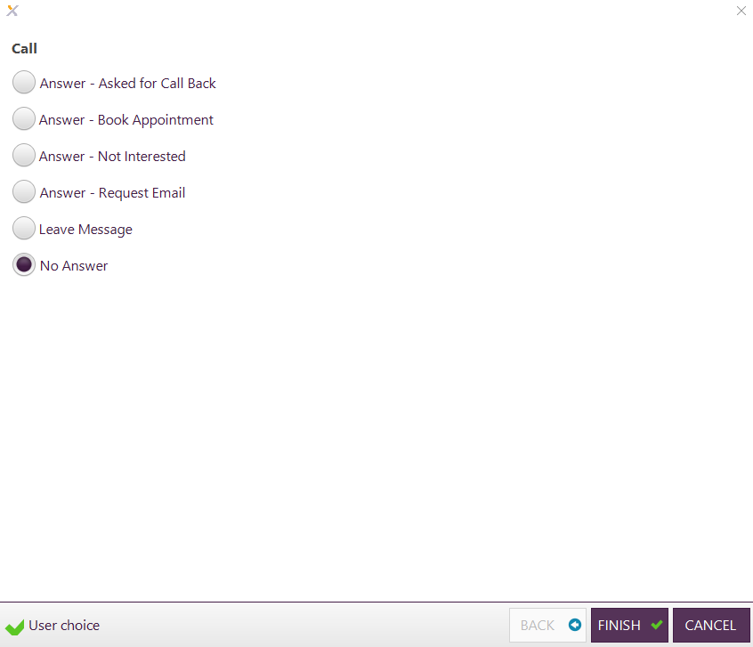

1. The lead will then transition to the Post Trial Contact 2 stage of the flow.

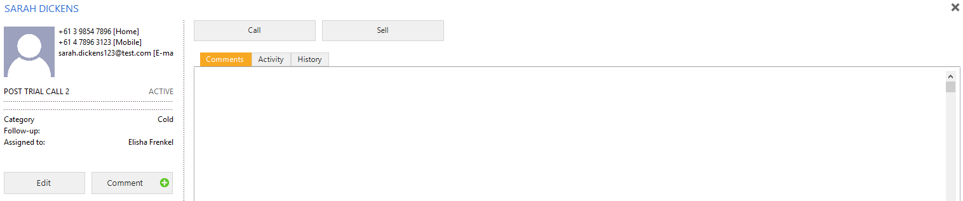

No Sale *The lead is not interested in purchasing a trial or member subscription.*

1. Add in a new lead using the instructions for add a new lead.
2. Click on the Call button.

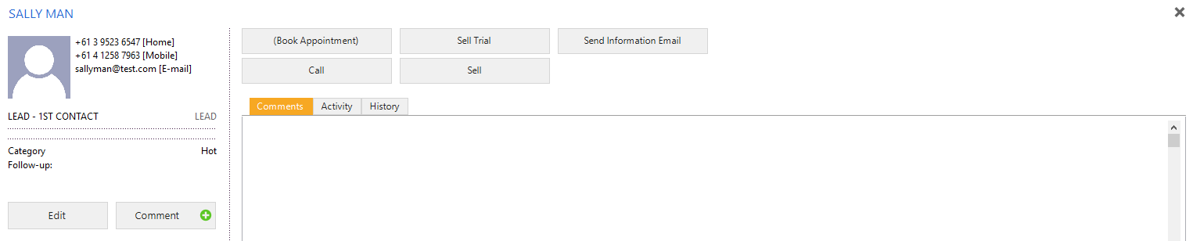

1. The Call screen will pop up. Click the button next to Answer – Not Interested. Then click the FINISH button.

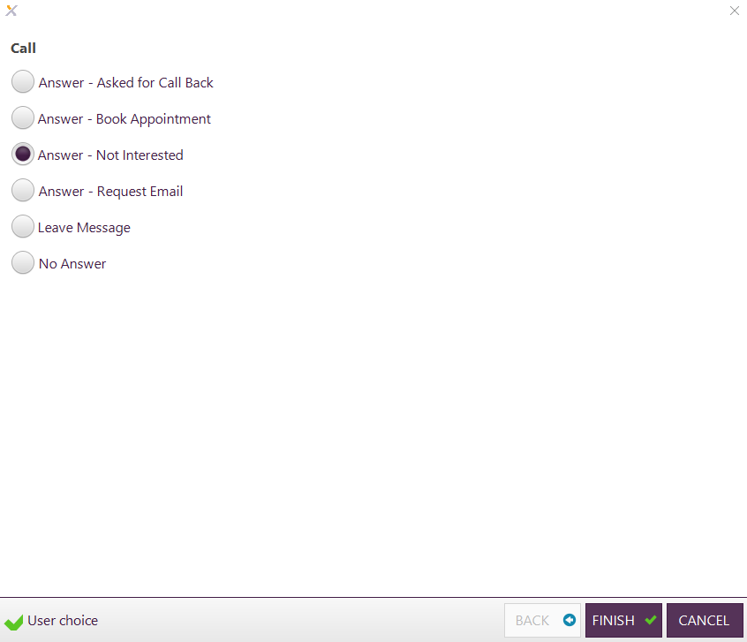

1. The lead will then transition to Closed and be sitting at the No Sale stage of the flow.

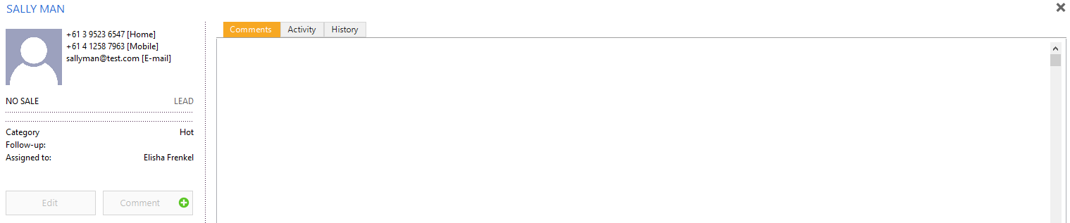

## Adding your Sales Availability

1. Go to the planning section of the Exerp platform.

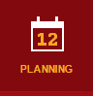

1. Click on the SALES banner and highlight Sales Availability underneath it.

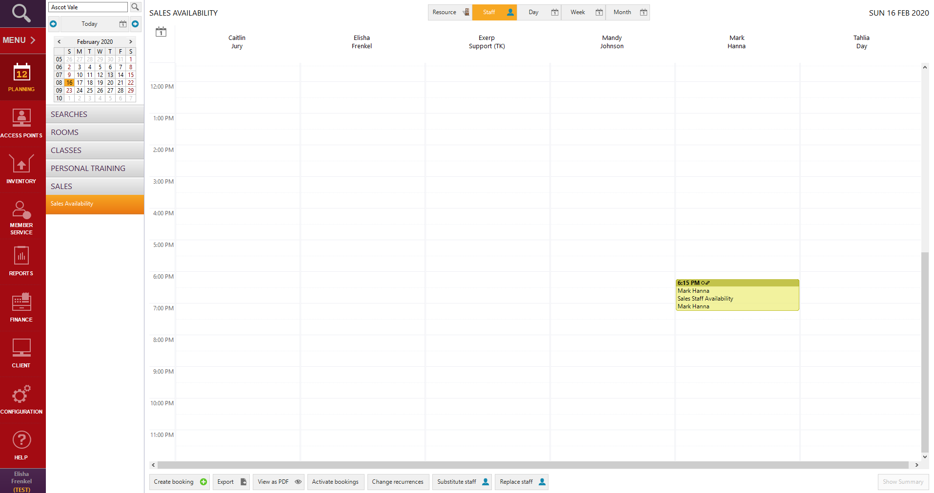

1. Click the Create booking button.



1. The Select activity screen will populate. Click Next.

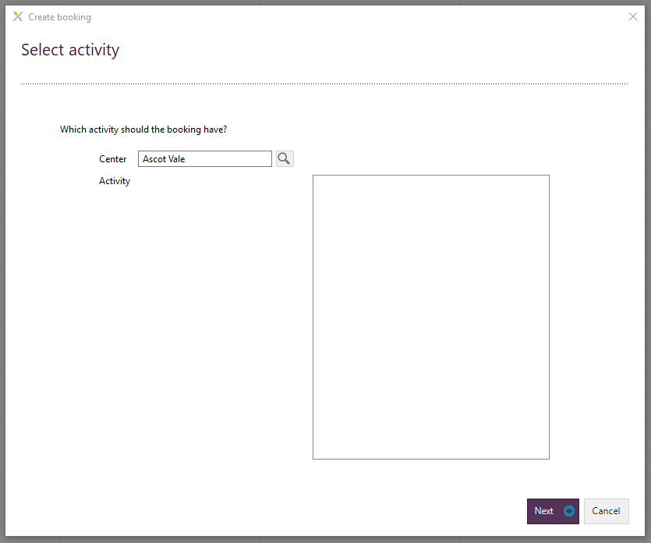

1. The Name and age limits screen will populate. Click Next.

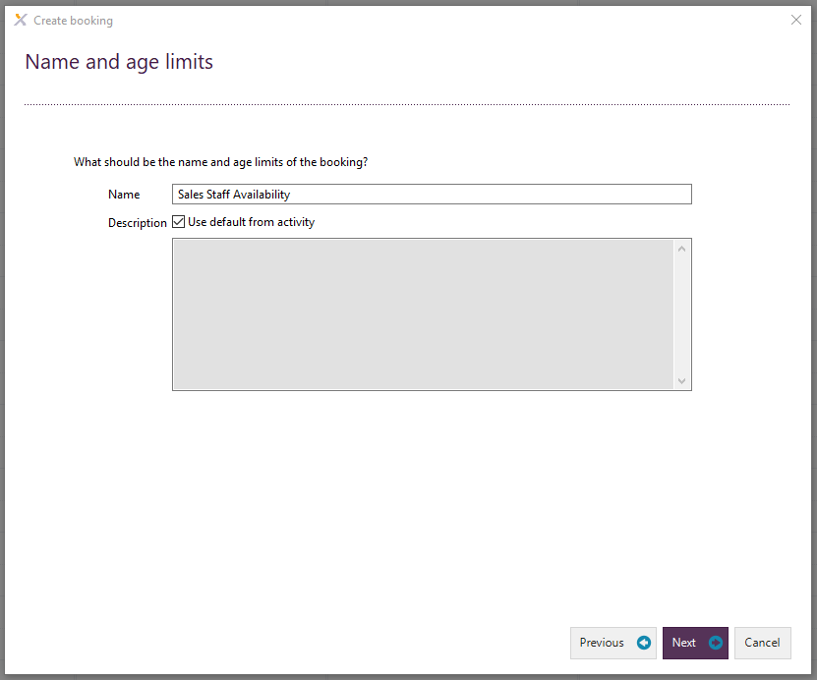

1. The Enter date and time screen will populate. Add in your relevant availability. The click Next.

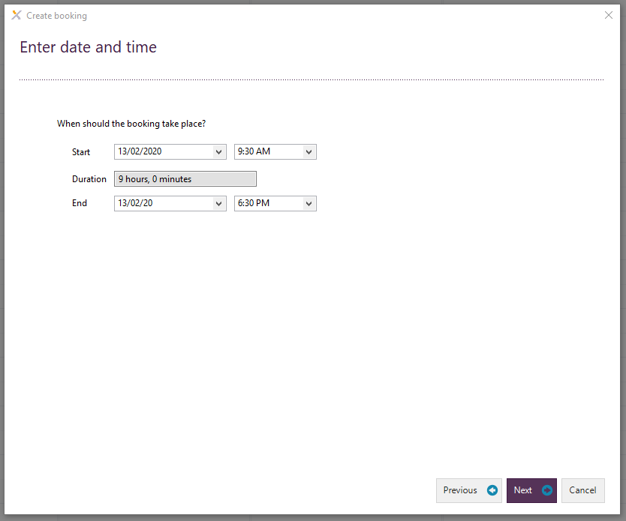

1. The Select staff screen will then populate. Choose the appropriate staff member that the sales booking is with. Then click Next.

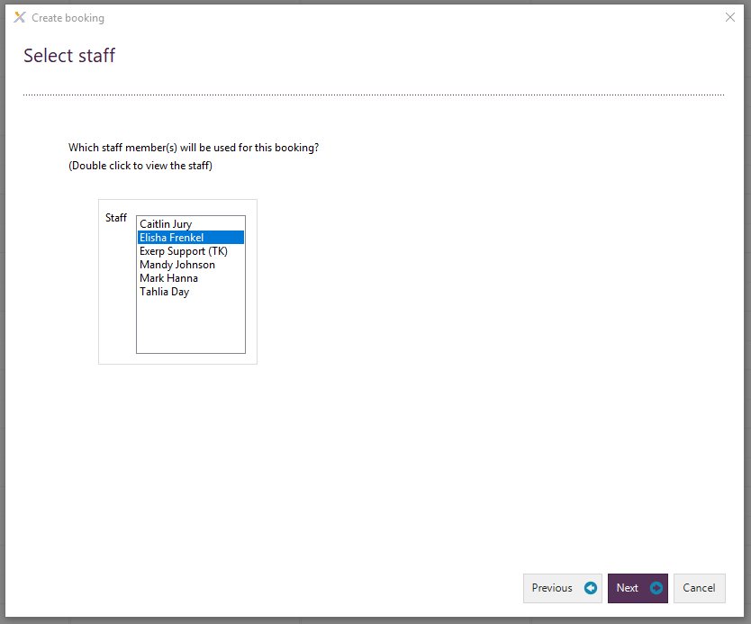

1. The Select recurrence screen will then populate. If you would like to set this availability as a daily/weekly/monthly occurrence you can do this here. Alternatively, this can be a once off occurrence. Then click Next.

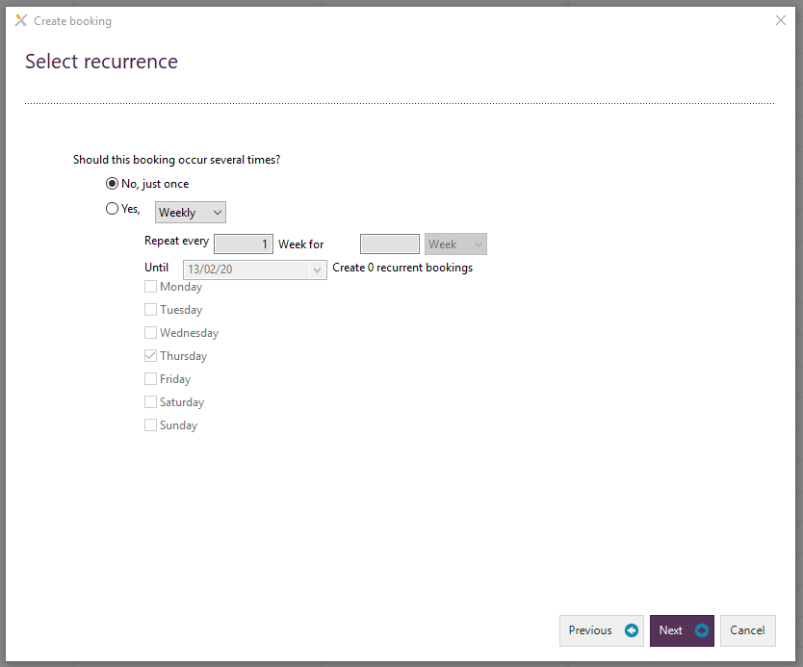

1. The Booking Summary screen will then populate. Click Finish.

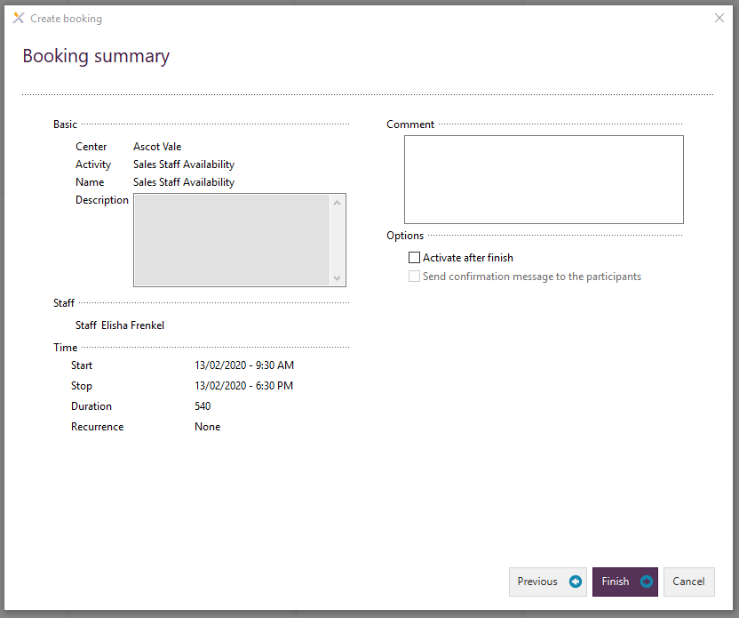

1. You will then be able to see your availability is blocked out.

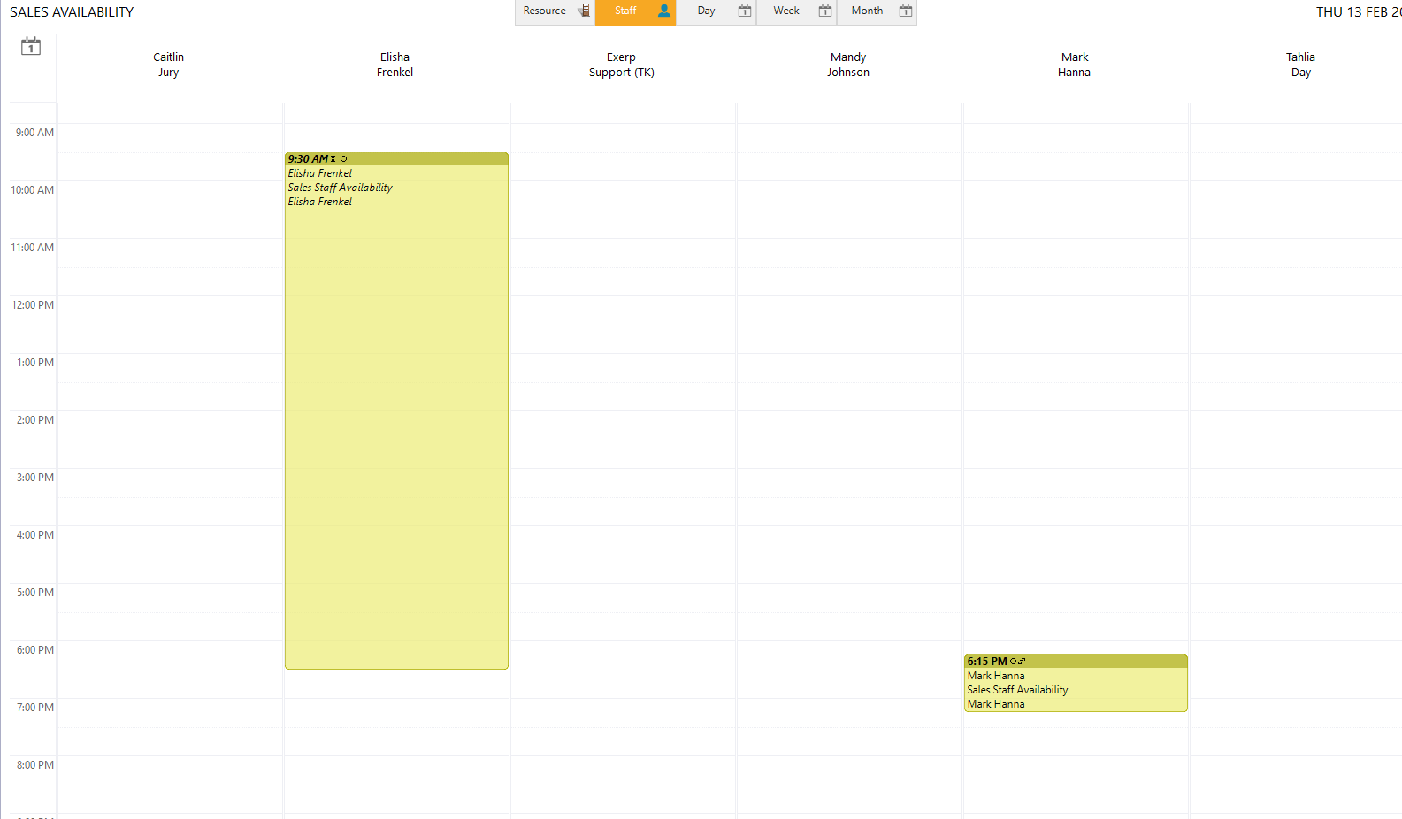

1. You will then need to activate your bookings in order to be able to actively book appointments during this block of time.

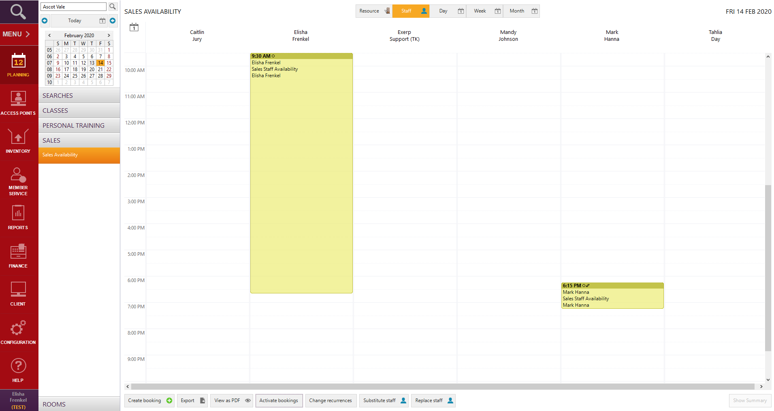

1. The Activate Bookings screen will then populate. You will need to click the sales availability period that you would like to activate or you can activate all your bookings if necessary. Click Activate. When activating bookings ensure to move the “To Date” field to the relevant date in the future so you can activate all availability into the future (if you created multiple recurrences).

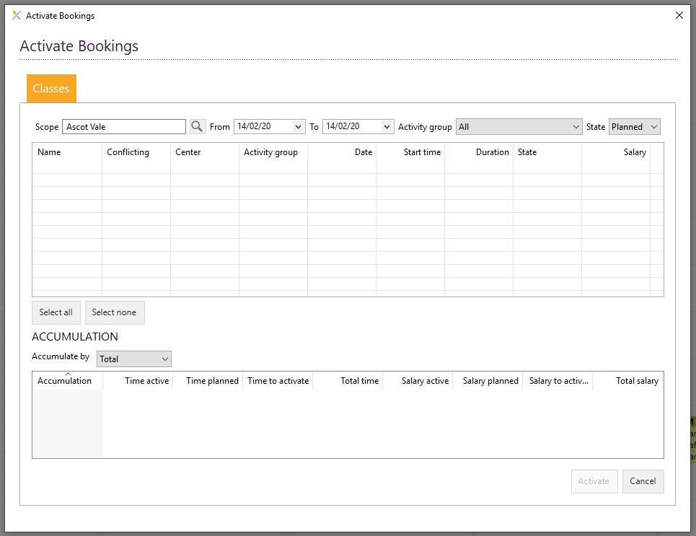

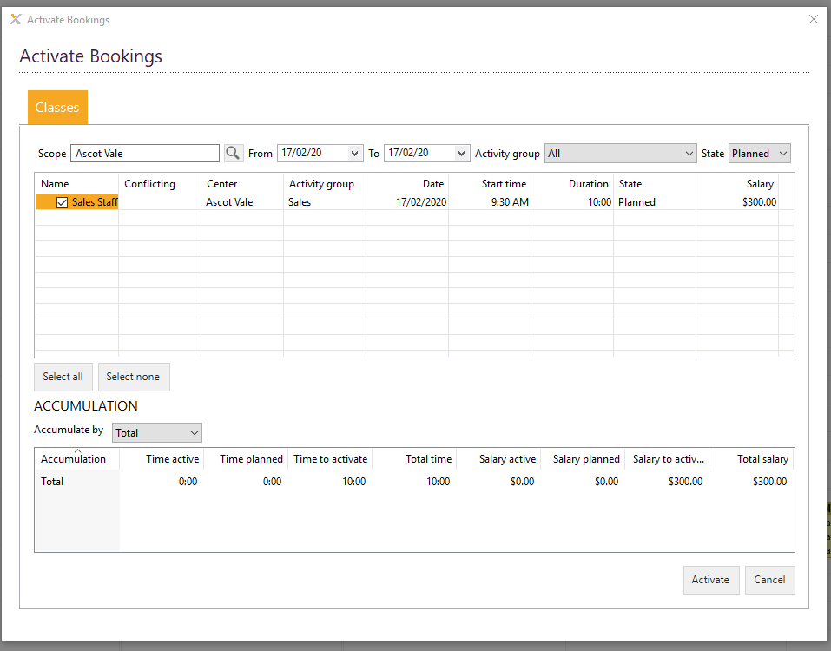

## Book a Sales Appointment (Tour)

* Before booking in a sales appointment please ensure that you have the required availability to book the appointment. You will need to use the planning section of the platform to add in your relevant sales availability. Please refer to adding your sales availability instructions.

1. Follow the previous instructions to add a new lead.
2. The lead will be sitting at the LEAD – 1st contact stage.

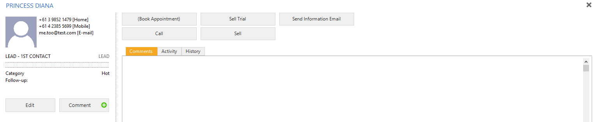

1. Click the Call button



1. The Call screen will then pop up with the user choices. Click the radio button next to Answer – Book Appointment.

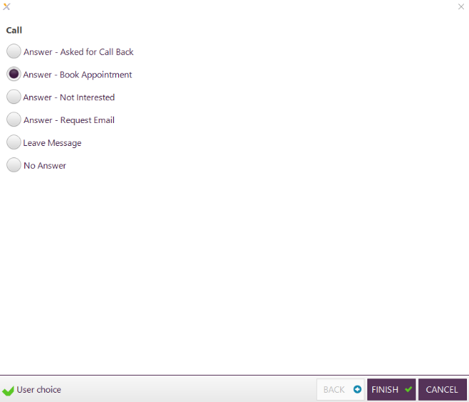

1. The Calendar will open where you can book in your Sales Appointment.

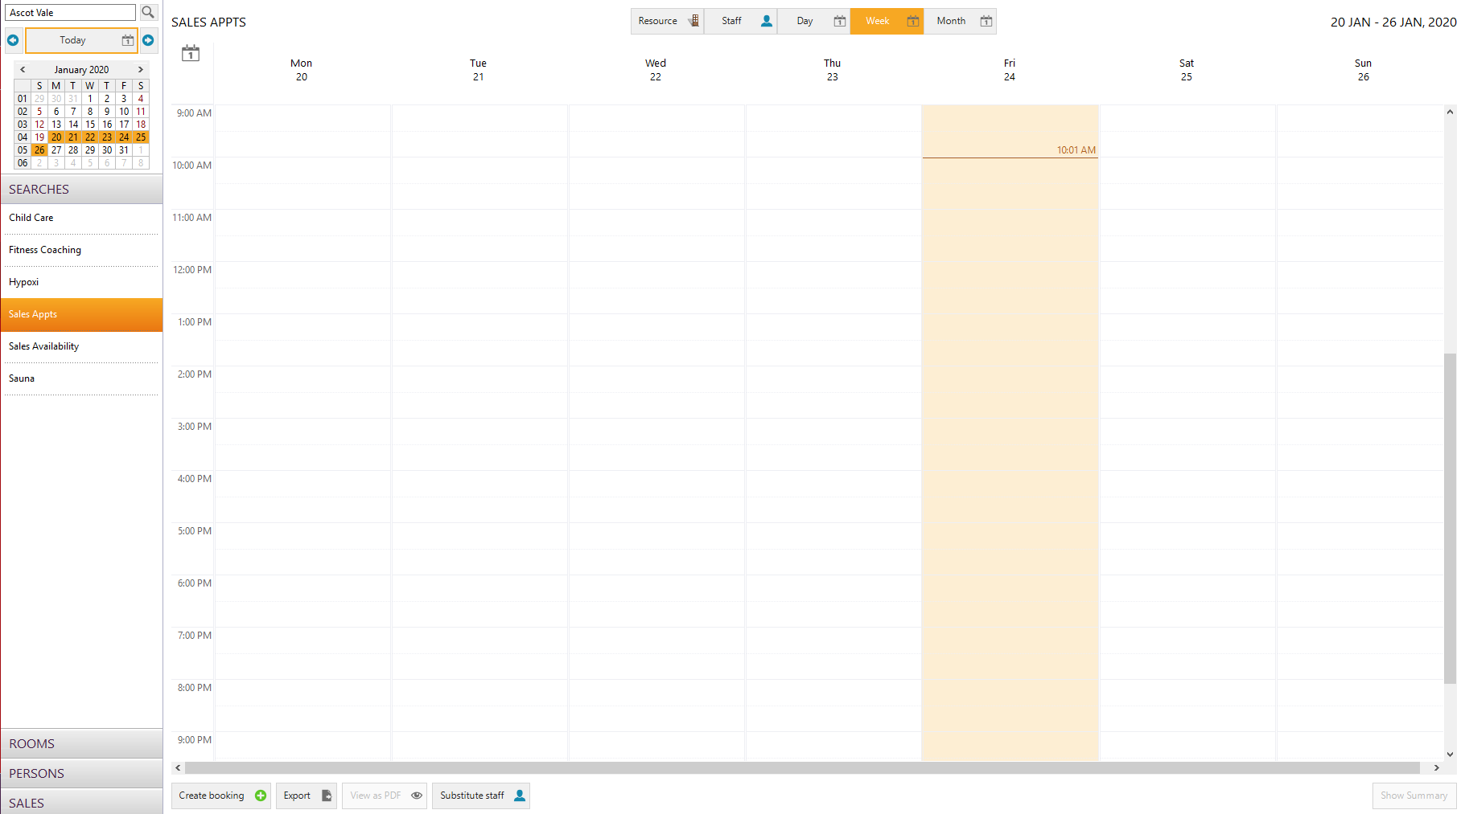

1. To add a sales appointment to the calendar please click on the PERSONS section and click on the name of the person that you are booking the sales appointment for.

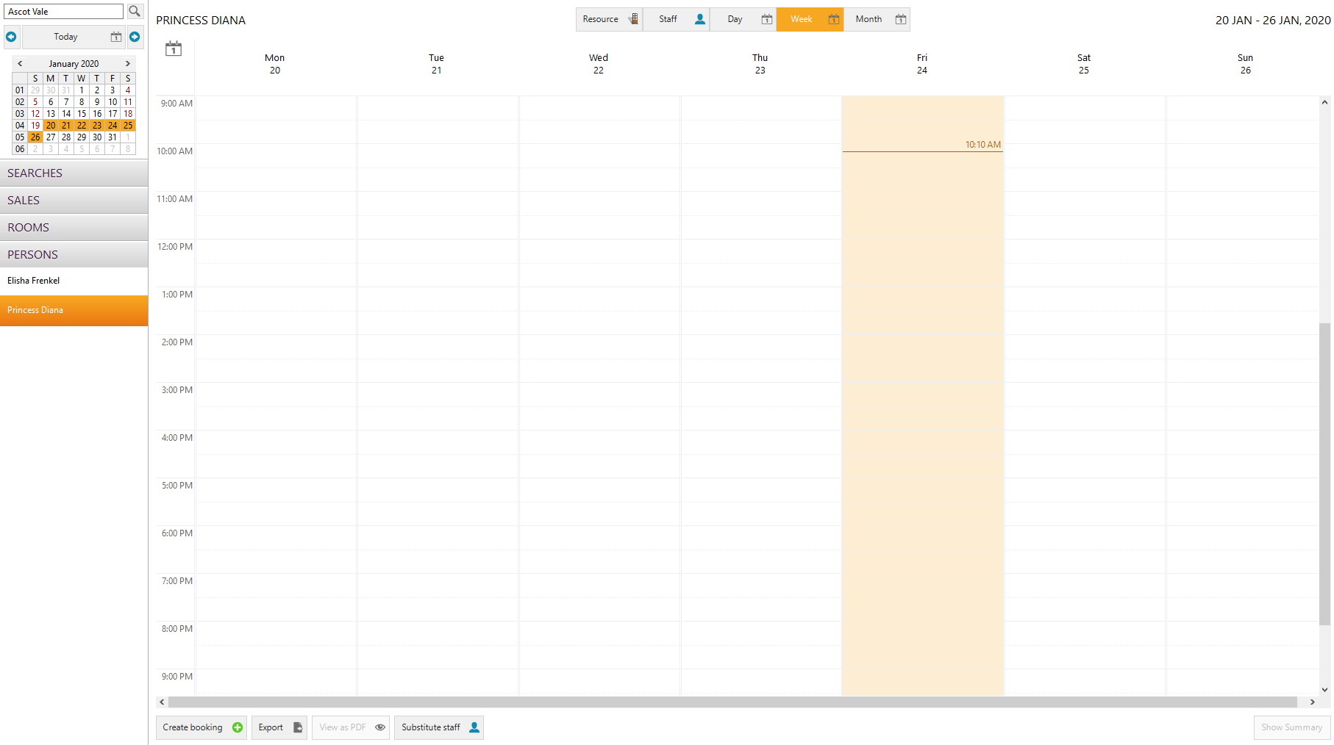

1. Double click on the time you would like to book the sales appointment for and the Select activity screen will pop up.

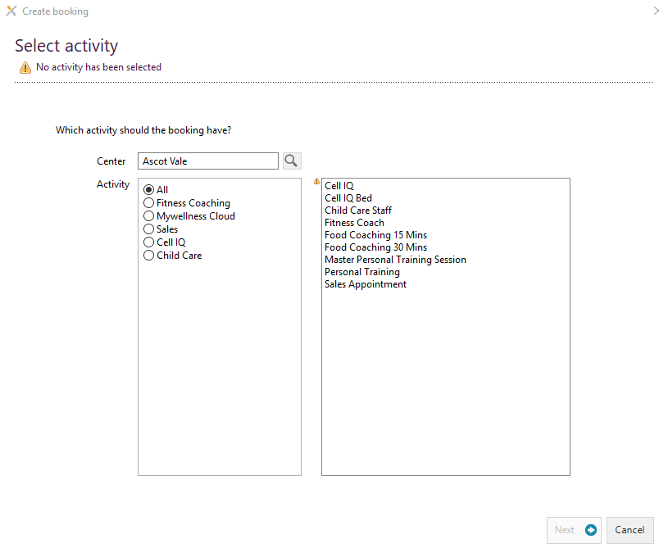

1. Under Activity click on the sales button.

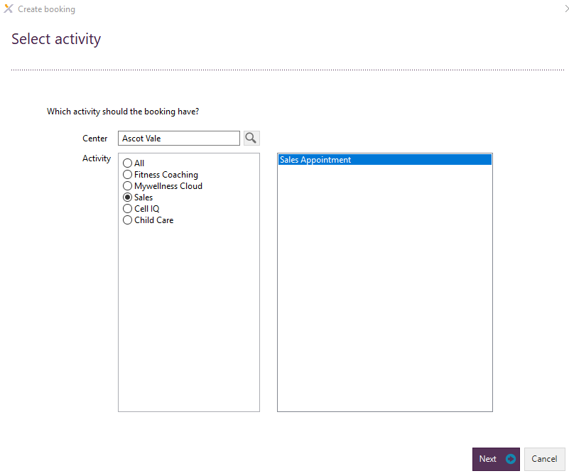

1. Click to highlight the option for Sales Appointment in the box to the right of Activity. Then click the Next button.



1. Enter the date and time of the sales appointment required. You are able to change the duration of the appointment using the drop down next to the duration field. Then click the Next button.

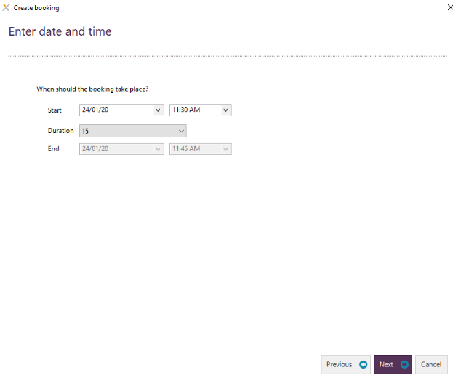

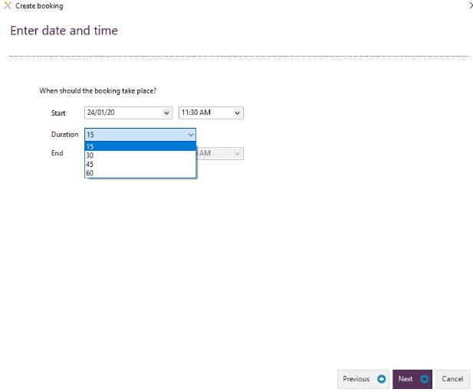

1. Choose the relevant staff member. Then click the Next button.

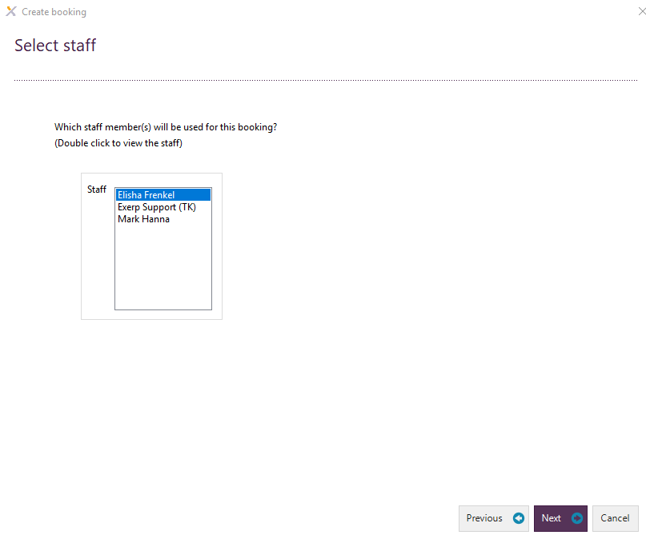

1. The next page is the Booking Summary. Click the Finish button on this screen.

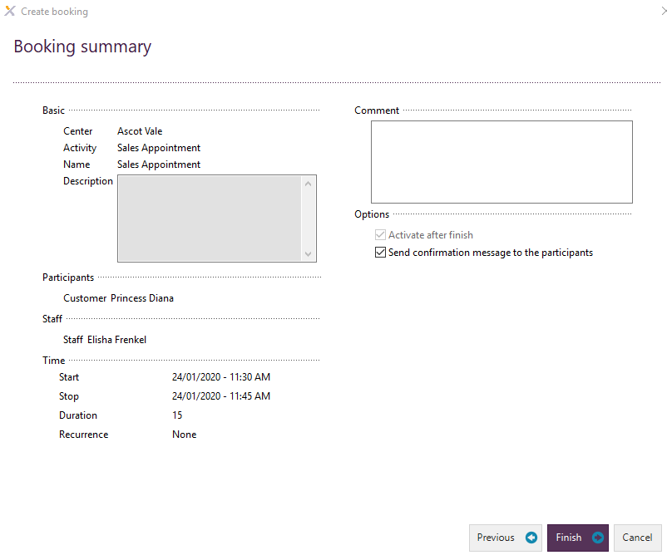

1. You will now see the appointment appear at the relevant timeslot in the calendar. The red dot next to the sales appointment indicates that the lead has not yet toured and once the lead been shown up for their tour then the dot will turn green.

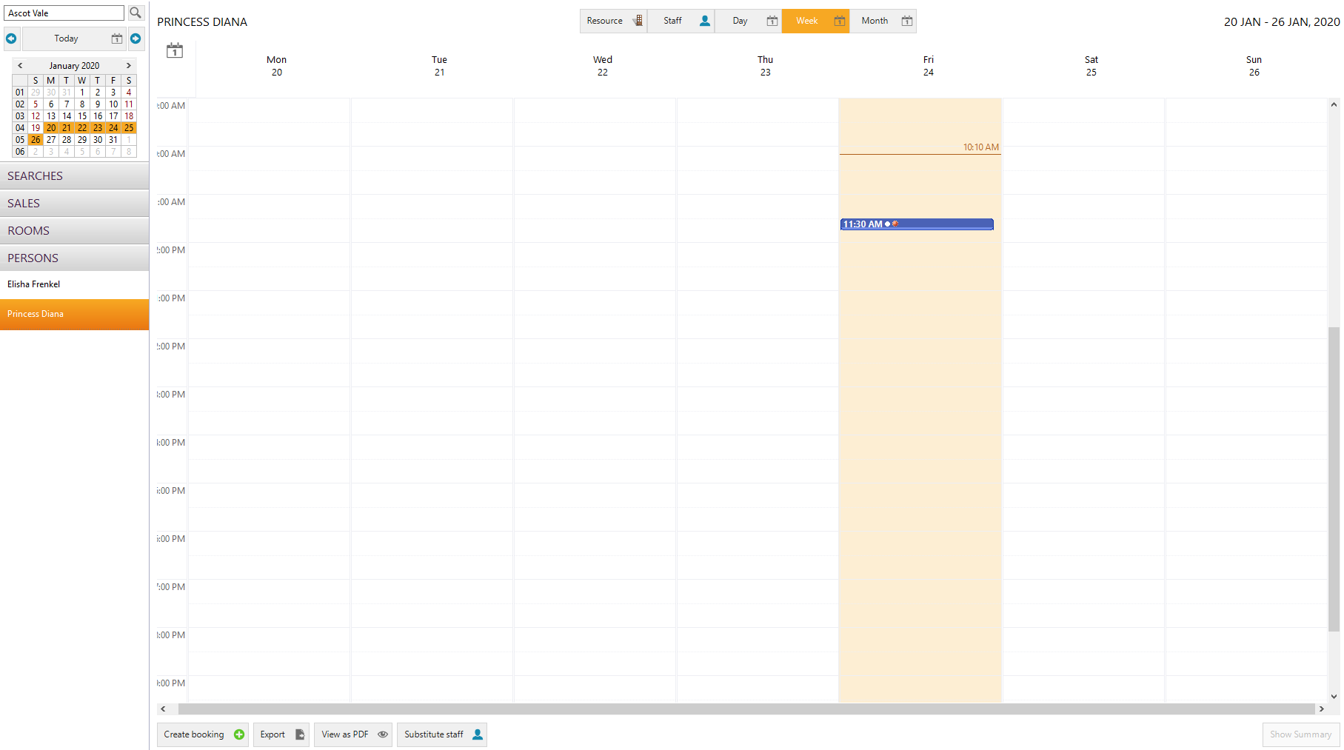

1. The lead will be sitting at the Lead – 1st contact stage of the lead management flow.

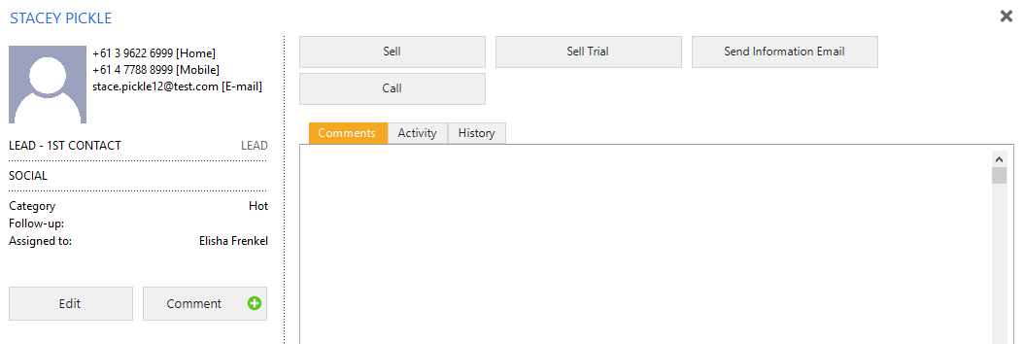

1. Once the appointment has been booked in the customer will be sitting under the open status and will be sitting at the Tour Booked stage.

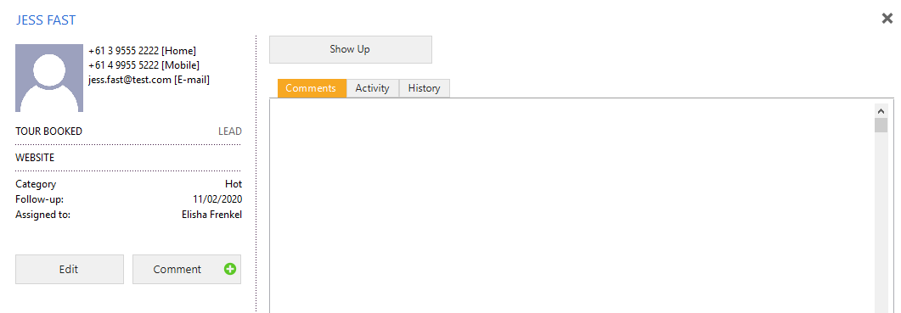

1. You can add more than one member to the booking as well, if you wanted to do a tour with 2 friends or a mother and daughter together -this is set up to allow up to 3 people at a time against one booking.
2. If you would like to add additional lead to the booking then you can do this by going to the calendar app. The click on the SALES heading and then on Sales Appointments.
3. Double click on the sales appointment that you would like to add participants to. The below screen will then populate.

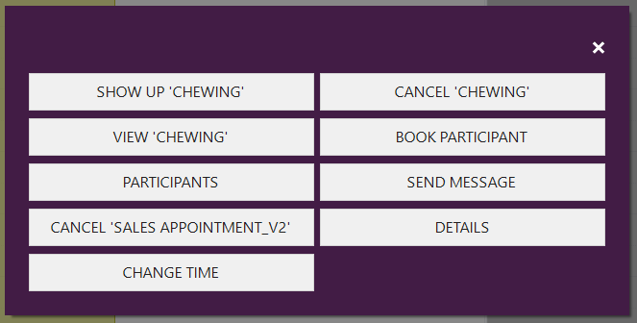

1. Click on participants. The Participation details screen will populate. Click Book + button.

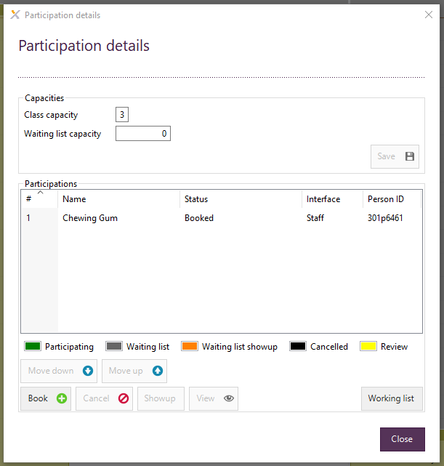

1. Book in the relevant participant(s) in the Book participant screen. Then click Close.

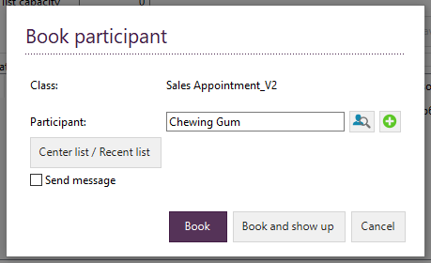

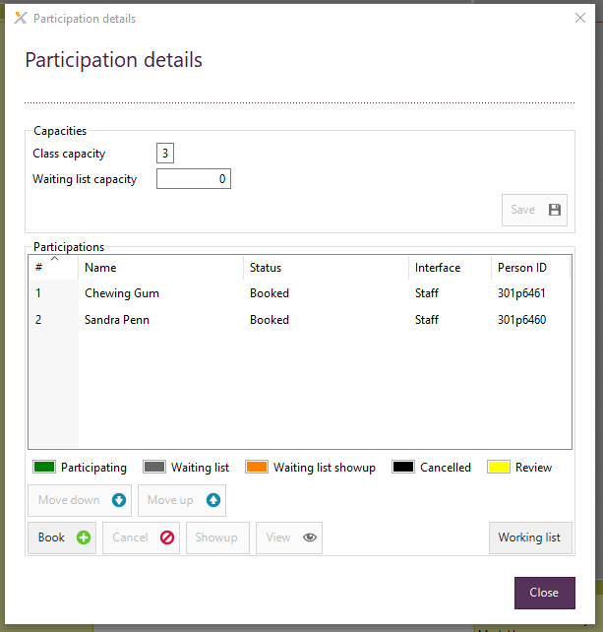

### Showing up a customer for a sales appointment

1. You will need to move to the Calendar application in Exerp.

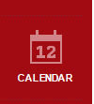

1. Click on ‘Sales Appointments’ on the left-hand side under SALES.

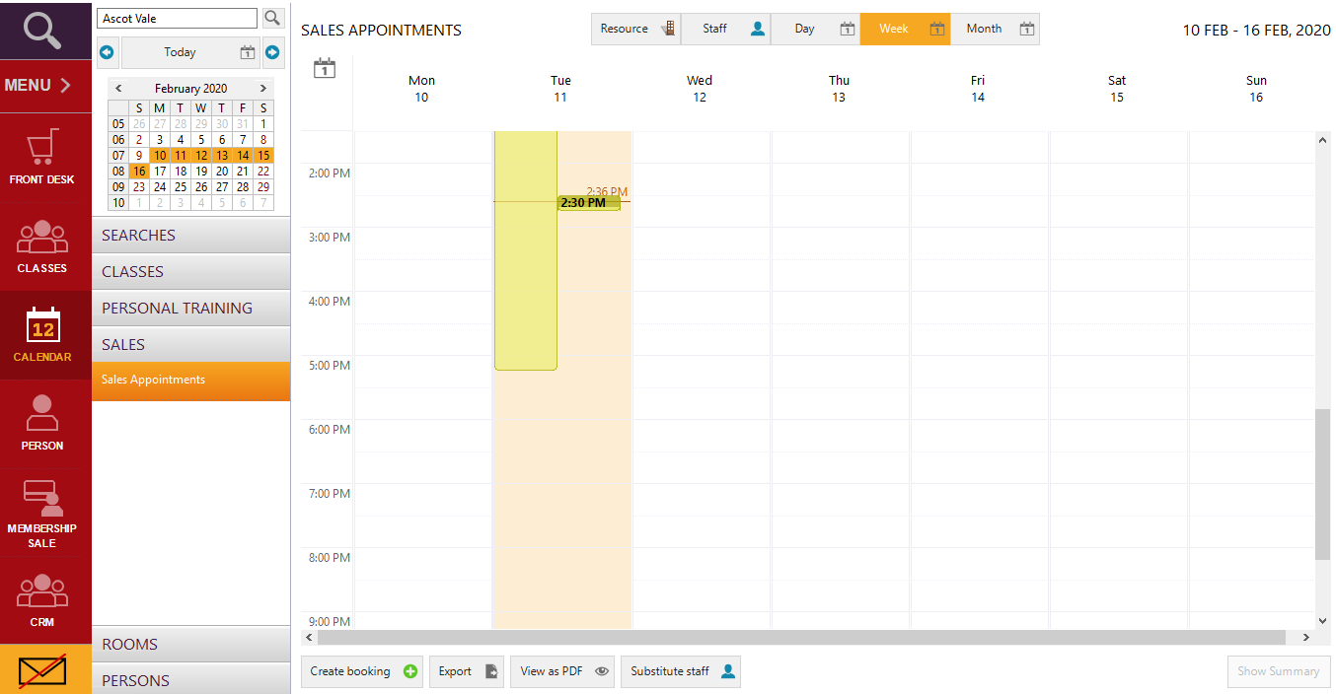

1. Double click on the relevant sales appointment.

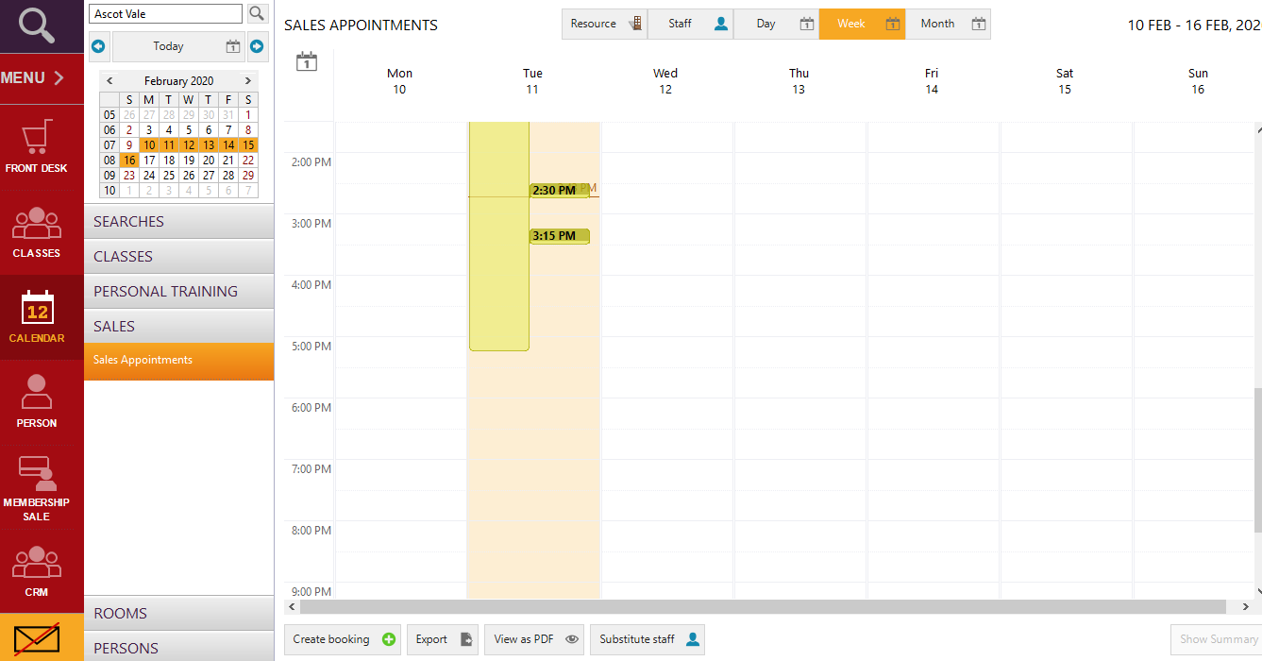

1. A screen will show up with a number of options. You will then click the SHOW UP ‘CUSTOMER’ button to show up the customer to their appointment.

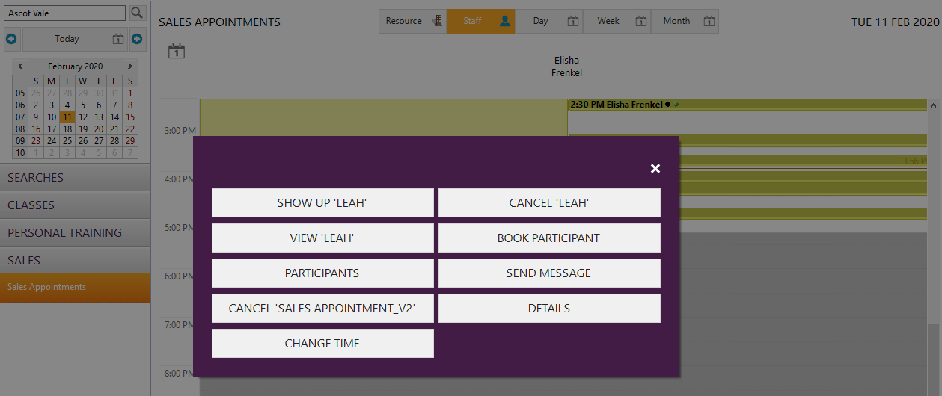

1. The customer will then be sitting in the open status and have moved to the Tour Complete stage.

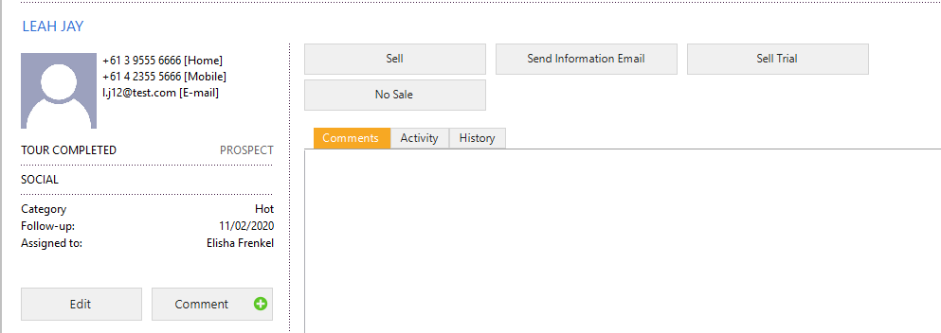

1. Alternatively, you could stay in the CRM app and show them up here.
2. Instead of moving to the calendar app you would just click on the ‘Show Up’ button on the lead who is sitting at the Tour Booked step.

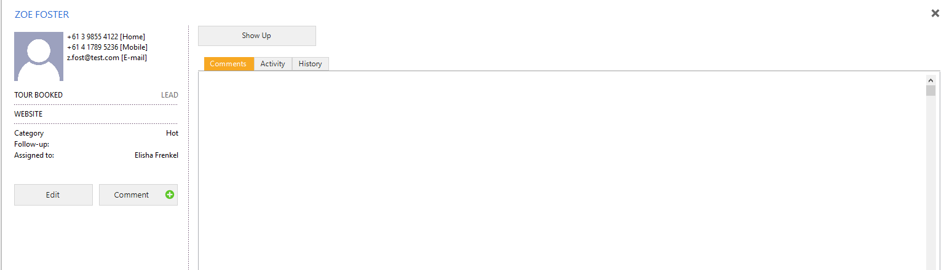

1. The Show Up screen will be populated. Click on the time of the relevant Sales Appointment. Then click FINISH.

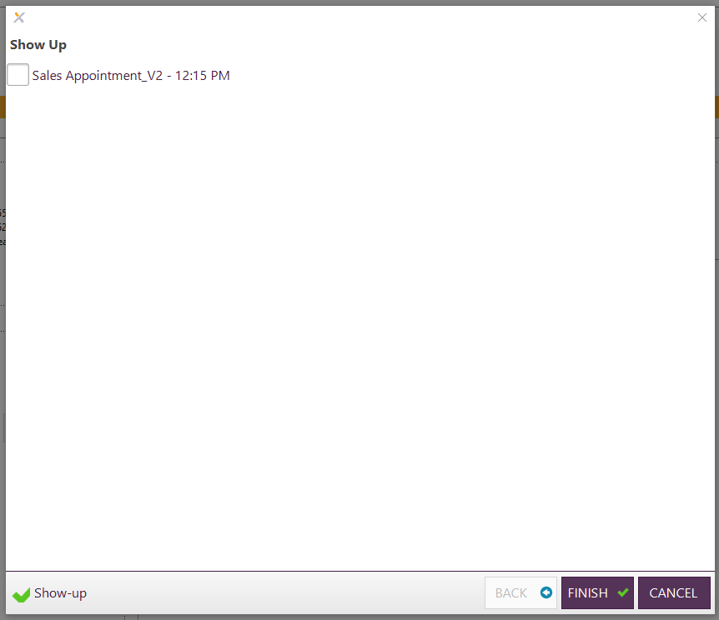

1. The lead will then also be taken to the next step which is Tour Completed.

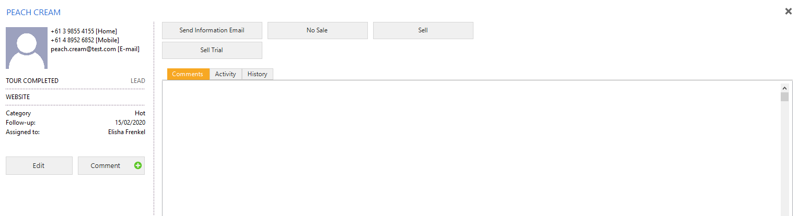

### Reschedule an appointment

1. In the Calendar section of the platform you will update the appointment if the lead is unable to make the original appointment time. You will need to go to the Calendar section and click on SALES and then on ‘Sales Appointments’.

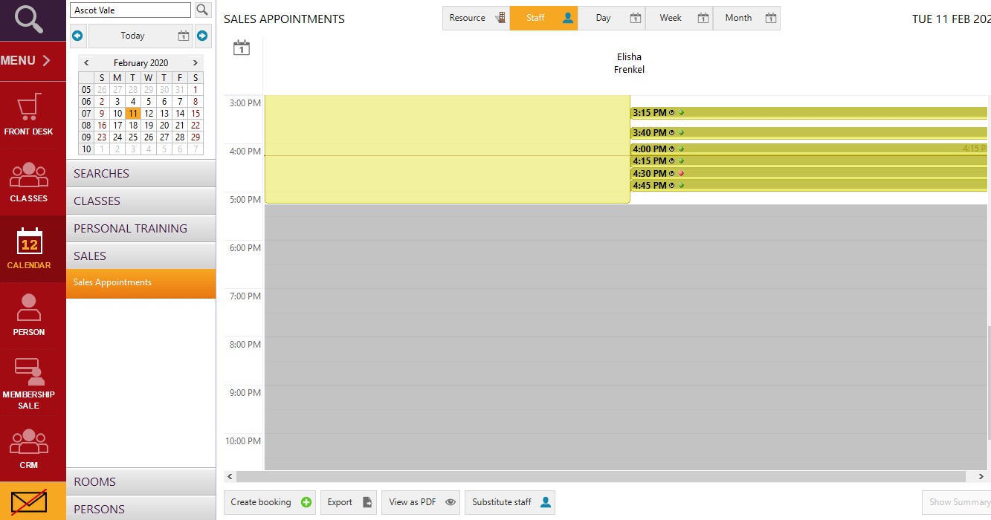

1. You can then drag and drop the appointment to the new time that the customer requests. A change time screen will then pop up.

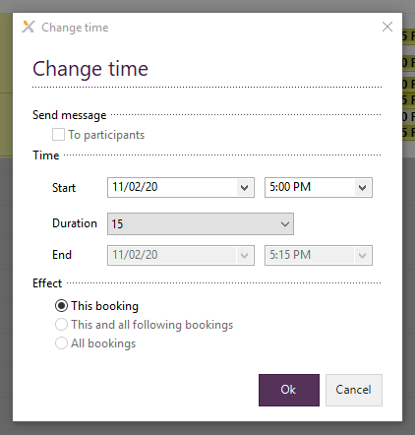

1. Make sure that the time in here is the updated time or if it is incorrect then please add in the correct time. Then click OK.



4. The appointment will now show as the updated time.

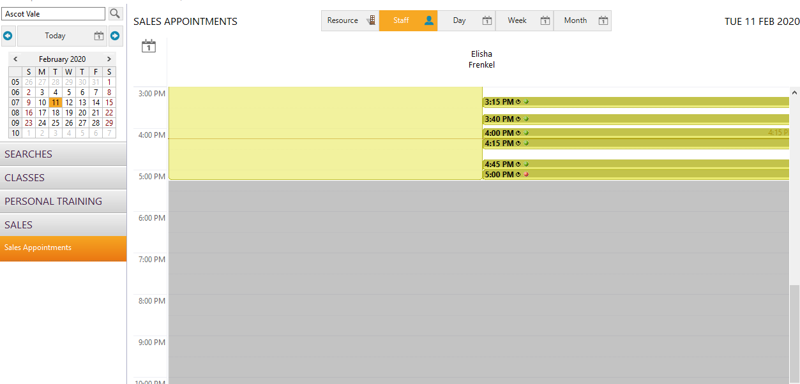

### Cancel an appointment and schedule a follow up call

1. If a lead does not show up to their Sales Appointment and is never marked as a ‘Show Up’ then the system will automatically update the lead to be a no show and transition the lead to the next step which is Reschedule Appointment.

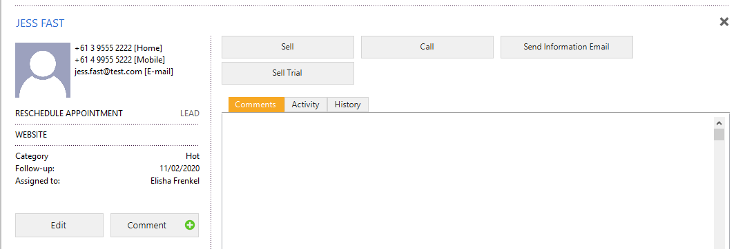

1. Click the Call button and then physically call the lead to reschedule the sales appointment.

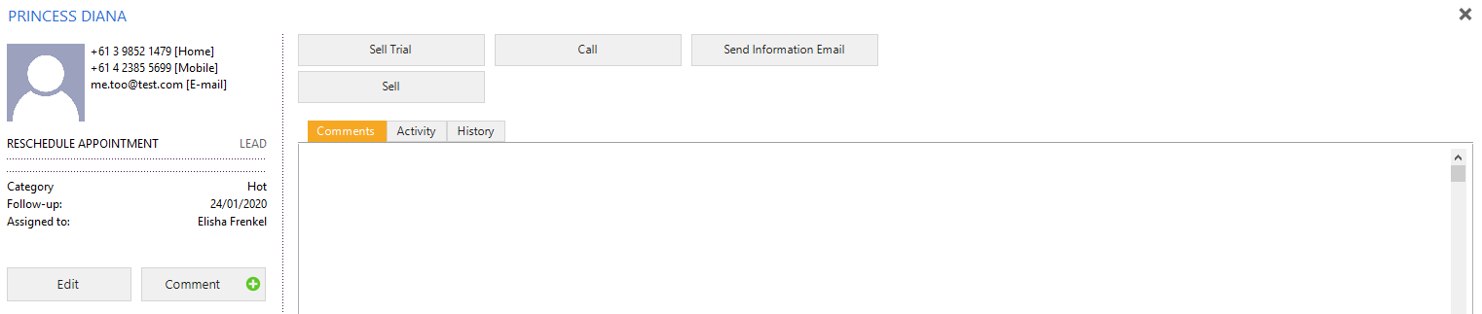

1. Pending that the lead answers and wants to book an appointment then you will be taken back to the calendar to follow the steps to book a sales appointment as you did previously. If the lead does not answer your call then you will record the user choice from the list in the Call screen after you click the call button. Then click the FINISH button.

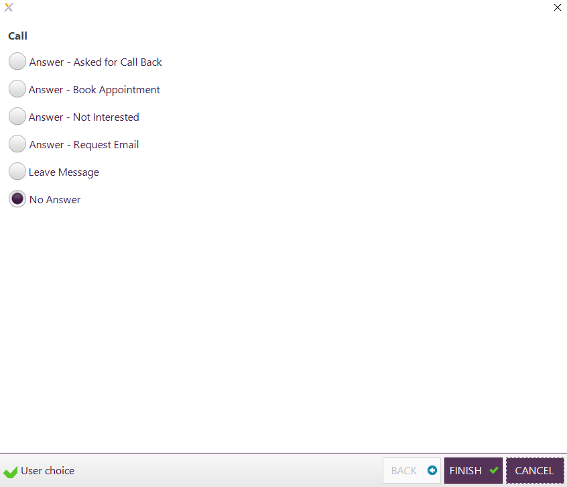

1. The lead will then transition to the Reschedule Appointment 2 stage of the flow.

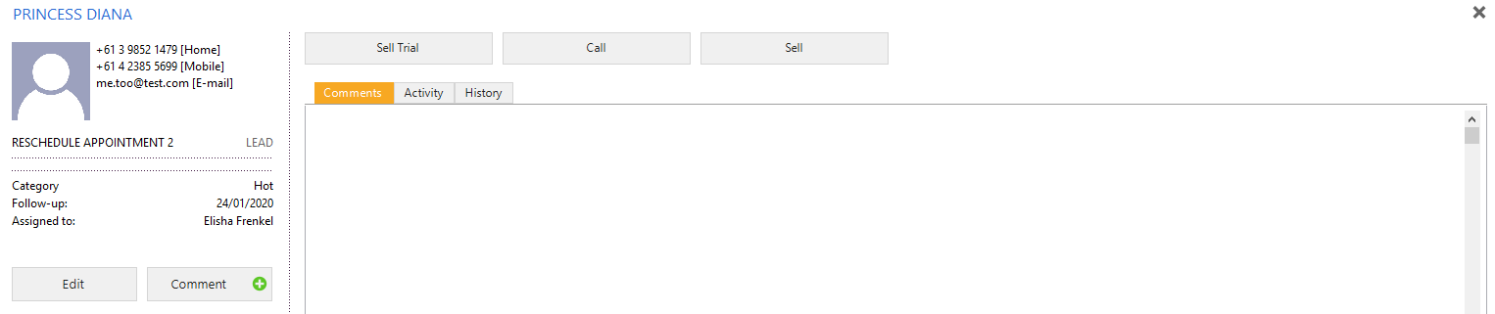

### Post Tour Call

1. Follow the instruction to book a sales appointment (tour).
2. There are two options which will result in a Post Tour Call – these are either the Send Information Email button or the No Sale Button.

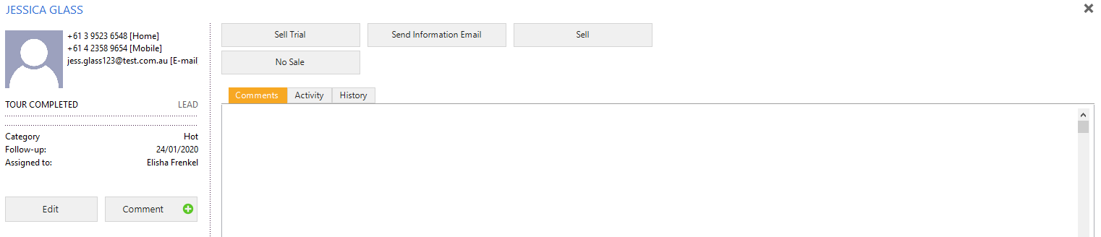

1. First, click on the Send Information Email button.



1. Then click on the radio button next to Answer – Request Email in the Send Information pop up screen. Then click the Next button.

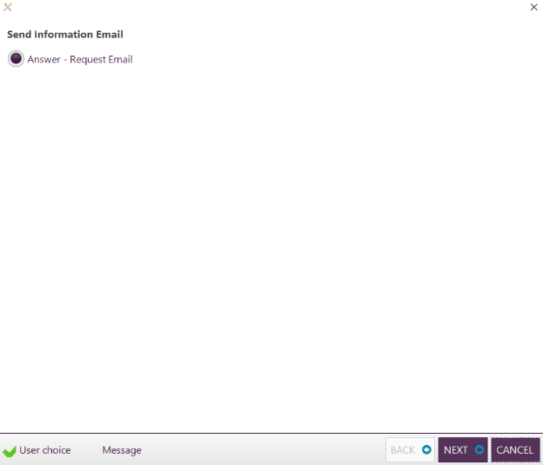

1. Click on the tick box next to Send Info Email. Then click the FINISH button.

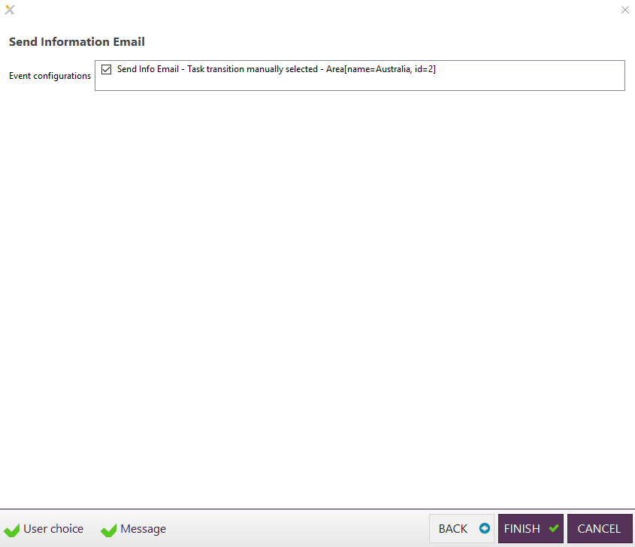

1. The lead will then transition to the Post Tour Call 1 stage. Here you can click on the Call button to schedule a call.

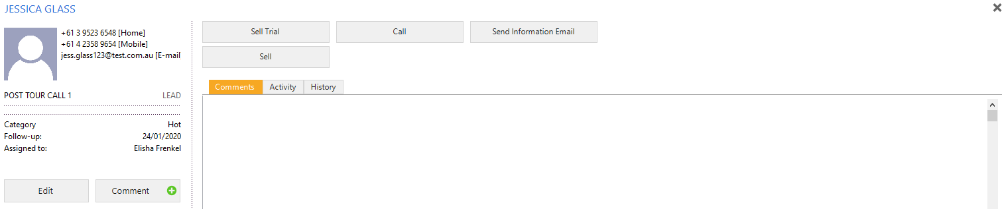

1. Alternatively, if you click on the No Sale button then the lead will transition straight to the Post Tour Call 1 stage.

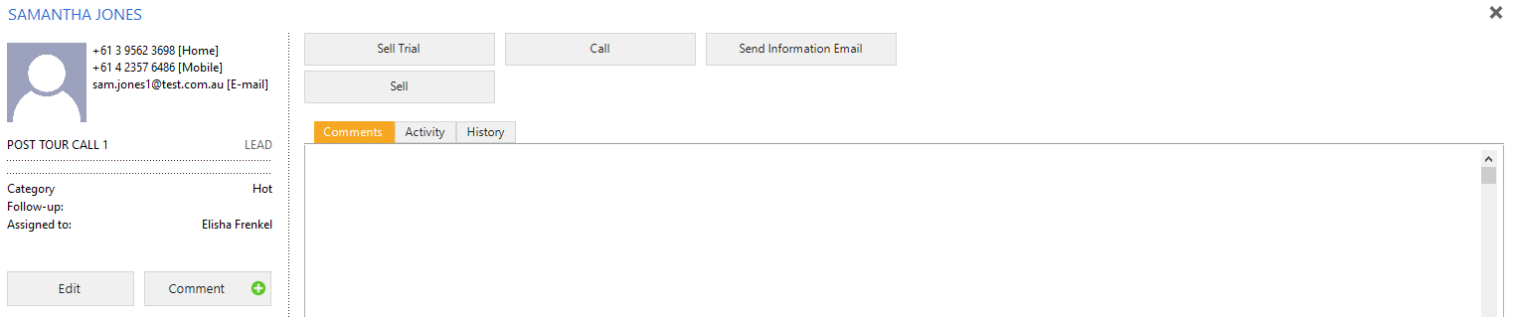

### Alternative CRM Bookings

The CRM can be used to book three appointment types.

1. **Sales appointment** – for all standard tours of leads
2. **Renewal** – for all PIF membership renewals
3. **Member Save** – for current members wishing to cancel a member save appointment can be booked to meet with the sales consultant to help save the member and reinspire them on their journey.

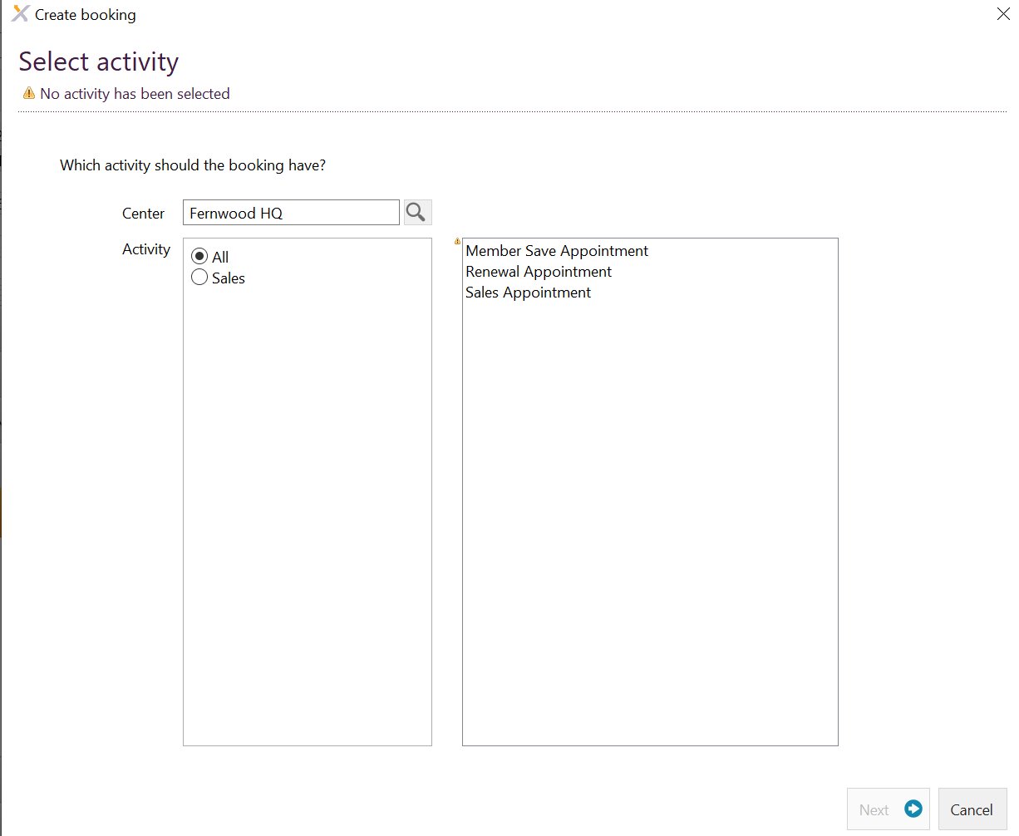

## My call list for today

1. Your call list for the day can be found in the CRM section of Exerp.
2. Click on the On-hold section under ‘Lead Management’.

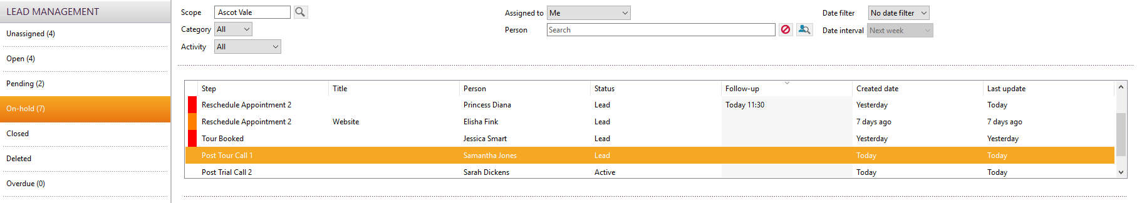

1. All of the people who appear in the list are people that require a call.
2. You can sort this by newest to oldest calls by clicking on the Follow-up tab and adjusting newest to oldest or vice versa.



1. If you do not action the Follow-up in time then the leads will appear under ‘Overdue’.

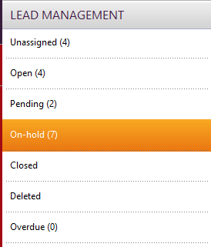

## How to view all closed leads

1. On the left-hand side of the CRM app you will see the different status in the lead management flow. Closed leads refer to leads who are sitting at the closed stage of the lead management flow i.e. sale has occurred or no sale. You are able to re-open these leads by creating a new task with the name of the closed lead.

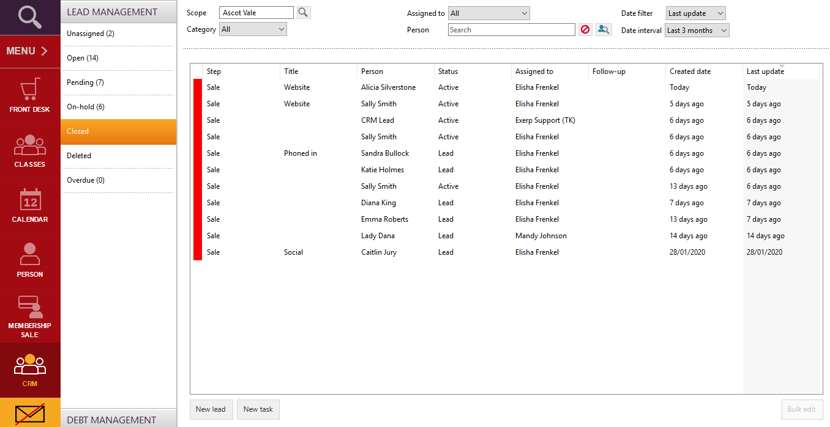

## How to view my leads VS all leads

1. In the CRM app in Exerp you can limit your view to see all leads in the CRM for your club versus all leads assigned to you.
2. You would instruct your sales teams to be in the habit of viewing all leads to ensure none are getting missed.
3. At the top of the CRM app you will see a field called Assigned to.

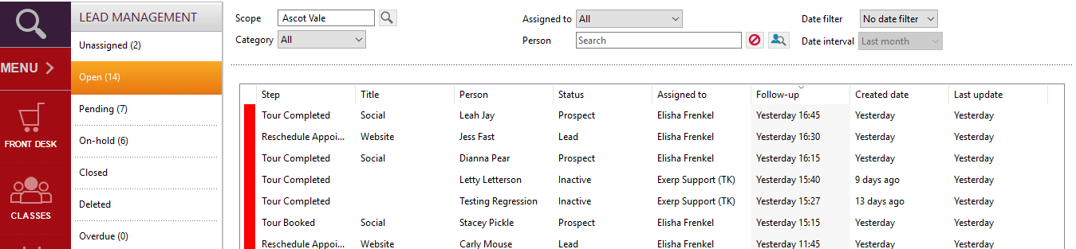

1. If you would like to view all leads then you should choose Assigned to: All



1. If you would like to view all leads assigned to you then choose Assigned to: Me

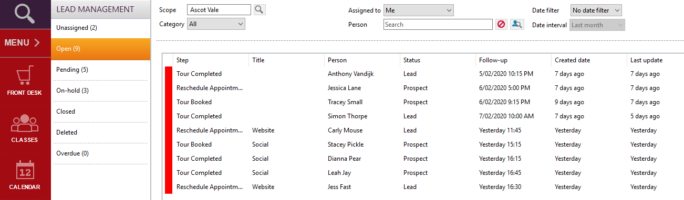

## Where are my overdue calls?

1. Overdue calls will fall into the overdue status in the lead management flow. To view your list of overdue calls you will need to click on the overdue status in the lead management flow.

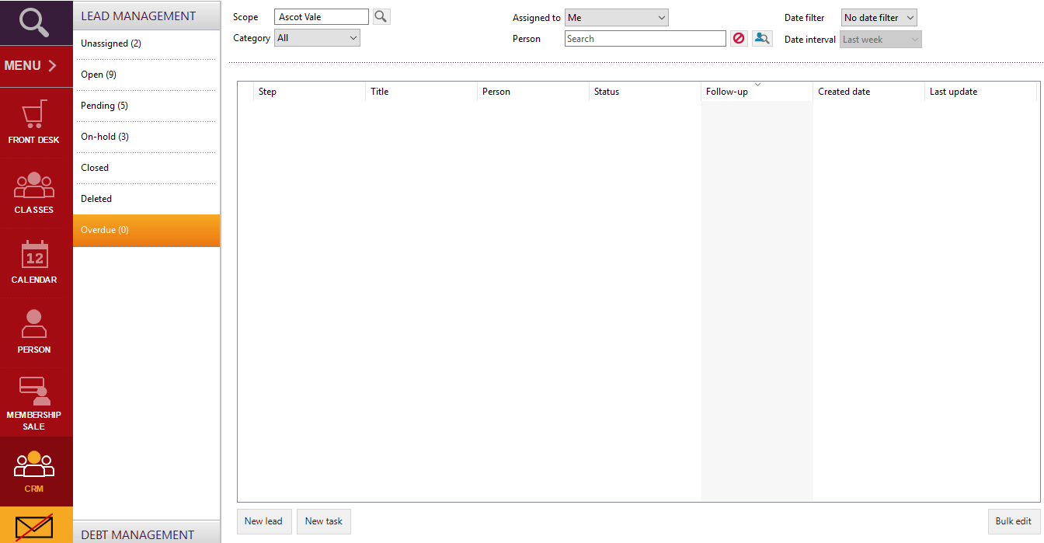

## Where are my closed lead and how do I reopen them?

1. You are able to locate all of your closed leads in the closed status in the lead management flow and also by choosing all leads assigned to me.

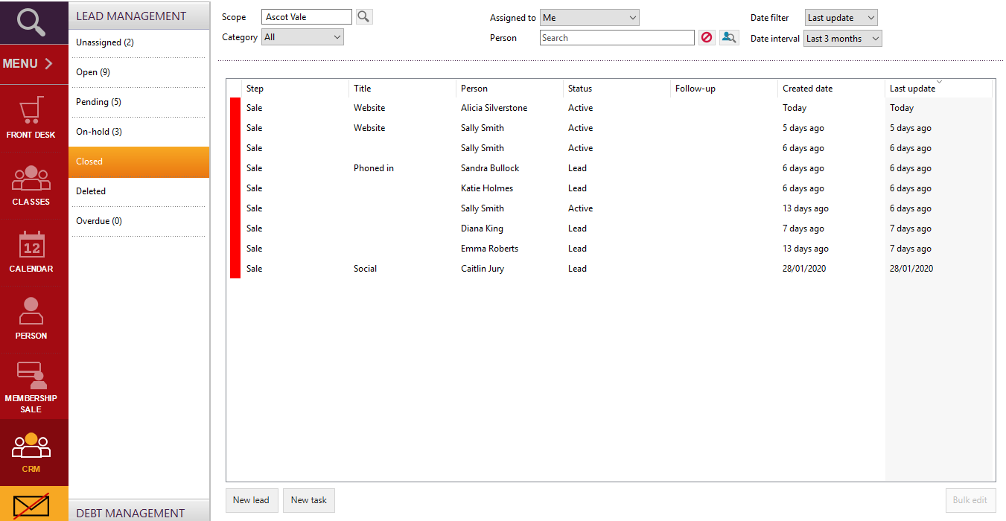

1. In order to re-open a closed lead you are able to click on the new task button at the bottom of the screen and then type in the name of lead you would like to reopen and it will take you back to the beginning of the lead management flow (lead – 1st contact).



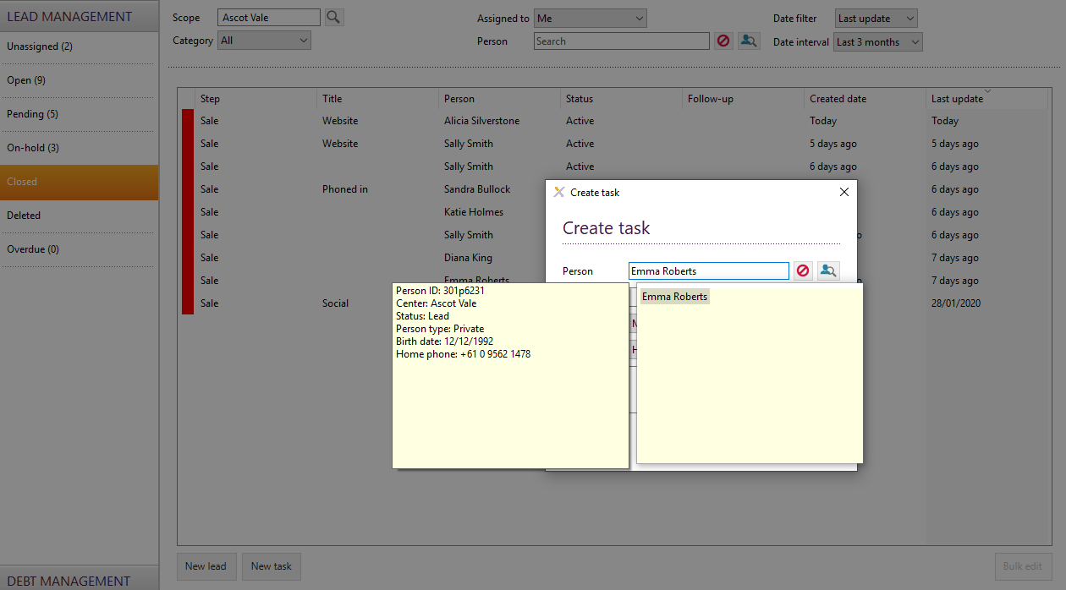

1. You will need to add in the title again (the source that the lead came from). Then click Ok.

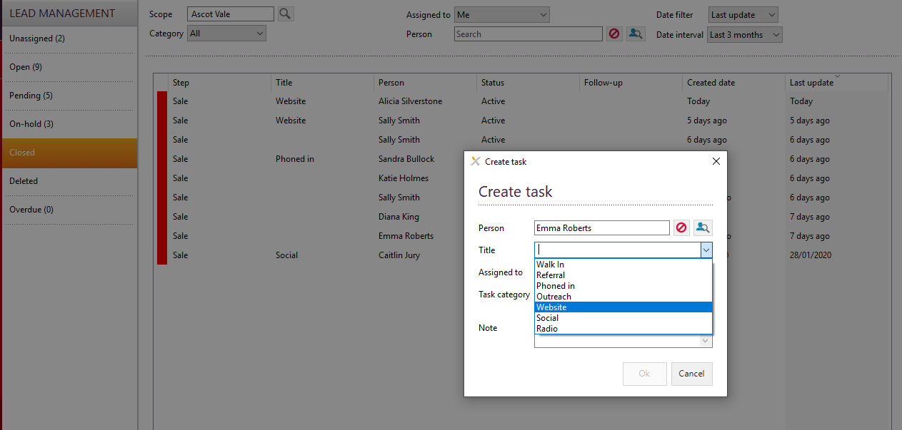

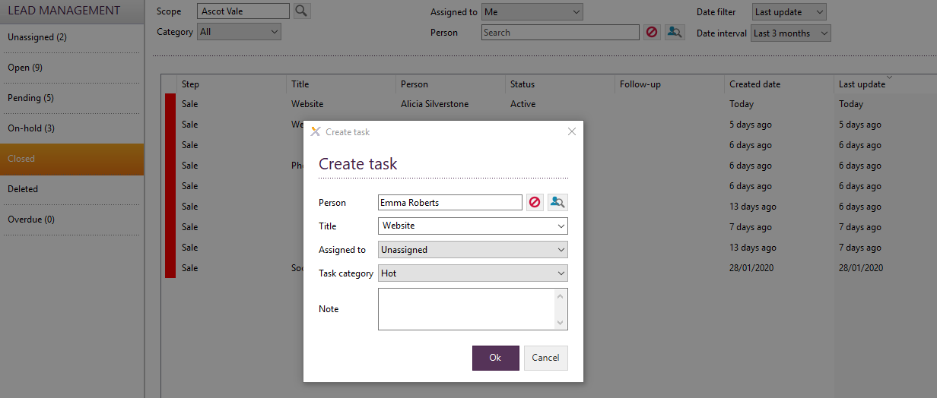

1. The lead will then sit as assigned until you click on the next action for this lead and then the lead will be assigned to you (or whoever clicked on the action).

## How to resend the Welcome Email

1. Click on the large magnifying glass at the top left corner of Exerp and type in the name of the member you would like to resend the welcome email to.

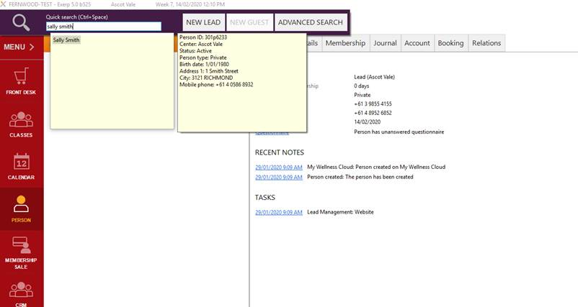

1. Double click on the name of the member when it populates her details.
2. Under Sally’s name there are a number of options – click on Journal.

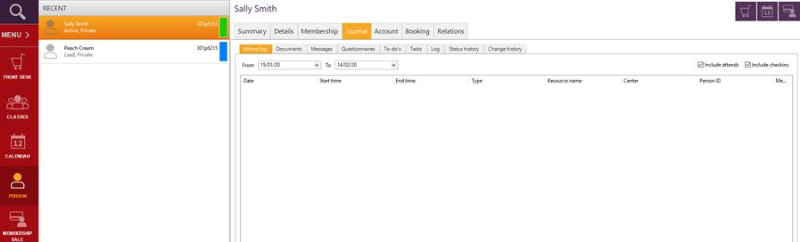

1. Click on messages in the row of options under Journal.

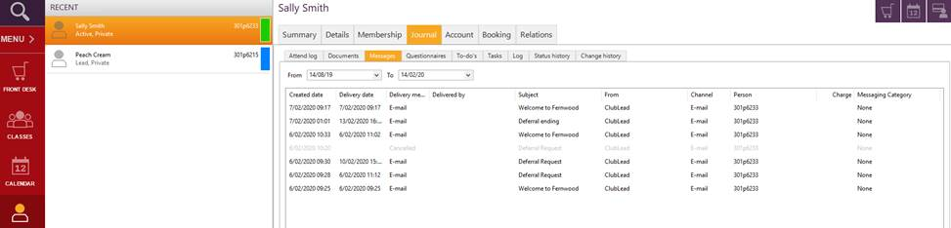

1. Click on the row where the subject is ‘Welcome to Fernwood’.

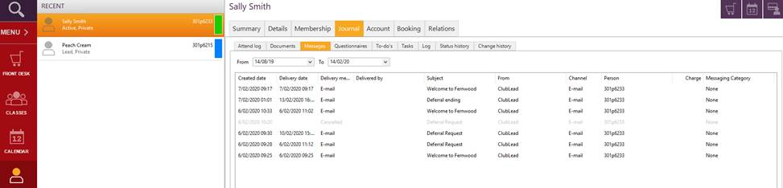

1. Click the button at the bottom of the page that says ‘Resend messages.

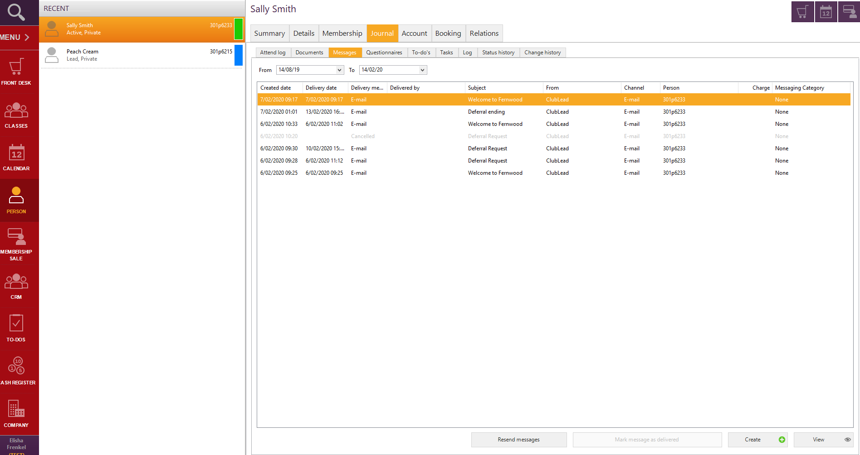

# Reports App

Various reports are available under the reports section of the menu.

*Menu > Reports App*

These reports are fairly high level and there is not much opportunity to drill down into these reports.

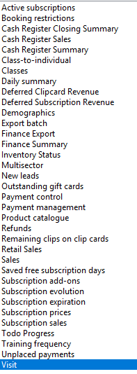

## Report Definitions from commonly used reports available in the Reports App

|  |  |  |
| --- | --- | --- |
| **Report** | **Target Audience** | **Definition** |
| Classes | Club | The classes report shows the number of classes, bookings, show-ups and absentees as well as additional information on the class i.e. the number of actual participations compared to the available number of seats for the classes. |
| Demographics | Club | The Demographics report shows persons grouped by ages and gender. |
| Visit Reports | Club | The Visits report shows check-ins, attends and class show-ups in a club, e.g. the number of visits in a club and what the members did during the visit. |
| Multi Sector | Club | The Multisector report shows attends into different resource happened during the visit of a club by the members. |
| New Leads Report | Club | The New Leads report shows new leads created by period of time, scope and employee. |
| Class – to – Individual | Club | The class-to-individual report shows info on classes and individual training. |
| Remaining Clips Cards on Clip Report | Club | Remaining clip card (sessions) on clip purchases for members |
| Daily Summary Report | Club | The Daily Summary report shows a summary of the activities in a club from a financial point of view. It is based solely on the finance transactions for a club in specific period and all financial movements are included in the report |
| Cash Register Closing Summary | Club | The Cash Register Closing Summary |
| Retail Sales Report | Finance | The Retail Sales report shows the sales, costs and profit margins of the retail sales per product in both units and amounts for a chosen date period. You can use this to see the profit margin on different products, product groups and suppliers. |
| Deferred Subscription Revenue Report | Finance | Report on deferred revenue |
| Subscription Expiration | Finance | The Subscription Expiration report shows all memberships with an end date in the defined date interval i.e. Paid in full memberships coming up for expiry |
| Subscription Evolution Report | Finance | The report Subscription Evolution will show the number of subscriptions at the beginning of a chosen period and at the end of this period. |
| Deferred Clip Card Revenue | Finance | In Exerp clip card sale is recognised as revenue, when the clip card is sold. This report shows the realised and deferred clips and related revenue for clip cards. |
| Finance Summary Report | Finance | The Finance Summary report provides a summary of the financial transactions on each account. |
| Subscription Sales | Club/Finance | The subscription sales report shows the sale of subscriptions for a report period or chosen date interval. |
| Subscription Prices Report | Club/Finance | The subscription prices report can be used to see the prices of all subscription products or to calculate the sum of subscriptions price changes. |
| Finance Export | Finance | The Finance Export report provides a summary of the financial transactions on each account in Exerp based on the book time of the transactions in Exerp. It includes all financial transactions created in Exerp with a book time within the chosen report period. |
| Active Subscriptions | Club/Finance | The Active subscriptions report shows the total number of active memberships and average prices on the day of generation. It has different grouping options giving for example total number, amounts and average by membership type, person type or by club. You can also use it to see the ration between cash (PIF/trials )and EFT (DD) memberships by club and region. |
| Sales Reports | Finance | The Sales reports shows the sum of invoices and credit notes generated within a given period. |

## Direct Debit Reports

Report to view a list of which members have been direct debited and the amounts they have been charged.

*Menu > reports > extract wizard > franchisee > ‘Periodical DAB Report – Detailed Billing’ > enter date of the direct debit in the from and to boxes > click next > extract to excel > finish.*

Go to the reports app in Exerp, and click on ‘Extract Wizard’.

Select the ‘Franchisee’ group of extracts and click next.

Scroll down to the report called ‘Periodical DAB Report – Detailed Billing’.

Click next.

**From Date:** enter the date of the direct debit.

**To Date:** enter the date of the direct debit.

Scope: If you own multiple clubs change the scope to be the club that you are extracting data for.

Click next.

Right click to export the data to excel.

In order to close the extract box in Exerp click finish.

## Rejection Reports

Report to view your members who have rejected.

*Menu > reports > extract wizard > franchisee > ‘Rejections Bank Account’ or ‘Rejections Credit Card’ > billing start = day before debit > billing end = day of debit > next > extract to excel > finish.*

Go to the reports app in Exerp, and click on ‘Extract Wizard’.

Select the ‘Franchisee’ group of extracts and click next.

Scroll down to the reports called ‘Rejections – Bank Account’ and ‘Rejections – Credit Card’.

In order to extract a listing of your bank account rejections, choose the ‘Rejections – Bank Account’ report and click next.

**In the billing start date:** enter the day before the day of the debit that you are extracting data for. For example if the debit you are extracting rejections for was on the 30/04/2020, enter the 29/04/2020.

**In the billing end date:** enter the date of the direct debit.

Scope: If you own multiple clubs change the scope to be the club that you are extracting data for.

Click next.

Right click to export the data to excel.

In order to close the extract box in Exerp click finish.

## Future Direct Debit - Estimate

Report to extract an estimate of what your next direct debit is going to be.

*Menu > reports > extract wizard > franchisee > ‘Estimate of Future Direct Debits > select either ‘Even Thursdays’ or ‘Odd Thursdays’ > click next > extract to excel* *> finish.*

Go to the reports app in Exerp, and click on ‘Extract Wizard’.

Select the ‘Franchisee’ group of extracts and click next.

Scroll down to the report called ‘Estimate of Future Direct Debits’.

Scope: If you own multiple clubs change the scope to be the club that you are extracting data for.

Payment Cycle: Click on either ‘Even Thursdays’ or ‘Odd Thursdays’ to select which direct debit you are extracting data for. Refer to the direct debit calendar to determine which direct debit week your club debits are in.

Click next.

Right click to export the data to excel.

**Once the data is in excel it is important to note** that members may appear multiple times in the report. The reason for this is that members may have multiple subscriptions, ie: membership, personal training, food coaching. Therefore, a member will appear in the report for each subscription that she has.

If reviewing this report throughout the fortnight prior to the billing processes being run, (ie: Tuesday and earlier prior to a debit day) column E will reflect the account balance which is made up of any new invoices raised throughout the fortnight, or any debt outstanding. The new subscription charges that will be included in the next direct debit will not yet reflect in this column as billing processes have not been run. Billing processes will only run on Tuesday night.

You will need to take the following into account to determine what your direct debit will be:

* Column C is the amount that will be picked up when billing processes are run on Tuesday night and is likely to be what the member will be charged.

However:

* Column O and P indicate the dates that members are on freeze for (freeze start and end dates). Therefore, it is recommended that you review the freeze dates for each member and reduce the amount in column C to be a freeze fee of $8.00 or less. Also, ensure that you remove multiple subscriptions. For example, if a member has a subscription for membership and for personal training, she will not be charged a freeze fee for each subscription, she will only be charged $8.00 for the membership subscription, therefore ensure that the price for any additional subscriptions is set to $0.00.
* Column S and T indicate the dates that members are on free time for (free period start and end dates).

Therefore, it is recommended that you review the free time dates for each member and reduce the amount in column C to $0.00 for all subscriptions for members who will be on free time during the next direct debit.

* Note: Column J reflects the fortnightly instalment amount that has been placed in an instalment plan. These amounts are not included in either the subscription price column C or the account balance column E.

Once the above has been reviewed and taken into account, the sum of column C, column E + column J will provide an indication of what your next direct debit is going to be.

If reviewing this report on a Wednesday the day prior to a direct debit after billing processes have run, column E will show the account balance for all amounts that will be direct debited. This includes invoices raised throughout the fortnight, outstanding debt, and any regular direct debit amounts for any subscriptions. **If reviewing the report on a Wednesday, you must ensure that you remove all duplicate members from the report, if this is not done members will be counted multiple times.**

How to remove duplicate members quickly and easily in excel:

Highlight the excel spreadsheet by clicking on the top left hand box:

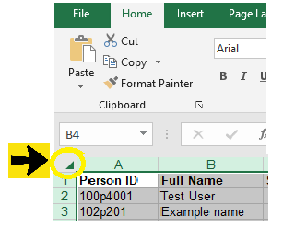

Click on the data tab in excel, then under the data tools menu click remove duplicates.

Unselect all and select only ‘Person ID’.

Click ok.

The sum of column E + column J will provide an indication of what your next direct debit is going to be.

## Payment Cycle Report

Report to identify which members are on each payment cycle.

*Menu > reports > extract wizard > franchisee > ‘Payment Cycles’ > scope = club name > click next > extract to excel > finish.*

Go to the reports app in Exerp, and click on ‘Extract Wizard’.

Select the ‘Franchisee’ group of extracts and click next.

Scroll down to the report called ‘Payment Cycles’.

Scope: If you own multiple clubs change the scope to be the club that you are extracting data for.

Click next.

Right click to export the data to excel.

Sort or filter by column D to show members on each payment cycle.

In order to close the extract box in Exerp click finish.

## Royalty Invoicing Reports

Reports to review details that make up royalty invoices.

## Periodical DAB Report – Detailed Billing

*Menu > reports > extract wizard > franchisee > ‘Periodical DAB Report – Detailed Billing’ > enter the start and end dates for the period royalties cover > click next > extract to excel > finish.*

Go to the reports app in Exerp, and click on ‘Extract Wizard’.

Select the ‘Franchisee’ group of extracts and click next.

Scroll down to the report called ‘Periodical DAB Report – Detailed Billing’.

Click next.

**From Date:** enter the start date that royalties cover

**To Date:** enter the end date that royalties cover

Scope: If you own multiple clubs change the scope to be the club that you are extracting data for.

Click next.

Right click to export the data to excel.

Using column F - remove any members who have rejected.

The sum of column E makes up the amount that will incur royalty charges that relates to direct debit income.

In order to close the extract box in Exerp click finish.

## Periodical DAB Report – Detailed POS

*Menu > reports > extract wizard > franchisee > ‘Periodical DAB Report – Detailed POS’ > enter the start and end dates for the period royalties cover > click next > extract to excel > finish.*

Go to the reports app in Exerp, and click on ‘Extract Wizard’.

Select the ‘Franchisee’ group of extracts and click next.

Scroll down to the report called ‘Periodical DAB Report – Detailed POS’.

Click next.

**From Date:** enter the start date that royalties cover

**To Date:** enter the end date that royalties cover

Scope: If you own multiple clubs change the scope to be the club that you are extracting data for.

Click next.

Right click to export the data to excel.

The sum of column D makes up the amount that will incur royalty charges that relates to POS sales.

In order to close the extract box in Exerp click finish.

## Payroll Reports

### Payroll – PT Report

Report to be able to pay personal trainers for sessions conducted.

*Menu > reports > extract wizard > franchisee > ‘Payroll – PT Report’ > date from = start date of payroll fortnight > end date = end date of payroll fortnight > scope = club name > click next > extract to excel > finish.*

Go to the reports app in Exerp, and click on ‘Extract Wizard’.

Select the ‘Franchisee’ group of extracts and click next.

Scroll down to the report called ‘Payroll – PT Report’.

Scope: If you own multiple clubs change the scope to be the club that you are extracting data for.

Click next.

Right click to export the data to excel.

Review the report and sort/filter to extract the relevant data for payroll.

In order to close the extract box in Exerp click finish.

### Group Fitness Report

Report to be able to pay group fitness instructors for classes conducted.

*Menu > reports > extract wizard > franchisee > ‘Group Fitness Report’ > date from = start date of payroll fortnight > end date = end date of payroll fortnight > scope = club name > click next > extract to excel > finish.*

Go to the reports app in Exerp, and click on ‘Extract Wizard’.

Select the ‘Franchisee’ group of extracts and click next.

Scroll down to the report called ‘Group Fitness Report’.

Scope: If you own multiple clubs change the scope to be the club that you are extracting data for.

Click next.

Right click to export the data to excel.

Review the report and sort/filter to extract the relevant data for payroll.

In order to close the extract box in Exerp click finish.

## Revenue Breakdown

Report to be able to split revenue types for P&L (Profit & Loss) Reporting

*Menu > reports > finance summary > scope = club name > period = interval > start date = first day of month > stop date = last day of month > view report or export to excel.*

Go to the reports app in Exerp, and click on ‘Finance Summary’.

Change the scope If you own multiple clubs change the scope to be the club that you are extracting data for.

Period: change to interval.

Start Date: first day of the month.

Stop Date: last day of the month.

View the report or export to excel.

The total column will provide a $ figure exclusive of GST for each income area for the month.

This total makes up both direct debit income and POS income.

Some income areas appear more than once in the report, this is due to the way that our global accounts have been set up, this simply means that you need to add these amounts together.

Simply journal/reallocate the revenue in your accounting software into the relevant income accounts in order to finalise your month end accounts and to submit your profit and loss report to us each month.

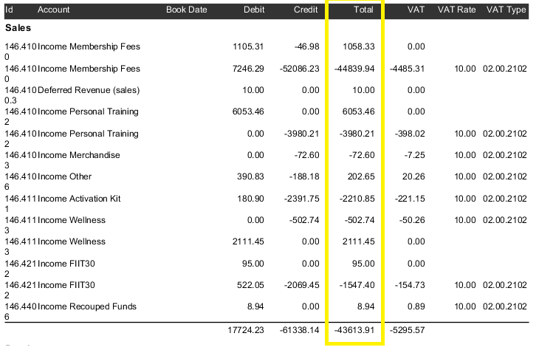

## Build your own reports – Easy Extracts

*Reports App > Easy Extracts*

You can build your own reports by working through the Easy Extract reports, click on Easy Extract located at the bottom of the reports menu.

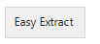

Once clicking on Easy Extract you can choose to extract data on a person level or a subscription level.

There is no need to change the extract type – generic extract should be used.

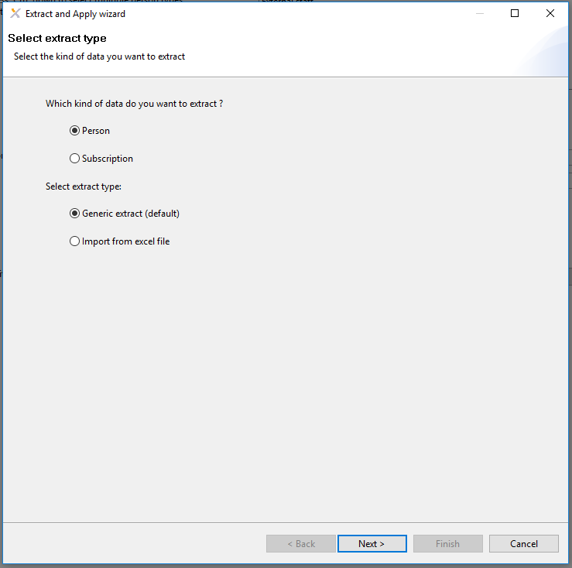

Once in the reporting criteria, use the filtering boxes to drill down into the information you are looking for.

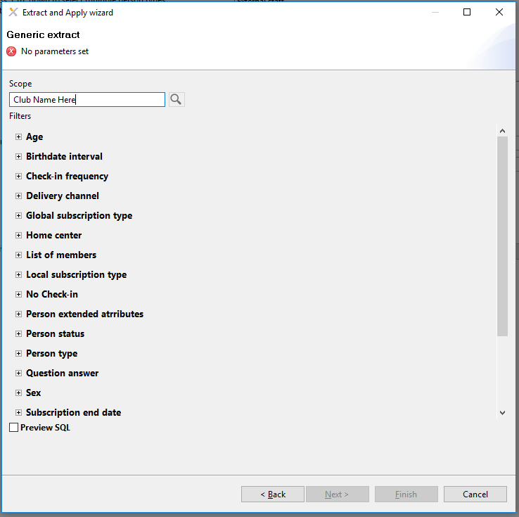

## Active Members Report

For example you may want to know who all your active members are, filter by person status and select active.

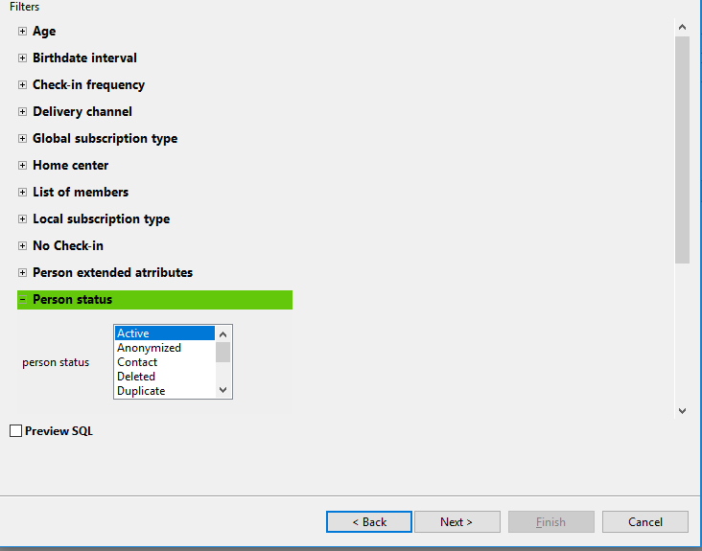

Click the next button to progress to the next screen. You will then see a box similar to the below:

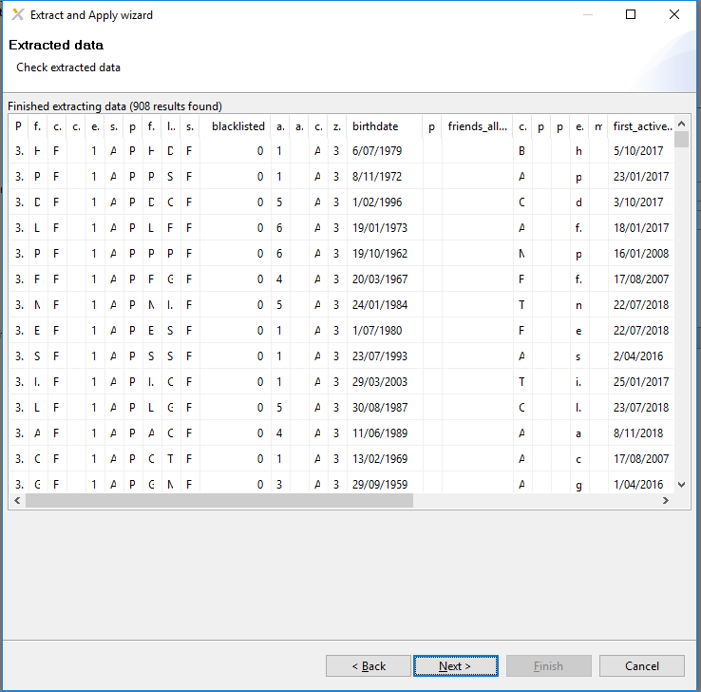

Right click to export your report to excel or to perform other tasks.

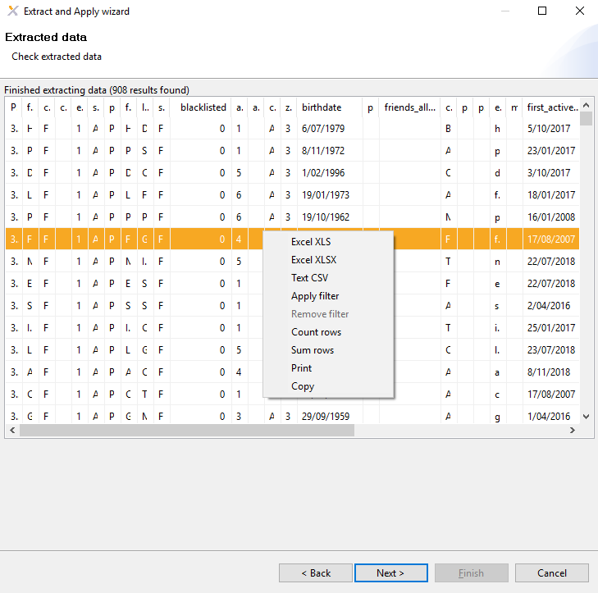

Once the report is in excel you can manipulate the date however you like.

Information in this report includes data such as:

_eClub_PERSON_ID

fullname

persontype

firstname

lastname

address1

address2

city

zipcode

birthdate

phonehome

phonemobile

email

first_active_start_date

last_active_start_date

last_active_end_date

memberdays

accumulated_memberdays

unbroken_member_days

broken_member_days

## Cancelled Members during a particular period Report

You may wish to see which members cancelled during a particular period, in which case you would select the subscription end date and choose the period you are wanting information from. Click next and extract the data to excel.

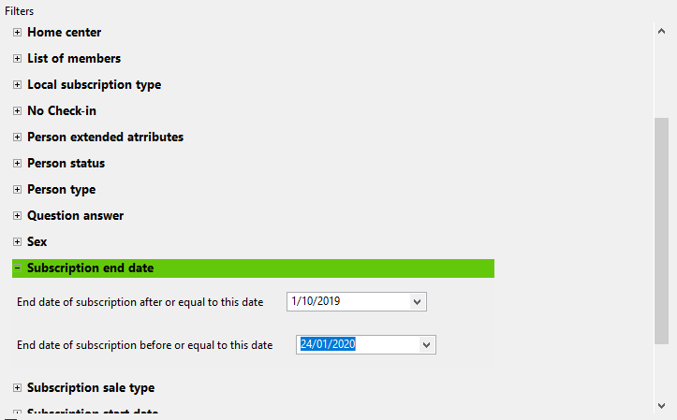

## Active Student Members

You may wish to see who your active student members are, in which case you choose the person type to active and the person type to be that of student, click next and extract to excel.

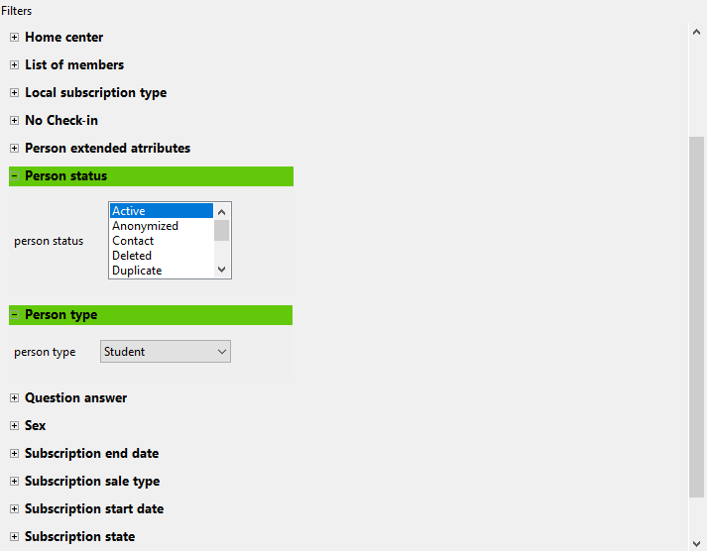

Various filtering options can be chosen:

You may wish to see who your active members are who renewed during a particular period. In which case you select the person status to be active, the subscription sale type to be renew and the subscription start date to select the period.

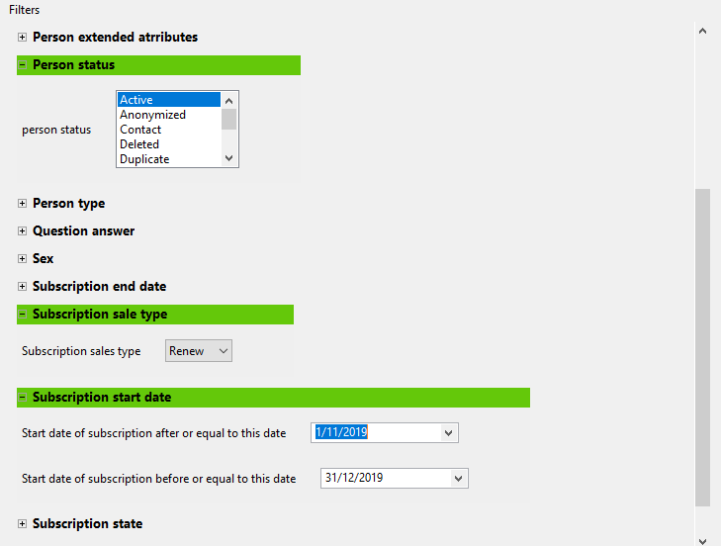

## 18-Day Non-Attendance Report

The 18-day non-attendance report has been set up to be sent to the default club email address each night. The report comes through as an excel spreadsheet attachment and will give you a list of members that haven’t recorded a visit in Exerp in the last 18 days. Please see an example below.



You can also access this report in Exerp via the Reports App if you would like to see members that haven’t vistied the club within a custom day range. For e.g. if you would like to see all members that haven’t been ot the club in the last 30 days you can review this in Exerp as well.

*Reports App > Extract Wizard > Select 18 Day No Visit Report > Enter the number of days in the window below*

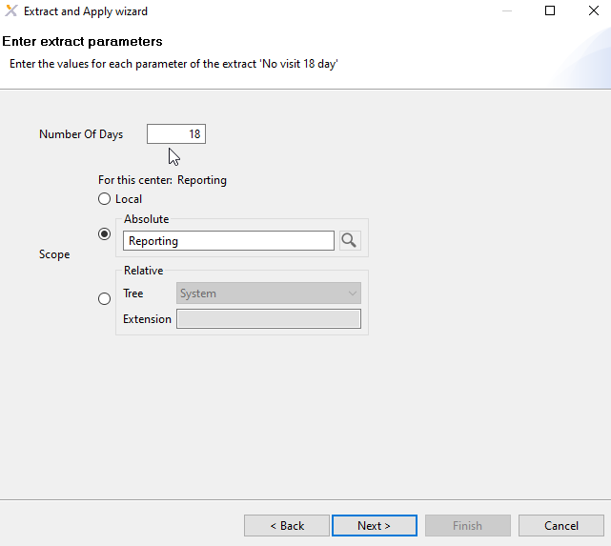

## Active Members – Last Visit Date Report

The Active Members – Last Visit Date Report will allow you to pull a report on all active members that have recorded a visit in the club within a certain range. You can customise the date range to be the last 30 days, everyone who visited in August or everyone who has visited the club since that start of the year.

*Reports App > Extract Wizard > Franchisee > Active Members – Last Visit Date Report > Select your date range > Next > Export to Excel.*

1. In Exerp go to the Reports App
2. Select the Extract Wizard in the bottom left corner
3. A new screen will pop up > Select Franchisee > Select Next
4. Select the Active Members – Last Visit Date > Select Next  
   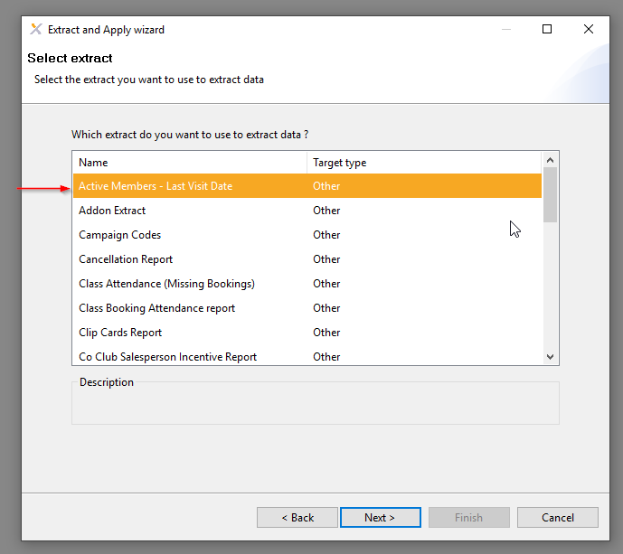
5. 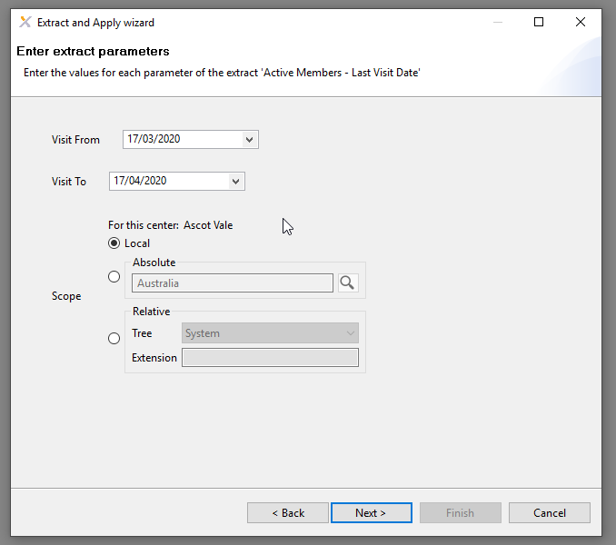Choose your date range > it will default to your club, however check the scope if you own multiple clubs.

1. Select Next and will export the data. Right click on the table and export to excel.

## Addon Extract Report

The Addon Extract Report is the report you will pull to view all of your members that have a current subscription add-on i.e. FIIT30 Flexi. You may want to see all your members that are on unlimited FIIT30 or unlimited Reformer Pilates – this is the report you will need to pull.

*Reports App > Extract Wizard > Franchisee > Addon Extract Report > Choose Scope > Next > Export to Excel.*

1. In Exerp go to the Reports App
2. Select the Extract Wizard in the bottom left corner
3. A new screen will pop up > Select Franchisee > Select Next
4. Select the Addon Extract > Select Next
5. Choose your scope it will default to your club, however check the scope if you own multiple clubs.
6. Select Next and will export the data. Right click on the table and export to excel.

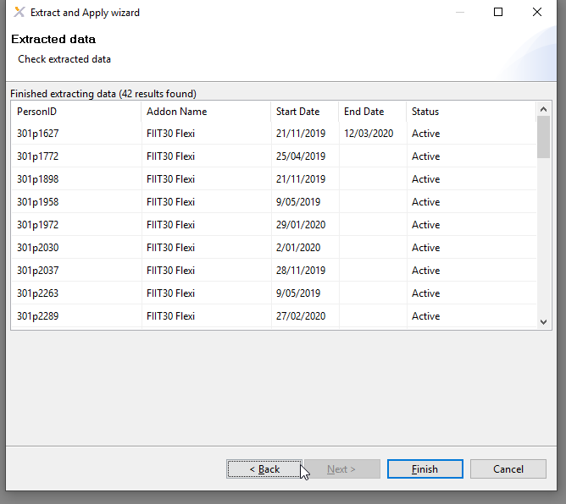

## Clip Cards Report

The Clip Cards Report is the report you will pull to view all of your members that have any clip cards available, including recurring clip card. You may want to see all your members that have Personal Training sessions on their account – you would pull the Clip Cards Report and then filter in excel to just display PT.

*Reports App > Extract Wizard > Franchisee > Clip Cards Report > Select date range and choose Scope > Next > Export to Excel.*

1. In Exerp go to the Reports App
2. Select the Extract Wizard in the bottom left corner
3. A new screen will pop up > Select Franchisee > Select Next
4. Select the Clip Cards Report > Select Next
5. Select your date range and choose your scope it will default to your club, however check the scope if you own multiple clubs.
6. Select Next and will export the data. Right click on the table and export to excel.

## Detailed POS Report – Cost Centre

*Menu > reports > extract wizard > franchisee > ‘Detailed POS – Cost Centre’ > enter the start and end dates > click next > extract to excel > finish.*

1. Go to the reports app in Exerp, and click on ‘Extract Wizard’.
2. Select the ‘Franchisee’ group of extracts and click next.
3. Scroll down to the report called ‘Detailed POS – Cost Centre’.
4. Click next.
5. **From Date:** enter the start date   
   **To Date:** enter the end date   
   Scope: If you own multiple clubs change the scope to be the club that you are extracting data for.
6. Click next.
7. Right click to export the data to excel.

This report shows a detailed summary of your sales through the cash register for both cash and credit card. It will also show new membership transactions for that day as well.

This report will assist with your daily reconciling as well as provide a breakdown of your revenue components for MYOB/XERO record keeping.

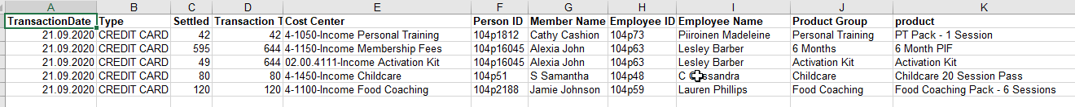

## How to send bulk communications in Exerp – Club Manager access and above.

Exerp can be used so clubs can send out service messages in bulk to their members. This may be used from anything for a COVID update where you need update all of your active members to a class update where Body Combat will now be a Zumba class and you only want to communicate to members booked into the class.

It is important to remember that these messages are NOT marketing and should not be used for marketing purposes.

**Checking if a member has opted in for Service Messages through Exerp.**

1. Search for the member in Exerp and go to their profile.
2. Open the Details tab. Under the Communication section next if they have a red circle icon next to their email or SMS with a cross through it, it means that the member has opted out of service messages.

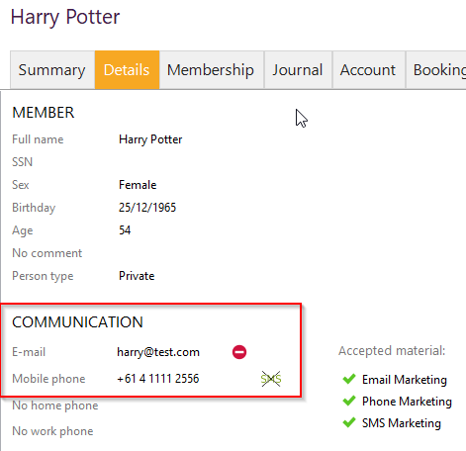

1. To update these > click on Edit and check the boxes next to Email & SMS.

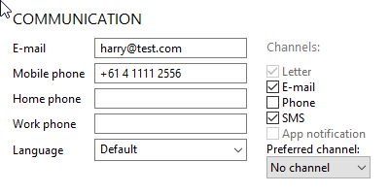

**How to send out the communication to your members**

1. First, you need to choose your target group or pull a report for the list of members you are wanting to send out the email/SMS to. You will need a list of their Exerp Person ID.
   1. This could be active members report, class booking list, all your FIIT30 members etc.
2. Go to Reports > Easy Extract > Next > Select **List of members** and copy and paste the list from your report above into the system > Next > It will give you a summary of how many members it will be sent to > Next > Choose **Execute Apply Step** > Next > Choose option **Apply: Send message.**
3. From this screen enter the following:
   1. *Subject line* – this is only applicable for Email, however for SMS it will display as the journal note title.
   2. *Content* – the copy of the message
   3. *Channel* – choose email or SMS
4. Select next and it will give you a summary of the communications
5. Select Next and this will send the communication
6. On the final screen it will give you a summary of the successful ones and if there are any errors which will apear in red.

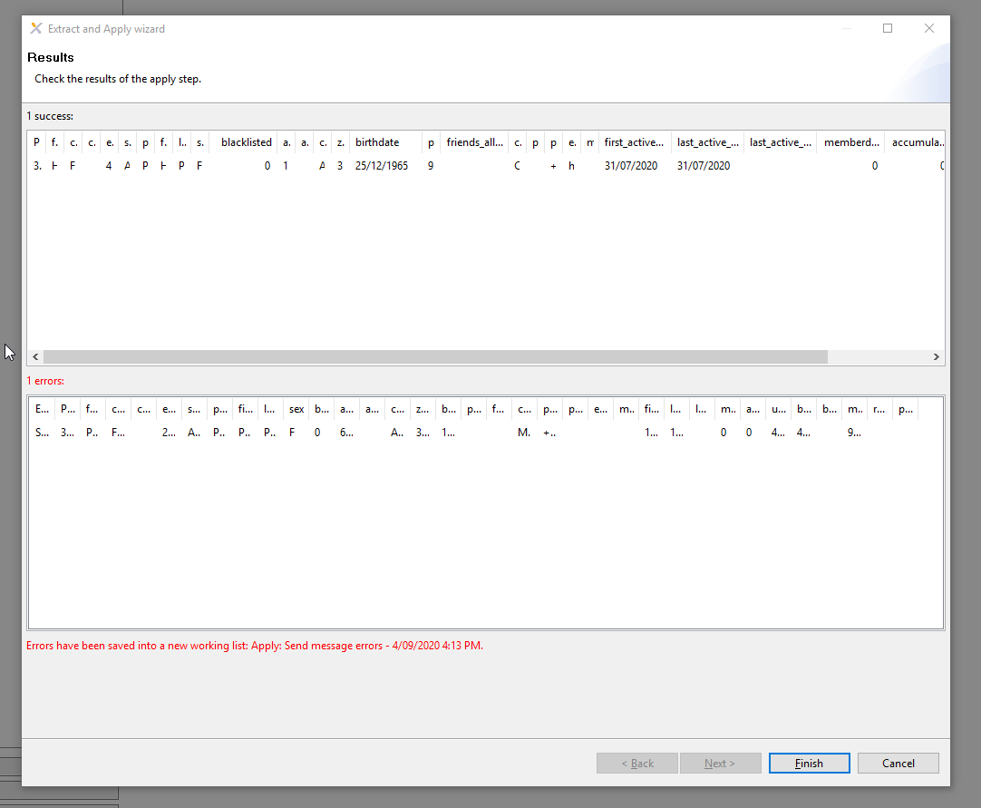

**To run a test communication**

To see an example of what your email is going to look like, you can send a test communication to yourself in Exerp.

1. Go to your profile in Exerp > Journal > Messages
2. Create > Choose the channel and enter the copy you are wanting to send > VIEW.
3. This will give you the preview of how the message will look to the member.

**A few things to remember with sending bulk communications through Exerp.**

* This should be used for service messages only, not marketing messages
* Check the member is opted in for service messages
* Emails and SMS will display under the member’s profile > Journal > Messages

## How to pull a duplicate report in Exerp

If you want to try and identify some of your duplicate profile in Exerp to be cleaned up by Helpdesk you can follow the below steps.

PLEASE NOTE: It is quite difficult to identify duplicate members in the database due to a lot of missing data we had in FCM. There are blank spaces for mobile number, email addresses etc. and quite often the DOB is incorrect so keep an eye out for the DOB with **29/02/1940** as this is the DOB imported in Exerp from landing pages when this information is not completed by the lead.

We recommend doing the below for MOBILE NUMBER & EMAIL ADDRESS first before applying the duplicate check on first and last name as this could take some time to sort through and check all fields.

1. Exerp > Reports App
2. Select Easy Extract > Lease default settings applied > Next > Person Status (Ctrl + Select all fields except Transferred) > Select Next
3. Right click on the data and export it to Excel
4. Once in Excel apply a filter on all columns
5. Select the first column you want to identify duplicates i.e. email address
6. Select Conditional Formatting in the Excel menu bar > Highlight Cell > Duplicate Values

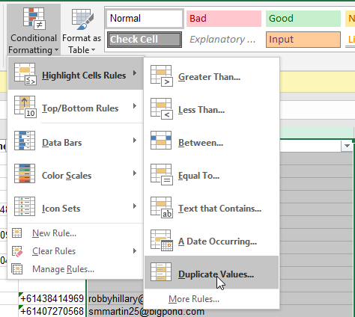

1. 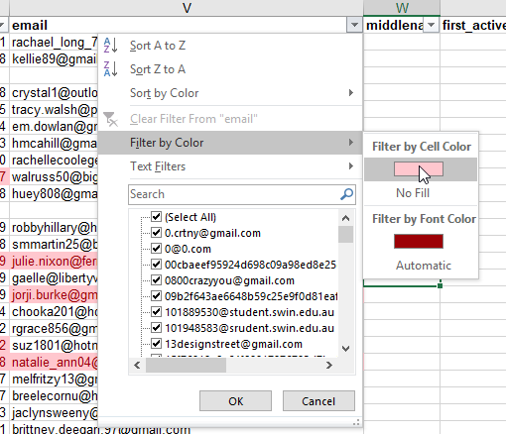This will highlight all of the duplicates in red. Then click on the filter drop down at the top of the column and select Filter by Colour > Red.

You can follow the above steps in Excel for email address, mobile number and then first and last name.

Once you have this information, you can send a completed spreadsheet to Helpdesk and they ill mark them as duplicates and remove the secondary profile.

PLEASE NOTE: Please be very clear as to which profile you want to be removed as the duplicate. I would recommend checking the status of the person as you need to keep any ACTIVE members as well as checking their pro.mywellness profile if they have an Fernwood app account linked as well.

As mentioned earlier it is quite difficult to identify every single duplicate in the system as there are a lot of missing fields, however this report will get a good percentage to start with.

# Pro.Mywellness

## Staff Profiles

*Pro.mywellness > Staff > Staff Members*

Staff profiles for Personal Trainers will be visible to their clients via the Fernwood App, so that when a member is booking an appointment with them they can see their name, photo (so they can recognise their trainer in the club) and a small biography about the trainer. This can include their qualifications and certificates or what they love most about being a PT.

### Edit your staff profile

*Pro.mywellness > Staff > Staff Members > Find your profile > Select Public Profile*  *> Edit/Add any information*

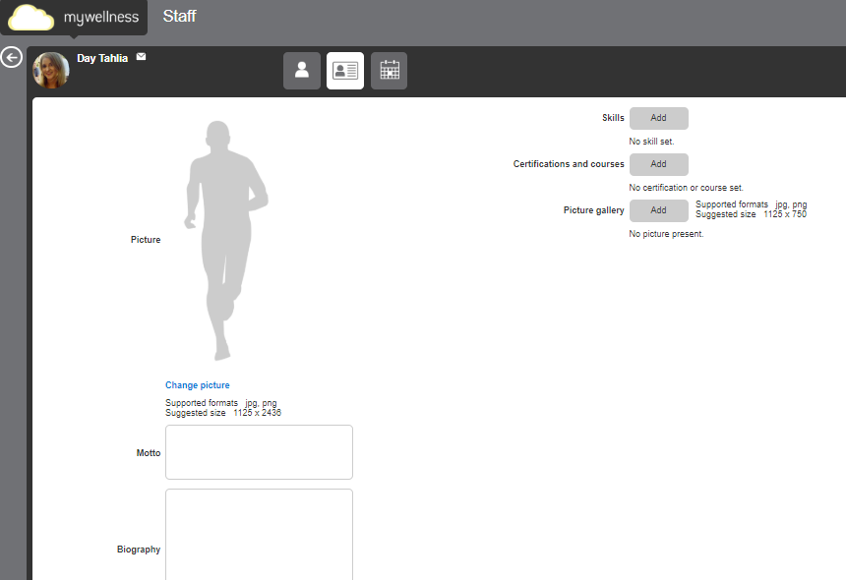

### View your schedule

*Pro.mywellness > Staff > Staff Members > Find your profile > Select Calendar* 

This will give trainers the ability to view **week by week** their activity in the club. It will show any classes they are teaching, Fitness Coach shifts and Personal Training times.

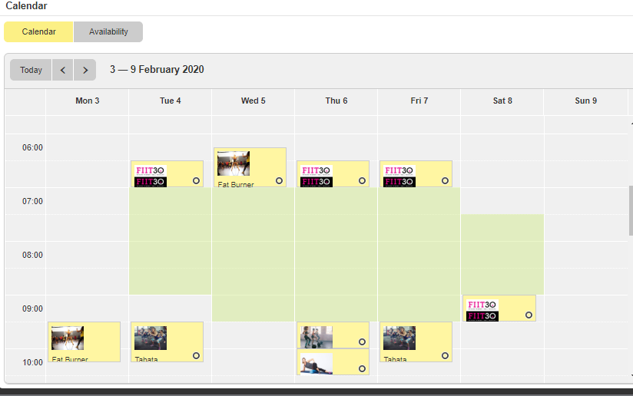

## Managing Calendars – Personal Training & Fitness Coach

### Open up a working time

***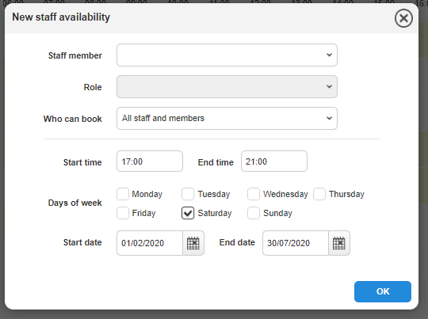****Pro.mywellness > Staff Profile > Calendar View > Availability > New*

1. Select your staff member
2. Select your role i.e. Personal Trainer OR Fitness Instructor (Fitness Coach)
3. Who can book – Leave this as All Staff and Members so that members can book via the Fernwood App
4. Select Start and End time of the shift
5. Select any days this shift time applies to
6. Select end date of this shift. If this a once off shift be sure to select the date as both the start and end date.
7. Select OK

### Edit/Remove a shift

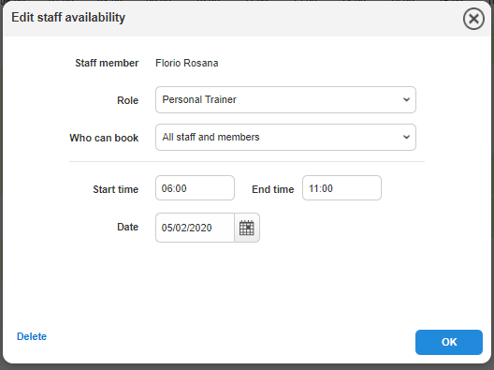*Pro.mywellness > Planner > Staff Availability > Find the shift > Select > Edit*

1. Select the shift you want to edit
2. Choose either the entire series or just this one
3. TO EDIT: Adjust the time and date   
   TO REMOVE: Select Delete

### Booking in a member

*Pro.mywellness > Planner > Staff Planner*

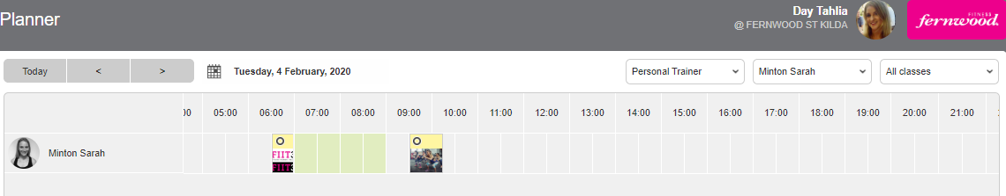

In Staff Planner you can view and book trainers and instructors from a **day to day** view. Use the filters in the top right hand side to search via role, staff member or class (or use two or three).

Once you’ve found the day you wish to book the member in for, you can easily view the trainers availabilities by any of the green squares. All spots that have been taken will show as a different colour.

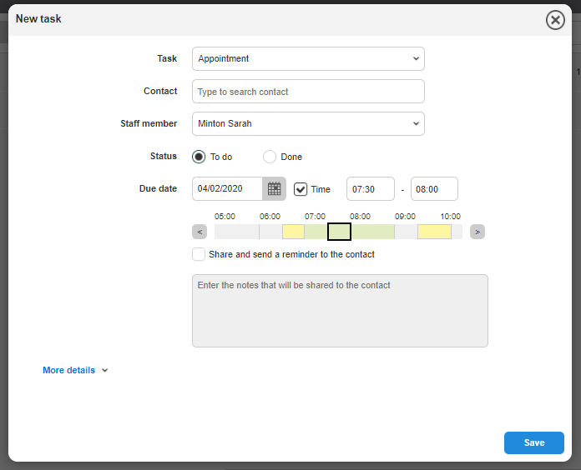

1. Click on the available spot with the preferred trainer
2. Select Task type  
   **Available options:** Personal Training 30mins, Personal Training 60mins, Break, Complimentary Training Session, Contact, Phone Call
3. Search for your member
4. Staff member will be pre-selected
5. Status: Any future appointments will be listed as To-Do, once a member signs in to the club and is marked as attended the appointment will be marked as Done
6. Confirm date and time of the session
7. **Optional:** Share a message to the member   
   If you would like to send any additional notes to the member about their appointment, please check this box and type in the message. For e.g. *Hi Mary, please remember to pay for your next session at the reception desk.*
8. 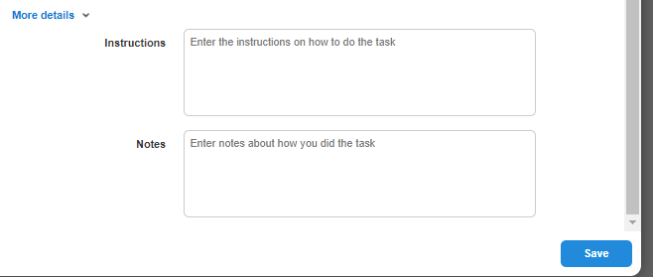**More details:** Trainers can add in any notes about the upcoming session.
9. SAVE

### Edit/reschedule a session

*Pro.mywellness > Planner > Staff Planner > Search for session > Edit*

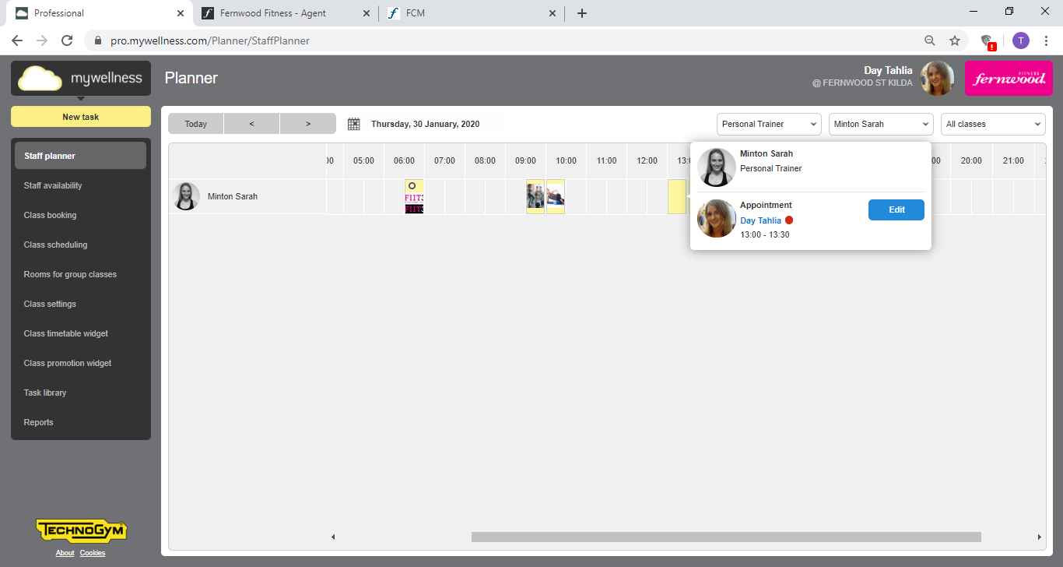

To view which member is booked in to the session, hover you mouse over the yellow square and it will load the member. This is also a short cut to Edit/Cancel the session.

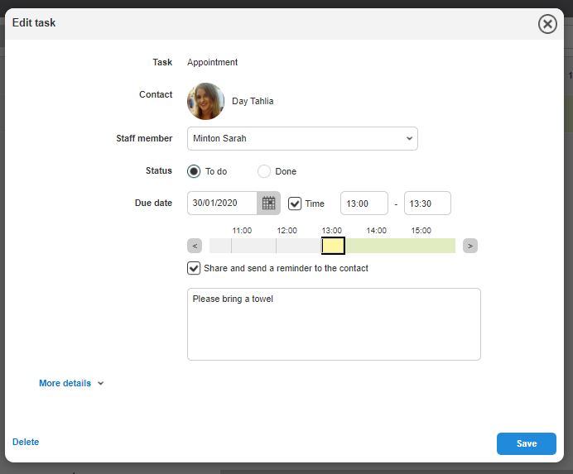

1. Find the session you need to reschedule, hover your mouse over the square and select Edit.
2. Adjust the date and/or time of the session as required.
3. Click SAVE.

### Cancel a session



1. Find the session you need to reschedule, hover your mouse over the square and select Edit.
2. Select Delete

The cancellation policy and booking rules are set in Exerp and will flow through to the appointments set up in pro.mywellness. For e.g. a PT session that is removed within the 12 hours prior to the session time, the member will automatically forfeit the session.   
Members will be unable to cancel their session via the Fernwood App in the 12 hour window before the session start time. They will be prompted to call the club to cancel.

PLEASE NOTE: all of the above functions are able to be completed in the Staff Profile section of pro.mywellness as well as managed by Personal Trainers at home via the MWPro App.

### How to assign a break in your calendar

To book in a break in your personal training calendar, simply find the time in your shift you need to block out for a break > Select BREAK as your task and this will block your calendar out for 30 minutes.

You will need to assign yourself (as a staff member) to the appointment, which will then allow you save.

## Tasks

Any outstanding tasks assigned to a staff member will come up on the home page dashboard of pro.mywellness when a member signs in.

This will display any tasks that the staff member needs to action – whether it be marking off a complimentary personal training session or actioning a follow up phone call.

It will give the staff a quick overview of all their outstanding tasks. This can also be viewed and marked off in the Staff App.

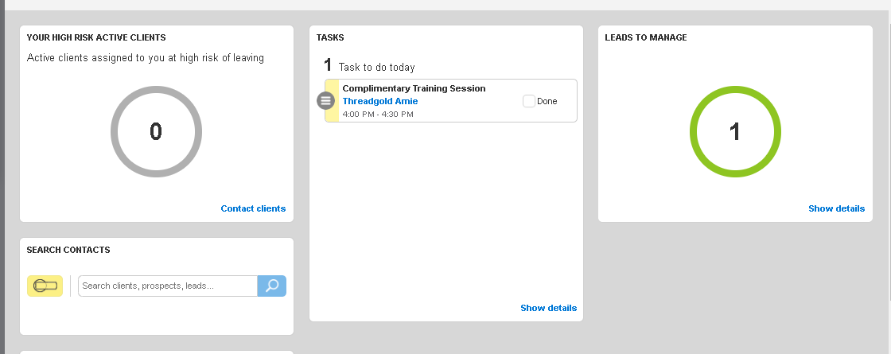

## Assign a Member to a Staff Member

For Personal Trainers to keep up to date with their client base, we recommend using pro.mywellness to assign your PT clients to their trainers. This make it easy for the trainers to search for their clients in pro.mywellness and send out communications if required.

(INCLUDE SCREENSHOTS)

## Staff App – Mywellness for Professionals

For Personal Trainers to view and book clients into the calendar easily from home and in the club they can do this all via the Mywellness for Professionals Staff App. Simply download from the App Store and log in using their existing credentials. This will automatically link them to their club and calendar.

### View any outstanding tasks

On the home page of the app, staff can view, add and action any tasks that are allocated to them. A task is a useful prompt for staff to create their own follow ups. For example, ‘Follow up Mary Smith on her complimentary PT session’.

### View & Manage the Calendar

In the calendar icon for the staff app, trainers can view and manage their working times as well as reschedule, cancel and book clients in.

This allows trainers to view their shifts any time, any where, without having to contact the club directly.

Click on the calendar icon in the app, search by the day to view and book in your clients.

* Either tap on the time in the calendar or tap the + icon in the top right hand side of the screen to add in a client.
* Trainers will be prompted to enter the same information as they would if they were booking via the pro.mywellness platform.

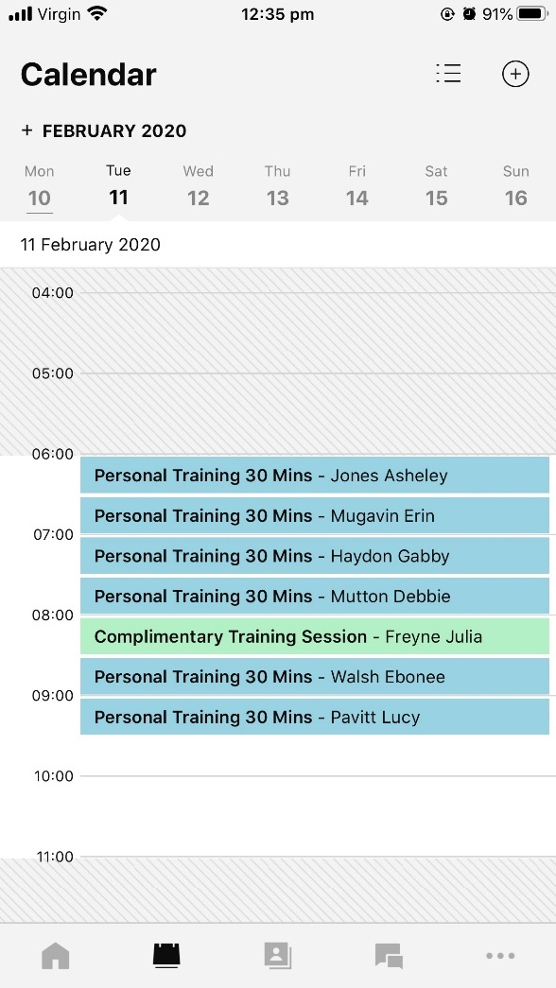

### See who is in the club

Add screenshots in here

## Fernwood App 2.0

## Notifications to members for classes and appointments

* Members that book into a class, they will receive a push notification the day before, and one hour before the class (include screenshot of appointment)
* Attendance will be marked off automatically if they swipe into the club at reception within a 2 hour window before the start time of their session or class
* Booking window – within the 12 hours for PT it will stop them from making any changes to their sessions via the app and will prompt them to contact the club directly.

## Waitlist function

## Book a Personal Training session via the App

*Fernwood App > Book a service > Personal Training > Select Trainer > Select time of session > Confirm booking*

(Include screenshots from Diego’s slide)

## Purchasing PT via the App

If a member has no PT sessions (clip cards) and they go to book a Personal Training session via the app, they will be prompted to purchase a pack before they can book a session in.

(Add screenshots from Diego’s slides)

## Managing Penalties for Classes

## Scheduling Classses in pro.mywellness

*Pro.mywellness > Planner > Class Scheduling*

1. Go to the Planner tab > Class Scheduling tab > New
2. Choose the class you wish to schedule from the drop down selection
3. Choose the room that the class will take place in from the drop down selection

**PLEASE NOTE:** Any classes that have been deleted in pro.mywellness, before you schedule a class in the same time spot, ensure you wait at least 60 second. This is to ensure pro.mywellness and Exerp are talking to each other and the class is set up correctly.

# Exerp Hardware Installation Instructions

## Step Over Signature Pad

### Requirements

* Step over Signature pad
* Spare USB port for the Billiance color
* 32-bit java installation of Exerp

**Note**

Step Over currently only has 32-bit drivers which is why the Java version of Exerp needs to be installed on the PC. For instructions on how to install the Java version of Exerp, please refer to the training manual.

### Installation

1. Plug the signature pad into the PC
2. Open Exerp and login
3. Go to Menu → Client
4. Select 'Devices'
5. Click ‘Add’
6. Select ‘StepOver v5_6’ from the drop[ down menu
7. 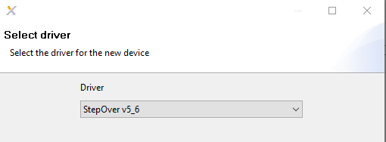
8. Select Next → Next → Finish
9. The driver installation files for the signature pad will start automatically, allow them to install. You amy also be prompted to install .net 3.5 framework if it is not already installed, please accept this installation also.
10. 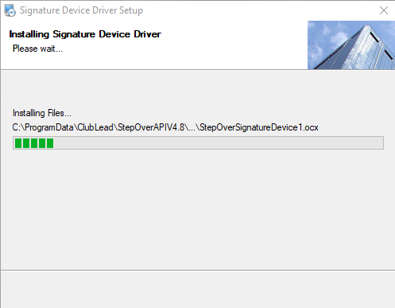
11. Once finished, close Exerp
12. Open Exerp and login
13. Go to Menu → Client
14. Select Devices
15. The ‘StepOver v5_6' should appear in the list with 2 Green ticks, select it and in the 'Log’ Window you should see 2 informational entries saying the device has initiated and started successfully
16. 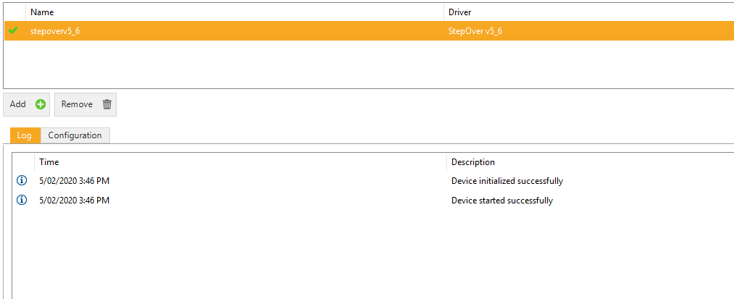
17. If you are using the Step Over Brilliance Color, you should see the Fernwood logo appear on the screen

Webcam Installation

Requirements

* USB Webcam or Internal webcam if using a laptop
* Spare USB port

Installation

1. Open Exerp
2. Go to Menu → Client
3. Click on Devices
4. Click Add
5. Select ‘DirectShow Webcam’ from the drop down list
6. 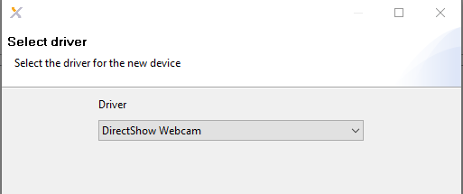
7. Click Next
8. From the drop down list, select the Webcam installed on the PC
9. 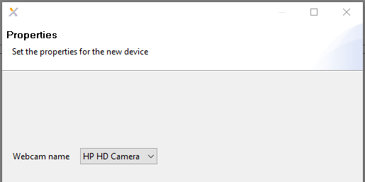
10. Click Next → Finish
11. Close down Exerp and open it up again
12. Log in and go back to Menu → Client → Devices
13. The ‘DirectShow Webcam' should appear in the list with 2 Green ticks, select it and in the 'Log’ Window you should see 2 informational entries saying the device has initiated and started successfully
14. 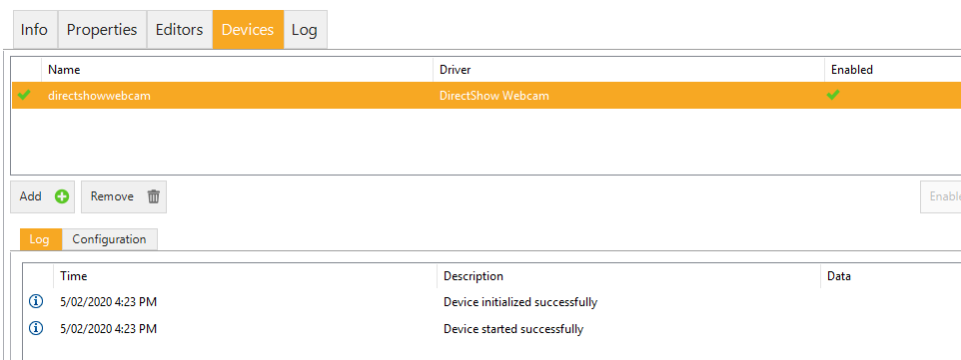

Posiflex MSR Driver Installation

This guide shows the necessary steps to install the Posiflex MR-2200U-3-B in to Exerp.

Requirements

* Posiflex MR-2200U-3-B
* Spare USB port
* Posiflex software

1. Go to <http://www.posiflex.com/en-global/Download/index/driver/MR/MR-2106_MR-2200>
2. From the drop down menu select “Drivers & Utility”
3. Download:
   1. MR-2XXX Series MSR Manager Utility for USB interface Magnetic Stripe Card Reader
   2. MR-2XXX Series USB Virtual Com Port Driver for WinXP/Win7/Win8/Win10_32Bit/64Bit
4. Extract the files

* WinRar installed as the files are in .rar format www.winrar.com

**Note**

You cannot have Exerp and the MSR Manager Utility open at the same time due the each programme locking the COM port in Windows

Installation

Configure the device for Exerp

1. Go to the MSR Manager Utility folder and run Setup.exe and accept all defaults
2. Plug the Card Reader into the PC
3. Run Posiflex USB MSR Manager
4. Make the following configuration changes:
   1. Tick the virtual COM port interface
   2. Change the MSR Track1 Leading Code from **%** to **; (semi colon)**
   3. Save & Exit
5. 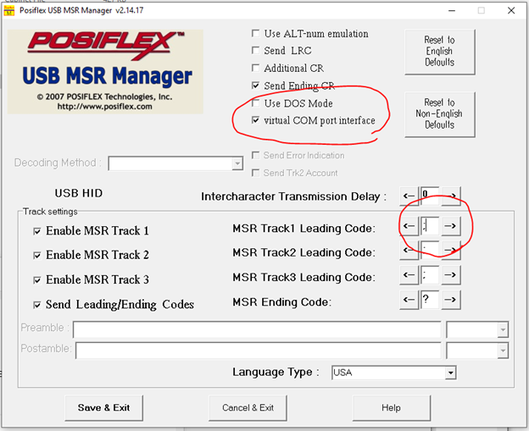

Set up the device as a COM port

1. Go to the USB Virtual Com Port Driver folder
2. Select the folder which represents the operating systems architecture (most Windows operating systems now are 64-bit)
3. Rick click USB_VCOM.inf and from the drop down list click ‘Install’
4. 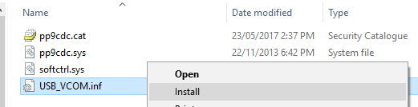
5. If any security Windows pop up, accept and install
6. Go to ‘Device Manager’ and check that a new port has been added in ‘Ports (COM & LPT)’ called Posiflex USB MSR (COMx)
7. 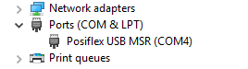
8. Take a note of the COM port number

Set up Exerp

1. Open Exerp
2. Go to Menu → Client
3. Click on Devices
4. Click Add
5. Select 'MagTek Swipe Reader'
6. 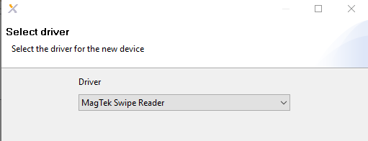
7. Select the COM port noted earlier
8. 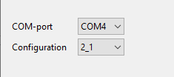
9. Select Next → Next
10. In Usages, select 'Attend'
11. 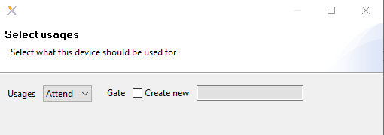
12. Click Finish
13. Please note that there is some additional configuration that is required after this which needs to be done by IT. Please send a request to [helpdesk@fernwoodfitness.com.au](mailto:helpdesk@fernwoodfgitness.com.au) for this to be completed
14. Close down Exerp and open it up again
15. Log in and go back to Menu → Client → Devices
16. The ‘MagTek Swipe Reader' should appear in the list with 2 Green ticks, select it and in the 'Log’ Window you should see 2 informational entries saying the device has initiated and started successfully
17. 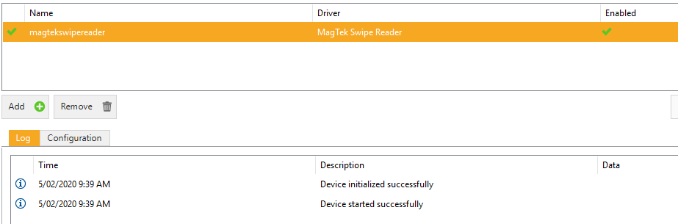
18. Go back to the front desk in Exerp and swipe a member’s card to see if it records a visit

RFID HID Omnikey reader

This guide shows how to set up the RFID reader into Exerp. The hardware is required to log member visits at reception via the fobs and to assign fobs to members. 2 readers are required per club as the readers are not able to do both jobs. It is advised that the readers are labelled so that the role of them can be easily identified and that they are plugged into separate PC’s.

The RFID reader that is used to log member visits should be connected to a reception PC and it is recommended that the RFID reader that is used to allocate fobs to members should also be a reception PC but if there is only 1 PC at reception then the franchisee\manager should use their discretion when selecting a suitable PC.

Requirements

* 2 x RFID HID Omnikey readers
* 2 x PC’s with a spare USB port

Set up Exerp

1. Plug the reader into your PC
2. Open Exerp
3. Go to Menu → Client
4. Click on the Devices tab
5. Click Add
6. Select ‘Generic PC/SC’ from the drop down menu

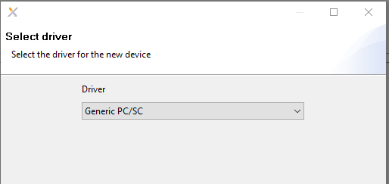

1. Select 'HID Global OMNIKEY 5022 Smart Card Reader 0’from the drop down menu

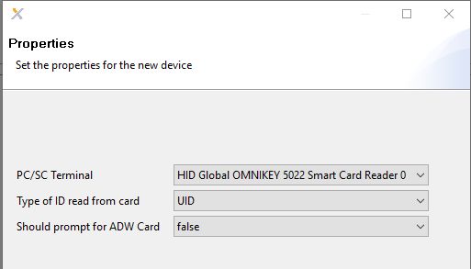

1. Click Next and Next again
2. For the PC that will use the RFID reader for allocating fobs to members select ‘None’ in Usages

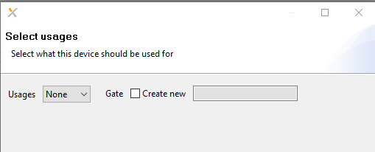

1. For the PC that will use the RFID reader for registering member visits select ‘Attend’ in Usages

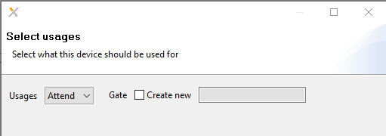

1. Click ‘Finish’
2. Close down Exerp
3. Open Exerp
4. Go to Menu → Client
5. Click on the Devices tab
6. The ‘Generic PC/SC' should appear in the list with 2 Green ticks, select it and in the 'Log’ Window you should see 2 informational entries saying the device has initiated and started successfully

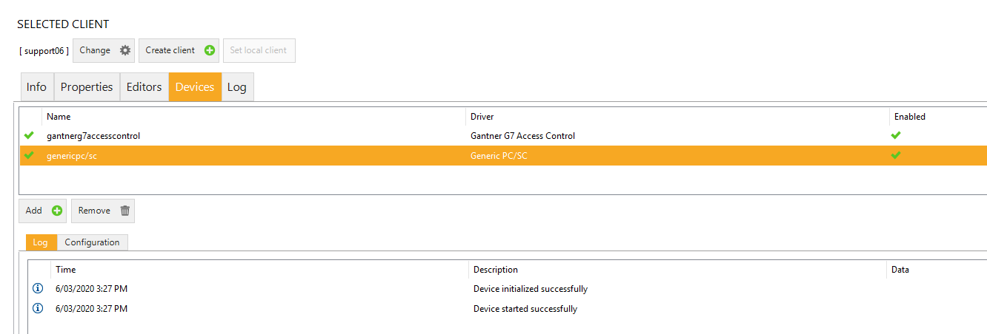

# Exerp Hardware Requirements

## Computers – minimum requirements (recommended)

* Operating system – Windows 10 64-bit (recommended)
* Processor – i3, i5 (recommended)
* Memory – 4GB, 8GB (recommended)
* Disk – 160GB, 240GB SSD (recommended)

**PLEASE NOTE:** Windows 7 is no longer supported by Microsoft and there are also compatibility issues with running Exerp so clubs must replace\upgrade any Windows 7 PC’s they currently have.

Exerp does not run on a Mac operating system. If you are running Windows on Parrallels or something similar on a Mac then this should work. Support for this is limited and you should seek further advice from your local IT Tech.

## Software

Java version – the 32-bit version of Java needs to be installed and can be downloaded at <http://java.com>

Installer version – this only runs on 64-bit operating systems. Most computers with Windows 10 will be 64-bit by default.

Exerp will be moving away from the Java install in the future so clubs must ensure that there PC’s are 64-bit.

## Printers

For printing contracts, your existing network printer should be compatible.  
We will not be printing receipts through Exerp so a receipt printer will not be required.

## Cameras

Most modern USB cameras will work with Exerp, we recommend using a Logitech WebCam that can be attached to your reception monitor. If you are using a Windows laptop or tablet with an inbuilt camera, this should also work but will need to be tested for compatibility.

## Signature Pads

For digital sign ups a signature pad from Step Over is required. There are 3 to choose from:

* Durasign 10” Signature Pad
* Billiance and Color
* NauraSign Mobile

## Tablets

IPads and Android tablets are not supported but can still be used in club for other functions e.g. Pro.mywellness and remote PT bookings via mywellness.